|  |  |  |  |  |
| --- | --- | --- | --- | --- |
|  | Finolex Academy of Management and Technology, Ratnagiri | | | |
| **Department of Information Technology** | | | |
| **Subject:** | **R Programming Lab. (ITL804)** | | | |
| **Class:** | **BE IT / Semester – VIII (Rev-2016) / Academic year: 2019-20** | | | |
| **Name of Student:** | **Kazi Jawwad A Rahim** | | | |
| **Roll No:** | **28** | | **Date of performance (DOP) :** |  |
| **Assignment/Experiment No:** | | **05** | **Date of checking (DOC) :** |  |
| **Title:** Working with graphics and tables | | | | |
| **Marks:** | |  | **Teacher’s Signature:** |  |

**1. Aim**: To understand the exploratory data analysis and the methods required to do it in R.

**2. Prerequisites**:

1. Basics of R programming, various data structures for data sets.

**3. Hardware Requirements**:

1. PC with minimum 2GB RAM

**4. Software Requirements:**

1. Windows / Linux OS.
2. R version 3.6 or higher

**5. Learning Objectives:**

1. To understand various graphical visualization of data sets.
2. To understand the use of tables.

**6. Learning Objectives Applicable: LO 5**

**7. Program Outcomes Applicable: PO 4, PO 5**

**8. Program Education Objectives Applicable: PEO 3, PEO 4**

**10. Results:**

**Plot:**

x=c(5,7,9,10,14,15,18)

y=c(1,2,3,4,5,6,7)

plot(x,y,'l',main="JK",sub="NK")

**OUTPUT:**

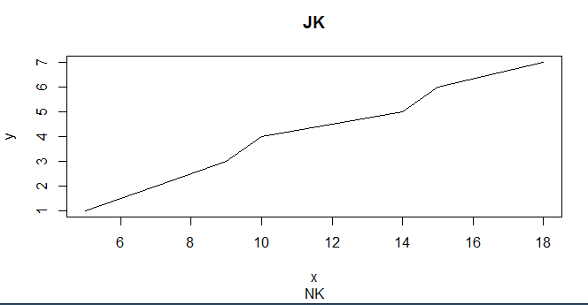

**Pie Charts:**

x1=c(21,42,63,84)

labels=c("Mumbai","Delhi","Kolkata","Chennai")

pie(x1,labels)

**OUTPUT:**

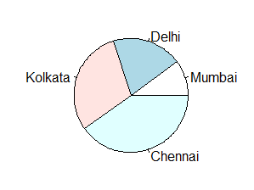

**Pairs:**

x2=1:5

y2=x2**2

z2=c(2,1,3,9,2)

A=cbind(x2,y2,z2)

pairs(A)

**OUTPUT:**

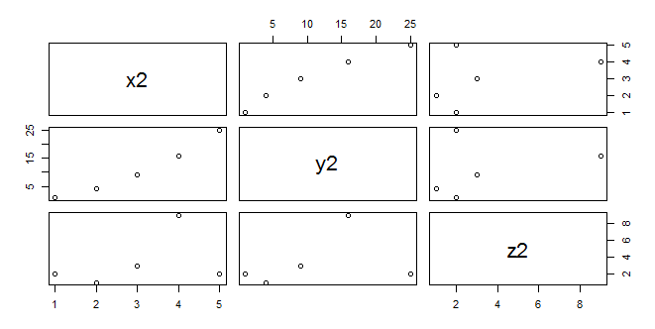

**Table:**

B=matrix(c(1:9),nrow=3,byrow=TRUE)

t=as.table(B)

print(t)

plot(t)

**OUTPUT:**

A B C

A 1 2 3

B 4 5 6

C 7 8 9

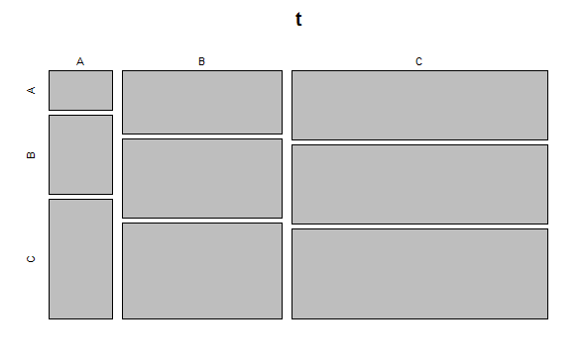

**11. Learning Outcomes Achieved:**

1. We understood various graphical visualization of data sets.
2. We understood the use of tables.

**12. Conclusion:**

We have successfully demonstrated the exploratory data analysis and the methods required to do it in R. We have also demonstrated various graphics methods such as scatterplots, pairs, pie charts and Tables.

**13. Experiment/Assignment Evaluation**

|  |  |  |  |  |  |
| --- | --- | --- | --- | --- | --- |
| **Experiment/Assignment Evaluation:** | | | | | |
| **Sr. No.** | **Parameters** | | | **Marks obtained** | **Out of** |
| **1** | Technical Understanding (Assessment may be done based on Q & A **or** any other relevant method.) Teacher should mention the other method used - | | |  | 6 |
| **2** | Neatness/presentation | | |  | 2 |
| **3** | Punctuality | | |  | 2 |
| **Date of performance (DOP)** | |  | **Total marks obtained** |  | **10** |
| **Date of checking (DOC)** | |  | **Signature of teacher** | | |

**References**:

1. URL: https://cran.r-project.org/doc/manuals/r-release/R-intro.pdf ( Online Resources)
2. R Cookbook Paperback – 2011 by Teetor Paul O Reilly Publications
3. Beginning R: The Statistical Programming Language by Dr. Mark Gardener, Wiley Publications
4. R Programming For Dummies by Joris Meys Andrie de Vries, Wiley Publications

**Viva Questions**

1. What are different data visualization command and functions in R?
2. What is table?
3. How table is different than data frame?