|  |  |  |  |  |
| --- | --- | --- | --- | --- |
|  | Finolex Academy of Management and Technology, Ratnagiri | | | |
| **Department of Information Technology** | | | |
| **Subject:** | **R Programming Lab. (ITL804)** | | | |
| **Class:** | **BE IT / Semester – VIII (Rev-2016) / Academic year: 2019-20** | | | |
| **Name of Student:** | **Kazi Jawwad A Rahim** | | | |
| **Roll No:** | **28** | | **Date of performance (DOP) :** |  |
| **Assignment/Experiment No:** | | **07** | **Date of checking (DOC) :** |  |
| **Title:** Program to demonstrate regression and correlation in tabular data including categorical data. | | | | |
| **Marks:** | |  | **Teacher’s Signature:** |  |

**1. Aim**: To understand the exploratory data analysis and the methods required to do it in R.

**2. Prerequisites**:

1. Working with larger data-sets.

**3. Hardware Requirements**:

1. PC with minimum 2GB RAM

**4. Software Requirements:**

1. Windows / Linux OS.
2. R version 3.6 or higher

**5. Learning Objectives:**

1. To understand the basic elements of larger data-sets.
2. To understand numerical and categorical variables in larger data-sets.
3. To understand how to apply regression to design decision model on the larger data-sets.

**6. Learning Objectives Applicable: LO 5, LO 6**

**7. Program Outcomes Applicable: PO 4, PO 5**

**8. Program Education Objectives Applicable: PEO 4, PEO 6**

**10. Results:**

Here we have considered a large data set *“lendingdata.csv”* of 15 columns and 27518 rows.

fr = read.csv("lendingdata.csv")

We are now considering three columns namely *loan_amount*, *lender_count* and *term_in_months*.

We will now plot regression line for above mentioned columns in pair of any two columns.

ggplot(fr,aes(x=fr$loan_amount,y=fr$lender_count))+geom_point()+geom_smooth(method=lm,formula=y~x)

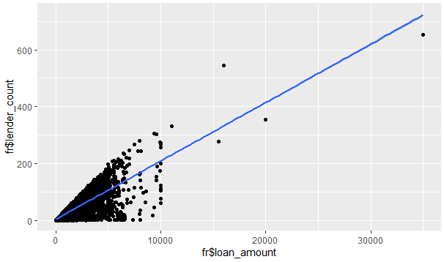

ggplot(fr,aes(x=fr$loan_amount,y=fr$term_in_months))+geom_point()+geom_smooth(method=lm,formula=y~x)

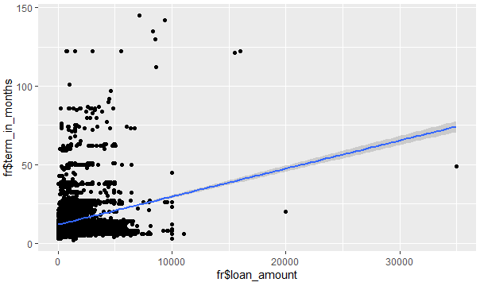

ggplot(fr,aes(x=fr$lender_count,y=fr$term_in_months))+geom_point()+geom_smooth(method=lm,formula=y~x)

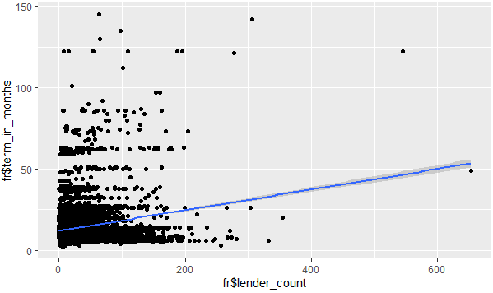

Following are the correlations and their visualization.

cor(fr$loan_amount,fr$lender_count)

>>>0.8151209

plot(fr$loan_amount,fr$lender_count)

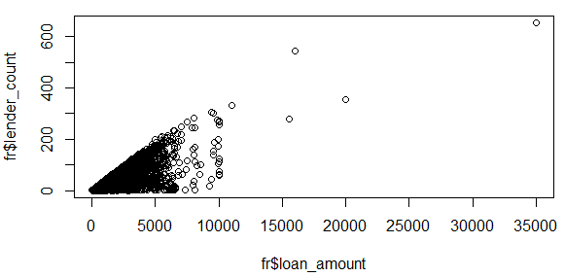

cor(fr$loan_amount,fr$term_in_months)

>>>0.2063649

plot(fr$loan_amount,fr$term_in_months)

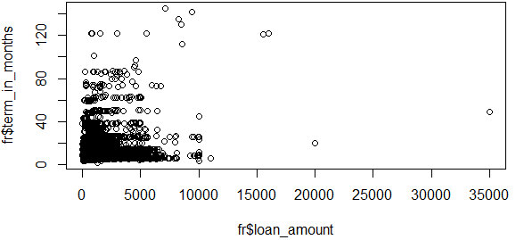

cor(fr$lender_count,fr$term_in_months)

>>>0.1846157

plot(fr$lender_count,fr$term_in_months)

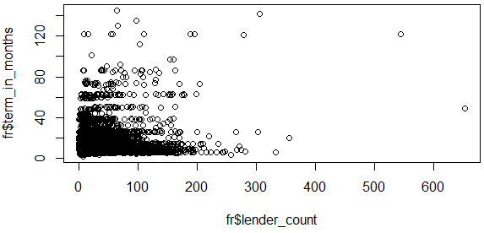

Now we will visualize correlation of categorical variable with a numeric variable using Boxplot for above mentioned three columns.

boxplot(fr$loan_amount)

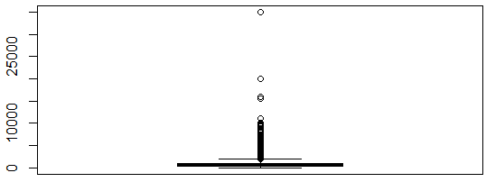

boxplot(fr$lender_count)

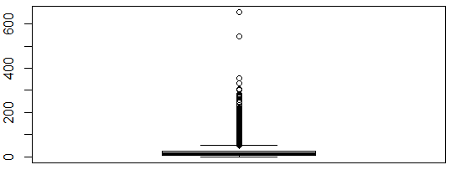

boxplot(fr$term_in_months)

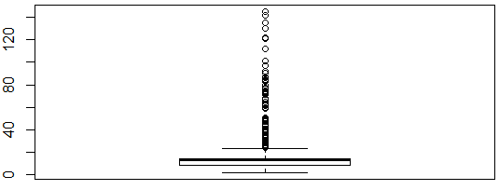

Now let’s apply a function by splitting the *loan_amount*, *lender_count* and *term_in_months* as per the genders each, it will display multiple boxplots for different possible genders.

boxplot(split(fr$loan_amount,fr$borrower_genders))

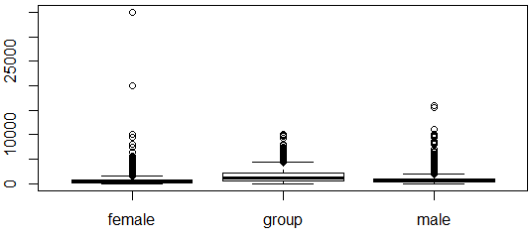

boxplot(split(fr$lender_count,fr$borrower_genders))

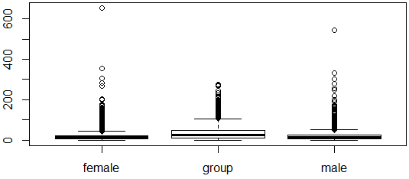

boxplot(split(fr$term_in_months,fr$borrower_genders))

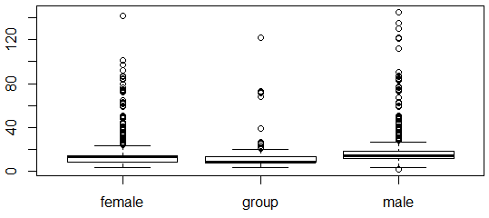

We can take log of *loan_amount, lender_count* and *term_in_months* each to have a broader view.

boxplot(split(log(fr$loan_amount),fr$borrower_genders))

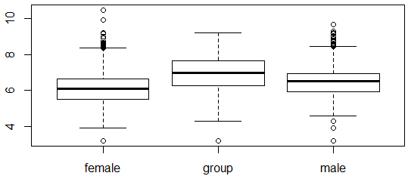

boxplot(split(log(fr$lender_count),fr$borrower_genders))

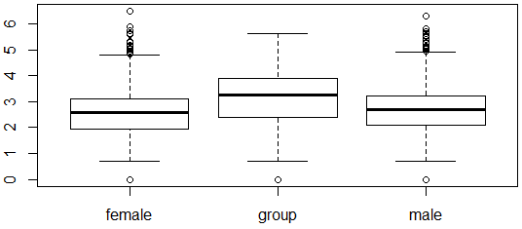

boxplot(split(log(fr$term_in_months),fr$borrower_genders))

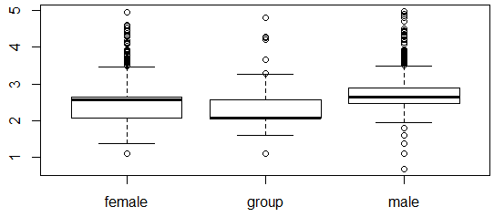

**11. Learning Outcomes Achieved:**

1. We understood the basic elements of larger data-sets.
2. We understood numerical and categorical variables in larger data-sets.
3. We understood how to apply regression to design decision model on the larger data-sets.

**12. Conclusion:**

We have successfully demonstrated the exploratory data analysis and the methods required to do it in R. Also, we have plotted the regression line, correlations between columns and boxplots.

**13. Experiment/Assignment Evaluation**

|  |  |  |  |  |  |
| --- | --- | --- | --- | --- | --- |
| **Experiment/Assignment Evaluation:** | | | | | |
| **Sr. No.** | **Parameters** | | | **Marks obtained** | **Out of** |
| **1** | Technical Understanding (Assessment may be done based on Q & A **or** any other relevant method.) Teacher should mention the other method used - | | |  | 6 |
| **2** | Neatness/presentation | | |  | 2 |
| **3** | Punctuality | | |  | 2 |
| **Date of performance (DOP)** | |  | **Total marks obtained** |  | **10** |
| **Date of checking (DOC)** | |  | **Signature of teacher** | | |

**References**:

1. URL: https://cran.r-project.org/doc/manuals/r-release/R-intro.pdf ( Online Resources)
2. R Cookbook Paperback – 2011 by Teetor Paul O Reilly Publications
3. Beginning R: The Statistical Programming Language by Dr. Mark Gardener, Wiley Publications
4. R Programming For Dummies by Joris Meys Andrie de Vries, Wiley Publications

**Viva Questions**

1. What does it mean by categorical variables in data-sets?
2. What does it mean by regression?
3. What is correlation and how is it useful in data-science?