|  |  |  |  |  |  |  |  |
| --- | --- | --- | --- | --- | --- | --- | --- |
|  | | **Hope Foundation’s**  **Finolex Academy of Management and Technology, Ratnagiri** | | | | | |
| **Department of Information Technology** | | | | | |
| Subject name: Software Design Lab | | | | | | Subject Code: ITL601 | |
| Class | | TE IT | | | Semester –VI (CBCGS) | Academic year: 2018-19 | |
| Name of Student | | **Kazi Jawwad A Rahim** | | | | **QUIZ Score : 06** | |
| Roll No | | **27** | | Assignment/Experiment No. | | 10 | |
| Title: **To create work breakdown structure** | | | | | | | |
|  | | | | | | | |
| **1. Lab objectives applicable: LOB5**. | | | | | | | |
| **2. Lab outcomes applicable: LO5** | | | | | | | |
| **3. Learning Objectives:**   1. To be able to define and organize the scope of the total project. 2. To understand the importance of a complete and accurate WBS from a planning and executing point of view. | | | | | | | |
| **4. Practical applications of the assignment/experiment:** The WBS provides the foundation for all project management work, including, planning, cost estimation, resource allocation, and scheduling | | | | | | | |
| **5. Prerequisites**:   1. Project Scope statement   2. Project Scope Management processes. | | | | | | | |
| **6. Hardware Requirements**:  Windows operating system (Windows 7 or higher)  **7. Software Requirements:**   1. Microsoft project 2007 | | | | | | | |
|  | | | | | | | |
| **8. Quiz Questions (if any): (Online Exam will be taken separately batch-wise, attach the certificate/ Marks obtained)**   1. What is Work Breakdown structure? 2. What purpose does it serve? | | | | | | | |
|  | | | | | | | |
| **9. Experiment/Assignment Evaluation:** | | | | | | | |
| **Sr. No.** | **Parameters** | | | | | **Marks obtained** | **Out of** |
| **1** | Technical Understanding (Assessment may be done based on Q & A **or** any other relevant method.) Teacher should mention the other method used - | | | | |  | 6 |
| **2** | Neatness/presentation | | | | |  | 2 |
| **3** | Punctuality | | | | |  | 2 |
| **Date of performance (DOP)** | | |  | | **Total marks obtained** |  | **10** |

**Signature of the faculty**

**11. Source code / Diagrams:**

Task Description

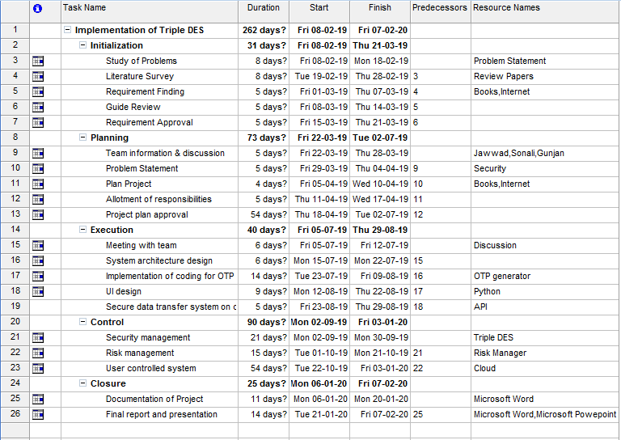

Gantt Chart

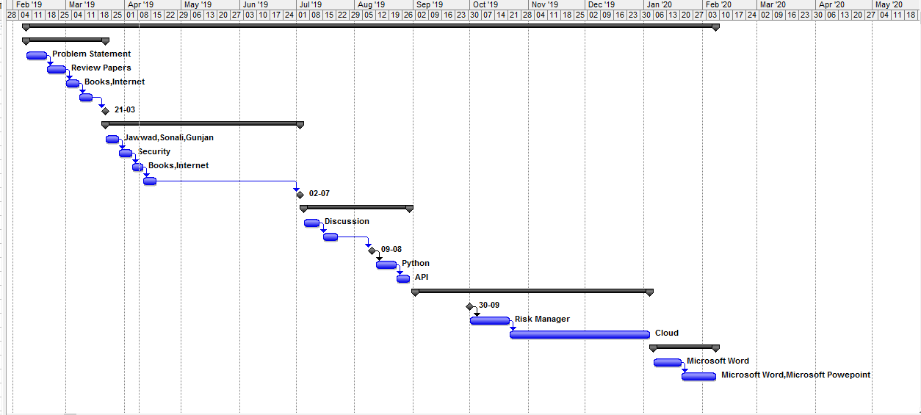

Network Diagram

