|  |
| --- |
| **A mini-project report on**  **IMPLEMENTATION OF TRIPLE DES USING OTP**  *submitted in partial fulfillment of the*  *requirements for*  **TE (Information Technology)**  *by*  **KAZI JAWWAD A RAHIM (Reg. no T-16-0020)**  **KIRATKAR GUNJAN NARAYAN (Reg. no T-16-0080)**  **GHOGLAE SONALI SUDHAKAR (Reg. no T-16-0212)**  **…………………**  *under the guidance of*  **Prof. Atiya Kazi**  main_logo  Department of Information Technology  Finolex Academy of Management and Technology, Ratnagiri  April 2019 |

Abstract:

Our aim is to develop a system where we can share files easily and securely in cloud environment. In our system there will be mainly two parts, one is Admin part. In Admin part, he will be allowed to login using credentials where he will upload files. These will be indexed and stored in the cloud database. Client will login to the system using his credentials. Client will search for the file which he wants to download. Client will send request of downloading file to Admin. Admin will also have a section where it will process to client request. Admin will generate an OTP for the file which is requested by the client. Admin will send OTP to the client. After receiving OTP client will enter that OTP. Entered OTP will be verified by Admin. Admin will then allow client to download the file. The file will be then downloaded to client end. If the OTP is expired, then client have to request again. OTP (One Time Password) is used to maintain integrity and provide security to the system. OTP is generated using Triple DES. Triple DES is a process where three keys are required for encryption. It provides most security to the system.

UML Diagrams:

1. UseCase Diagram

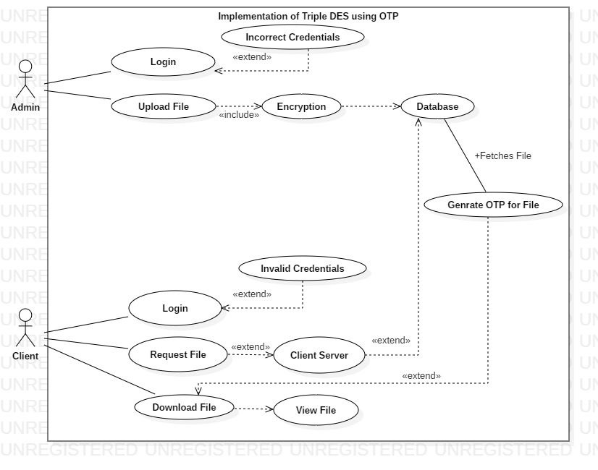

1. Class Diagram

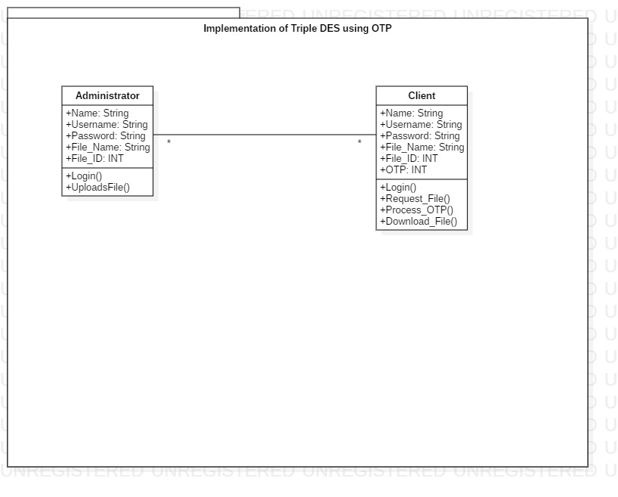

1. Object Diagram

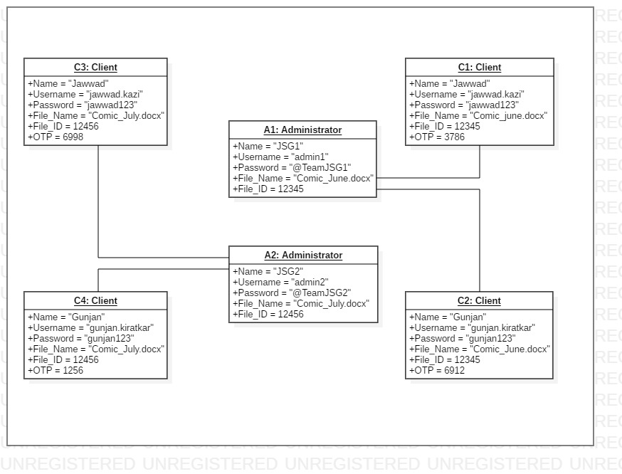

1. Activity Diagram

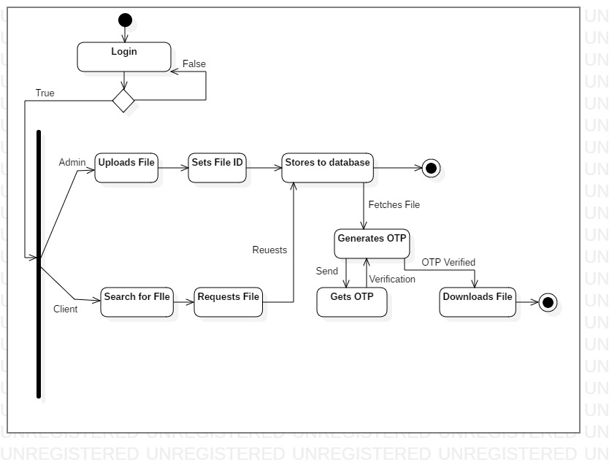

1. Sequence Diagram

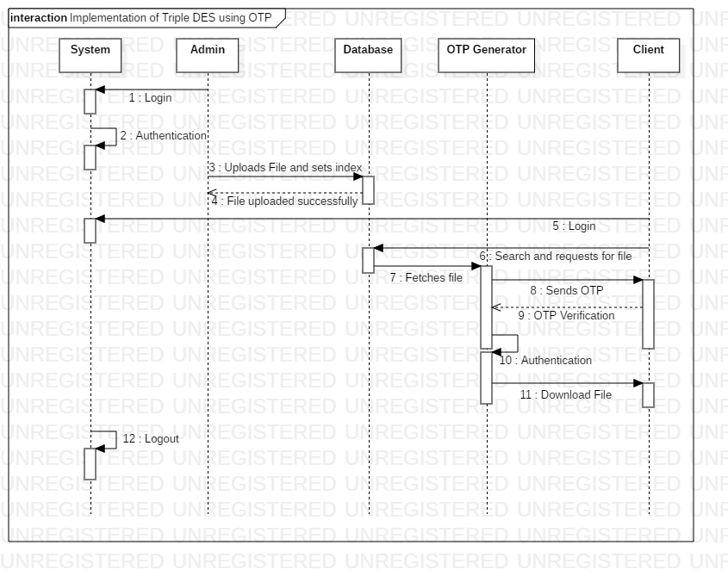

1. Collaboration Diagram

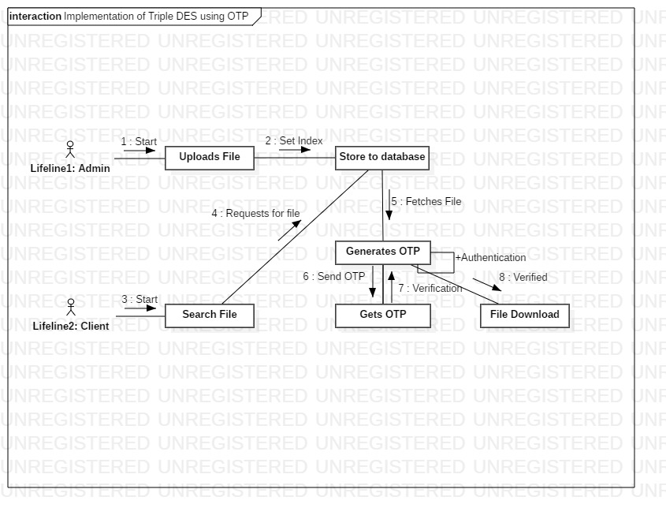

1. Statechart Diagram

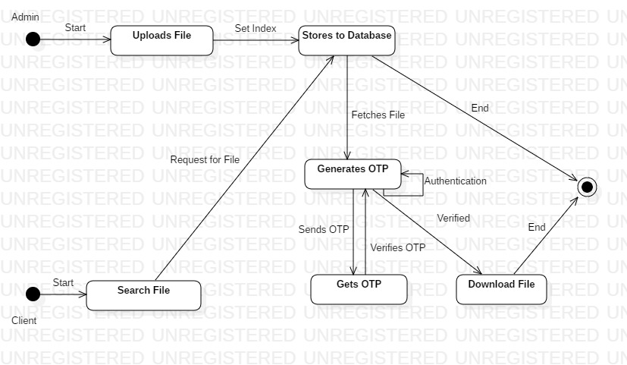

1. Component Diagram

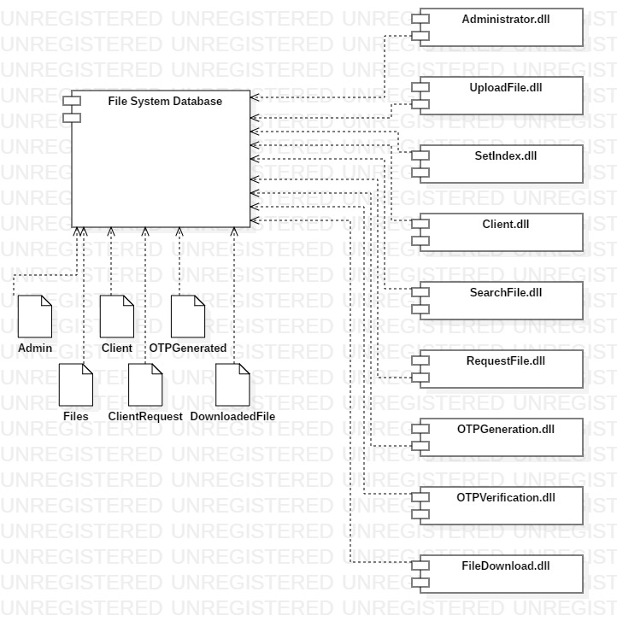

1. Deployment Diagram

