|  |  |  |  |  |  |  |  |
| --- | --- | --- | --- | --- | --- | --- | --- |
|  | | **Hope Foundation’s**  **Finolex Academy of Management and Technology, Ratnagiri** | | | | | |
| **Department of INFORMATION TECHNOLOGY** | | | | | |
| Subject name: Software Design Lab | | | | | | Subject Code: ITL601 | |
| Class | | TE IT | | | Semester –VI (CBCGS) | Academic year: 2018-19 | |
| Name of Student | | **Kazi Jawwad A Rahim** | | | | **QUIZ Score : 06** | |
| Roll No | | **27** | | Assignment/Experiment No. | | 03 | |
| Title: **Designing of Use case Diagrams** | | | | | | | |
|  | | | | | | | |
| **1. Lab objectives applicable: LOB1** | | | | | | | |
| **2. Lab outcomes applicable: LO3** | | | | | | | |
| **3. Learning Objectives:**   1. To identify different actors and use cases from a given problem statement 2. To associate use cases with different types of relationships 3. To draw a use-case diagram | | | | | | | |
| **4. Practical applications of the assignment/experiment:** Diagrams are used in order to give an insight for the development of any specific system. | | | | | | | |
| **5. Prerequisites**:   1. Not Required | | | | | | | |
| **6. Hardware Requirements**:  Windows operating system (Windows 7 or higher)  **7. Software Requirements:**  UML designing tool such as IBM Rational Rose/StarUML | | | | | | | |
|  | | | | | | | |
| **8. Quiz Questions (if any): (Online Exam will be taken separately batch-wise, attach the certificate/ Marks obtained)**   1. What is the purpose of a use case diagram? 2. What are the components of a use case diagram? 3. What are the different types of relationships? | | | | | | | |
|  | | | | | | | |
| **9. Experiment/Assignment Evaluation:** | | | | | | | |
| **Sr. No.** | **Parameters** | | | | | **Marks obtained** | **Out of** |
| **1** | Technical Understanding (Assessment may be done based on Q & A **or** any other relevant method.) Teacher should mention the other method used - | | | | |  | 6 |
| **2** | Neatness/presentation | | | | |  | 2 |
| **3** | Punctuality | | | | |  | 2 |
| **Date of performance (DOP)** | | |  | | **Total marks obtained** |  | **10** |

**Signature of the faculty**

**10. Theory:**

* **Purpose**

The purpose of use case diagram is to capture the dynamic aspect of a system. But this definition is too generic to describe the purpose.

Now when the initial task is complete use case diagrams are modeled to present the outside view.

So in brief, the purposes of use case diagrams can be as follows:

1. Used to gather requirements of a system.
2. Used to get an outside view of a system.
3. Identify external and internal factors influencing the system.
4. Show the interacting among the requirements are actors.

* **How to draw Use Case Diagram?**

Use case diagrams are considered for high level requirement analysis of a system. So when the requirements of a system are analyzed the functionalities are captured in use cases.

So we can say that use cases are nothing but the system functionalities written in an organized manner. Now the second things which are relevant to the use cases are the actors. Actors can be defined as something that interacts with the system.

The actors can be human user, some internal applications or may be some external applications. So in a brief when we are planning to draw an use case diagram we should have the following items identified.

1. Functionalities to be represented as an use case
2. Actors
3. Relationships among the use cases and actors.

**Use Case Relationships**

Three types of relationships exist among use cases:

1. Include relationship
2. Extend relationship
3. Use case generalization

**Graphical Representation**

An actor is represented by a stick figure and name of the actor is written below it. A use case is depicted by an ellipse and name of the use case is written inside it. The subject is shown by drawing a rectangle. Label for the system could be put inside it. Use cases are drawn inside the rectangle, and actors are drawn outside the rectangle, as shown in figure - 01.

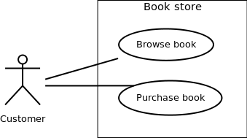

Use case diagram Figure - 01: A use case diagram for a book store

* **Where to Use Case Diagrams?**

Use case diagrams specify the events of a system and their flows. But use case diagram never describes how they are implemented. Use case diagram can be imagined as a black box where only the input, output and the function of the black box is known.

These diagrams are used at a very high level of design. Then this high level design is refined again and again to get a complete and practical picture of the system. A well structured use case also describes the precondition, post condition, exceptions. And these extra elements are used to make test cases when performing the testing.

Although the use cases are not a good candidate for forward and reverse engineering but still they are used in a slight different way to make forward and reverse engineering. And the same is true for reverse engineering. Still use case diagram is used differently to make it a candidate for reverse engineering.

In forward engineering use case diagrams are used to make test cases and in reverse engineering use cases are used to prepare the requirement details from the existing application.

So the following are the places where use case diagrams are used:

1. Requirement analysis and high level design.
2. Model the context of a system.
3. Reverse engineering.
4. Forward engineering.

Guidelines for drawing Use Case diagrams

* Following general guidelines could be kept in mind while trying to draw a use case diagram
* Determine the system boundary
* Ensure that individual actors have well-defined purpose
* Use cases identified should let some meaningful work done by the actors
* Associate the actors and use cases -- there shouldn't be any actor or use case floating without any connection
* Use include relationship to encapsulate common behavior among use cases , if any

Use case diagram for Online Feedback System

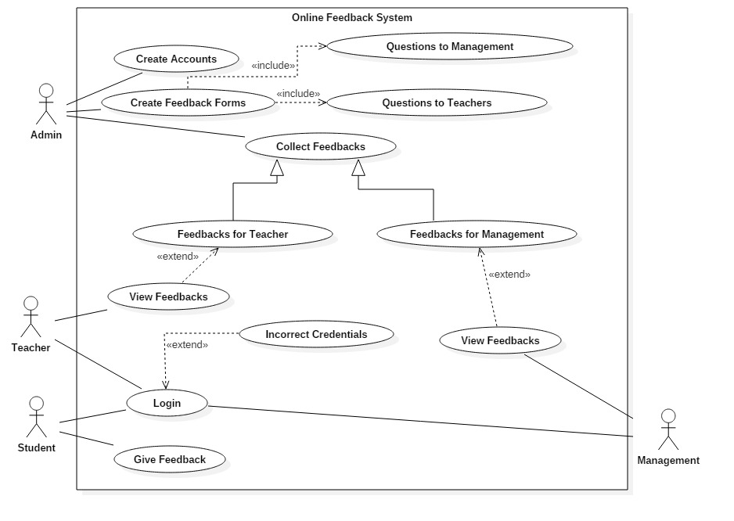

**12. Learning Outcomes Achieved**

1. We have learnt how to draw UML Use case Diagram.

**13. Conclusion:**

1. **Applications of the studied technique in industry**
   1. Every software industry makes use of UML diagrams as a part of system modeling and designing.
2. **Engineering Relevance** 
   1. Helpful in designing a software user manual.
3. **Skills Developed**
   1. Use Case diagram familiarity.

**14. References**:

1. <https://www.geeksforgeeks.org/unified-modeling-language-uml-introduction/>
2. <https://www.tutorialspoint.com/uml/>
3. Object-Oriented Modeling and Design with UML, Michael Blaha, James Rumbaugh, Prentice-Hall of India, 2nd Edition
4. Object-Oriented Analysis and Design using UML, Mahesh P. Matha, Prentice-Hall of India,