|  |  |  |  |  |  |  |  |
| --- | --- | --- | --- | --- | --- | --- | --- |
|  | | **Hope Foundation’s**  **Finolex Academy of Management and Technology, Ratnagiri** | | | | | |
| **Department of Information Technology** | | | | | |
| Subject name: Software Design Lab | | | | | | Subject Code: ITL601 | |
| Class | | TE IT | | | Semester –VI (CBCGS) | Academic year: 2018-19 | |
| Name of Student | | **Kazi Jawwad A Rahim** | | | | **QUIZ Score : 06** | |
| Roll No | | **27** | | Assignment/Experiment No. | | 05 | |
| Title: **Designing of Activity Diagrams** | | | | | | | |
|  | | | | | | | |
| **1. Lab objectives applicable: LOB4**. Understand the basics of UML with respect to use case, class, object and activity diagrams. | | | | | | | |
| **2. Lab outcomes applicable: LO3** | | | | | | | |
| **3. Learning Objectives:**   1. To understand basics of activity diagrams in UML. 2. Identify activities representing basic units of work, and represent their flow 3. To visualize the dynamic behavior of an information system. | | | | | | | |
| **4. Practical applications of the assignment/experiment:** Diagrams are used in order to give an insight for the activities involved in the functionality of a system. | | | | | | | |
| **5. Prerequisites**:   1. Not Required | | | | | | | |
| **6. Hardware Requirements**:  Windows operating system (Windows 7 or higher)  **7. Software Requirements:**  UML designing tool such as IBM Rational Rose/StarUML | | | | | | | |
|  | | | | | | | |
| **8. Quiz Questions (if any): (Online Exam will be taken separately batch-wise, attach the certificate/ Marks obtained)**   1. What is the purpose of an activity diagram? 2. Which are different elements of an activity diagram? | | | | | | | |
|  | | | | | | | |
| **9. Experiment/Assignment Evaluation:** | | | | | | | |
| **Sr. No.** | **Parameters** | | | | | **Marks obtained** | **Out of** |
| **1** | Technical Understanding (Assessment may be done based on Q & A **or** any other relevant method.) Teacher should mention the other method used - | | | | |  | 6 |
| **2** | Neatness/presentation | | | | |  | 2 |
| **3** | Punctuality | | | | |  | 2 |
| **Date of performance (DOP)** | | |  | | **Total marks obtained** |  | **10** |

**Signature of the faculty**

**10. Theory:**

## Purpose:

The basic purposes of activity diagrams are similar to other four diagrams. It captures the dynamic behavior of the system. Other four diagrams are used to show the message flow from one object to another but activity diagram is used to show message flow from one activity to another.

Activity is a particular operation of the system. Activity diagrams are not only used for visualizing dynamic nature of a system but they are also used to construct the executable system by using forward and reverse engineering techniques. The only missing thing in activity diagram is the message part.

It does not show any message flow from one activity to another. Activity diagram is some time considered as the flow chart. Although the diagrams looks like a flow chart but it is not. It shows different flow like parallel, branched, concurrent and single.

So the purposes can be described as:

1. Draw the activity flow of a system.
2. Describe the sequence from one activity to another.
3. Describe the parallel, branched and concurrent flow of the system.

So before drawing an activity diagram we should identify the following elements:

1. Activities
2. Association
3. Conditions
4. Constraints

Once the above mentioned parameters are identified we need to make a mental layout of the entire flow. This mental layout is then transformed into an activity diagram.

## Where to use Activity Diagrams?

The basic usage of activity diagram is similar to other four UML diagrams. The specific usage is to model the control flow from one activity to another. This control flow does not include messages.

The activity diagram is suitable for modeling the activity flow of the system. An application can have multiple systems. Activity diagram also captures these systems and describes flow from one system to another. This specific usage is not available in other diagrams. These systems can be database, external queues or any other system.

Now we will look into the practical applications of the activity diagram. From the above discussion it is clear that an activity diagram is drawn from a very high level. So it gives high level view of a system. This high level view is mainly for business users or any other person who is not a technical person.

This diagram is used to model the activities which are nothing but business requirements. So the diagram has more impact on business understanding rather implementation details.

Following are the main usages of activity diagram:

1. Modeling work flow by using activities.
2. Modeling business requirements.
3. High level understanding of the system's functionalities.

Guidelines for drawing an activity diagram

The following general guidelines could be followed to pictorially represent a complex logic.

* Identify tiny pieces of work being performed by the system
* Identify the next logical activity that should be performed
* Think about all those conditions that should be made, and all those constraints that should be satisfied, before one can move to the next activity
* Put non-trivial guard conditions on the edges to avoid confusion

**11. Source code / Diagrams:**

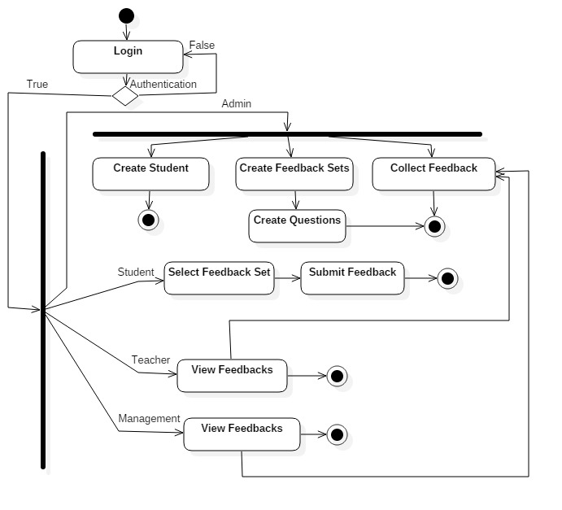

**12. Learning Outcomes Achieved**

1. We have learnt how to draw UML activity diagrams.

**13. Conclusion:**

1. **Applications of the studied technique in industry**
   1. Every software industry makes use of UML diagrams as a part of project documentation.
2. **Engineering Relevance** 
   1. Helpful in designing a software system’s when business logic is complex.
3. **Skills Developed**
   1. Activity Diagram familiarity.

**14. References**:

1. <https://www.geeksforgeeks.org/unified-modeling-language-uml-introduction/>
2. <https://www.tutorialspoint.com/uml/>
3. <https://www.ibm.com/developerworks/rational/library/769.html>