|  |  |  |  |  |  |  |  |
| --- | --- | --- | --- | --- | --- | --- | --- |
|  | | **Hope Foundation’s**  **Finolex Academy of Management and Technology, Ratnagiri** | | | | | |
| **Department of Information Technology** | | | | | |
| Subject name: Software Design Lab | | | | | | Subject Code: ITL601 | |
| Class | | TE IT | | | Semester –VI (CBCGS) | Academic year: 2018-19 | |
| Name of Student | | **Kazi Jawwad A Rahim** | | | | **QUIZ Score : 06** | |
| Roll No | | **27** | | Assignment/Experiment No. | | 07 | |
| Title: **Designing of Collaboration/Communication Diagrams** | | | | | | | |
|  | | | | | | | |
| **1. Lab objectives applicable: LOB4**. | | | | | | | |
| **2. Lab outcomes applicable: LO4** | | | | | | | |
| **3. Learning Objectives:**   1. To understand basics of collaboration diagram in UML. 2. To understand interaction between objects. | | | | | | | |
| **4. Practical applications of the assignment/experiment:** Diagrams are used in order to give an insight for the activities involved in the functionality of a system. | | | | | | | |
| **5. Prerequisites**:   1. SRS | | | | | | | |
| **6. Hardware Requirements**:  Windows operating system (Windows 7 or higher)  **7. Software Requirements:**  UML designing tool such as IBM Rational Rose/StarUML | | | | | | | |
|  | | | | | | | |
| **8. Quiz Questions (if any): (Online Exam will be taken separately batch-wise, attach the certificate/ Marks obtained)**   1. How do you define Collaboration/Communication diagram? 2. Which are the different notations in Communication diagram? | | | | | | | |
|  | | | | | | | |
| **9. Experiment/Assignment Evaluation:** | | | | | | | |
| **Sr. No.** | **Parameters** | | | | | **Marks obtained** | **Out of** |
| **1** | Technical Understanding (Assessment may be done based on Q & A **or** any other relevant method.) Teacher should mention the other method used - | | | | |  | 6 |
| **2** | Neatness/presentation | | | | |  | 2 |
| **3** | Punctuality | | | | |  | 2 |
| **Date of performance (DOP)** | | |  | | **Total marks obtained** |  | **10** |

**Signature of the faculty**

**10. Theory:**

## Introduction:

A collaboration diagram shows elements as they interact over time and how they are related. That is, it shows a collaboration or collaboration instance. Collaboration diagrams are time- and space-oriented and emphasize the overall interaction, the elements involved, and their relationships. Collaboration diagrams are especially useful for visualizing the impact of an interaction on the various elements, because you can place an element on a diagram and immediately see all the other elements with which it interacts.

## Definition

A collaboration diagram shows the interactions organized around the structure of a model, using either:

1. Classifiers (e.g. classes) and associations, or
2. Instances (e.g. objects) and links.
3. is an interaction diagram
4. is similar to the sequence diagram
5. reveals both structural and dynamic aspects of a collaboration
6. reveals the need for the associations in the class diagram

## Notations

1. A collaboration diagram shows a graph of either instances linked to each other or classifiers and associations.
2. Navigability is shown using arrow heads on the lines representing links.
3. An arrow next to a line indicates a stimuli or message flowing in the given direction.
4. The order of interaction is given with a number

## Repetition

In a collaboration diagram, repetition (which involves repeating a set of messages or stimuli) within a generic-form interaction is shown as a property. An iteration expression indicating the number of times the communications occur may be enclosed in a pair of braces ({}) and attached to the communications to which it applies using dashed lines.

## Conditional messaging

In a collaboration diagram, conditional messaging which involves communicating one set of messages or stimuli rather than another set of messages or stimuli — within a generic-form interaction is shown using the dot notation where the communication at a specific level indicates the guard expression that must be satisfied for the next level of communications to occur.

## Object creation and destruction

A communication that creates an element and a communication that destroys an element are simply shown like any other communication.

**Source code / Diagrams:**

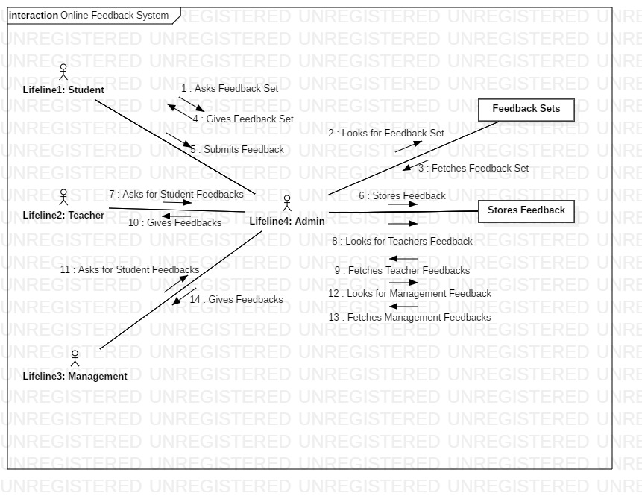

**References**:

1. <https://www.geeksforgeeks.org/unified-modeling-language-uml-introduction/>
2. <https://www.tutorialspoint.com/uml/>
3. <https://www.ibm.com/developerworks/rational/library/769.html>