|  |  |  |  |  |
| --- | --- | --- | --- | --- |
|  | Finolex Academy of Management and Technology, Ratnagiri | | | |
| **Department of Information Technology** | | | |
| **Subject:** | **Unix Lab(**SE ITL402**)** | | | |
| **Class:** | **SE IT / Semester – IV (CBCGS) / Academic year: 2017-18** | | | |
| **Name of Student:** | **Kazi Jawwad A Rahim** | | | |
| **Roll No:** | **28** | | **Date of performance (DOP) :** |  |
| **Assignment/Experiment No:** | | **02** | **Date of checking (DOC) :** |  |
| **Title:** To Study and implement UNIX general purpose commands | | | | |
| **Marks:** | |  | **Teacher’s Signature:** |  |

**1. Aim**: To study and implement UNIX general purpose utility command.

**2. Prerequisites**:

C Programming Language and Operating System

**3. Hardware Requirements**:

* PC with minimum 2GB RAM

**4. Software Requirements:**

* Fedora installed.

**5. Learning Objectives:**

To introduce basic UNIX general purpose commands.

**6.Course Objectives Applicable: LO1**

**7. Program Outcomes Applicable: PO1**

**8. Program Education Objectives Applicable: PEO1**

**9. Theory:**

List of commands:

1.date

Description: It shows current date and time.

Syntax: date

Output:

[students@localhost ~]$ date

Thu Jan 11 11:40:17 IST 2018

2.calender

Description:Shows calender.

Syntax: cal

OUTPUT:

[students@localhost ~]$ cal

January 2018

Su Mo Tu We Th Fr Sa

1 2 3 4 5 6

7 8 9 10 11 12 13

14 15 16 17 18 19 20

21 22 23 24 25 26 27

28 29 30 31

3.calender

Description:Shows calender.

Syntax: cal moth_number year

OUTPUT:

[students@localhost ~]$ cal 9 1998

September 1998

Su Mo Tu We Th Fr Sa

1 2 3 4 5

6 7 8 9 10 11 12

13 14 15 16 17 18 19

20 21 22 23 24 25 26

27 28 29 30

4.echo

Description:Prints String

Syntax:echo “string”

OUTPUT:

[students@localhost ~]$ echo "Jawwad"

Jawwad

5.calculator

Description: Single math operation

Syntax:bc

OUTPUT:

[students@localhost ~]$ bc

bc 1.06.95

10+2

12

4*5

20

6.calculator

Description: Multiple math operations

Syntax:bc

OUTPUT:

[students@localhost ~]$ bc

bc 1.06.95

4*5;2+3;9/3

20

5

3

7.who

Description: Show who is loged in.

syntax: who

OUTPUT:

[students@localhost ~]$ who

students tty2 2018-01-11 11:34 (:0)

8.whoami

Description: Shows who logged in

Syntax: whoami

OUTPUT:

[students@localhost ~]$ whoami

students

9.ls

Description: It shows directory

Syntax: ls

OUTPUT: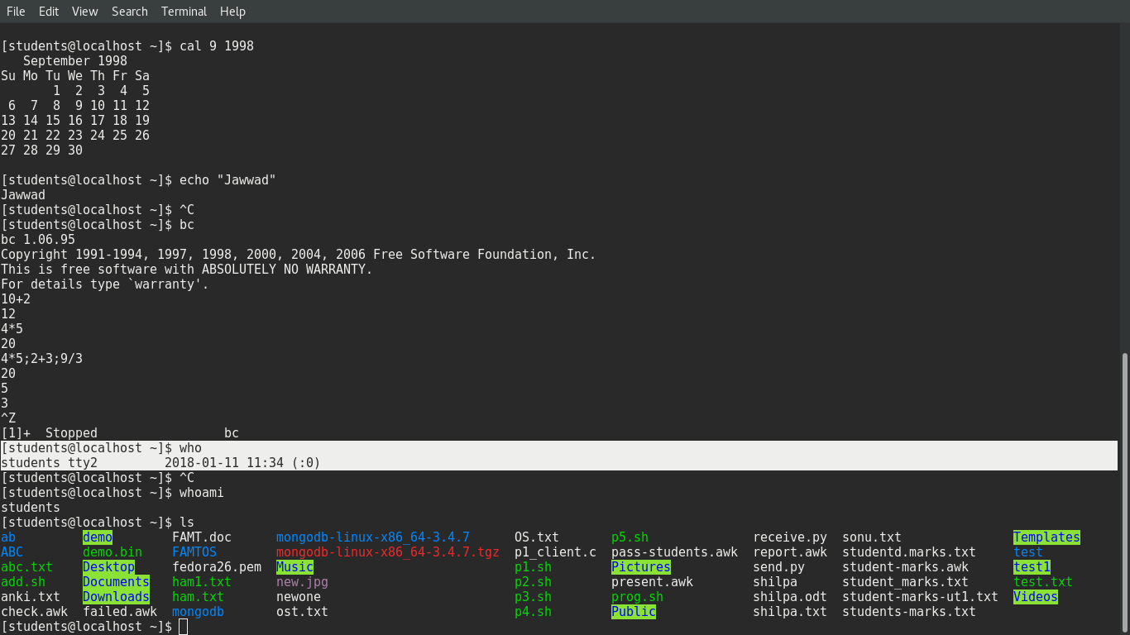

10.clear

Description: It clears the screen

Syntax: clear

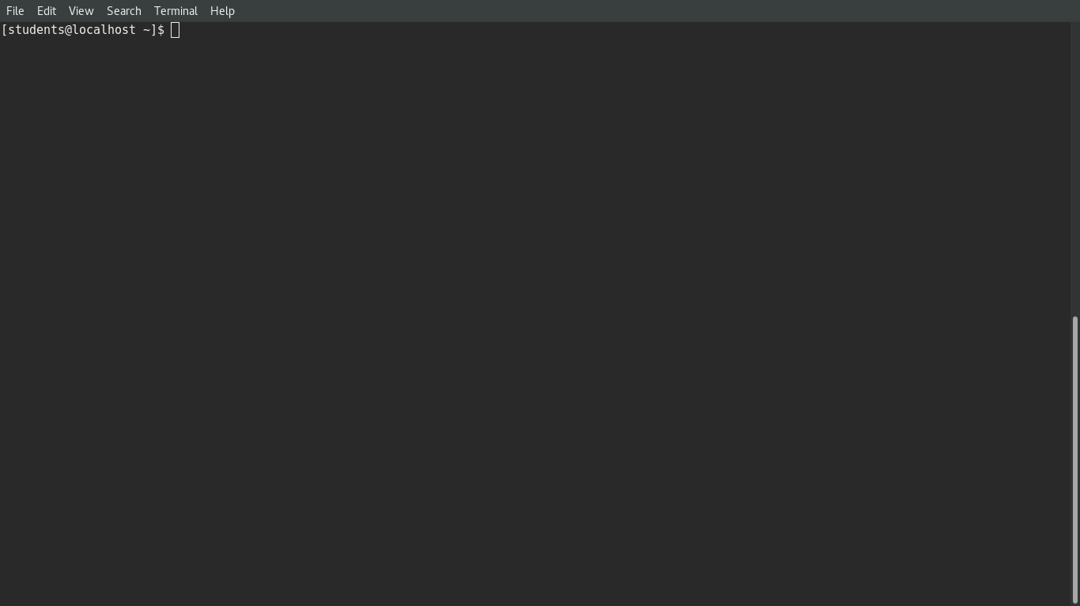OTPUT:

11.make directory  
Description: Creates new directory

Syntax: mdir folder_name

OUTPUT:

[students@localhost ~]$ mkdir FAMT

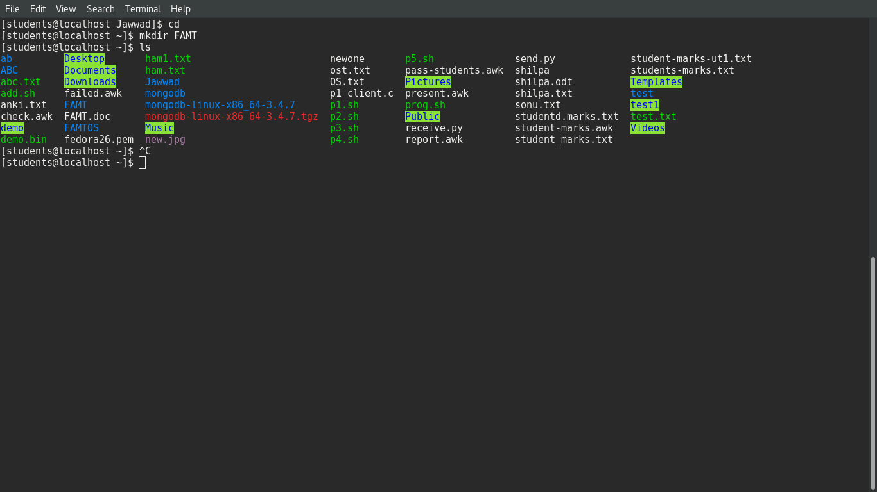

[students@localhost ~]$

12.change directory

Description: Changes the directory

Syntax: cd foldername

OUTPUT:

[students@localhost ~]$ cd FAMT

[students@localhost FAMT]$

13.create a file

Description: Creating file

Syntax:cat>filename.extension

OUTPUT:

[students@localhost ~]$ cat>jk.doc

Hi, this is a test message.

Welcome to Unix Lab.

This file has been created at FAMT.

Nice to meet you.

Best of Luck.^Z

[2]+ Stopped cat > jk.doc

[students@localhost ~]$ cat jk.doc

Hi, this is a test message.

Welcome to Unix Lab.

This file has been created at FAMT.

Nice to meet you.

14.No of lines from head

Description: Shows no of lines in the file from head

Syntax: head -n filename.extension

OUTPUT:

[students@localhost ~]$ head -2 jk.doc

Hi, this is a test message.

Welcome to Unix Lab.

15.No of lines from tail

Description: Shows no of lines in the file from bottom

Syntax: tail -n filename.extension

OUTPUT:

[students@localhost ~]$ tail -2 jk.doc

This file has been created at FAMT.

Nice to meet you.

16.Move

Description: Moves the file

Syntax: mv filename foldername

OUTPUT:

[students@localhost ~]$ mv jk.doc FAMT

[students@localhost ~]$ cd FAMT

[students@localhost FAMT]$ ls

jk.doc

17.Move contents of one file to other

Description: It moves all the contents of file1 to file2

Syntax: mv file1 file2

OUTPUT:

[students@localhost FAMT]$ mv jk.doc famt.doc

[students@localhost FAMT]$ cat famt.doc

Hi, this is a test message.

Welcome to Unix Lab.

This file has been created at FAMT.

Nice to meet you.

18.print working directory

Description: it prints current working directory

Syntax:pwd

OUTPUT:

[students@localhost FAMT]$ pwd

/home/students/FAMT

19.Remove folder(empty)

Description: Removes folder which is empty.

Syntax: rm foldername

rmdir foldername

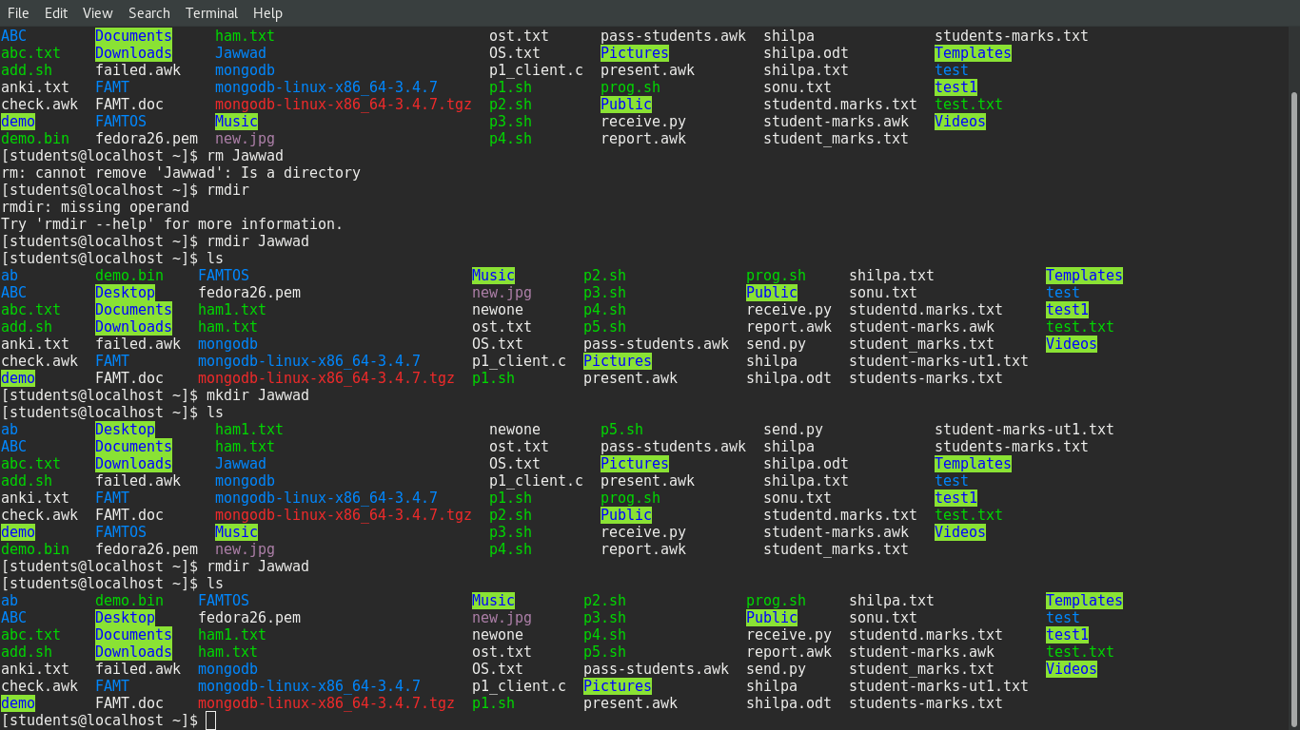OUTPUT:

20.Remove folder(non-empty)

Description: Removes folder which is non-empty.

Syntax: rm -rf foldername

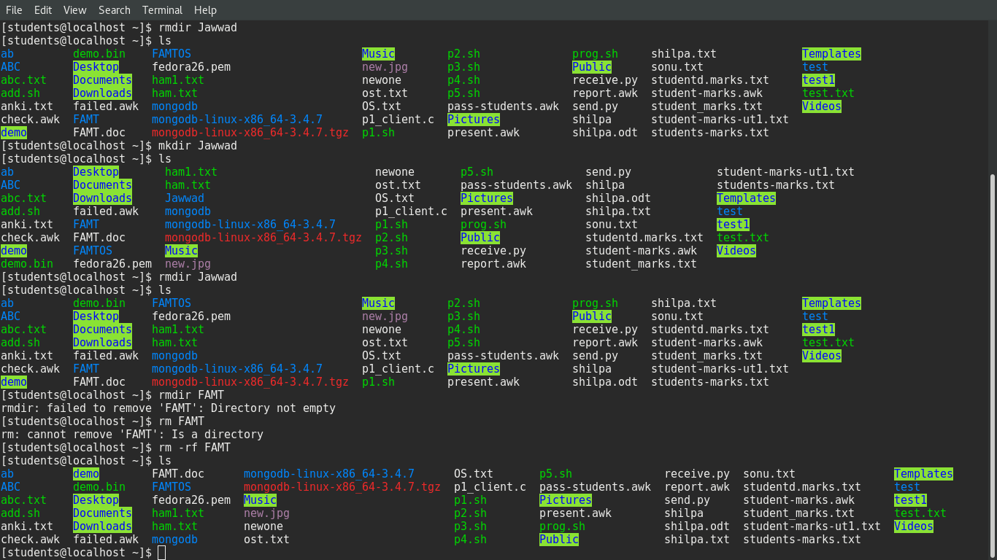OUTPUT:

21.Change Password

Description: Changes the password

Syntax:passwd

OUTPUT:

students@localhost ~]$ passwd

Changing password for user students.

Changing password for students.

Current password:

New password:

Retype new password:

passwd: all authentication tokens updated successfully.

22.Logout

Description: Logged out from current login

Syntax: logout

23.Shutdown

Description: Shutdown the PC

Syntax: shutdown now

**11. Learning Outcomes Achieved**

Students will be able to identify the basic Unix general purpose commands

**12. Conclusion:**

Thus we have understand general purpose commands of Unix.

**13. Experiment/Assignment Evaluation**

|  |  |  |  |  |  |  |  |
| --- | --- | --- | --- | --- | --- | --- | --- |
| **SR** | **Parameters** | **Weight** | **Excellent** | **Good** | **Average** | **Poor** | **Not as per requirement** |
| **Scale Factor ->** | 5 | 4 | 3 | 2 | 0 |
| 1 | Technical Understanding | 25 |  |  |  |  |  |
| 2 | Performance / Execution | 25 |  |  |  |  |  |
| 3 | Question Answers | 20 |  |  |  |  |  |
| 4 | Punctuality | 20 |  |  |  |  |  |
| 5 | Presentation | 10 |  |  |  |  |  |
|  | Total out of 100 -->  #(to be converted as per term-work evaluation applicable to the subject) | | **∑ (Weight * Scale Factor)/5 = ________** | | | | |

**References**:

[1] Unix, concepts and applications by Sumitabha Das, McGraw-Hill

[2] Mastering Shell Scripting, Randal. K. Michael, Second Edition, Wiley Publication

**Viva Questions**

* What are UNIX general purpose commands?