|  |  |  |  |  |
| --- | --- | --- | --- | --- |
|  | Finolex Academy of Management and Technology, Ratnagiri | | | |
| **Department of Information Technology** | | | |
| **Subject:** | **Unix Lab(**SE ITL402**)** | | | |
| **Class:** | **SE IT / Semester – IV (CBCGS) / Academic year: 2017-18** | | | |
| **Name of Student:** | **Kazi Jawwad A Rahim** | | | |
| **Roll No:** | **28** | | **Date of performance (DOP) :** |  |
| **Assignment/Experiment No:** | | **03** | **Date of checking (DOC) :** |  |
| **Title: To implement UNIX Networking and File System commands** | | | | |
| **Marks:** | |  | **Teacher’s Signature:** |  |

**1. Aim**: To study UNIX networking and file system commands.

**2. Prerequisites**:

C Programming Language and Operating System

**3. Hardware Requirements**:

* PC with minimum 2GB RAM

**4. Software Requirements:**

* Fedora installed.

**5. Learning Objectives:**

To learn network UNIX command.

**6.Course Objectives Applicable: LO1,LO2,LO5,LO6**

**7. Program Outcomes Applicable: PO2,PO3,PO4**

**8. Program Education Objectives Applicable: PEO2,PEO3,PEO4**

**9. Theory:**

**1. Hostname**

Description: It is a label assigned to a device connected to a computernetwork & is used to identify the device in various forms.

Syntax: hostname :displays machine host name.

hostname -f :displays fully qualified host and domain name.

hostname –i :displays ip address of current machine.

Output:

[students@localhost ~]$ hostname

localhost.localdomain

[students@localhost ~]$ hostname -f

localhost

[students@localhost ~]$ hostname -i

::1 127.0.0.1

**2. Ping**

Description: It is a basic internet program that allows a user to verify that a particular ip address exists & can accept requests. If you do ping www.google.com it will display its ip address. Use ctrl+c to stop.

Syntax: ping website _address

Output:

[students@localhost ~]$ ping www.google.com

PING www.google.com (216.58.196.68) 56(84) bytes of data.

64 bytes from bom05s11-in-f4.1e100.net (216.58.196.68): icmp_seq=1 ttl=57 time=306 ms

64 bytes from bom05s11-in-f4.1e100.net (216.58.196.68): icmp_seq=2 ttl=57 time=273 ms

64 bytes from bom05s11-in-f4.1e100.net (216.58.196.68): icmp_seq=3 ttl=57 time=272 ms

64 bytes from bom05s11-in-f4.1e100.net (216.58.196.68): icmp_seq=4 ttl=57 time=348 ms

64 bytes from bom05s11-in-f4.1e100.net (216.58.196.68): icmp_seq=5 ttl=57 time=321 ms

64 bytes from bom05s11-in-f4.1e100.net (216.58.196.68): icmp_seq=6 ttl=57 time=275 ms

^C

--- www.google.com ping statistics ---

6 packets transmitted, 6 received, 0% packet loss, time 5000ms

rtt min/avg/max/mdev = 272.144/299.513/348.880/28.769 ms

**3. Netstat**

Description: Most useful and very versatile tool for finding connection to and from the host.

Syntax: netstat

netstat -a :Displays all the connections.

netstat -l :Lists only listening ports.

netstat -g :Display all multicast network subscribed by host.

Output:

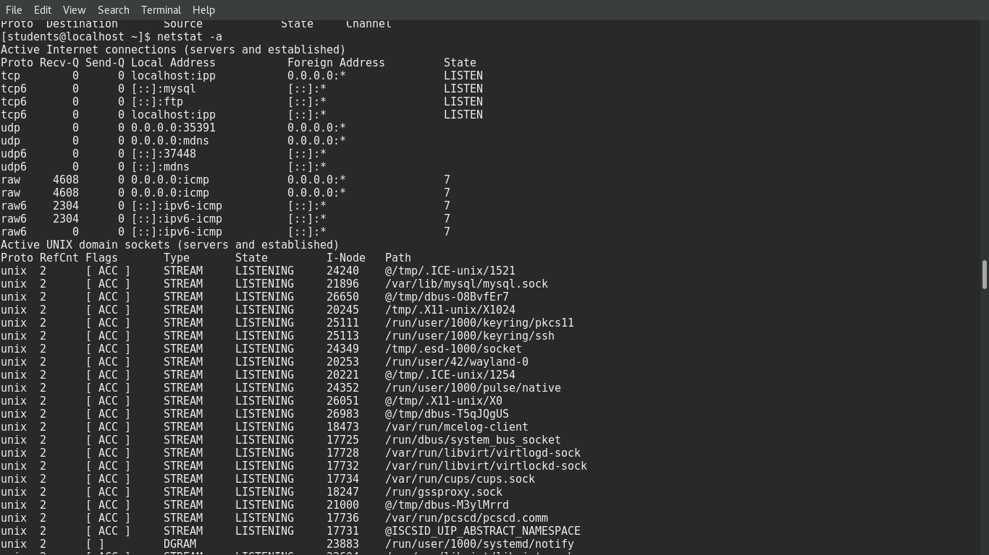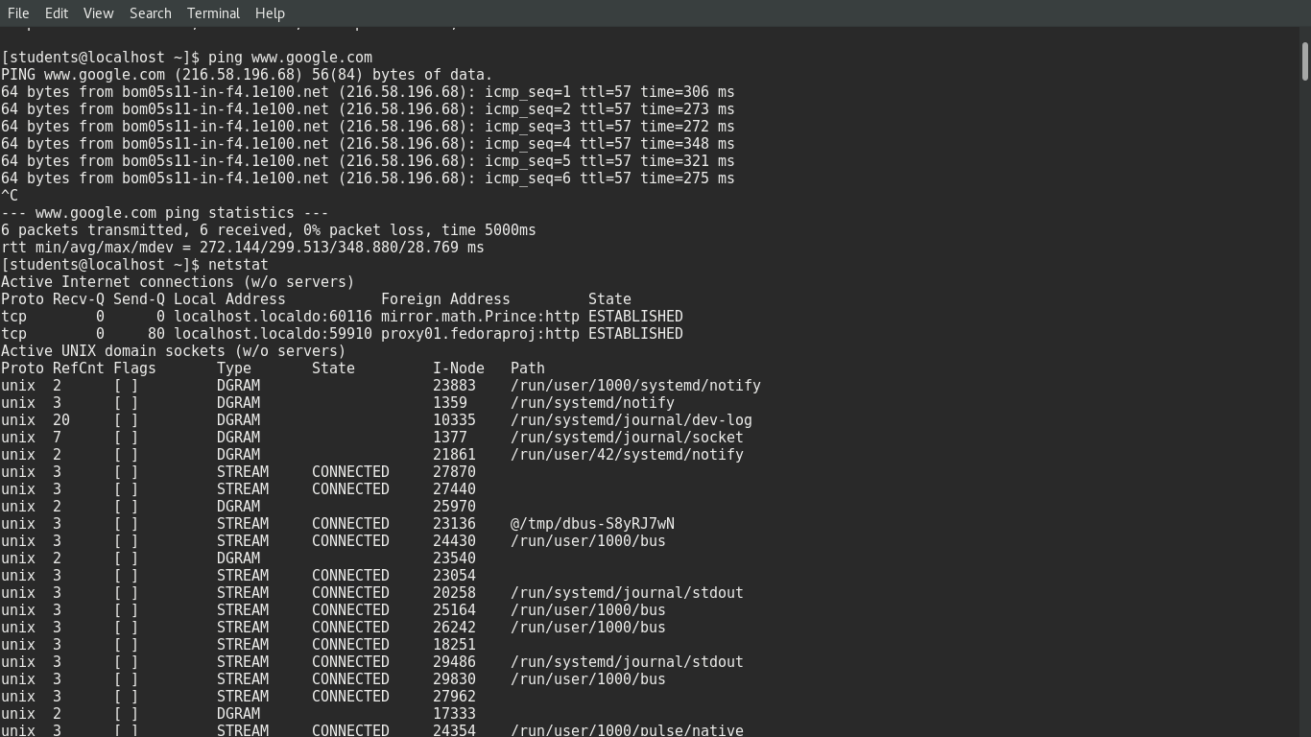

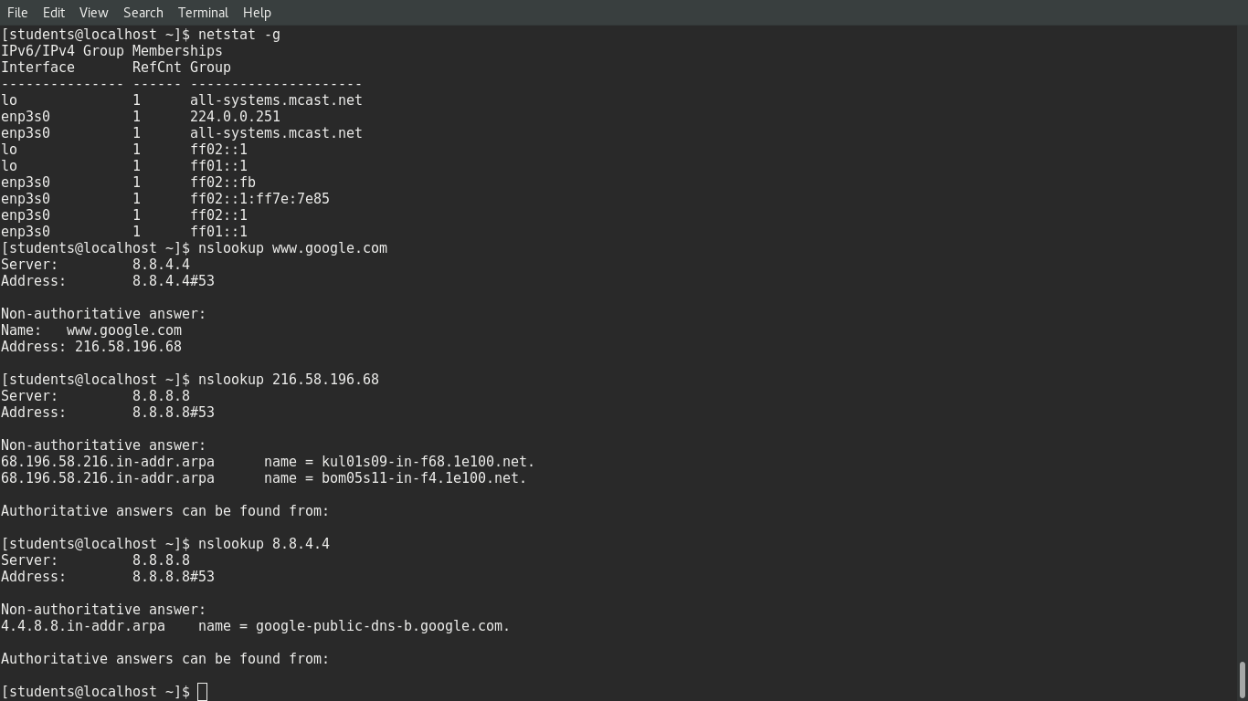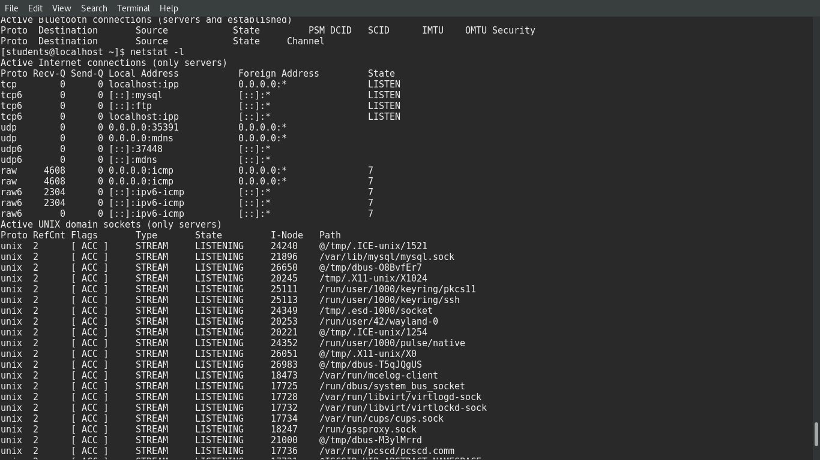

**4.Name Server Lookup**

Description:It is useful tool for finding information about a named domain.

Syntax: nslookup website_address :Displays name & address.

nslookup ip_address :Displays address & name.

OUTPUT:





**5. Trace Route**

Description: Trace the route the packets take between your system & the host named. A hand utility to view no of hops & response time to get a remote system or website is traceroute, you need an internet connection to make use of this tool.

Syntax: traceroute website :Displays the all possible roots.

Output:

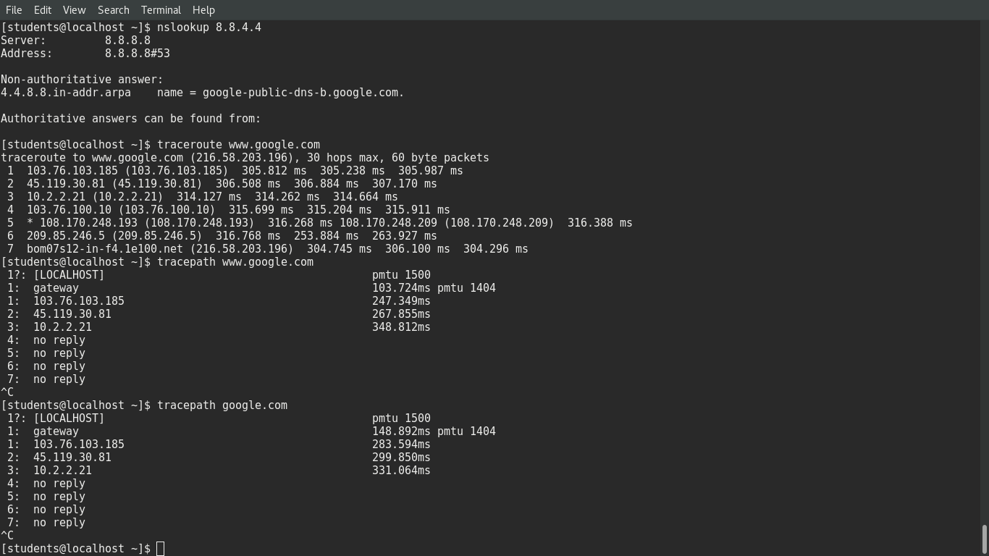

**6.Trace Path**

Description: It shows the shortest path for reaching to that website.

Syntax: tracepath website

OUTPUT:



**7. Interface configuration**

Description: ifconfig is a system administration utility in UNIX like OS for network interface configuration. It displays current network configuration information.

Syntax: ifconfig

Output:

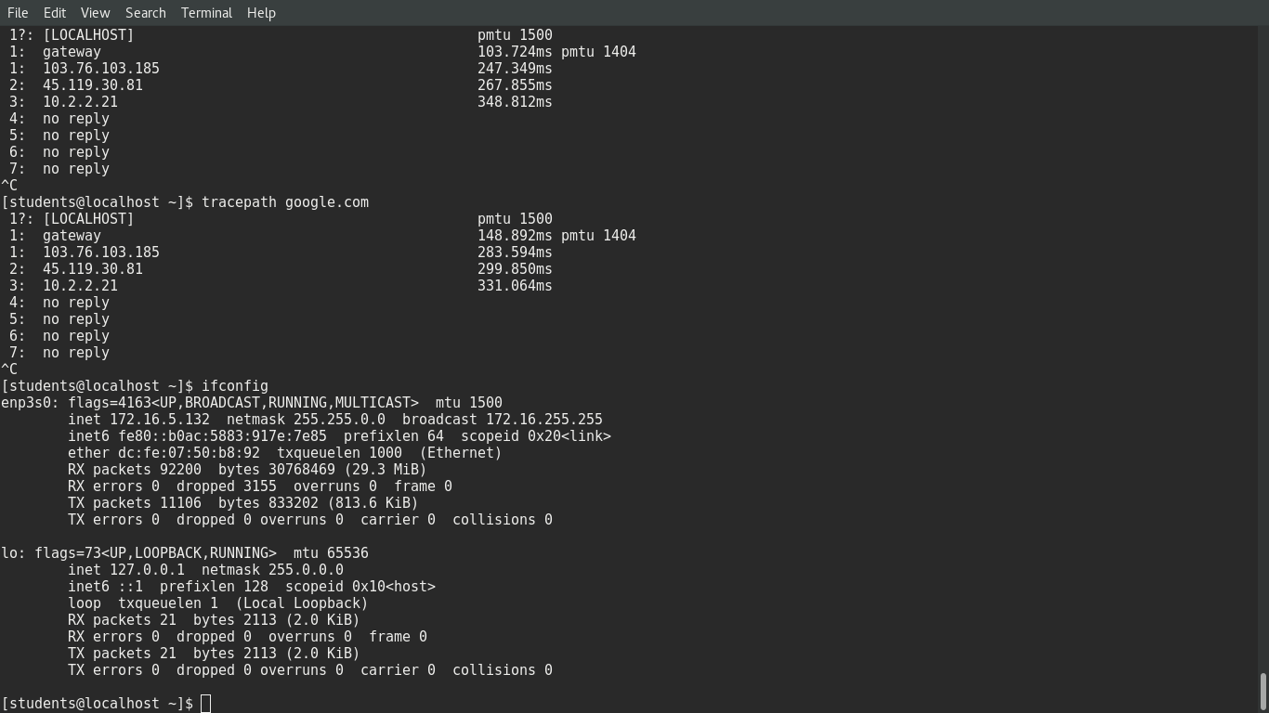

**8.Findsmb**

Description: It is used to list information about machines that respond to SMB name queries.

e.g: Windows based machines sharing their hard disks.

Syntax: findsmb

Output:

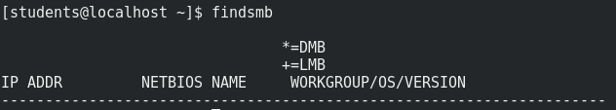

**11. Learning Outcomes Achieved**

Learned general UNIX networking and file system commands.

**12. Conclusion:**

Thus we have studied general UNIX networking and file system commands.

**13. Experiment/Assignment Evaluation**

|  |  |  |  |  |  |  |  |
| --- | --- | --- | --- | --- | --- | --- | --- |
| **SR** | **Parameters** | **Weight** | **Excellent** | **Good** | **Average** | **Poor** | **Not as per requirement** |
| **Scale Factor ->** | 5 | 4 | 3 | 2 | 0 |
| 1 | Technical Understanding | 25 |  |  |  |  |  |
| 2 | Performance / Execution | 25 |  |  |  |  |  |
| 3 | Question Answers | 20 |  |  |  |  |  |
| 4 | Punctuality | 20 |  |  |  |  |  |
| 5 | Presentation | 10 |  |  |  |  |  |
|  | Total out of 100 -->  #(to be converted as per term-work evaluation applicable to the subject) | | **∑ (Weight * Scale Factor)/5 = ________** | | | | |

**References**:

[1] Unix, concepts and applications by Sumitabha Das, McGraw-Hill

[2] Mastering Shell Scripting, Randal. K. Michael, Second Edition, Wiley Publication

**Viva Questions**

* What are UNIX networking and file system commands?