|  |  |  |  |  |
| --- | --- | --- | --- | --- |
|  | Finolex Academy of Management and Technology, Ratnagiri | | | |
| **Department of Information Technology** | | | |
| **Subject:** | **Unix Lab(**SE ITL402**)** | | | |
| **Class:** | **SE IT / Semester – IV (CBCGS) / Academic year: 2017-18** | | | |
| **Name of Student:** | **Kazi Jawwad A Rahim** | | | |
| **Roll No:** | **28** | | **Date of performance (DOP) :** |  |
| **Assignment/Experiment No:** | | **04** | **Date of checking (DOC) :** |  |
| **Title: To study Editor Vi/other editor** | | | | |
| **Marks:** | |  | **Teacher’s Signature:** |  |

**1. Aim**: To study Vi/other editor.

**2. Prerequisites**:

C Programming Language and Operating System

**3. Hardware Requirements**:

* PC with minimum 2GB RAM

**4. Software Requirements:**

* Fedora installed.

**5. Learning Objectives:**

To introduce basic UNIX general purpose commands.

**6.Course Objectives Applicable:**  **LO1,LO2,LO5,LO6**

**7. Program Outcomes Applicable: PO1**

**8. Program Education Objectives Applicable: PEO1**

**9. Theory: Vi Editor**

**vi** is a screen-oriented text editor originally created for the Unix operating system. The portable subset of the behavior of vi and programs based on it, and the ex editor language supported within these programs, is described by (and thus standardized by) the Single Unix Specification and POSIX.

The original code for vi was written by Bill Joy in 1976, as the visual mode for a line editor called ex that Joy had written with Chuck Haley. Bill Joy's ex 1.1 was released as part of the first BSD Unix release in March 1978. It was not until version 2.0 of ex, released as part of Second Berkeley Software Distribution[4] in May 1979, that the editor was installed under the name "vi" (which took users straight into ex's visual mode), and the name by which it is known today. Some current implementations of vi can trace their source code ancestry to Bill Joy; others are completely new, largely compatible reimplementations.

The name "vi" is derived from the shortest unambiguous abbreviation for the ex command visual, which switches the ex line editor to visual mode. The name is sometimes pronounced /ˈviːˈaɪ/ (as in the discrete English letters *v* and *i*) and sometimes to rhyme with *bye*.

In addition to various non–free software variants of vi distributed with proprietary implementations of Unix, vi was opensourced with OpenSolaris, and several free and open source software vi clones exist. A 2009 survey of *Linux Journal* readers found that vi was the most widely used text editor among respondents, beating gedit, the second most widely used editor, by nearly a factor of two (36% to 19%).

**10. Results:**

|  |  |
| --- | --- |
| **Commands** | **Description** |
| **I) Creating file in Vi Editor** | |
| vi filename.extension | Through this method we can create file in Vi Editor |
| **II) Saving and quitting the file** | |
| :wq | Saves the file and quit. |
| :q! | Unsave the file and quit |
| **III)Displaying and hiding line numbers** | |
| :set nu | Shows line number |
| :set nonu | Hide line numbers |
| :set list | Shows blank character |
| **IV)Insert mode commands** | |
| :u | Undo Changes |
| Shift+~ | Changes case of characters |
| Shift+j | Joins the two lines |
| **V) Copy - Paste** | |
| y/Y | Copy(Yank) |
| p/P | Paste |
| 4yy | No of lines copy |
| **VI) Edit file positioning cursor** | |
| h | Moves cursor to left |
| j | Moves cursor to down |
| k | Moves cursor to up |
| l | Moves cursor to right |
| w | Moves word to right |
| b | Moves word to left |
| e | Moves word to end |
| backspace | Moves cursor to left |
| 1G / H | Moves cursor to top of screen |
| M | Moves cursor to middle of screen |
| G/L | Moves cursor to bottom of screen |
| 5G | Moves cursor to 5th line |
| Ctrl+F | Moves one screen forward |
| Ctrl+D | Moves half screen forward |
| Ctrl+B | Moves half screen forward |
| **VII) Deleting Commands** | |
| x | Deletes the current character |
| X | Deletes the left character |
| dw | Deletes the current word |
| dd | Deletes the current line |
| D | Deletes the right side word |
| dG | Deletes the all lines below |
| d1G | Deletes the first line |
| :3,8 | Deletes the line from line no.3 to 8 |
| **VIII)Changing Text** | |
| cW | Changes the word |
| cc | It changes the character |
| c/C | It changes the character from right |
| r | It can replace only character |
| S | Substitute |
| **IX) Edit file commands** | |
| O | Insert the line below cursor again above |
| I | Insert the text before cursor |
| **X) Refresh screen including files** | |
| :r filename.extension | It refreshes the file |
| :line_number filename.extension | It refreshes the lines from ahead |

**OUTPUT:**

**I) Creating file in Vi Editor**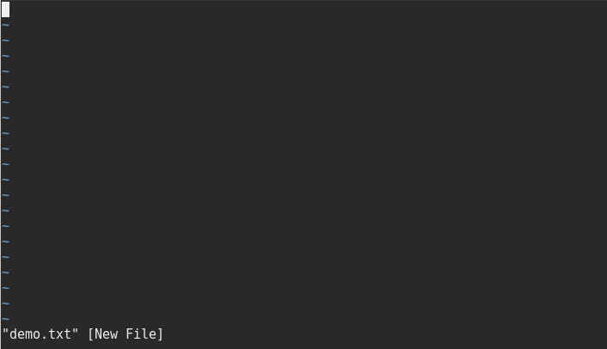

**II) Saving and quitting the file**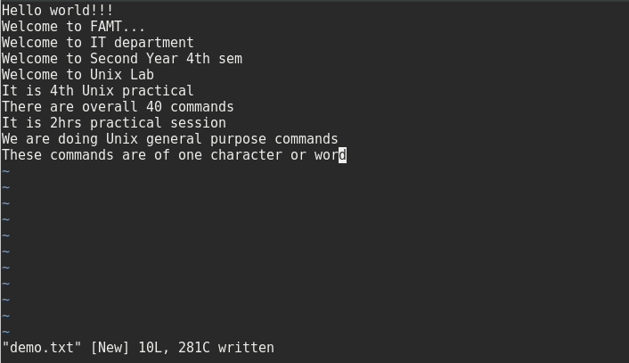

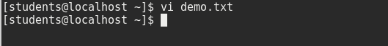

**III)Displaying and hiding line numbers**

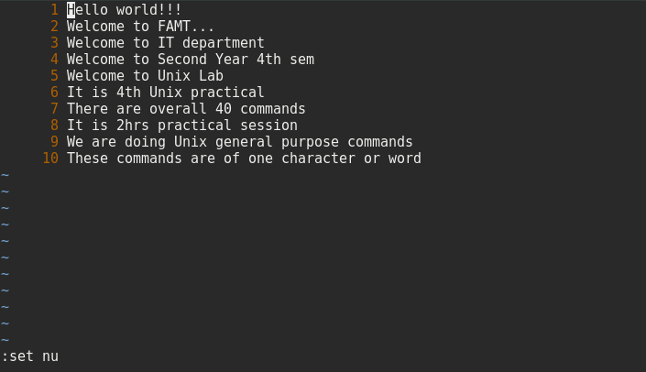

**IV)Insert mode commands Shift+j**

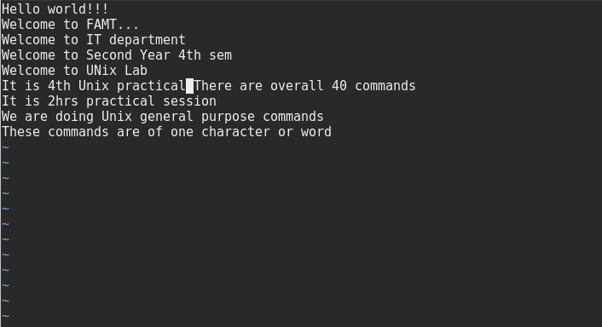

**V) Copy – Paste**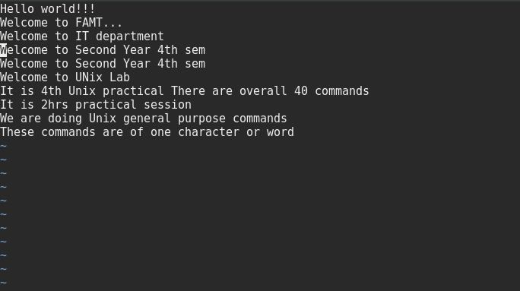

**VI) Deleting Commands**

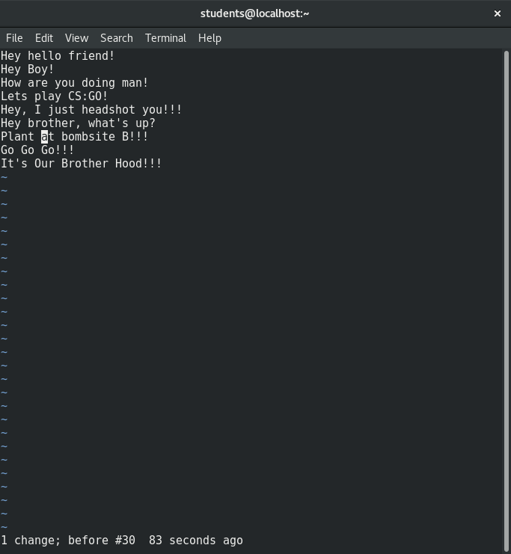

**VII) Changing Text**

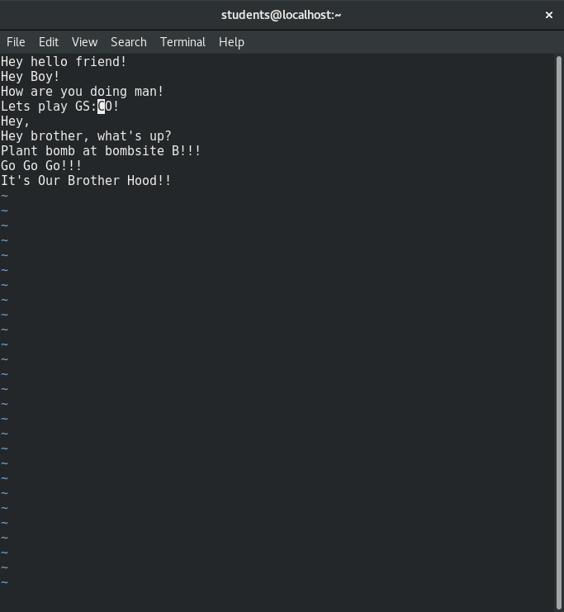

**IX) Edit file commands**

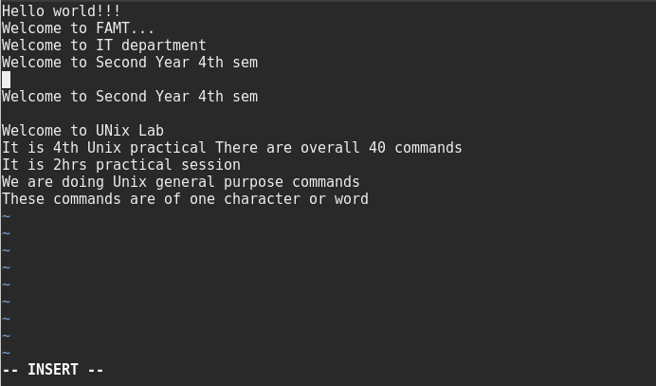

**X) Refresh screen including files**

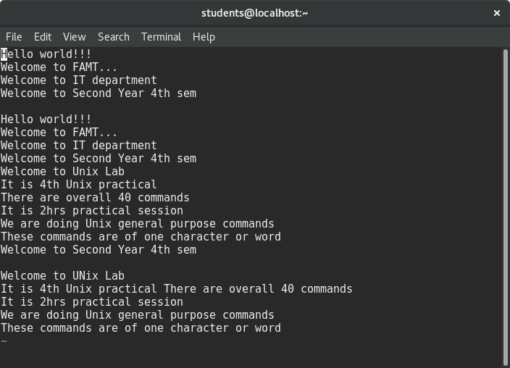

**11. Learning Outcomes Achieved**

Learned basic UNIX general purpose commands.

**12. Conclusion:**

Thus we have studied the Vi editor and its important commands.

**13. Experiment/Assignment Evaluation**

|  |  |  |  |  |  |  |  |
| --- | --- | --- | --- | --- | --- | --- | --- |
| **SR** | **Parameters** | **Weight** | **Excellent** | **Good** | **Average** | **Poor** | **Not as per requirement** |
| **Scale Factor ->** | 5 | 4 | 3 | 2 | 0 |
| 1 | Technical Understanding | 25 |  |  |  |  |  |
| 2 | Performance / Execution | 25 |  |  |  |  |  |
| 3 | Question Answers | 20 |  |  |  |  |  |
| 4 | Punctuality | 20 |  |  |  |  |  |
| 5 | Presentation | 10 |  |  |  |  |  |
|  | Total out of 100 -->  #(to be converted as per term-work evaluation applicable to the subject) | | **∑ (Weight * Scale Factor)/5 = ________** | | | | |

**References**:

[1] Unix, concepts and applications by Sumitabha Das, McGraw-Hill

[2] Mastering Shell Scripting, Randal. K. Michael, Second Edition, Wiley Publication

**Viva Questions**

* What is Vi editor?
* What are the applications of Vi editor?
* What are the basic commands of Vi editor?