|  |  |  |  |  |
| --- | --- | --- | --- | --- |
|  | Finolex Academy of Management and Technology, Ratnagiri | | | |
| **Department of Information Technology** | | | |
| **Subject:** | **Unix Lab(**SE ITL402**)** | | | |
| **Class:** | **SE IT / Semester – IV (CBCGS) / Academic year: 2017-18** | | | |
| **Name of Student:** | **Kazi Jawwad A Rahim** | | | |
| **Roll No:** | **28** | | **Date of performance (DOP) :** |  |
| **Assignment/Experiment No:** | | **05** | **Date of checking (DOC) :** |  |
| **Title: To implement system administrative tasks: Process Management and File Management** | | | | |
| **Marks:** | |  | **Teacher’s Signature:** |  |

**1. Aim**: To implement system administrative tasks: Process Management and File Management

**2. Prerequisites**:

C Programming Language and Operating System

**3. Hardware Requirements**:

* PC with minimum 2GB RAM

**4. Software Requirements:**

* Fedora installed.

**5. Learning Objectives:**

To learn file management and permission advance commands.

**6.Course Objectives Applicable: LO1,LO2,LO5**

**7. Program Outcomes Applicable: PO2,PO3,PO4**

**8. Program Education Objectives Applicable: PEO2,PEO3,PO4**

**9. Theory:**

An instance a program is called as a process.

Types of process:

1. Foreground Process: They run on the screen and need user input.

e.g: Office Program.

1. Background Process: They run in the background and usually do not require user input.

e.g: Anti Virus.

Commands:

I) Runnig foreground process

Description: It runs the process which runs on foreground.

Syntax: processname

OUTPUT:

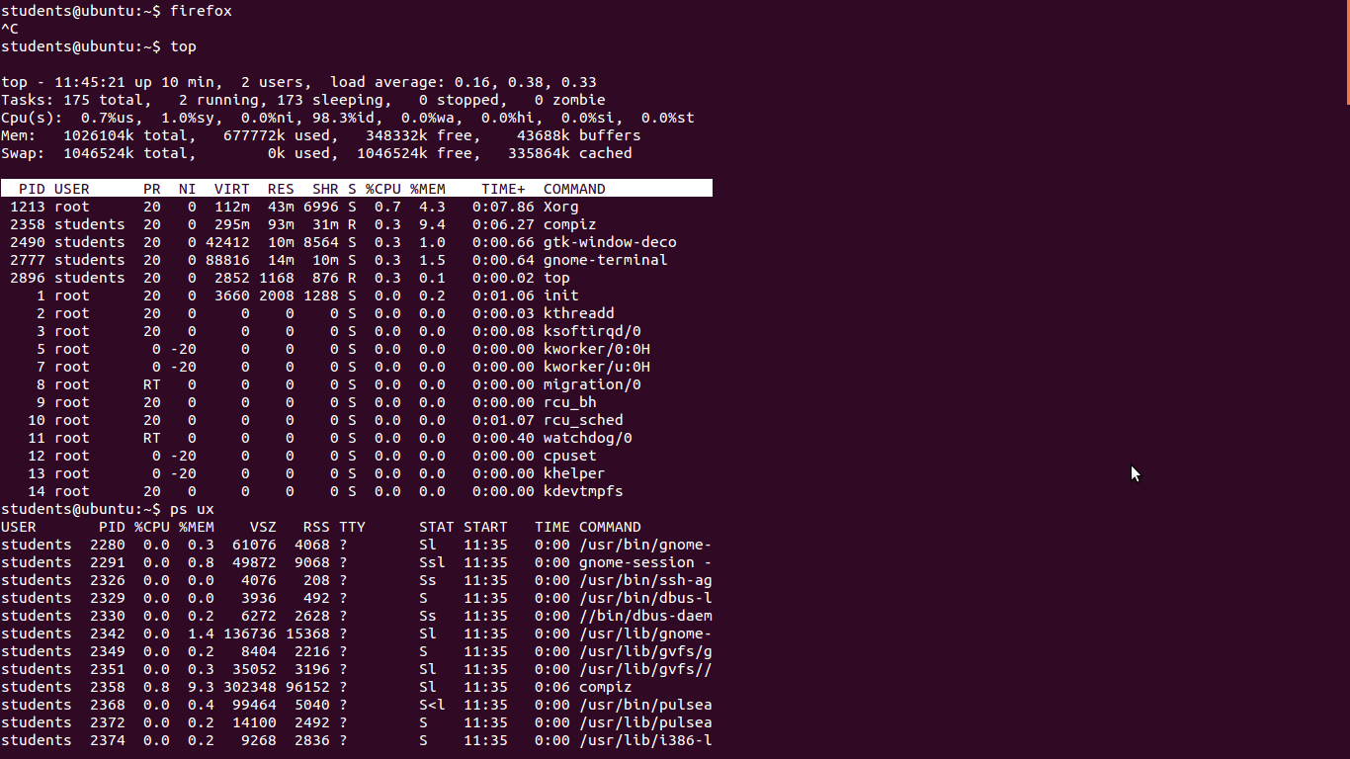

II) Top

Description: It will show all running processes on Linux Machine.

Syntax: top

q - To stop.

OUTPUT:



III) PS

Description: This command stand for process status. It is similar to the task manager that pop-ups in the windows machine when we use Ctrl+alt+delete. This is similar to top command but information displayed is different.

Syntax: ps ux - To check all the processes running under a user.

ps pid - Checking for the process status of single status.

kill pid - To kill any process.

pidof process_name - Retrieving process id of any process.

OUTPUT: ps ux

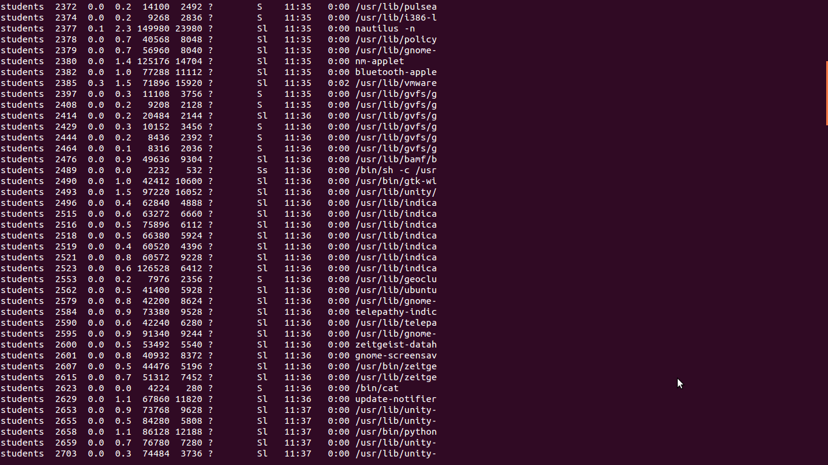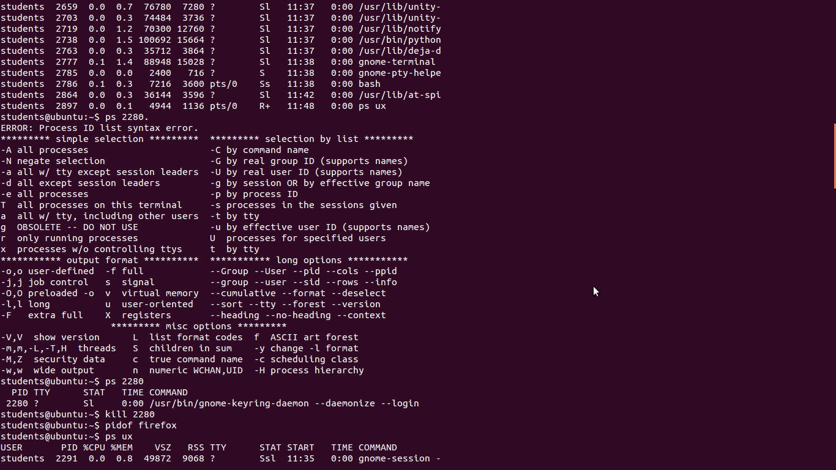

ps pid



kill pid



pidof process_name

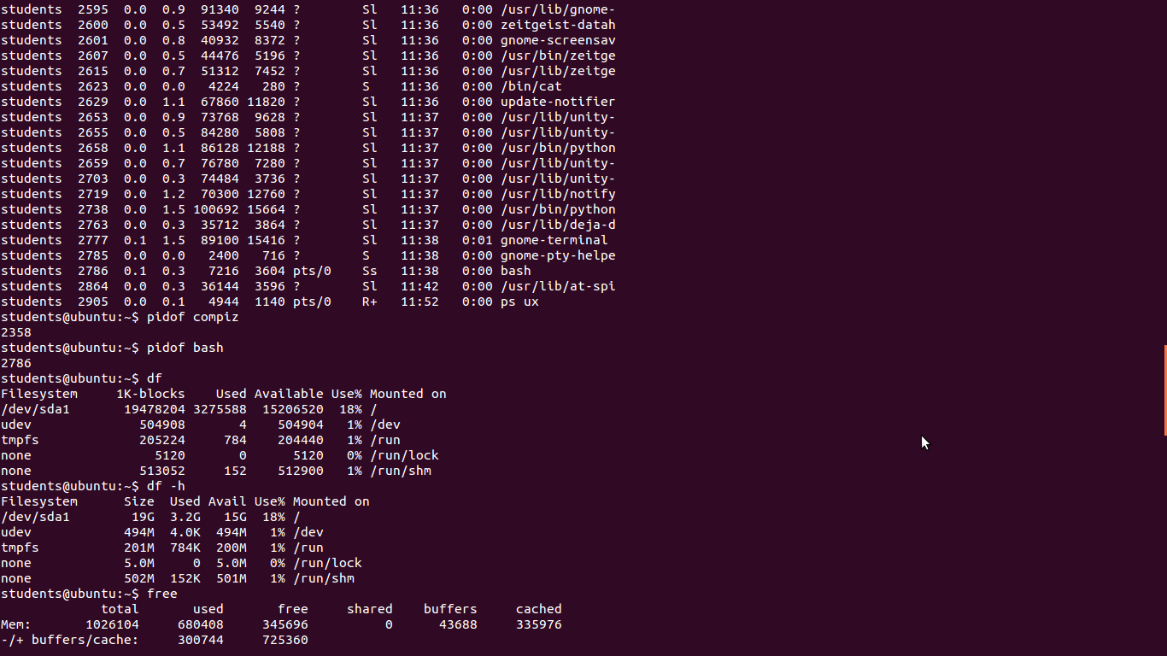

IV) Disk Free

Description: It shows free space.

Syntax: df - It shows free space on disk.

df -h - It shows information in readable format.

OUTPUT:



V) Free

Description: It is use to display free space on Linux.

Syntax: free - It shows free as well as utilized space.

free -m - It shows information in megabytes.

free -g - It shows information in gigabytes.

OUTPUT:

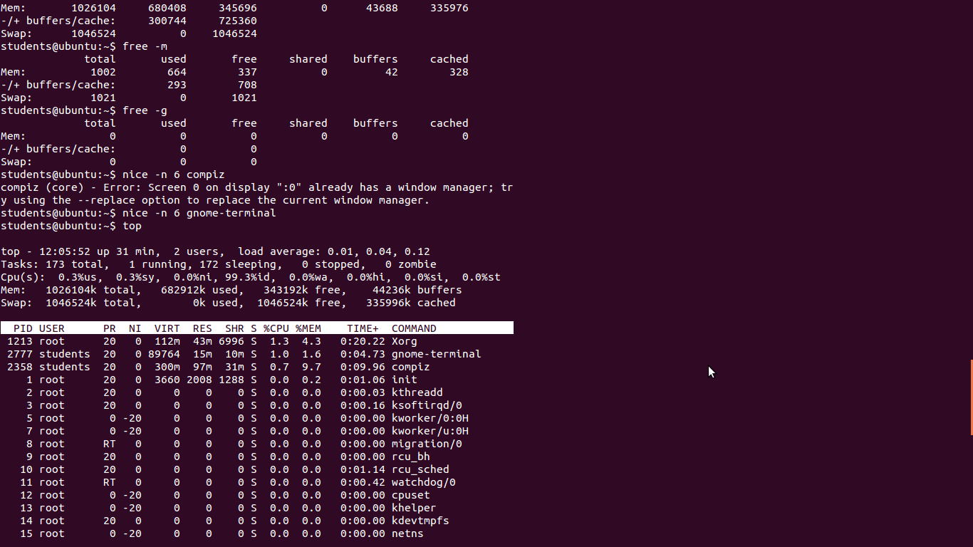

VI) Nice

Description: Linux can run lot of processes at a time which can slow down the speed of some high priority processes and results in poor performance. To avoid this you can tell your machine to prioritize process as per your requirement. This priority is called as niceness in Linux. It has value between -20 to 19. The lower niceness value is higher priority given to the task. Default value of all the process is zero.

Syntax: nice –n niceness_value process_name - To start process with niceness value sudo renice niceness_value –p process_id - To change the niceness value

OUTPUT:

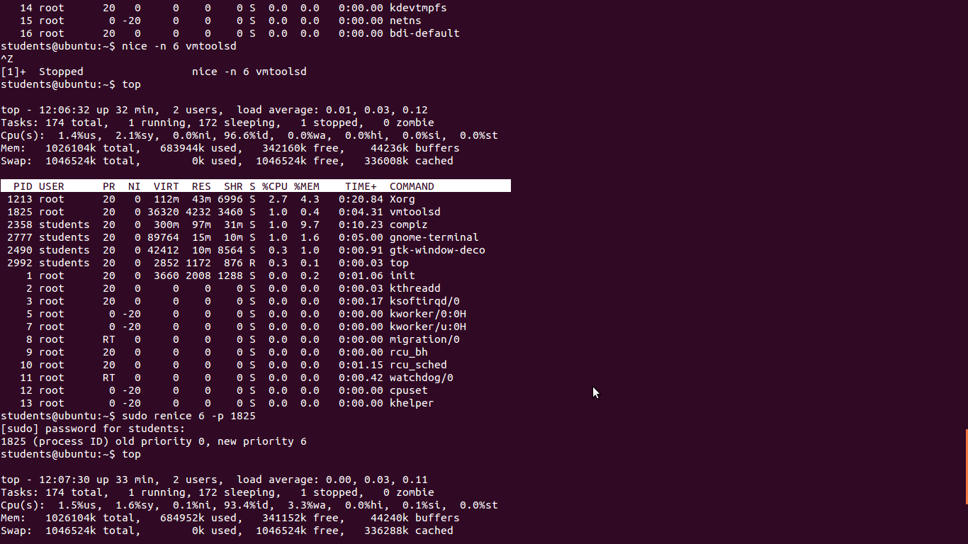

**Learning Outcomes Achieved**

Learned advance commands of process management and file management.

**Conclusion:**

Thus we have studied the advance commands of Process Management and File Management.

**13. Experiment/Assignment Evaluation**

|  |  |  |  |  |  |  |  |
| --- | --- | --- | --- | --- | --- | --- | --- |
| **SR** | **Parameters** | **Weight** | **Excellent** | **Good** | **Average** | **Poor** | **Not as per requirement** |
| **Scale Factor ->** | 5 | 4 | 3 | 2 | 0 |
| 1 | Technical Understanding | 25 |  |  |  |  |  |
| 2 | Performance / Execution | 25 |  |  |  |  |  |
| 3 | Question Answers | 20 |  |  |  |  |  |
| 4 | Punctuality | 20 |  |  |  |  |  |
| 5 | Presentation | 10 |  |  |  |  |  |
|  | Total out of 100 -->  #(to be converted as per term-work evaluation applicable to the subject) | | **∑ (Weight * Scale Factor)/5 = ________** | | | | |

**References**:

[1] Unix, concepts and applications by Sumitabha Das, McGraw-Hill

[2] Mastering Shell Scripting, Randal. K. Michael, Second Edition, Wiley Publication

**Viva Questions**

* What is Process?
* What are advance commands of Process Management?
* What are the advance commands of File Management?