

National Textile University
Department of Computer Science
Subject
Mobile App Development
Submitted to:
Sir Rehan Sarwar

Submitted by:
Abdul Rehman
Registration Number
23-NTU-CS-1122

Lab Task
05
Semester
6th

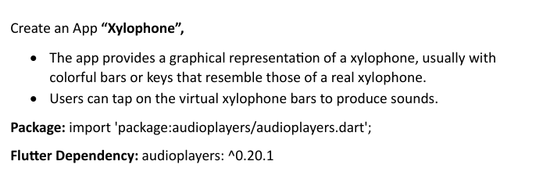
Code:
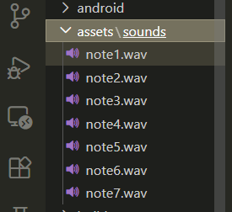
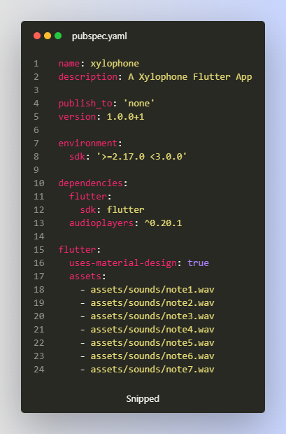
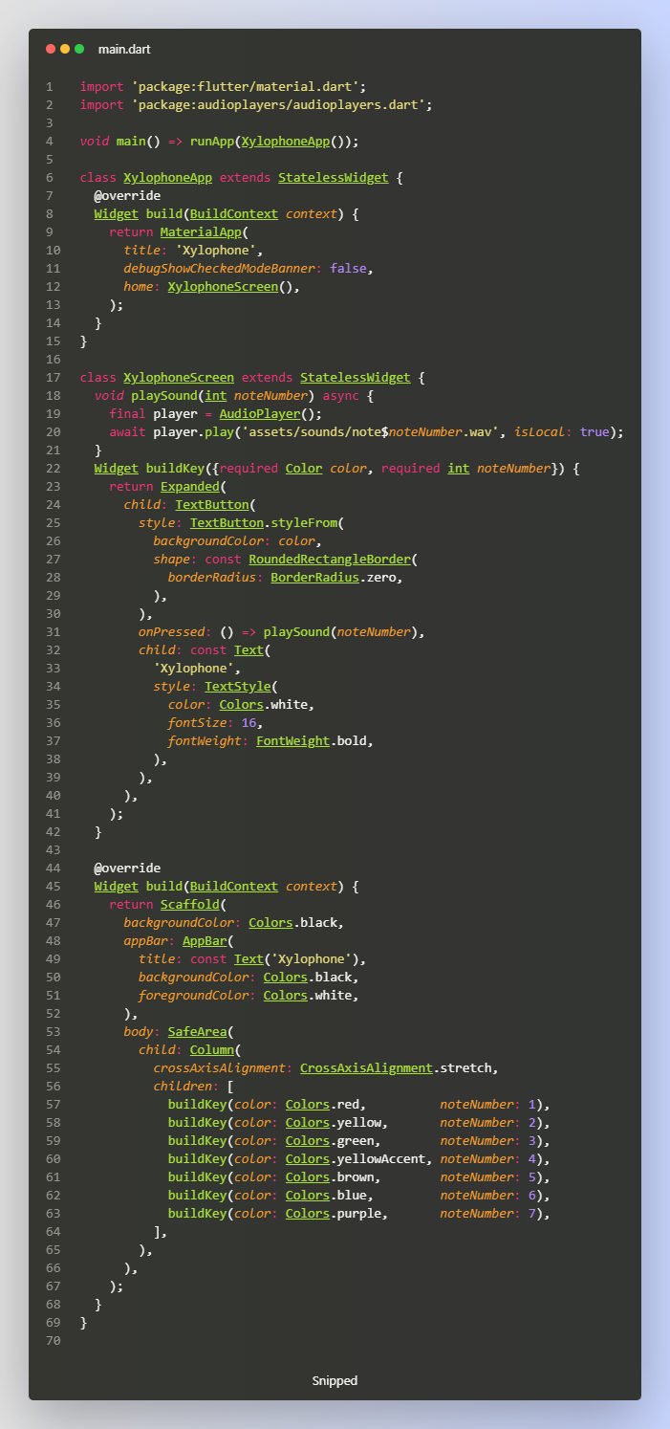

Output:
