Updating the Badge Firmware

You can use any method to program the PIC32MM0256GPM048 that supports it. This example uses Microchip’s tools as that is what we have.

The PICkit 3 Programmer will program the chip in ~32 seconds and the PICkit 4 will program them in ~8s each.  Both are available on Digikey, or Microchip’s website.

1. Plug in the USB port to supply 5V power to the badge.  Plug the PICKit 3/4 to USB as well.
2. 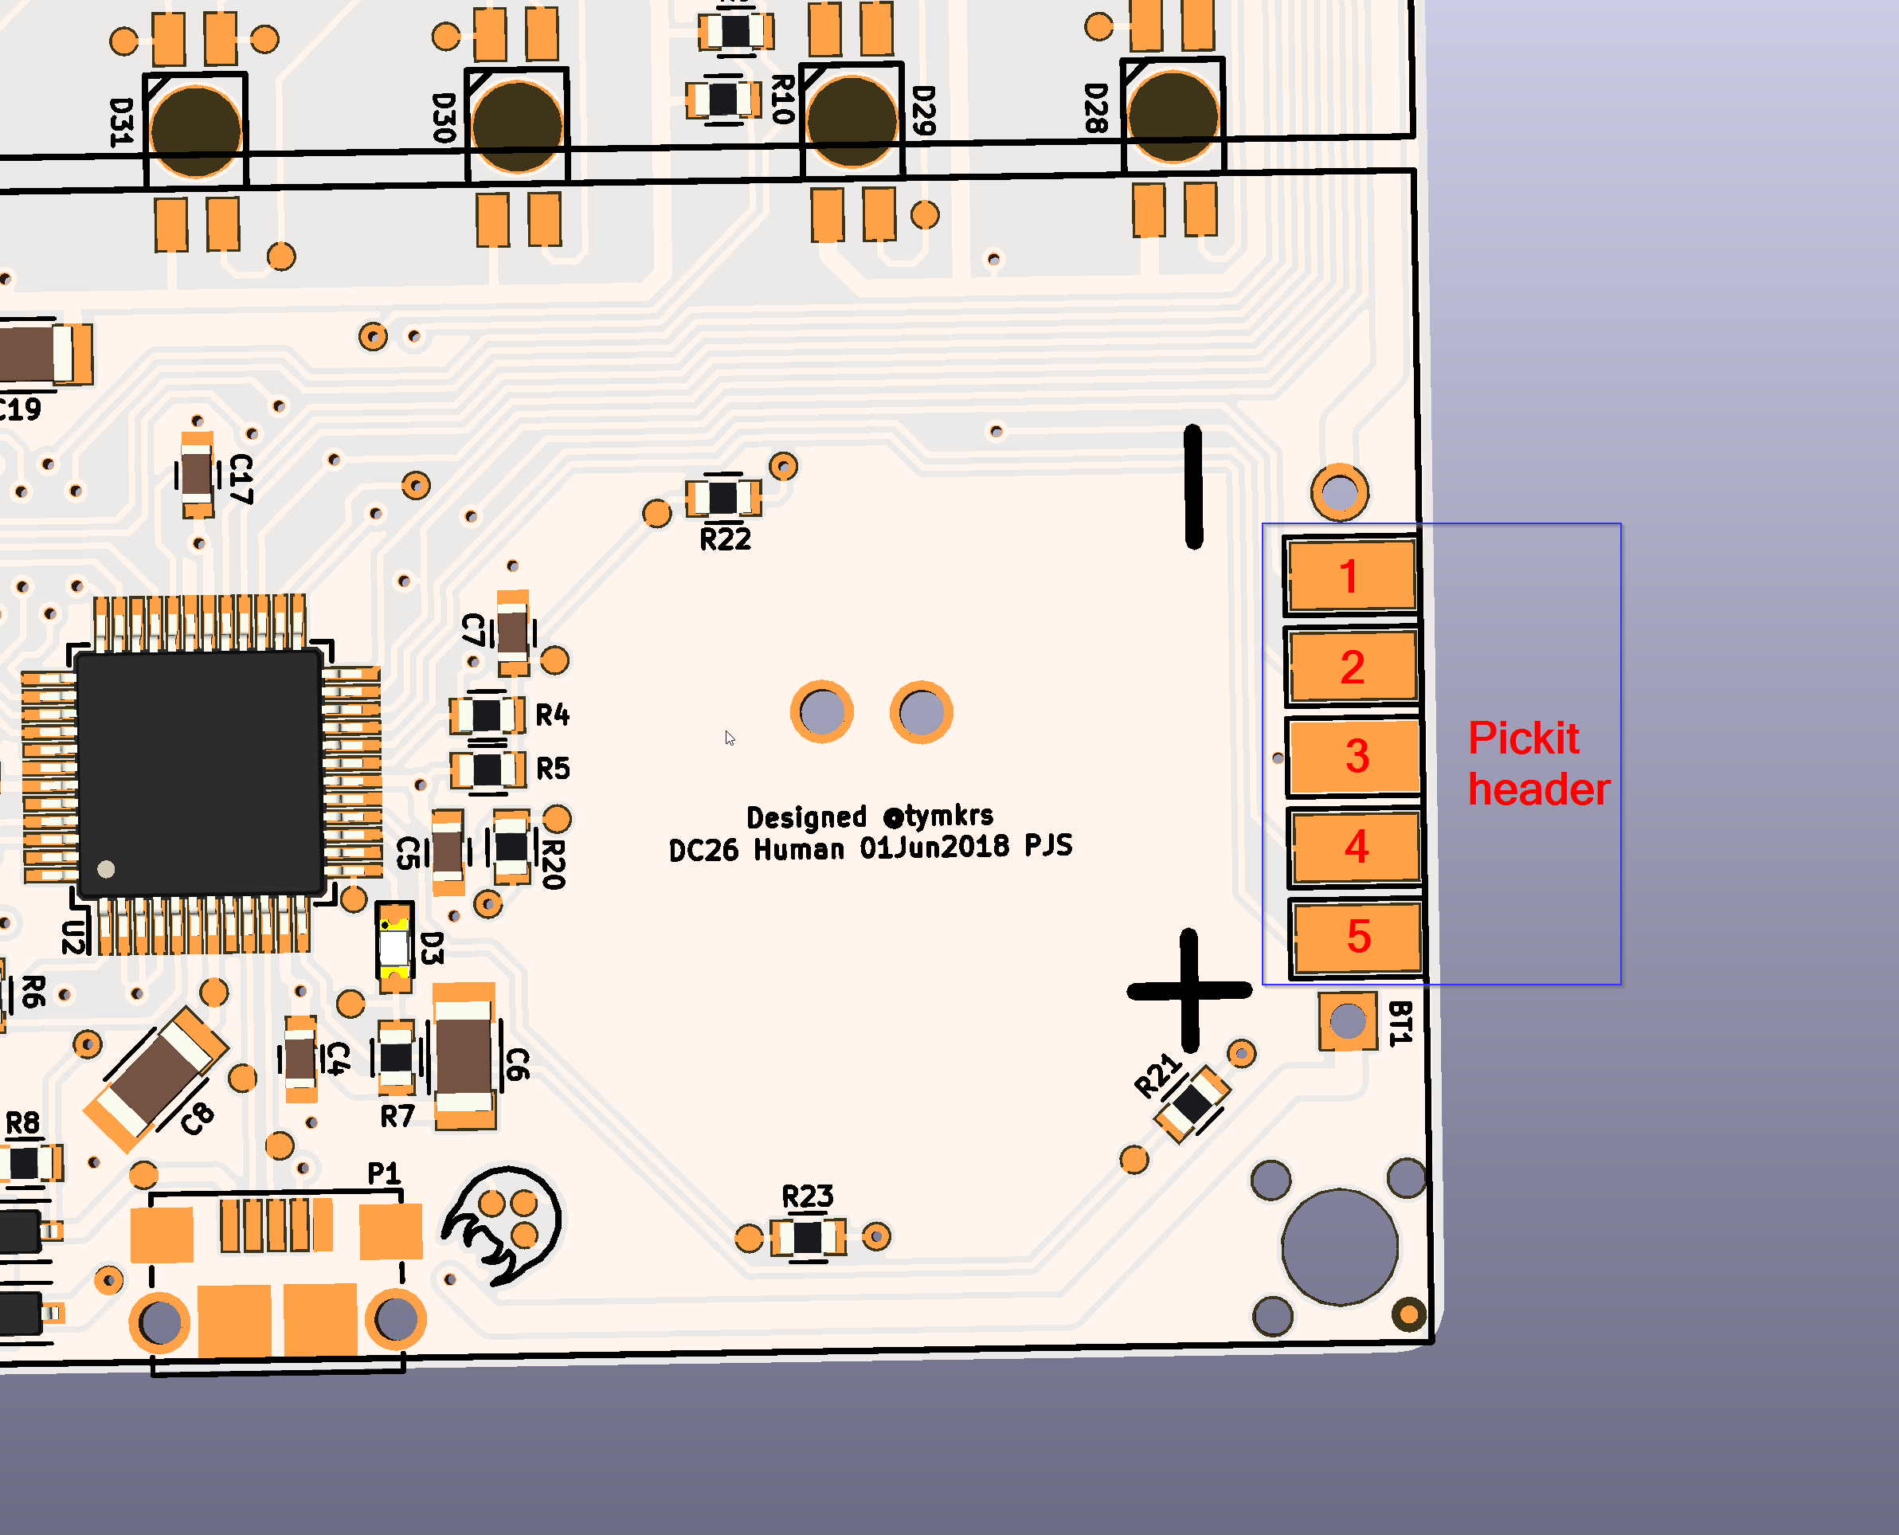Attach the PICkit 3/4 to the pads shown. I use a spring probe adapter to make the connection.
3. Start the Mplab x IPE (comes with the Mplab X IDE <http://www.microchip.com/mplab/mplab-x-ide>)
4. 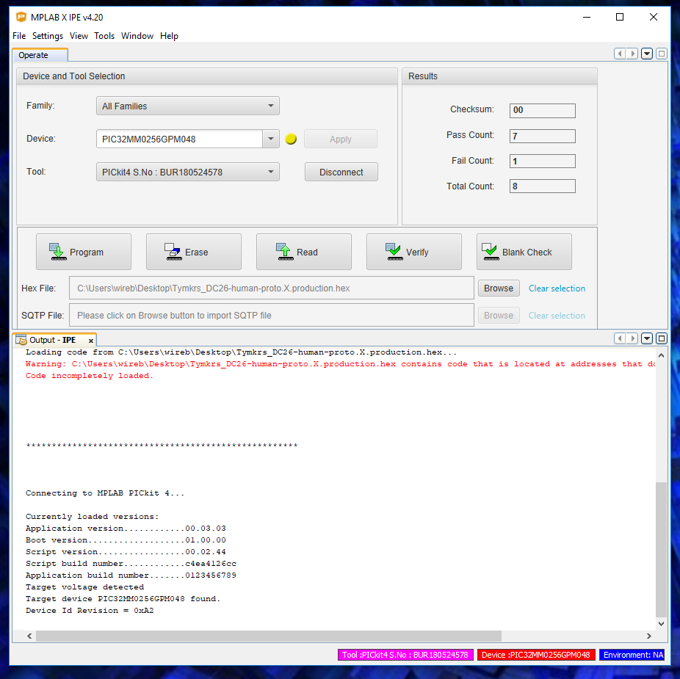Configure IPE as shown. As long as your PICKit is plugged in, the Tool field will automatically populate. Be sure to choose the correct hex file!:  
     
   5. Click program and wait for all operations to complete (8 to 35 seconds). You may need to click “Connect” first before clicking “Program” depending on what state IPE comes up in.  
   6. Verify program was successful (see output below) make sure there are no error or failure messages.

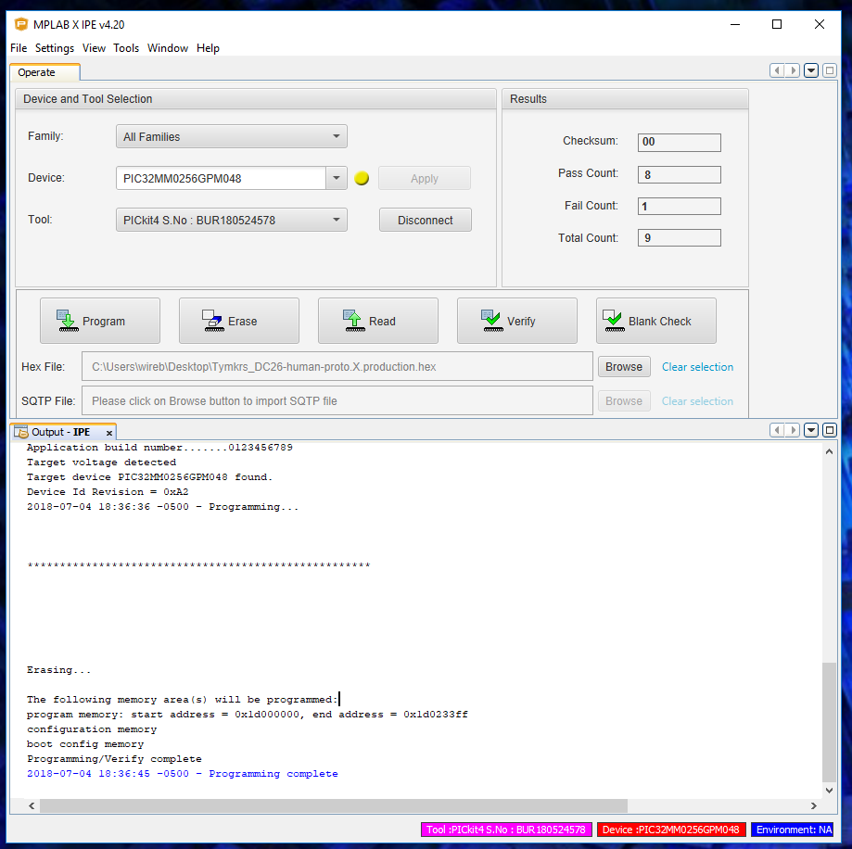Please feel free to reach out to @wireengineer/@whixr for any questions on reflashing the firmware.