dz

Professor322

11/12/2019

Проверка остатков на гетероскедасичность (тест Шлдфелда Квандта) Перенесем таблицу данных в R

data <- data.frame(GDP = c(10.13,18.88,20.94, 22.16, 24.64,27.75,40.15,51.62,57.71,66.32,76.88,101.65,115.97,124.15,140.98,169.38,186.33,211.78,261.41,395.51),  
 GovSpendings = c(0.22,1.23,1.81,1.02,1.07,0.67,0.75,2.80,4.90,4.45,4.26,5.31,6.40,11.22,8.66,13.41,5.46,4.79,18.9,15.95))  
data

## GDP GovSpendings  
## 1 10.13 0.22  
## 2 18.88 1.23  
## 3 20.94 1.81  
## 4 22.16 1.02  
## 5 24.64 1.07  
## 6 27.75 0.67  
## 7 40.15 0.75  
## 8 51.62 2.80  
## 9 57.71 4.90  
## 10 66.32 4.45  
## 11 76.88 4.26  
## 12 101.65 5.31  
## 13 115.97 6.40  
## 14 124.15 11.22  
## 15 140.98 8.66  
## 16 169.38 13.41  
## 17 186.33 5.46  
## 18 211.78 4.79  
## 19 261.41 18.90  
## 20 395.51 15.95

Построим график зависимости расходов от ВВП

gg0 <- qplot(data=data, GDP, GovSpendings)  
gg0 + aes(col=GDP)+stat_smooth(method="lm")

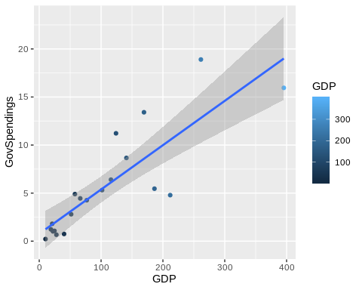

Оценим модель и построим график квадратов остатков в зависимости от регрессора

model <- lm(data = data, GovSpendings~0+GDP)  
summary(model)

##   
## Call:  
## lm(formula = GovSpendings ~ 0 + GDP, data = data)  
##   
## Residuals:  
## Min 1Q Median 3Q Max   
## -5.8094 -0.3950 0.2538 1.2491 5.8167   
##   
## Coefficients:  
## Estimate Std. Error t value Pr(>|t|)   
## GDP 0.05005 0.00449 11.15 8.91e-10 ***  
## ---  
## Signif. codes: 0 '***' 0.001 '**' 0.01 '*' 0.05 '.' 0.1 ' ' 1  
##   
## Residual standard error: 2.885 on 19 degrees of freedom  
## Multiple R-squared: 0.8674, Adjusted R-squared: 0.8604   
## F-statistic: 124.3 on 1 and 19 DF, p-value: 8.908e-10

data <- augment(model, data)  
qplot(data=data, .resid^2)

## `stat_bin()` using `bins = 30`. Pick better value with `binwidth`.

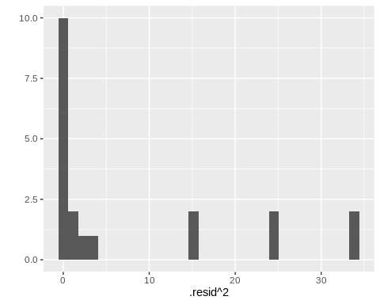 После анализаа этого графика есть основания предполагать наличие гетероскедастичности

Ручная проверка Сформируем два набора оценим их

data1 <- data.frame(GDP = data$GDP[1:7], GovSpendings = data$GovSpendings[1:7])  
data1

## GDP GovSpendings  
## 1 10.13 0.22  
## 2 18.88 1.23  
## 3 20.94 1.81  
## 4 22.16 1.02  
## 5 24.64 1.07  
## 6 27.75 0.67  
## 7 40.15 0.75

data2 <- data.frame(GDP = data$GDP[14:20], GovSpendings = data$GovSpendings[14:20])  
data2

## GDP GovSpendings  
## 1 124.15 11.22  
## 2 140.98 8.66  
## 3 169.38 13.41  
## 4 186.33 5.46  
## 5 211.78 4.79  
## 6 261.41 18.90  
## 7 395.51 15.95

aux_model1 <- lm(data=data1, GovSpendings~0+GDP)  
aux_model2 <- lm(data=data2, GovSpendings~0+GDP)  
RSS1 <- deviance(aux_model1)  
RSS2 <- deviance(aux_model2)  
RSS2/RSS1

## [1] 70.61321

qf(0.95, df1=6, df2 = 6)

## [1] 4.283866

Проверим тестом Квандта

gqtest(model, fraction = 0.3, order.by = ~GDP, data=data)

##   
## Goldfeld-Quandt test  
##   
## data: model  
## GQ = 70.613, df1 = 6, df2 = 6, p-value = 2.666e-05  
## alternative hypothesis: variance increases from segment 1 to 2