Нано исследование

в этом исследовании мы рассмотрим цены на квартиры в Москве.

library("memisc")

## Loading required package: lattice

## Loading required package: MASS

##   
## Attaching package: 'memisc'

## The following objects are masked from 'package:stats':  
##   
## contr.sum, contr.treatment, contrasts

## The following object is masked from 'package:base':  
##   
## as.array

library("lmtest")

## Loading required package: zoo

##   
## Attaching package: 'zoo'

## The following objects are masked from 'package:base':  
##   
## as.Date, as.Date.numeric

library("ggplot2")

##   
## Attaching package: 'ggplot2'

## The following object is masked from 'package:memisc':  
##   
## syms

library("dplyr")

##   
## Attaching package: 'dplyr'

## The following objects are masked from 'package:memisc':  
##   
## collect, recode, rename, syms

## The following object is masked from 'package:MASS':  
##   
## select

## The following objects are masked from 'package:stats':  
##   
## filter, lag

## The following objects are masked from 'package:base':  
##   
## intersect, setdiff, setequal, union

library("foreign")  
library("vcd")

## Loading required package: grid

library("devtools")

## Loading required package: usethis

library("hexbin")  
library("pander")  
library("sjPlot")

## Install package "strengejacke" from GitHub (`devtools::install_github("strengejacke/strengejacke")`) to load all sj-packages at once!

library(knitr)  
f <- read.csv("flats_moscow.txt", sep="\t", header=TRUE, dec=".")

в нашем наборе данных 2040 наблюдений. Средняя цена квартиры равна 127.4965686 тысяе у.е.

Красивый график:

f <- mutate_each(f, "factor", walk, brick, floor, code)  
qplot(data=f, log(price), fill=brick, position="dodge")

## Warning: `position` is deprecated

## `stat_bin()` using `bins = 30`. Pick better value with `binwidth`.

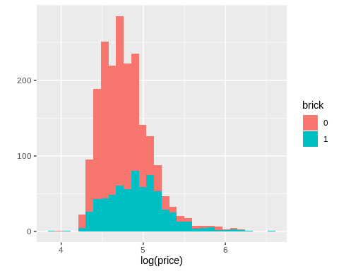

Оценим и сравним модели

model_0 <- lm(data=f, log(price)~log(totsp))  
model_1 <- lm(data=f, log(price)~log(totsp)+brick)  
model_2 <- lm(data=f, log(price)~log(totsp)+brick+brick:log(totsp))  
mtable(model_0, model_1, model_2)

##   
## Calls:  
## model_0: lm(formula = log(price) ~ log(totsp), data = f)  
## model_1: lm(formula = log(price) ~ log(totsp) + brick, data = f)  
## model_2: lm(formula = log(price) ~ log(totsp) + brick + brick:log(totsp),   
## data = f)  
##   
## ==============================================================  
## model_0 model_1 model_2   
## --------------------------------------------------------------  
## (Intercept) -0.766*** -0.650*** -0.459***   
## (0.098) (0.094) (0.121)   
## log(totsp) 1.301*** 1.264*** 1.219***   
## (0.023) (0.022) (0.028)   
## brick: 1/0 0.129*** -0.350   
## (0.009) (0.193)   
## log(totsp) x brick1 0.112*   
## (0.045)   
## --------------------------------------------------------------  
## R-squared 0.611 0.647 0.648   
## N 2040 2040 2040   
## ==============================================================  
## Significance: *** = p < 0.001; ** = p < 0.01; * = p < 0.05

У нас оказалась лучше модель 2.