**Assignment-1**

**Connect to a running mongo instance, use a database named mongo_practice.**

**Insert the following documents into a movies collection**

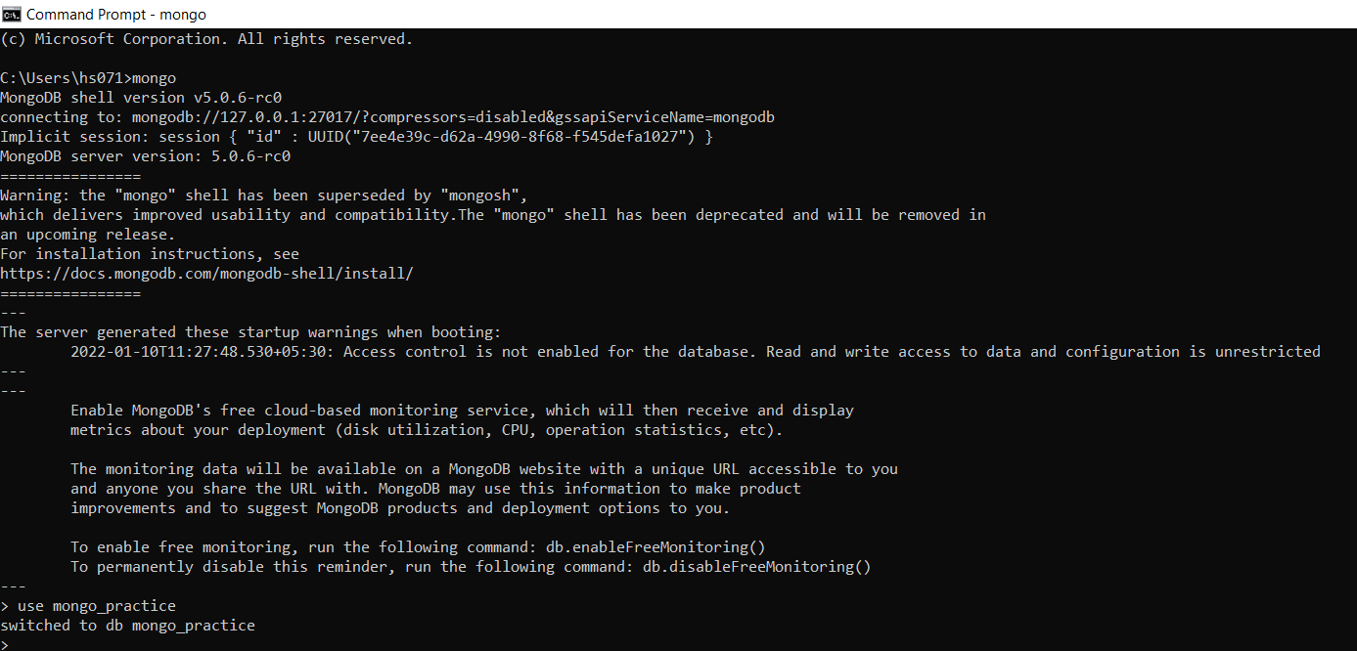

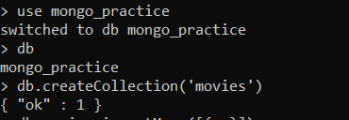

**Query / Find Documents**

**query the movies collection to**

**1. get all documents**

**db.movies.find()**

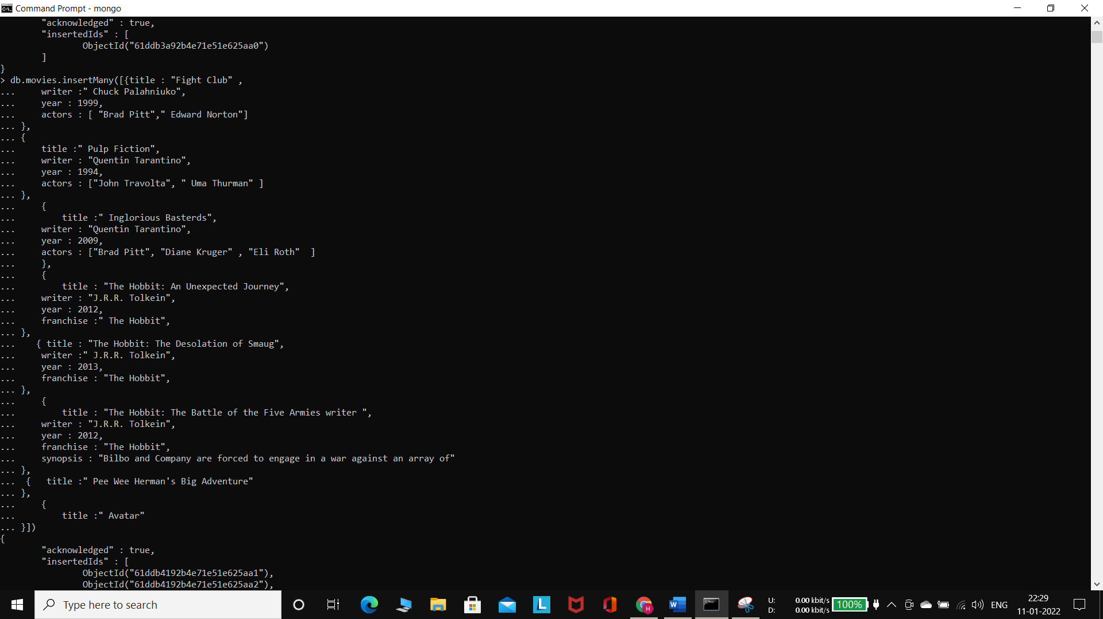

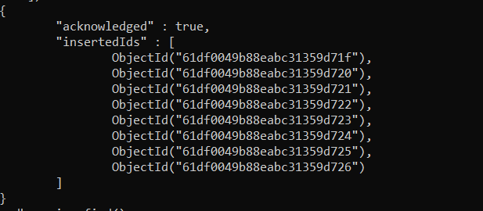

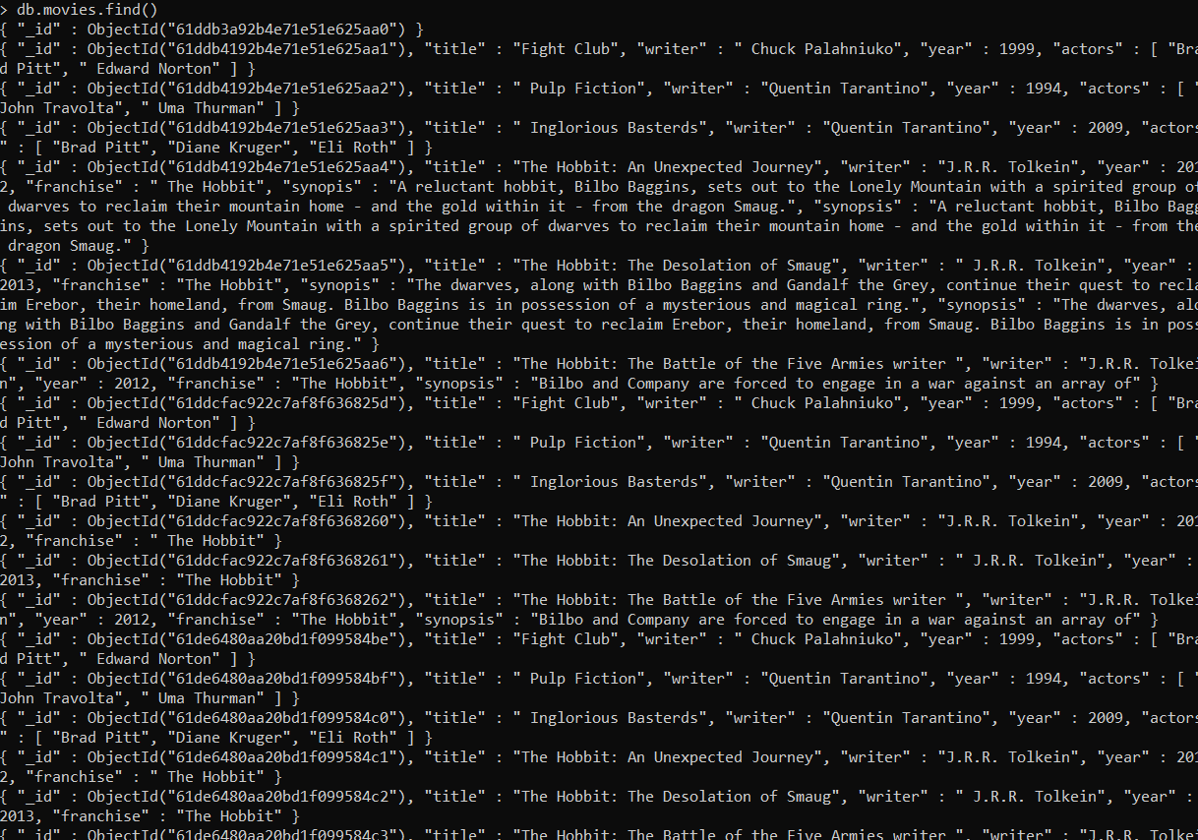

**2. get all documents with writer set to "Quentin Tarantino"**

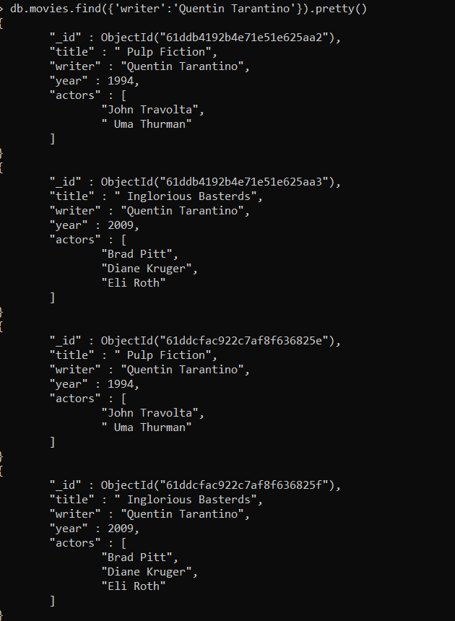

**3. get all documents where actors include "Brad Pitt"**

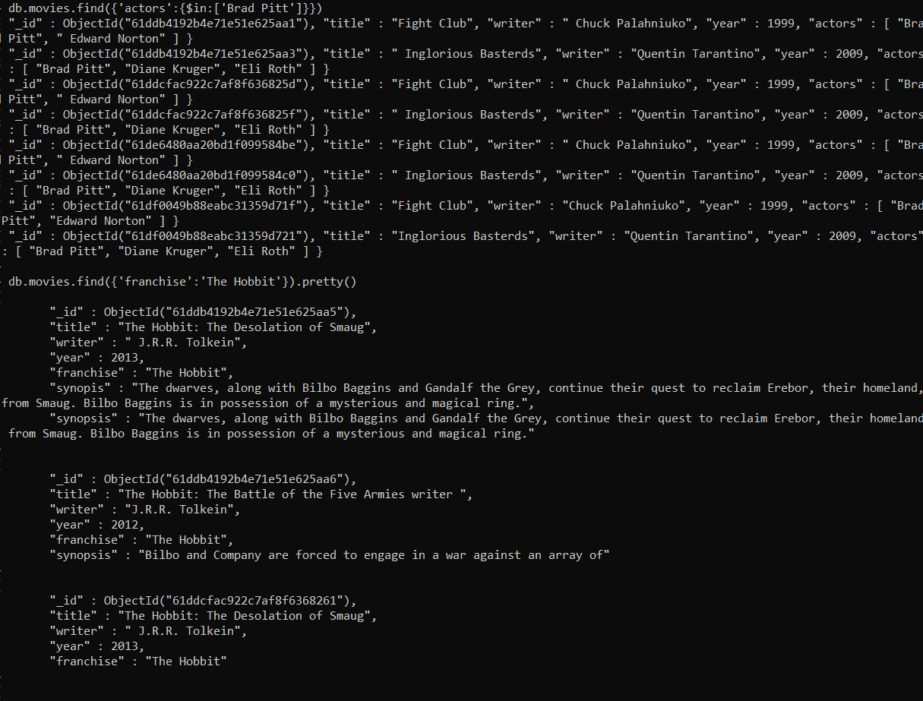

**4. get all documents with franchise set to "The Hobbit"**

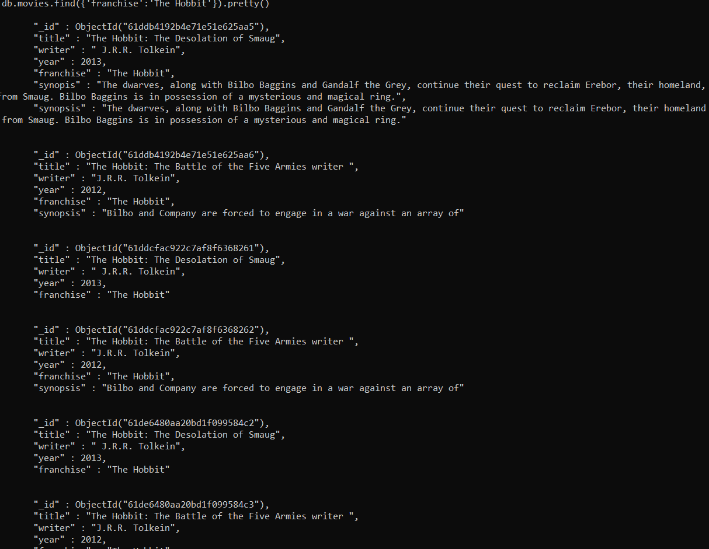

**5. get all movies released in the 90s**

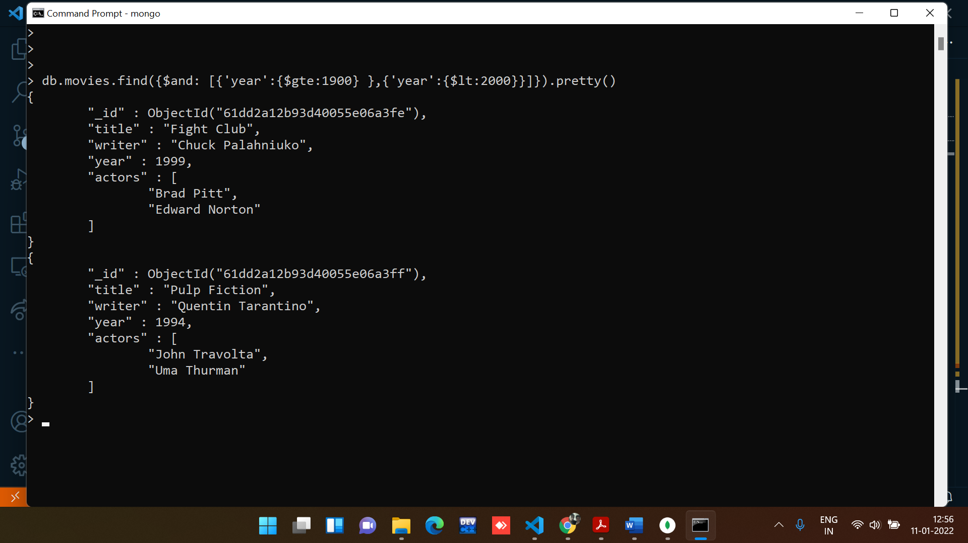

**6. get all movies released before the year 2000 or after 2010**

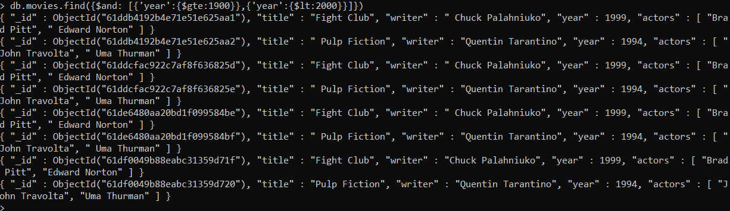

**Update Documents**

**1. add a synopsis to "The Hobbit: An Unexpected Journey" : "A reluctant hobbit, Bilbo Baggins, sets out to the Lonely Mountain with a spirited group of dwarves to reclaim their mountain home - and the gold within it - from the dragon Smaug."**



**2. add a synopsis to "The Hobbit: The Desolation of Smaug" : "The dwarves, along with Bilbo Baggins and Gandalf the Grey, continue their quest to reclaim Erebor, their homeland, from Smaug. Bilbo Baggins is in possession of a mysterious and magical ring."**



**3. add an actor named "Samuel L. Jackson" to the movie "Pulp Fiction"**

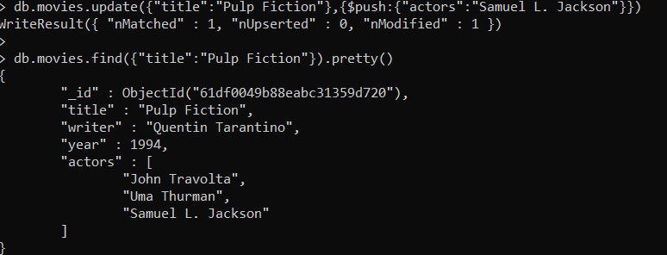

**Text Search**

1. **find all movies that have a synopsis that contains the word "Bilbo"**

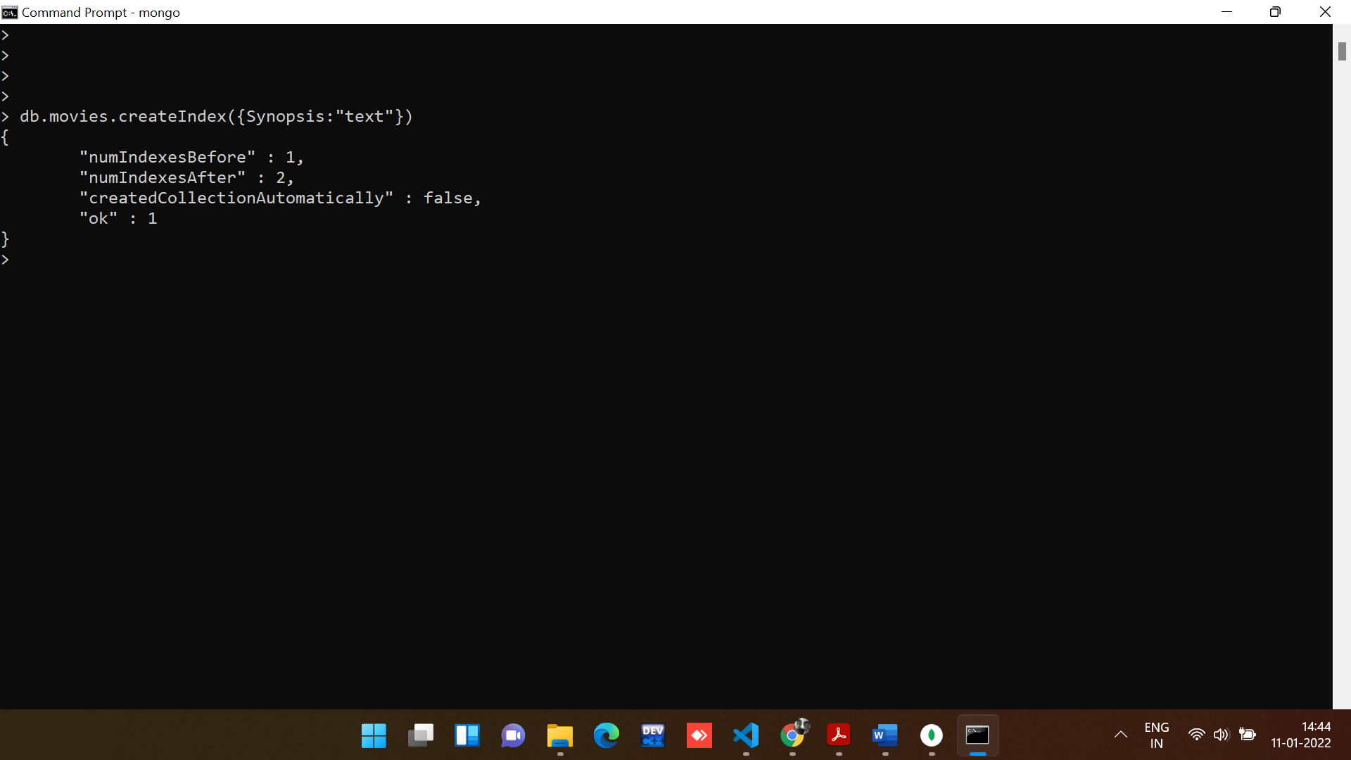

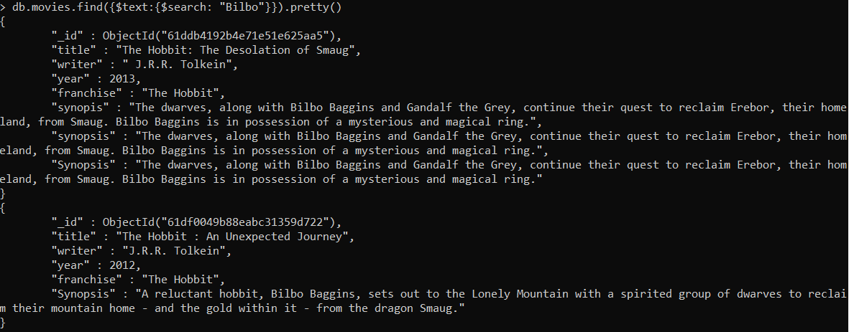

**2. find all movies that have a synopsis that contains the word "Gandalf"**

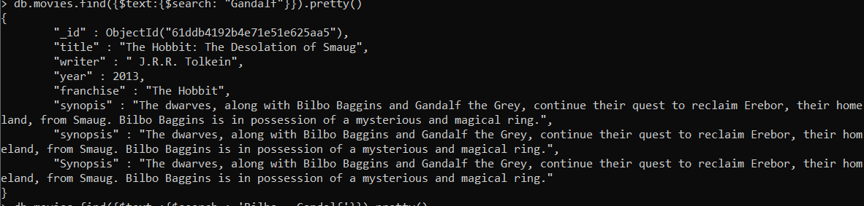

**3. find all movies that have a synopsis that contains the word "Bilbo" and not the word "Gandalf"**

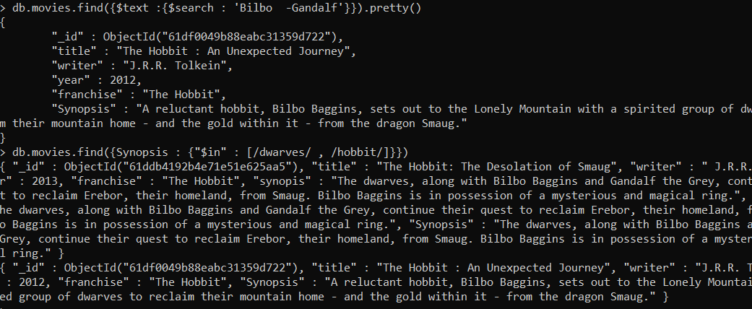

**4. find all movies that have a synopsis that contains the word "dwarves" or "hobbit"**

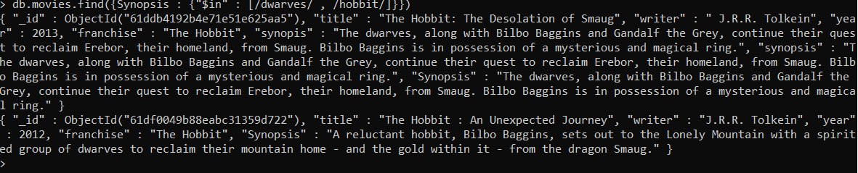

**5. find all movies that have a synopsis that contains the word "gold" and "dragon"**

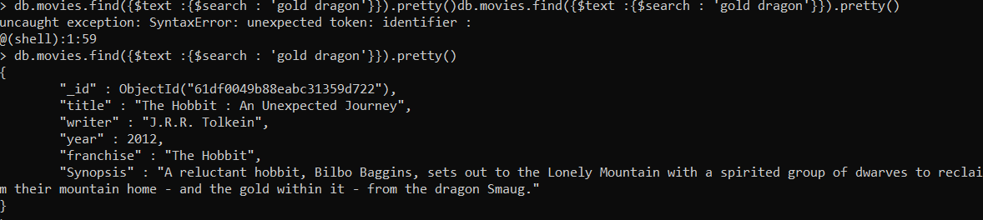

**Delete Documents**

**1. delete the movie "Pee Wee Herman's Big Adventure"**



**2. delete the movie "Avatar"**

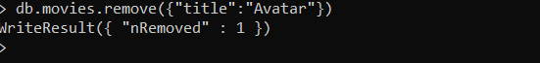

**Relationships**

**Insert the following documents into a users collection**

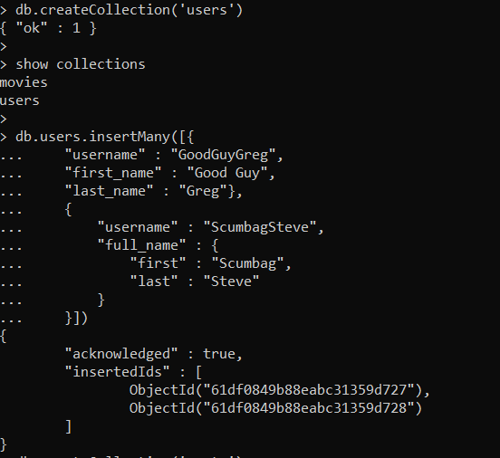

**Insert the following documents into a posts collection**

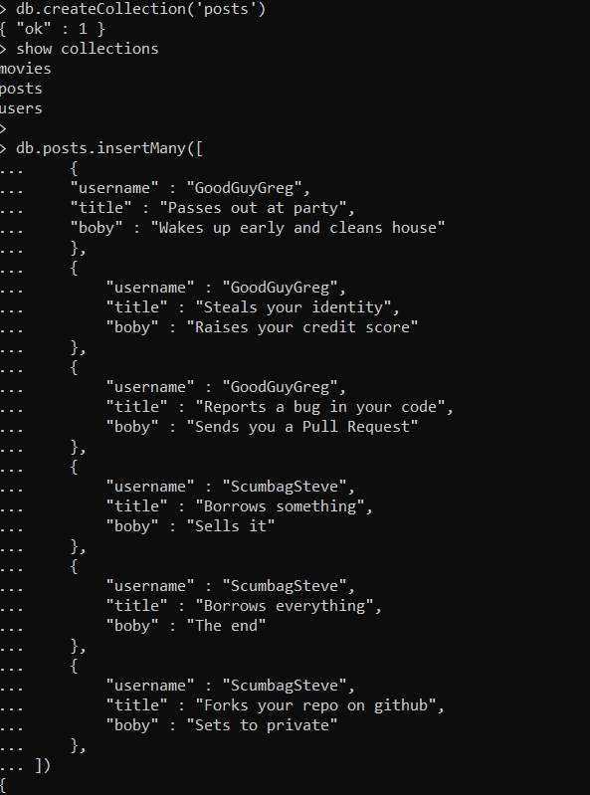

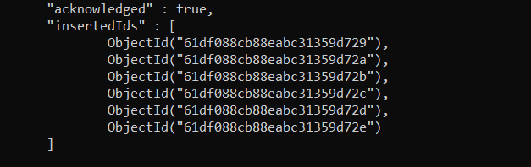

**Insert the following documents into a comments collection**

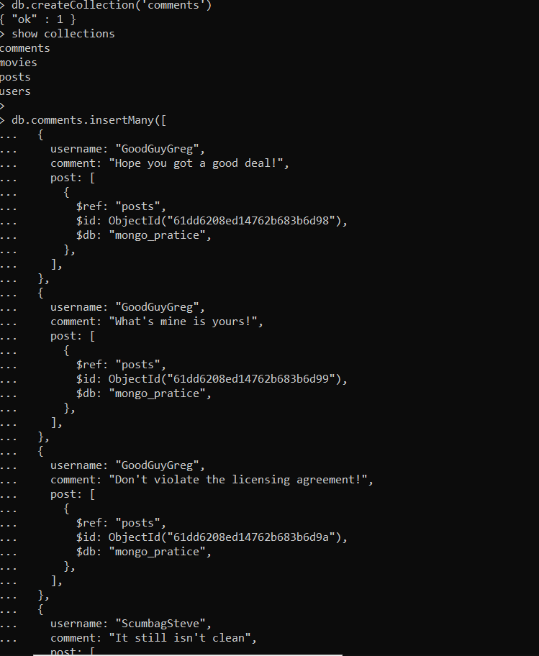

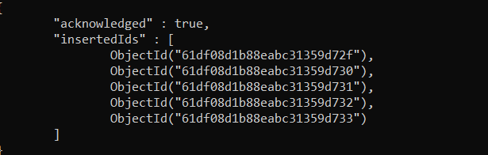

**Querying related collections**

**1. find all users**

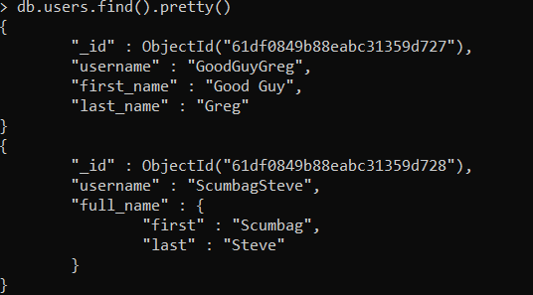

**2. find all posts**

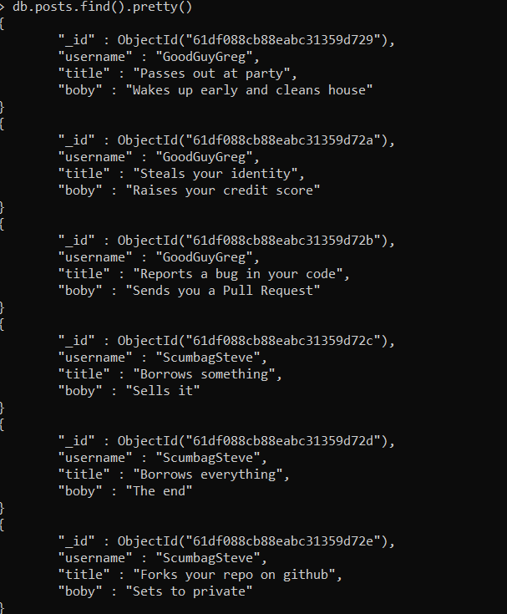

**3. find all posts that was authored by "GoodGuyGreg"**

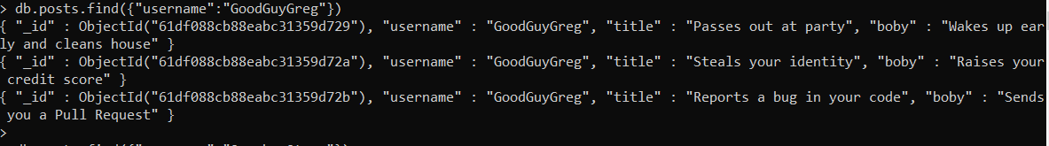

**4. find all posts that was authored by "ScumbagSteve"**

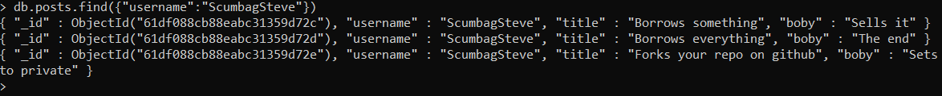

**5. find all comments**

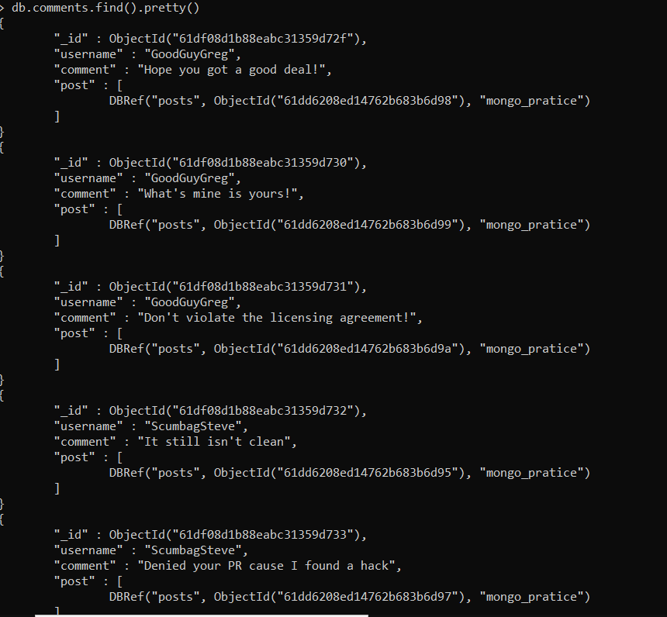

**6. find all comments that was authored by "GoodGuyGreg"**

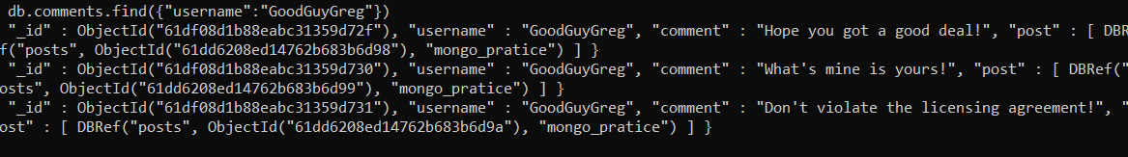

**7. find all comments that was authored by "ScumbagSteve"**



**8. find all comments belonging to the post "Reports a bug in your code"**

