**Last Updated Module**

Tracking the last time a node was changed

Contents

Last Updated Module 4

Description 4

Applications 4

Availability 4

Version 4

Dependencies 5

Installation 5

Screen Widgets 5

Administrative GUI Changes 6

Changes to the Authoring Information Area of the Node Edit Form 6

Changes to the Publishing Options Area of the Node Edit Form 7

User GUI Changes 8

Changes to the Node Metadata Display 8

Mentioned But Missing 9

Permissions 9

Block Layout UI 9

Placement Control 9

Format Control 9

Default Values 9

Potential Upgrades 10

Add Identity 10

Add Logging 10

Add Roll Back 10

Add Roll Forward 10

This page left intentionally blank

# Last Updated Module

## Description

The *Last Updated* module (updated) enables node-oriented revision tracking by:

* Adding an Administrator-oriented *Last updated* screen widget to the *Authoring Information* area of every node edit form in the Administrative GUI.
* Adding a User-oriented *Last updated* screen widget to the node metadata display already being exposed by default in the User GUI. The visibility of the User-oriented screen widget is controlled via a checkbox in the Administrative GUI. The checkbox enables the display of *Last updated* metadata on a selective, per-node basis.

The *Last updated* module maintains internal state by creating, assigning and/or updating a per-node internal variable that is updated every time a node is changed.

## Applications

There are a number of use cases where the Last Updated module could prove to be indispensible, all of which are predicated on a need to determine when a node was last altered:

* High risk / high value applications include the custodianship of legally relevant documents such as contract, wills, receipts, statements, testimony, depositions, transcriptions, confessions and all other documents that may be used in a legal proceeding.
* Medium risk / medium value applications include the need to monitor documents with a slight requirement for alteration tracking, or a need to be able to detect unwanted, unexpected or accidental changes like lab notes, diaries, journals, manuals, official documentation, standard operating procedures, workflows, production reports, inspection reports, press releases, product descriptions and so forth.
* Low risk / low value applications represent yet another class of documents that may need some form of revision detection, including curricula, website comments, product reviews and customer testimonials.
* The relevance of the Last Updated module is very broad, and there are a myriad of other potential applications. The only criteria that needs to be met is detecting a change to a digital document so that change can be interpreted and, potentially, responded to.

## Availability

The *Last updated* module is available at:

https://www.drupal.org/project/updated

## Version

The *Last updated* module version being considered here is:

https://www.drupal.org/project/updated/releases/7.x-1.x-dev

## Dependencies

The *Last updated* module has no dependencies.

## Installation

The *Last updated* module has no special installation requirements.

It should suffice to simply follow the standard contributed modules installation workflow:

***https://www.drupal.org/docs/7/extend/installing-modules***

## Screen Widgets

The *Last updated* module adds an Administrative GUI screen widget that looks like this:



The *Last updated* module adds a User GUI screen widget that looks like this:



## Administrative GUI Changes

### Changes to the Authoring Information Area of the Node Edit Form

#### Pre-Installation

Prior to the installation of the Last Updated module, the *Authoring Information* area of the node edit form in the Administrative GUI looks like this:

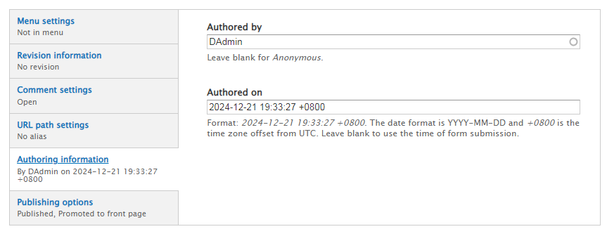

#### Post-Installation

After the installation of the Last Updated module, the Authoring Information area of the node edit form in the Administrative GUI looks like this:

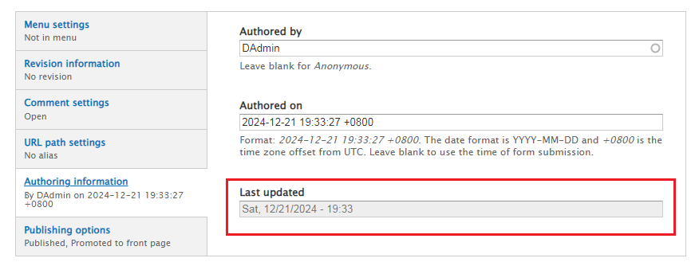

What has changed is that a screen widget has been added that features a *Last updated* label and a read-only field containing system-generated information regarding the last time the node was updated.

### Changes to the Publishing Options Area of the Node Edit Form

#### Pre-Installation

Prior to the installation of the Last Updated module, the *Publishing options* of the node edit form in the Administrative GUI looks like this:

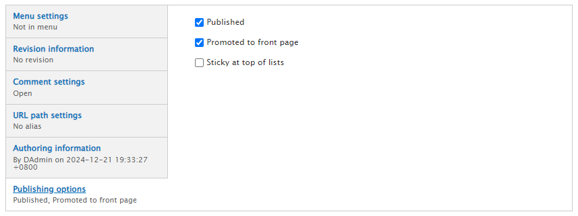

#### Pre-Installation

After to the installation of the Last Updated module, the *Publishing options* of the node edit form in the Administrative GUI looks like this:

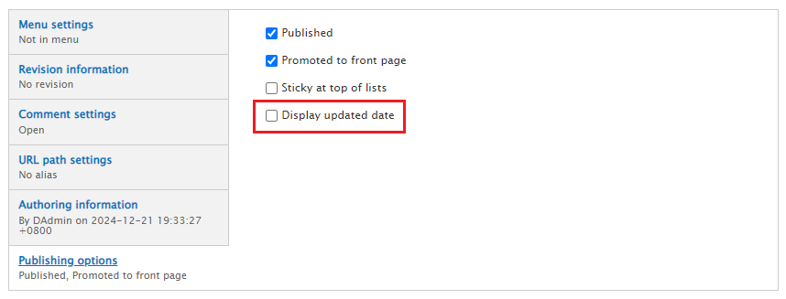

What has changed is that a screen widget has been added that features a *Display updated date* label and a checkbox. This checkbox controls the visibility of the *Last updated* screen widget (with respect to this node only) in the User GUI.

## User GUI Changes

### Changes to the Node Metadata Display

#### Pre-Activation

When the *Display updated date* checkbox has not been checked, Drupal exhibits stock behavior with respect to node metadata: The identity of the submitter, the day, the date and the time are all exposed:

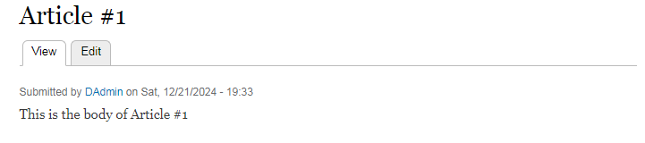

#### Post-Activation

When the *Display updated date* checkbox has been checked, the node metadata display is extended to expose the last time the node was updated in terms of the day, the date and the time:

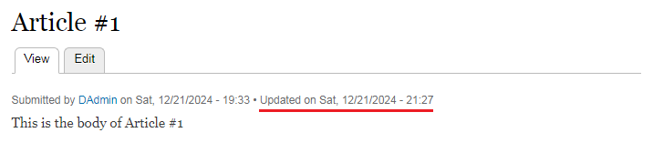

What has changed is that a screen widget has been added that extends the node metadata display via system-generated information regarding the last time the node was updated.

# Mentioned But Missing

## Permissions

Access permissions for the Last Updated module may be configured on a per-user basis at:

Administration » People » Permissions (/admin/people/permissions)

The permission *Configure the display of the node last updated date* grants the ability to toggle the display of the last updated date on all node types;

Users with the additional *Administer content types* permission will be able to set the default display (on/off) per node type.

[I cannot find this functionality in my installed version of this module]

## Block Layout UI

### Placement Control

Control the placement of this information through the Block Layout UI

Place the "Last Updated date block" block in the active theme layout at:

Administration » Structure » Block layout /admin/structure/block).

Although it may be placed anywhere, the "Last Updated date block" was originally designed to appear in the main content region. It may be placed above or below the "Main page content" block according to the preference of the site Administrator or Interface Designer.

[I cannot find this functionality in my installed version of this module]

### Format Control

Control the text and date format of the display

Optionally set the default display for existing content types at

Administration » Structure » Content types (/admin/structure/types)

[I cannot find this functionality in my installed version of this module]

### Default Values

Set a default value for newly created nodes, per node type

On the "Edit" tab for each content type, use the "Page Display Defaults" section to set whether new nodes should default to having the display of the last updated date toggled on or off

(this is just the default, and can be toggled on or off on the individual node).

[I cannot find this functionality in my installed version of this module]

# Potential Upgrades

## Add Identity

[an obvious, easy and presumably simple upgrade here is to also store the identity of whoever updated the node, and expose that information as well]

## Add Logging

[another obvious, easy and presumably simple upgrade here is to store a log of the updates]

## Add Roll Back

[another obvious, easy and presumably simple upgrade here is to store the content that was changed so that it may be "rolled back"]

## Add Roll Forward

[another obvious, easy and presumably simple upgrade here is to store the content that was changed so that it may be "rolled forward"]