**Система управления базой данных инвентаря интернет-магазина**

**(Online-Store inventory Database Management System)**

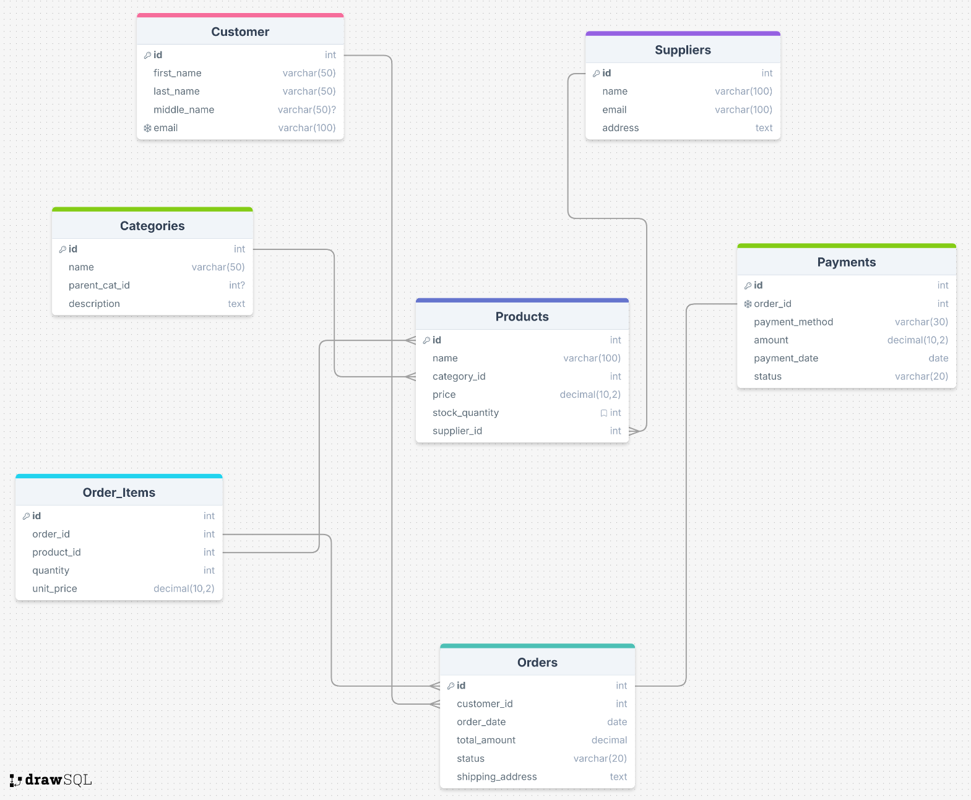

**Обзор системы базы данных (Database System Overview)**

База данных будет управлять онлайн-платформой электронной коммерции.

Сущности (Entities):

1. Клиенты (Customers)

**Attributes and Data types:**

* id (int)
* first_name (varchar(50) NOT NULL)
* last_name (varchar(50) NOT NULL)
* middle_name (varchar(50) NOT NULL)
* email (varchar(100) NOT NULL)

**Primary key:**

* id

**Constraints:**

* email – UNIQUE

1. **Поставщики (Suppliers)**

**Attributes and Data types:**

* id (int)
* name (varchar(100) NOT NULL)
* email (varchar(100) NOT NULL)
* address (text NOT NULL)

**Primary key:**

* id

**Constraints:**

* email – UNIQUE

1. **Продукты (Products)**

**Attributes and Data types:**

* id (int)
* name (varchar(100) NOT NULL)
* category_id (int)
* price (decimal(10, 2))
* stock_quantity (int NOT NULL)
* supplier_id (int NOT NULL)

**Primary key:**

* id

**Foreign key(s):**

* supplier_id REFERENCES Suppliers(id)
* category_id REFERENCES Categories(id)

**Constraints:**

* price > 0
* stock_quantity >= 0

**Default values:**

* stock_quantity DEFAULT (0)

1. Заказы (Orders)

**Attributes and Data types:**

* id (int)
* customer_id (int NOT NULL)
* order_date (timestamp NOT NULL)
* total_amount (decimal(12, 2) NOT NULL)
* status (varchar(20)
* shipping_address (text NOT NULL)

**Primary key:**

* id

**Foreign key(s):**

* customer_id REFERENCES Customers(id)

**Constraints:**

* total_amount > 0
* status IN ('Processing', 'Shipped', 'Delivered', 'Cancelled')

**Default values:**

* order_date DEFAULT CURRENT_TIMESTAMP
* status DEFAULT 'Processing'

1. **Элементы заказа (Order_Items)**

**Attributes and Data types:**

* id (int)
* order_id (int NOT NULL)
* product_id (int NOT NULL)
* quantity (int NOT NULL)
* unit_price (decimal(10, 2) NOT NULL)

**Primary key:**

* id

**Foreign key(s):**

* order_id REFERENCES Orders(id)
* product_id REFERENCES Products(id)

**Constraints:**

* unit_price > 0
* quantity > 0

1. **Платежи (Payments)**

**Attributes and Data types:**

* id (int)
* order_id (int NOT NULL)
* payment_method (varchar(30) NOT NULL)
* amount (decimal(12, 2) NOT NULL)
* payment_date (timestamp)
* status (varchar(20))

**Primary key:**

* id

**Foreign key(s):**

* order_id REFERENCES Orders(id)

**Constraints:**

* amount > 0
* order_id - UNIQUE
* status IN ('Pending', 'Completed', 'Failed', 'Refunded')
* payment_method IN ('Credit Card', 'PayPal', 'Bank Transfer', 'Cash on Delivery')

**Default values:**

* payment_date DEFAULT CURRENT_TIMESTAMP
* status DEFAULT 'Pending'

1. **Категории (Categories)**

**Attributes and Data types:**

* id (int)
* name(varchar(50) NOT NULL)
* parent_cat_id (int NULL)
* description (text)

**Primary key:**

* id

**Foreign key(s):**

* parent_cat_id REFERENCES Categories(id)

**Демонстрация отношений (Relationships demonstration)**

* **1-к-1 (One-To-One)**
  + Заказы ↔ Платежи (Orders ↔ Payments)
* **1-ко-многим**
  + Клиенты → Заказы (Customers → Orders)
  + Поставщики → Продукты (Suppliers → Products)
  + Категории → Продукты (Categories → Products)
* **Многие-ко-многим**
  + Заказы ↔ Продукты (Orders ↔ Products) через Order_Items