**Digital Image Processing – Homework #6**

**Juan Silva**

**ECE 595**

**October 9, 2019**

1. The white bars in the test pattern shown are 7 pixels wide and 210 pixels high. The separation between bars is 17 pixels. What would this image look like after application of:  
     
   (a) A 3x3 arithmetic mean filter?   
     
   (b) A 7x7 arithmetic mean filter?   
     
   (c) A 9x9 arithmetic mean filter?

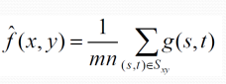

**hw5_q1.m**:  
N = 150;

M = 160;

f=zeros(N,M);

for i = 1:N

for j = 1 : M

if mod(i, 7) == 0 && mod(i, 2) ~= 0

f(7:140,i:i+7) = 1;

end

end

end

%Arithmetic mean

filter = fspecial('average', 3);

g = imfilter(f,filter);

imshow(g,'InitialMagnification','fit')

**Results**:

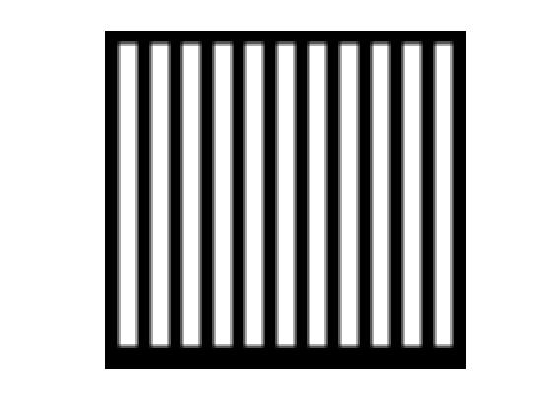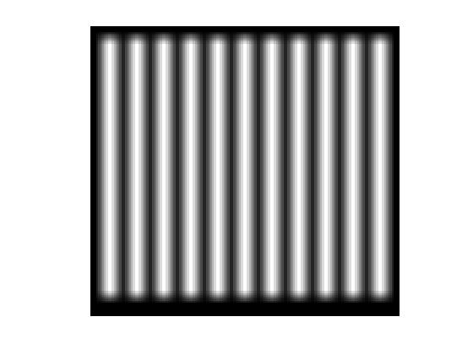

3x3 Mean Filter; Some Blurring. 7x7 Mean Filter; More Blurring.

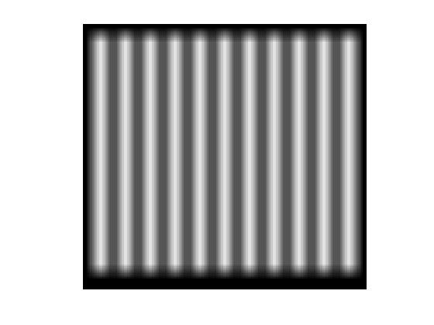

9x9 Mean Filter; Most Blurring.

1. **Geometric Filter**

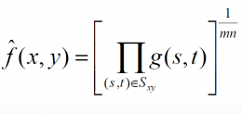

**(a)** When the 3x3 filter is applied, there should be little change to the original image since the weight of the polynomial 1/mn is small.

**(b)** When the 7x7 filter is applied, there should be some detail lost. The details lost here would make the white lines smaller.

**(c)** When the 9x9 filter is applied, significant details would be lost. Additionally, the image would be very blurry similar to the output from the 9x9 arithmetic mean filter. However, even more detail would be lost.

**3. Harmonic Mean Filter**

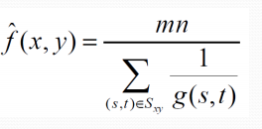

**(a)** When the 3x3 filter is applied, it will affect the white portion of the image but only slightly. This is because the harmonic mean filter handles salt noise well but not pepper.

**(b)** When the 7x7 filter is applied, the failure of pepper is more apparent. More of the white rectangle will be lost.

**(c)** When the 9x9 filter is applied, even more detail is lost. There will be more black than white.

**4. Contraharmonic Mean Filter (Q = 1)**

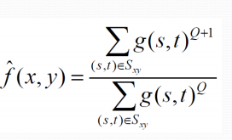

**(a)** When the 3x3 filter is applied, the white portions of the image will be affected. When Q = 1, the pepper noise will be affected which changes the black portions near the white portions

**(b)** When the 7x7 filter is applied, the change between black and white are more noticeable. Less black around the white parts of the image.

**(c)** When the 9x9 filter is applied, the white portions of the image should be larger than the original image.

**5. Contraharmonic Mean Filter (Q = -1)**

When Q = -1, this will act as a harmonic filter.

**6. Median Filter**

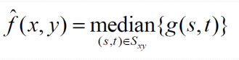

**(a)** When the 3x3 filter is applied, the median filter replaces the pixel values with the intensity levels that are nearby. Therefore, the corners of the white rectangles will smooth out.

**(b)** When the 7x7 filter is applied, the corner smoothing becomes more apparent. There are no rectangular corners because the median around them are larger than the value zero so there are more white than black.

**(c)** When the 9x9 filter is applied, the image should look the same aside from the corners. The smoothing in every corner will smooth out and the rectangular does not have any sharp lines anymore.

**7. Max Filter**

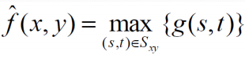

**(a)** When the 3x3 filter is applied, the max filter checks for the largest pixel values or the brightest points on the image. Therefore, the white portions of the image are magnified or their intensities levels increase at surrounding neighborhoods.

**(b)** When the 7x7 filter is applied, the white parts of the image become slightly larger due to the larger filter size

**(c)** When the 9x9 filter is applied, the white parts of the image become larger due to the larger filter size.

**8. Min Filter**

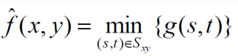

**(a)** When the 3x3 filter is applied, the min filter checks for the smallest pixel values or the darkest points on the image. Therefore, the black portions of the image are magnified or their intensities levels at surrounding neighborhoods.

**(b)** When the 7x7 filter is applied, the dark parts of the image become slightly smaller due to the larger filter size

**(c)** When the 9x9 filter is applied, the dark parts of the image become smaller due to the larger filter size.

**9. Midpoint Filter**

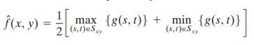

**(a)** When the 3x3 filter is applied, the midpoint filter will take the median of the max and min filter which will combine the characteristics of both filters. For this filter size, the changes are hardly noticeable.

**(b)** When the 7x7 filter is applied, the white portions of the image become larger. However, since the midpoint is applied, that means the min filter is also applied resulting in a “blend” of white and black making the image a combination of black and white due to the averaging of both filters.

**(c)** When the 9x9 filter is applied, the change in the white portion is most noticeable due to the size of the filter. The “blend” effect is most noticeable meaning the white portions are not likely to be white but the median values of the neighboring which is the “blend” effect stated in part (b).