**Digital Image Processing – Homework #9**

**Juan Silva**

**ECE 595**

**November 27, 2019**

1. **Question 10.1**

Prove the validity of Eq. (10.2-1). (Hint: Use a Taylor series expansion and keep only the linear terms.) $$f\left(x+∆x\right) → \sum_{k=0}^{n}{1+x+}\frac{x^{2}}{2!}+…+\frac{x^{n}}{n!} \\ \frac{d}{dx}[f\left(x+∆x\right)] → f\left(x\right)+∆x*f^{'}\left(x\right)+\frac{∆x}{2!}*f^{''}\left(x\right)+… \\ f\left(x+1\right)=f\left(x\right)+\left(1\right)*f^{'}\left(x\right) (where ∆x=1)$$

$$f^{'}\left(x\right)=f\left(x+1\right)-f(x)$$

1. **Question 10.5**Refer to the edge models in Fig. 10.8.  
      
   (a) Suppose that we compute the gradient magnitude of each of these models using the Prewitt operators in Fig. 10.14. Sketch what a horizontal profile through the center of each gradient image would look like.   
   (b) Sketch a horizontal profile for each corresponding angle image

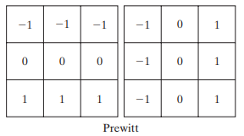

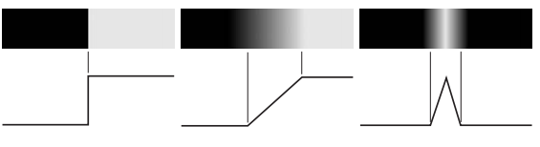

 

1. There will be a sharp transition from black to white at the peak for the peak magnitude.
2. The slope of the magnitude will have a gradual change resulting in a gray, not white, transition.
3. There is a sharp peak for the triangle peaks. At the tip of the triangle, there is a darker transition.

**Question 10.6**

Consider a horizontal intensity profile through the middle of a binary image that contains a step edge running vertically through the center of the image. Draw what the profile would look like after the image has been blurred by an averaging mask of size with coefficients equal to For simplicity, assume that the image was scaled so that its intensity levels are 0 on the left of the edge and 1 on its right. Also, assume that the size of the mask is much smaller than the image, so that image border effects are not a concern near the center of the horizontal intensity profile

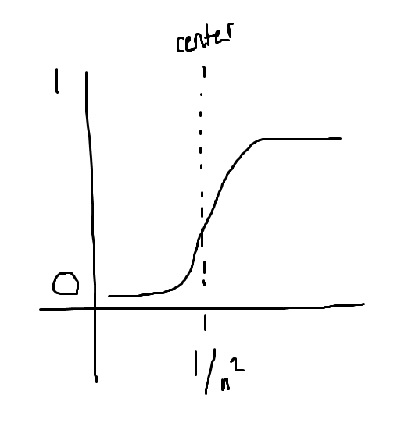

**Question 10.7**

Suppose that we had used the edge models shown in the next page, instead of the ramp model in Fig. 10.10. Sketch the gradient and Laplacian of each profile.

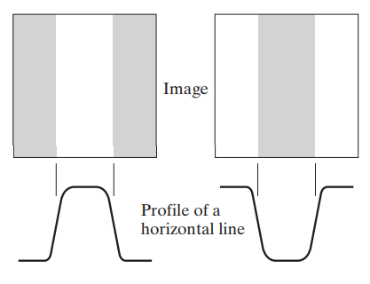

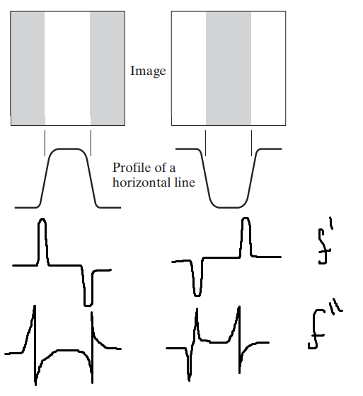

**Question 10.8**  
  
(a) Assume that the Sobel masks are used to obtain and Show that in this case the magnitude of the gradient computed using Eqs. (10.2-10) and (10.2-20) give identical results. (b) Show that this is true also for the Prewitt masks.

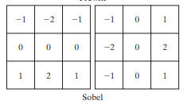

The gradiant for the vertical Sobel operators will result in a result of zero. The magnitude of this gradient in the vertical axis and the horizontal axis will both result in zero. The total magnitude of the Sobels will be the magnitude of both the vertical and horizontal. This also applies for the Prewitt masks.