**Digital Image Processing – Chapter 2 HW**

**Juan Silva**

**ECE 595**

**Sept. 17, 2019**

**2.1** Using the background information provided in Section 2.1, and thinking purely in geometric terms, estimate the diameter of the smallest printed dot that the eye can discern if the page on which the dot is printed is 0.2 m away from the eyes. Assume for simplicity that the visual system ceases to detect the dot when the image of the dot on the fovea becomes smaller than the diameter of one receptor (cone) in that area of the retina. Assume further that the fovea can be modeled as a square array of dimensions and that the cones and spaces between the cones are distributed uniformly throughout this array.  
  
Given distance of the dot and the focal area is 17 mm, the diameter can be solved:

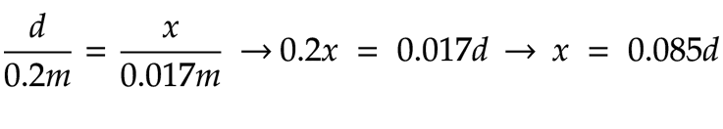

Given that amount of cones is 33700, the dimension size is a square array of 580x580. A dot will take on spot in the array. Then, the size of the array will be the dimension over available squares in L and W. The diameter will be a position within a defined range:

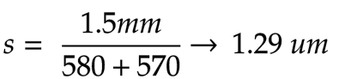

**2.7** Suppose that a flat area with center at is illuminated by a light source with intensity distribution Assume for simplicity that the reflectance of the area is constant and equal to 1.0, and let If the resulting image is digitized with k bits of intensity resolution, and the eye can detect an abrupt change of eight shades of intensity between adjacent pixels, what value of k will cause visible false countouring?

**i(x, y) = Ke^-[(x-x0)^2 + (y - y0)^2]**

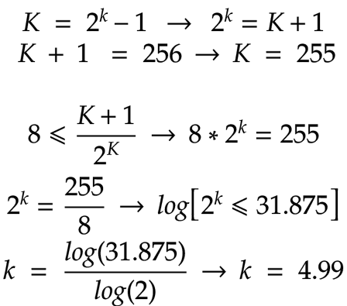

**2.8** Sketch the image in Problem 2.7 for 2.9 A common measure of transmission for digital data is the baud rate, defined as the number of bits transmitted per second. Generally, transmission is accomplished k = 2.

**hw3.m:**

clear, clc, close all

format short, format compact

K = 255;

x = -5:0.1:5;

y = -5:0.1:5;

y0 = 0;

x0 = 0.01;

z = K .* exp(-(((x-x0).^2)+((y-y0).^2)));

**Results:**

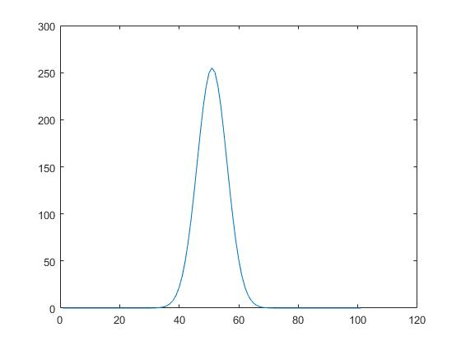

**2.9** A common measure of transmission for digital data is the baud rate, defined as the number of bits transmitted per second. Generally, transmission is accomplished in packets consisting of a start bit, a byte (8 bits) of information, and a stop bit. Using these facts, answer the following:

(a) How many minutes would it take to transmit a image with 256 intensity levels using a 56K baud modem?

(b) What would the time be at 3000K baud, a representative medium speed of a phone DSL (Digital Subscriber Line) connection?

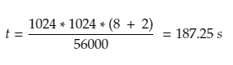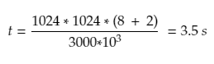

**2.9** (a) With reference to Fig. 2.31, sketch the set   
 (A /\ B) U (A U B)’  
 (b) Give expressions for the sets shown shaded in the following figure in terms of sets A, B, and C. The shaded areas in each figure constitute one set, so give one expression for each of the three figures.

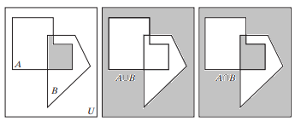

(A /\ B /\ C)   
(B /\ C) U (A U B’) U (A /\ C)  
(A /\ C) U (B /\ A’)