**Digital Image Processing – Homework #7**

**Juan Silva**

**ECE 595**

**November 6, 2019**

1. **Question 8.5**

A 8-bit image with 5.3 bits / pixel entropy [computed from its histogram using Eq. (8.1-7)] is to be Huffman coded.   
 (a) What is the maximum compression that can be expected?  
 (b) Will it be obtained?   
 (c) If a greater level of lossless compression is required, what else can be done?  
  
The maximum compression will be a ratio by the number of bits over the entropy value: $C= \frac{8}{5.3} → 1.509$  
 . Therefore, this will not be obtained because over 33% of the image will be lost to image redundancy. $R= 1-\frac{1}{1.509} → 0.337$. One way to reduce repeating values is taking different, non-redundant values in the neighborhood before applying the Hoffman code.

1. **Question 8.8**(a) How many unique Huffman codes are there for a three-symbol source?   
   (b) Construct them.

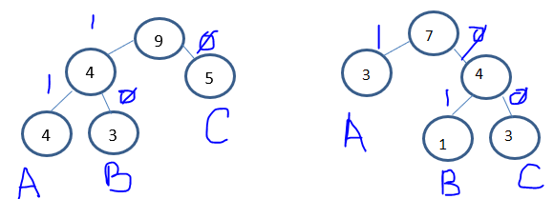

|  |  |  |
| --- | --- | --- |
|  | **Left Side** | **Right Side** |
| **A** | 11 | 1 |
| **B** | 10 | 01 |
| **C** | 0 | 00 |

1. **Question 8.10**Using the Huffman code in Fig. 8.8, decode the encoded string 0101000001010111110100.

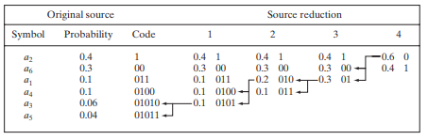

01010 00 00 1 0101011 1 1 1 0100

$$a_{3} a_{6} a_{6} { a}_{2} { a}_{5} a_{2} a_{2} a_{2} a_{4}$$

The decoded string is $a_{3}a_{6}a_{6}a_{2}a_{5}a_{2}a_{2}{a_{2}a}_{4}.$

1. **Question 8.22**  
     
   (a) Construct the entire 4-bit Gray code.   
   (b) Create a general procedure for converting a Gray-coded number to its binary equivalent and use it to decode 0111010100111.

|  |  |
| --- | --- |
| **0** | 0000 |
| **1** | 0001 |
| **2** | 0011 |
| **3** | 0010 |
| **4** | 0110 |
| **5** | 0111 |
| **6** | 0101 |
| **7** | 0100 |
| **8** | 1100 |
| **9** | 1101 |
| **10** | 1111 |
| **11** | 1110 |
| **12** | 1010 |
| **13** | 1011 |
| **14** | 1001 |
| **15** | 1000 |

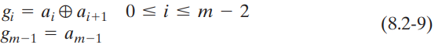

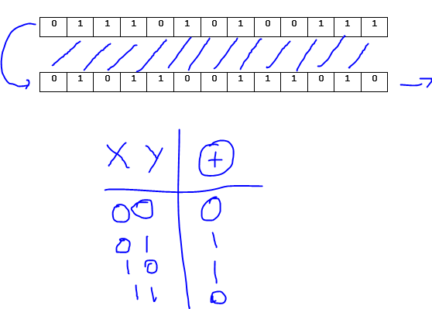

The binary equivalent of 0111010100111 will

equal to 0101100111010.