Assignment 4

Juan Silva

ECE 309

Feb. 21, 2018

***Problem Set 7***

**Problem Set 7-1:**

Generate a plot for the decaying exponential:

s(t) = sin(4πt)exp(-t), for t values from 0 to 1 sec.

t = 0:0.001:1;

s = sin(4*pi*t) .* exp(-t);

plot(t,s), xlabel('t'),ylabel('s(t)')

grid, title('Exponential Decay')

**Results**

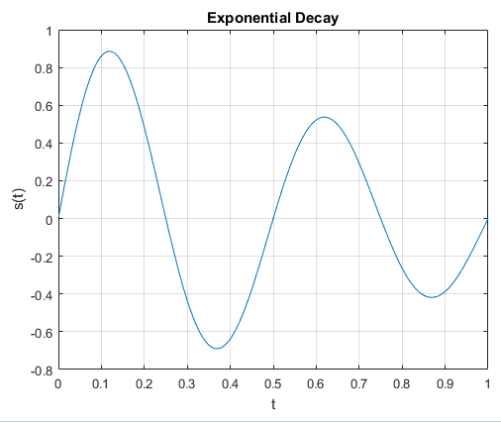

**Problem Set 7-2:**

Plot y(t)= t^3 and z(t)= t^(1/3), for 0 ≤t ≤2, on a single graph. Make the plot for *z* a dashed line, and the plot for *y* a solid line.

t = 0:0.001:2;

y = t.^3;

z = t.^(1/3);

plot(t,y,t,z,'--')

xlabel('t'), ylabel('f(t)');

grid, title('Mathematical Functions');

legend('y(t)', 'z(t)')

**Results**

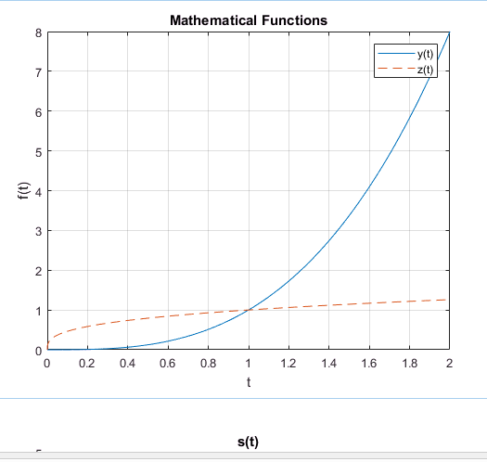

**Problem Set 7-3:**

Plot s(t) = e^(t/2), and w(t) = sin(2pt), for 0 ≤ t ≤ p, one underneath the other on a single page. Use circles for the data points for s, with no line connecting the points. Use triangles for the data points for w, with a solid line connecting the points.

t = linspace(0, pi, 100);

s = exp(t/2);

w = sin(2*pi*t);

subplot(2,1,1), plot(t,s,'o')

grid, title('s(t)');

subplot(2,1,2), plot(t,w,'-^')

grid, title('w(t)'); figure

**Results**

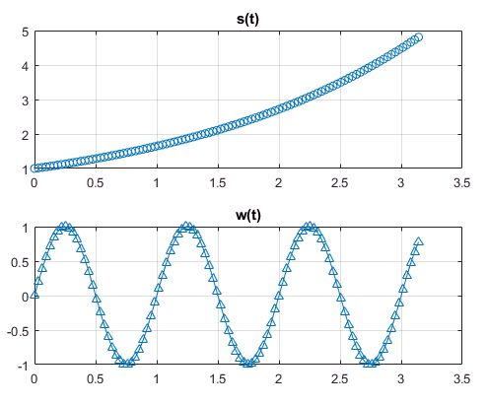

**Problem Set 7-4:**

Recall that the x and y coordinates for a point on a circle of radius r, at angle q, are: x = r cos(q),y = r sin(q). To plot a circle of radius 5:

% a. Create a vector containing 100 q-values, linearly spaced

% between 0 and 2pi.  
v = linspace(0, 2*pi,100);

% b. Create a vector of corresponding x values (one for each value of q)

% and another vector of corresponding y values (one for each value of q),

% assuming that the radius of the circle is 5.

x = 5 * cos(v);

y = 5 * sin(v);

% d. Generate a plot of (x, y) values. After your plot command, insert the

% command: axis(‘equal’) to make the scaling on the x and y axes identical (to avoid distortion of the circle).

plot(x,y)

title('Circle with Radius 5')

axis('equal')

figure

**Results**

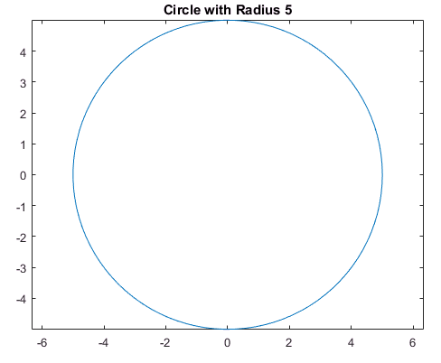

**Problem Set 7-5:**

Plot the function y = 10x, for x values ranging from 0 to 4, using a linear scale on the x-axis and a log scale on the y-axis.

x = linspace(0,4,100);

y = 10.^x;

semilogy(x,y), grid

title('Function y(x)')

**Results**

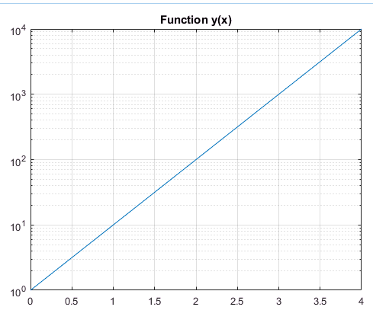

**Problem Set 7-6:**

Generate a vector x containing 20 points, logarithmically spaced, between 1 and 10,000. Plot y = ln(x), using a log scale on both the x and y axes.

x = logspace(1,4,20); % 1 - 10^4; 20 spaces

y = log(x);

loglog(x,y), grid

title('y = ln(x)')

**Results**

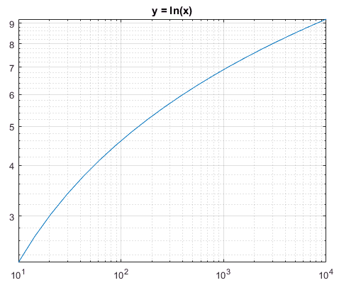

**Problem Set 7-7:**

% 7a. For integer values of n ranging from 0 to 8, plot the discrete data set:

% x[n] = ln(n)  
n = [0:8];  
x = log(n);  
stem(n,x)

% 7b. Generate another plot for the data given in 7a, with the data circles filled in.

m = [0:8];

y = log(m);

stem(m,'ro', 'filled')

**Results**

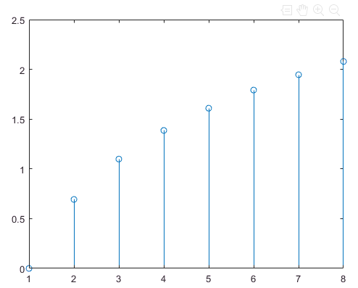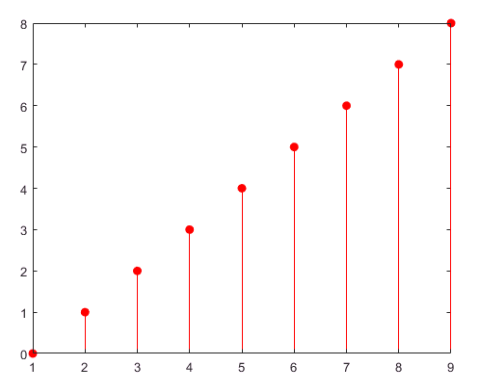

**Problem Set 7-8:**

Recall that the RC filter has transfer function: H(f) = (1 + 2*pi*f*R*C)^-1. For frequencies ranging from f = -200 KHz to 200 KHz, with R = 10 KΩ and C = 1 µF, plot the magnitude and phase angle for the transfer function, on one plot, with the left vertical axis showing |H(f)|, and the right vertical axis showing the phase angle, in radians.

% Program Name: graphs.m

% Author: Juan Silva Last Modified: Feb. 20, 2018

% Description: This program will graph the transfer function using plotyy in order to graph two separate plots into one graph.

clear, clc, close all

format short, format compact

% *** Define variables ***

R = 10e3; %kΩ

C = 1e-6; %µF

% *** Start Code ***

f = linspace(-200e3, 200e3, 200);

h = (1 + j*2*pi*f*R*C).^-1;

magH = abs(h); %Produce magnitude

angH = angle(h); %Produce angle in radians

% Magnitude is left side

plotyy(f,magH,f,angH)

grid

title('RC Filter - Transfer Function');

legend('Magnitude', 'Angle (in radians)')

xlabel('Frequency (in Hz)')

**Results**

