Assignment 5

Juan Silva

ECE 309

Feb. 28, 2018

***Problem Set 8***

**Problem Set 8-1:**

Generate a plot for the signal that is the output of a sample-and-hold circuit, if the samples values: {1, 2.6, 3.4, 5, 8} were taken at fs = ½ sample/sec., starting at t = 0 sec.

fs = [0.5:0.5:2.5];

values = [1 2.6 3.4 5 8];

stairs(fs,values)

axis([0.499 2.6 0 8])

grid

title('Sample-and-Hold Circuit')

xlabel('Sample Values')

ylabel('Time (s)')

**Results**

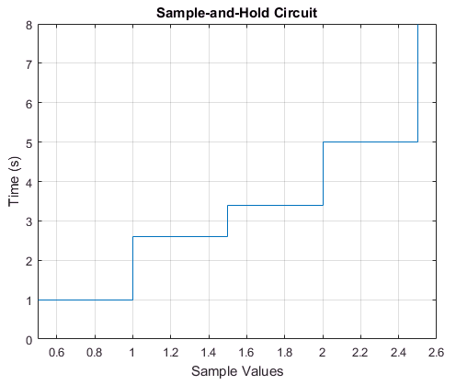

**Problem Set 8-2:**

Use a strip plot to generate 4 seconds worth of data (starting at t = 0), where each “strip” is .5 seconds worth of data, for the AM signal: s(t) {

cos(2pπ100t) + 2} if s(t) is the message signal: s(t) = sin(10πt).

fs = 1000; %sample

ts = 1/fs; %time value

t = [0:ts:4]; %4 seconds of time values

message = sin(10*pi*t); %message frequency

signalFreq = message .* (cos(2*pi*100*t) + 2); %signal frequency

strips(signalFreq, .5, fs); %plot strip

title('AM Waveform')

xlabel('cos(2π100t) + 2')

**Results**

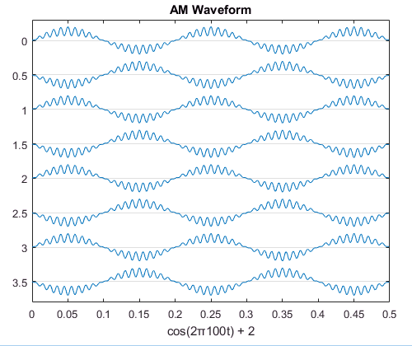

**Problem Set 8-3:**

% 3a. Plot 4 cycles of the square wave with amplitude levels {+2, -2},

% period T = 2 sec., and duty cycle 25% (for the “high” value).

% (Choose a reasonable value for fs.)

fs = 1000; % sample

ts = 1/fs; % sampe time

T = 2; % two seconds

f = 1/T; % frequency

amp = 2; % amplitude

t = 0:ts:8; % time in seconds (4 cycles * 2 seconds)

D = 25; % duty percent

subplot(2,1,1)

sqw = amp .* square(2*pi.*f.*t, D);

plot(t,sqw);

ylim([-2.5 2.5])

grid

title('Square Waves with Variable Amplitude Levels')

% 3b. Repeat problem 3a, but change the amplitude levels to {0, 2}.

subplot(2,1,2)

sqw2 = (sqw + 2) / 2;

plot(t,sqw2);

ylim([-0.5 2.5])

grid

xlabel('4 cycles')

figure

**Results**

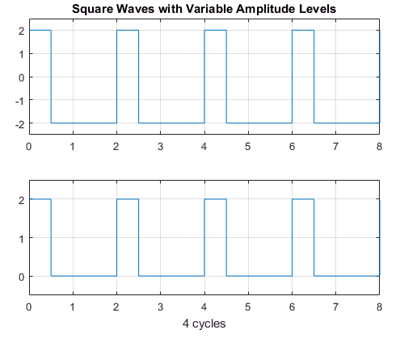

**Problem Set 8-4:**

Plot 5 cycles of a triangular (sawtooth) wave, where the peak is at the end of the cycle, and the period is T = .2 sec. (Choose a reasonable value for fs.)

fs = 1000;

ts = 1/fs;

T = 0.2;

f = 1/T;

t = 0:ts:1;

k = 1; %default value

saw = sawtooth(2*pi*f.*t, k);

plot(t,saw);

grid

title('Sawtooth Wave')

xlabel('5 cycles')

figure

**Results**

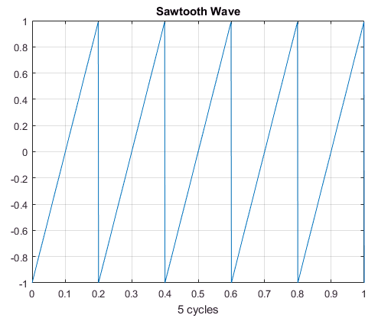

**Problem Set 8-5:**

Use MATLAB’s repmat function to plot a discrete sequence with 6 repetitions of: {0, 1, 2, 3, 4}, starting at n = 0.

A = [0:4]

B = repmat(A,1,6)

**Results**

A =

0 1 2 3 4

B =

0 1 2 3 4 0 1 2 3 4 0 1 2 3 4 0 1 2 3 4 0 1 2 3 4 0 1 2 3 4

**Problem Set 8-6:**

Use logical switches to plot the function shown:

fs = 8192;

ts = 1/fs;

t = 0:ts:2;

sw1 = (t < 0.5);

sw2 = (t >= 0.5) & (t < 1.5);

sw3 = (t >= 1.5);

x = sw1 .* sin(6*pi.*t) + sw2 * 0 + sw3 .* sin(6*pi.*t);

plot(t,x)

grid  
title('Function With Logical Switches')

**Results**

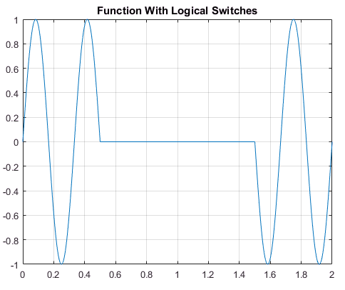

**Problem Set 8-7:**

Consider the matrix pascal(6). Make a 2-column table showing the row and column for all entries in this matrix that are greater than 50. Hint: Type: >> help pascal, and >> help find.

A = pascal(6)

[row, column] = find(A > 50);

display(' row column')

display([row, column])

**Results**

A =

1 1 1 1 1 1

1 2 3 4 5 6

1 3 6 10 15 21

1 4 10 20 35 56

1 5 15 35 70 126

1 6 21 56 126 252

row column

6 4

5 5

6 5

4 6

5 6

6 6

**Problem Set 8-8:**

Use MATLAB’s stairs function to generate the plot below. (If you have had ECE 350, you may recognize this as the window: u(t) –u(t –3).) Use the same scales for the axes as shown.

t = [-2:5];

values = [0 0 1 1 1 0 0 0];

stairs(t,values)

axis([-2 5 -0.5 1.5])

grid

title('Stairs Function')

figure

**Results**

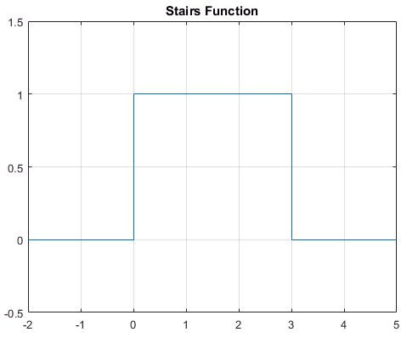

% 8b. Create an array 'U' implementing the expression u(t)-u(t-3). Use

% Comparison switches (<, >, etc.) as it was demonstrated in the classroom.

U = [-2:0.01:5];

sw2 = (u > 0) - (u - 3 > 0);

plot(u, sw2)

axis([-2 5 -0.5 1.5])

grid

title('U(t) - U(t-3)')

**Results**

