Assignment 8

Juan Silva

ECE 309

April 11, 2018

***Problem Set 8***

Objective: Given a simplified model of a DC motor with some mechanical load and input/output requirements:  
  
 1. Simulate a feedback controlled system

2. Export results to MATLAB

3. Write a single script to display results in several graphs

4. Analyze results (observations)

***Armature Schematic***

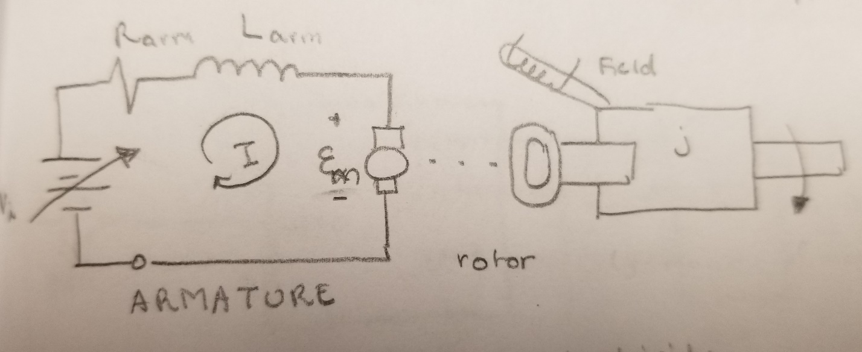  
  
***Differential Equations***

Position: $IR_{a}+L\frac{ⅆI}{ⅆt}+ε_{m}-V_{i}=0$

$\frac{ⅆI}{ⅆt}=\frac{1}{L}{(V}_{i}-ε_{m}+IR_{a} )$

Speed: $j\frac{d^{2}Θ}{ⅆt^{2}}+B\frac{dΘ}{ⅆt}=T$

$\frac{d^{2}Θ}{ⅆt^{2}}=\frac{1}{j}(T-B\frac{dΘ}{ⅆt})$

***Simulink Block Diagram Inside DC Motor Subsystem***

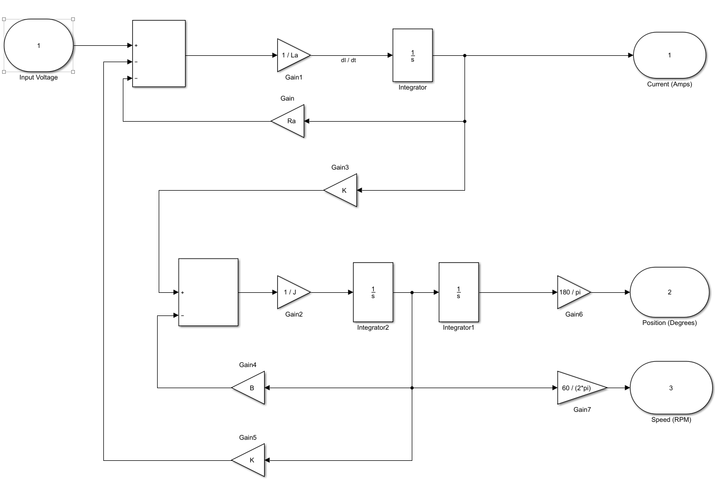

**Main Script**

% Program Name: Assignment8.m

% Author: Juan Silva Last Modified: April 10, 2018

% Description: This program will utilize a simplified model of a DC motor to explore some functions of Simulink software. This is done by constructing the DC motor in Simulink and export the results to this program. This script will assign values for the simulation and graph the exported results.

% ***************************************************************************  
% Assignment8_case1.m   
%

% Case 1: System without Position and Speed feedback (Controller Gain = 1)

%

% Input = 0 to 10 volts (Step waveform)

% Validate your model:

% a)Confirm that Time Constant at 63% of Current (I) plot is identical to L/R

% b)Confirm that slope of Position plot(RPM)is identical to Speed plot (RPM)

% c)Show your hand calculations. In addition, show all MATLAB cursors on the

% plots.

% d)Do the three plots (Current, Position, and Speed) make sense? Why or why

% not? Please explain.

% ***************************************************************************

%Elements in circuit

Ra = 10; %resistor (Ω)

La = 0.5e-3; %inductor (mH)

B = 0.1; %damping ratio (Nm/rad/S)

J = 0.01; %moment of inertia (Nm/rad/S^2)

K = 0.1; %EMF and torque constant (Kt = Ke = K)

Step = 0; %step time value

FV = 10; %final value for step time

lim = 5 * (La/Ra); %limit to smooth x-axis

FromSimulink = sim('Assignment8', 'StopTime', '2'); %Starts simulation

FromSimulink.who;

FromSimulink.Case1;

Time = FromSimulink.tout;

Voltage = FromSimulink.Case1(:,1);

Current = FromSimulink.Case1(:,2);

Postion = FromSimulink.Case1(:,3);

Speed = FromSimulink.Case1(:,4);

%Produce graphs

subplot(2,1,1)

title('Case 1 - System w/o Positon and Feedback')

yyaxis left

plot(Time, Voltage)

ylabel('Voltage (Volts)')

yyaxis right

plot(Time, Current)

xlabel('Time (sec)')

ylabel('Current (Amps)')

xlim( [0 lim])

subplot(2,1,2)

yyaxis left

plot(Time, Postion)

ylabel('Position (degrees)')

yyaxis right

plot(Time, Speed)

xlabel('Time (sec)')

ylabel('Speed (RPM)')

***Simulink Block Diagram For Case 1***

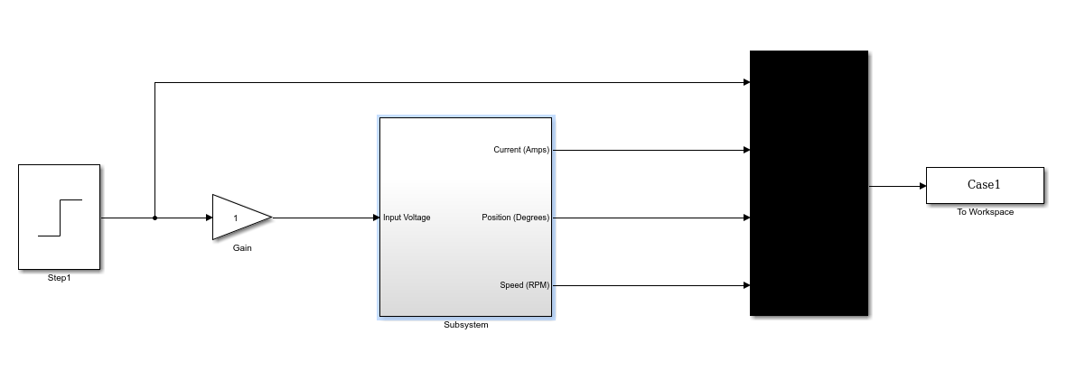

***Graph for Case 1***



**Discussion**

According to the top graph, the time at 63% of current matches the value $τ =\frac{L}{R}.$  
  
*Given the equation $τ= k_{t}ⅈ,$ we see the relationship between current and tao being equal to each other.

$$τ=\frac{0.5*{10}^{-3}}{10}=0.00005$$

According to the bottom graph, two plots were chosen to calculate the slope of the position. This slope is converted to RPM and the value is compared to the speed plot. Therefore, the position slope proves that the motor shaft is increasing at the rate of the speed.

$$slope=\frac{y_{2}- y_{1} }{x_{2}- x_{1}}=\frac{45.01 - 41.34 }{0.8924 - 0.8277}=56.66$$

$$RPM= \frac{slope°}{1 sec.}*\frac{60 sec.}{1 min.}*\frac{1 rev.}{360°}=\frac{56.66}{6}=9.45$$

% ***************************************************************************  
% Assignment8_case2.m   
%  
% Case 2: System with Position feedback only (Controller Gain = 0.1):  
% -Apply sufficient input voltage(Step waveform)such that motor shaft will   
% move 2.5 revolutions from its starting (reference) position and stop   
% -Confirm that output response(Position)is stable and reaches 2.5   
% revolutions, exponentially.  
% -Record Time Constant at 63% of Position plot. In addition, show all MATLAB   
% cursors on the plots.  
% -Gradually increase Controller Gain and record your observations (change in % Time Constant, Rise % Time, Overshoot, and Oscillations)  
% -Do the two plots (Position and Speed) make sense? Why or why not? Please   
% explain.  
% ***************************************************************************

clear, clc, close all

format compact, format short

%Elements in circuit

Ra = 10; %resistor (Ω)

La = 0.5e-3; %inductor (mH)

B = 0.1; %damping ratio (Nm/rad/S)

J = 0.01; %moment of inertia (Nm/rad/S^2)

K = 0.1; %EMF and torque constant (Kt = Ke = K)

Step = 0; %step time value

FV = 900; %final value for step time

FromSimulink = sim('Assignment8', 'StopTime', '15'); %Starts simulation

FromSimulink.who;

FromSimulink.Case2;

Time = FromSimulink.tout;

Voltage = FromSimulink.Case2(:,1);

Current = FromSimulink.Case2(:,2);

Direction = FromSimulink.Case2(:,3);

Speed = FromSimulink.Case2(:,4);

%Produce graphs

subplot(2,1,1)

title('Case 2 - System w/ Position Feedback Only')

yyaxis left

plot(Time, Voltage)

ylabel('Voltage (Volts)')

yyaxis right

plot(Time, Current)

xlabel('Time (sec)')

ylabel('Current (Amps)')

subplot(2,1,2)

yyaxis left

plot(Time, Direction)

ylabel('Position (degrees)')

yyaxis right

plot(Time, Speed)

xlabel('Time (sec)')

ylabel('Speed (RPM)')

***Simulink Block Diagram For Case 2***

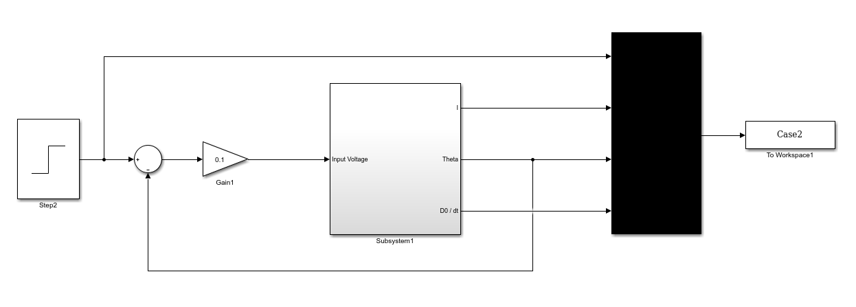

***Graph for Case 2***



**Discussion**To confirm that the position has moved 2.5 revolutions, we convert the revolutions to degrees:

$1 rev=360°$ $2.5 rev=\left(2*360°\right)+\left(0.5*360°\right)=900°$

According to the top graph, the position reaches 900 $°$ and stops. At 63% of the position, we see the value of tao equal 1.753 s.

* When the gain gradually increases to 0.5, $τ$ equals 0.3844. As a result, the oscillation stabilizes  
  sooner at about 0.3 s compared to 6 s. There was no overshoot and stabilize at 900 $°$.
* When the gain increases to 1.0, $τ$ equals 0.2248. As a result, the oscillation becomes unstable and rises at about 0.7 s compared to 6 s.

% ***************************************************************************  
% Assignment8_case3.m   
%  
% Case 3: System with Speed feedback only (Controller Gain = 1):   
% -Input = 0 to 10 volts (Step waveform)  
% -Confirm that output response(Speed)is stable and reaches a steady state   
% value, exponentially. Record Time Constant at 63% of Speed plot. In   
% addition, show all MATLAB cursors on the plots.  
% -Gradually increase Controller Gain and record your observations (change in   
% Time Constant, Rise Time, Overshoot, and Oscillations)  
% -Do the two plots (Position and Speed) make sense? Why or why not? Please   
% explain.  
% ***************************************************************************

clear, clc, close all

format compact, format short

%Elements in circuit

Ra = 10; %resistor (Ω)

La = 0.5e-3; %inductor (mH)

B = 0.1; %damping ratio (Nm/rad/S)

J = 0.01; %moment of inertia (Nm/rad/S^2)

K = 0.1; %EMF and torque constant (Kt = Ke = K)

Step = 0; %step time value

FV = 10; %final value for step time

lim = 10 * (La/Ra);

FromSimulink = sim('Assignment8', 'StopTime', '2'); %Starts simulation

FromSimulink.who;

FromSimulink.Case3;

Time = FromSimulink.tout;

Voltage = FromSimulink.Case3(:,1);

Current = FromSimulink.Case3(:,2);

Direction = FromSimulink.Case3(:,3);

Speed = FromSimulink.Case3(:,4);

subplot(2,1,1)

title('Case 3 - System w/ Speed Feedback Only')

yyaxis left

plot(Time, Voltage)

ylabel('Voltage (Volts)')

yyaxis right

plot(Time, Current)

xlabel('Time (sec)')

ylabel('Current (Amps)')

xlim( [0 lim])

legend('Voltage', 'Current')

subplot(2,1,2)

yyaxis left

plot(Time, Direction)

ylabel('Position (degrees)')

yyaxis right

plot(Time, Speed)

xlabel('Time (sec)')

ylabel('Speed (RPM)')

legend('Position', 'Speed')

***Simulink Block Diagram For Case 3***

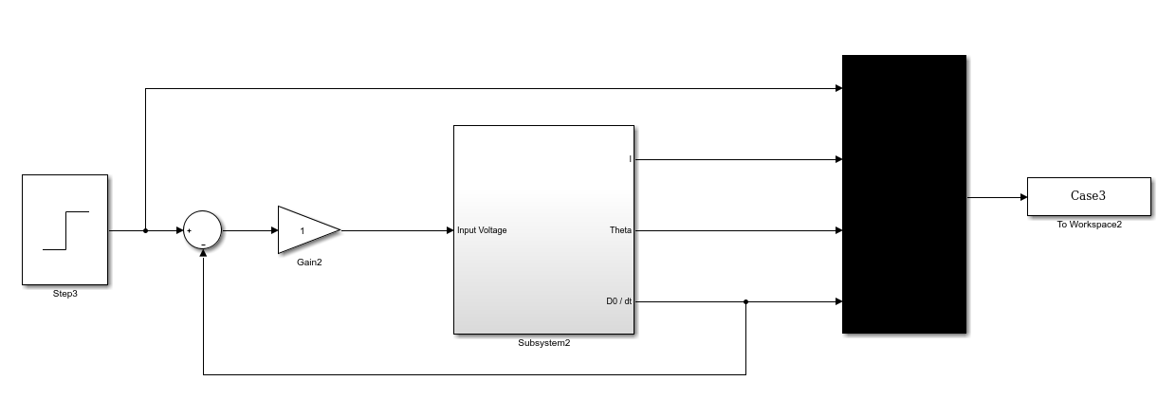

***Graph for Case 3***



**Discussion**

Speed is stable and reaches a steady state value of 4.86 RPM. At 63% of the speed plot, t = 0.05073.

* When the gain gradually increases to 2.0, $τ$ equals 0.03. As a result, the oscillation remains stable, no overshoot occurs, and the rise increases sooner at about 0.034 s.
* When the gain increases to 5.0, $τ$ equals 0.01723. As a result, the oscillation remains stable, no overshoot occurs, and the rise occurs at 0.1 s.

% ***************************************************************************  
% Assignment8_case4.m   
%  
% Case 4: System with both Position & Speed feedback  
% -Input = 0 to 10volts(Step waveform)  
% -Adjust Controller Gain such that Time Constant of Position plot < 0.2   
% Seconds  
% -Confirm that output response(Position)is stable and reaches a steady state % value, exponentially. Record Time Constant(?)at 63 of Position plot. In   
% addition, show all MATLAB cursors on the plots  
% -Do the two plots (Position and Speed) make sense? Why or why not? Please   
% explain  
% ***************************************************************************

clear, clc, close all

format compact, format short

%Elements in circuit

Ra = 10; %resistor (Ω)

La = 0.5e-3; %inductor (mH)

B = 0.1; %damping ratio (Nm/rad/S)

J = 0.01; %moment of inertia (Nm/rad/S^2)

K = 0.1; %EMF and torque constant (Kt = Ke = K)

Step = 0; %step time value

FV = 10; %final value for step time

lim = 10 * (La/Ra);

FromSimulink = sim('Assignment8', 'StopTime', '3'); %Starts simulation

FromSimulink.who;

FromSimulink.Case4;

Time = FromSimulink.tout;

Voltage = FromSimulink.Case4(:,1);

Current = FromSimulink.Case4(:,2);

Direction = FromSimulink.Case4(:,3);

Speed = FromSimulink.Case4(:,4);

subplot(2,1,1)

title('Case 4 - System w/ Both Position & Speed feedback')

yyaxis left

plot(Time, Voltage)

ylabel('Voltage (Volts)')

yyaxis right

plot(Time, Current)

xlabel('Time (sec)')

ylabel('Current (Amps)')

xlim( [0 lim])

legend('Voltage', 'Current')

subplot(2,1,2)

yyaxis left

plot(Time, Direction)

ylabel('Position (degrees)')

yyaxis right

plot(Time, Speed)

xlabel('Time (sec)')

ylabel('Speed (RPM)')

legend('Position', 'Speed')

***Simulink Block Diagram For Case 4***

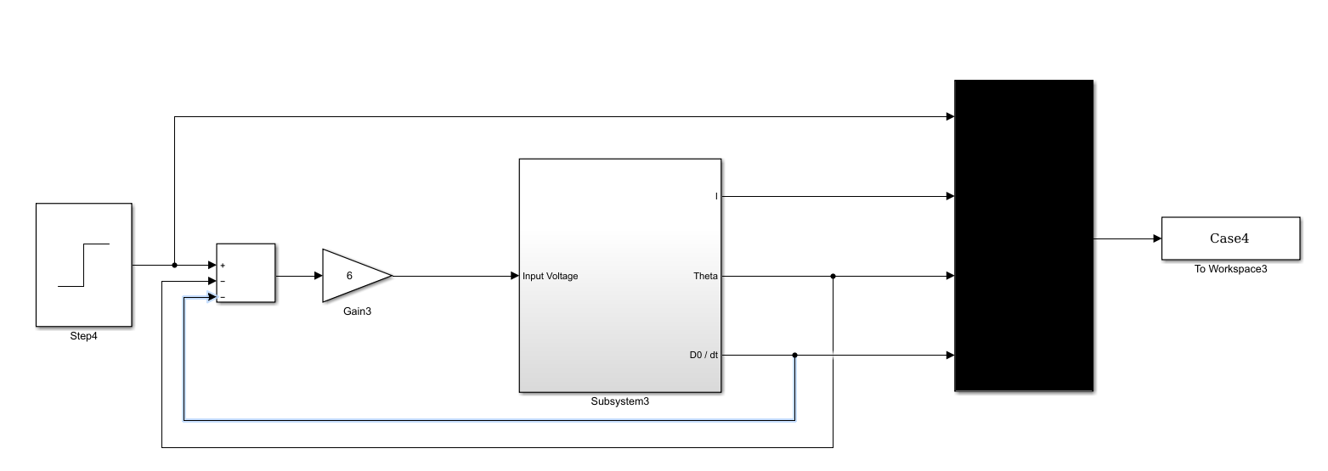

***Graph for Case 4***



**Discussion**  
When the gain is set to 6, the time constant $τ$ is less than 0.2 s. Position is stable and reaches a steady state value of 10 RPM. At 63% of the speed plot, t = 0.1974.

% ***************************************************************************  
% Assignment8_case5.m   
%

% Case 5: Remove Speed feedback from step 4 above  
% -Record your observations (change in Time Constant, Rise Time, Overshoot,   
% and Oscillations  
% -Do the two plots (Position and Speed) make sense? Why or why not? Please   
% explain.

% ***************************************************************************

clear, clc, close all

format compact, format short

%Elements in circuit

Ra = 10; %resistor (Ω)

La = 0.5e-3; %inductor (mH)

B = 0.1; %damping ratio (Nm/rad/S)

J = 0.01; %moment of inertia (Nm/rad/S^2)

K = 0.1; %EMF and torque constant (Kt = Ke = K)

Step = 0; %step time value

FV = 10; %final value for step time

lim = 10 * (La/Ra);

FromSimulink = sim('Assignment8', 'StopTime', '1'); %Starts simulation

FromSimulink.who;

FromSimulink.Case5;

Time = FromSimulink.tout;

Voltage = FromSimulink.Case5(:,1);

Current = FromSimulink.Case5(:,2);

Direction = FromSimulink.Case5(:,3);

Speed = FromSimulink.Case5(:,4);

subplot(2,1,1)

title('Case 5 - Remove Speed feedback')

yyaxis left

plot(Time, Voltage)

ylabel('Voltage (Volts)')

yyaxis right

plot(Time, Current)

xlabel('Time (sec)')

ylabel('Current (Amps)')

xlim( [0 lim])

legend('Voltage', 'Current')

subplot(2,1,2)

yyaxis left

plot(Time, Direction)

ylabel('Position (degrees)')

yyaxis right

plot(Time, Speed)

xlabel('Time (sec)')

ylabel('Speed (RPM)')

legend('Position', 'Speed')

***Simulink Block Diagram For Case 5***

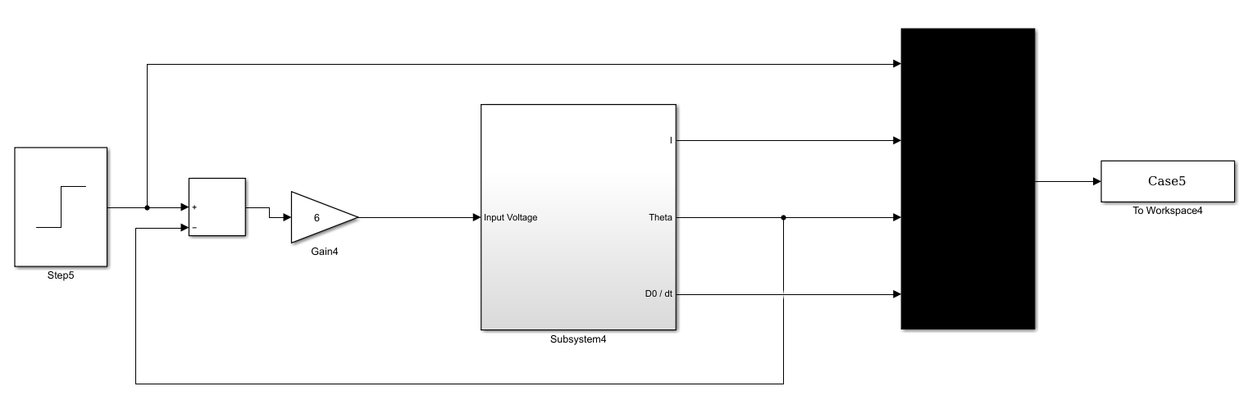

***Graph for Case 5***



% ***************************************************************************  
% Assignment8_case6.m   
%% Case 6: Add Transducer [which converts degrees to volts] with gain of 10   
% degrees/volt to the position feedback in case 5.  
% -Apply sufficient input voltage (Step waveform) such that motor shaft will   
% move 15 degrees from its starting (reference) position and stop.

% ***************************************************************************

clear, clc, close all

format compact, format short

%Elements in circuit

Ra = 10; %resistor (Ω)

La = 0.5e-3; %inductor (mH)

B = 0.1; %damping ratio (Nm/rad/S)

J = 0.01; %moment of inertia (Nm/rad/S^2)

K = 0.1; %EMF and torque constant (Kt = Ke = K)

Step = 0; %step time value

FV = 12.25; %final value for step time

lim = 10 * (La/Ra);

FromSimulink = sim('Assignment8', 'StopTime', '2'); %Starts simulation

FromSimulink.who;

FromSimulink.Case6;

Time = FromSimulink.tout;

Voltage = FromSimulink.Case6(:,1);

Current = FromSimulink.Case6(:,2);

Direction = FromSimulink.Case6(:,3);

Speed = FromSimulink.Case6(:,4);

subplot(2,1,1)

title('Case 6 - Add Transducer')

yyaxis left

plot(Time, Voltage)

ylabel('Voltage (Volts)')

yyaxis right

plot(Time, Current)

xlabel('Time (sec)')

ylabel('Current (Amps)')

xlim( [0 lim])

legend('Voltage', 'Current')

subplot(2,1,2)

yyaxis left

plot(Time, Direction)

ylabel('Position (degrees)')

yyaxis right

plot(Time, Speed)

xlabel('Time (sec)')

ylabel('Speed (RPM)')

legend('Position', 'Speed')

***Simulink Block Diagram For Case 6***

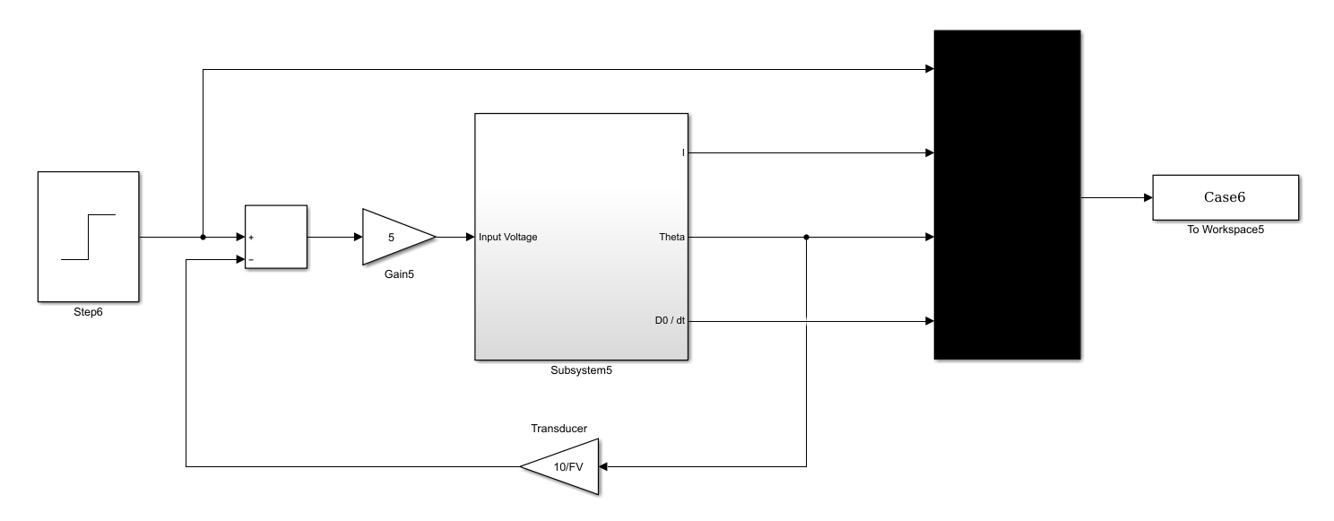

***Graph for Case 6***

