# 

***Whispers of the American West: Desert Rain God***

**Level Design Document**

Written by: Theresa Devine and Richard Griffin

Version: *v2.0*

Date:*02/24/2021*



Copyright 2018-2021 *Studio 4 Game Innovation*. All Rights Reserved.

Do not Duplicate or Distribute without the express permission of the copyright holder.

This document is considered to be CONFIDENTIAL and PRIVATE.

# TABLE OF CONTENTS

TABLE OF CONTENTS 2

version HISTORY 4

01.00.00 4

02.00.00 4

Introduction 5

CONCEPTUAL DEVELOPMENT 5

WORLD DIAGRAM 7

OVERVIEW OF LEVEL DESIGN (RAIN PAINTER) 7

LEVEL DESIGN DIAGRAM 7

Mission DESIGN List 9

ACCESSIBILITY & Use 9

INCLUSION 9

GAME REQUIREMENTS 9

USER CHARACTERISTICS 10

USER OBJECTIVES 10

USE CASE DIAGRAM 10

USE CASE NARRATIVE (Game Start) 11

USE CASE NARRATIVE (Main Menu) 12

USE CASE NARRATIVE (Games State 3) 12

USE CASE NARRATIVE (Games State 4) 12

USE CASE NARRATIVE (Options) 13

VISUAL ARCHITECTURE 13

AESTHETICS 13

COLOR THEORY 14

BUTTON MAP 14

USER INTERFACE 14

NAVIGATION HIERARCHY*.* 15

Screen [x.1] 15

ENVIRONMENT DESIGN 15

VISUAL CHARACTER DESIGN (Little Rain God) 16

sonic ARCHITECTURE 18

SOUND EFFECTS: STINGERS 18

SOUND EFFECTS: TAGS 18

MUSIC: INTRO 18

MUSIC: LOOP 18

MUSIC: TRANSITION 18

SOFTWARE gameplay ARCHITECTURE 18

LOGICAL VIEW 19

DATA VIEW 19

LOCALIZATION 19

INSTRUMENTATION VIEW 20

SECURITY VIEW 20

# version HISTORY

*About version numbers:*

*XX.YY.ZZ format*

*XX – major revisions, new sections, complete section revisions*

*YY – revisions to existing sections, major and minor*

*ZZ – small corrections, typos, grammar, formatting, etc.*

## 01.00.00

Written by Avin Thai, Maedsyn Matthews, Ian McGonigle, Rinaldo Del Gallo

*Added*: Initial Documentation

*Software Gameplay Architecture, Sonic Architecture, Visual Architecture, Accessibility and Use, Introduction*

## 02.00.00

Added Conceptual Development section

# Introduction

*Louisa McElwain was fascinated by the way light changes when a storm comes. This will reflect in visual changes as the avatar collects raindrops. Moving left, right, and jumping is meant to emulate what the painter feels as she creates/ adds light to the piece.*

## CONCEPTUAL DEVELOPMENT

Treaties still in effect today: Treaty of 1868 with the Dine (who we know as Navajo). 4 defining mountains, Blanca Peak (Sis Naajini); Mount Taylor (Tsoodzil); San Francisco Peaks (Dook’oosliid); Mount Hesperus (Dibe Nitsaa)

Sunny Dooley: Do we focus on the atom bomb testing? Yes. Article XI of the Treaty

<https://bombshelltoe.com>

<http://johnnyhozho.blogspot.com/2012/07/hozho-dine-concept-of-balance-and.html>

Richard Griffin mechanic: Change the position of the sun and use the sunlight to reveal objects and using shadows to hide obstacles.

* Example: rain cloud becomes atomic bomb mushroom cloud. (Ultimate reveal: wink and nudge to Jonathan Blow’s Braid)

Games that matches perspective as mechanic: Luna, Superliminal, Devil May Cry 5 (Hidden quests: complete symbols to reveal a hidden level [Watchdog QR codes in game serve as lock and actually go to a webpage]), Braid and The Witness,

<https://www.youtube.com/watch?v=_SX8XMwMw6Y>

## Art that shifts perspective: [Shigeo Fukuda](https://www.spoon-tamago.com/2015/08/03/illusionistic-shadow-art-by-shigeo-fukuda/)

<https://www.spoon-tamago.com/2015/08/03/illusionistic-shadow-art-by-shigeo-fukuda/>

|  |
| --- |
| Read through treaty on 03-17 |
| Is this culturally ignorant? 5th. They will never kill or scalp white men, nor attempt to do them harm  Article X – sexist  Long walk? |
| Email to Richard on 03-15 |
| [https://americanindian.si.edu/nk360/navajo/treaty/treaty.cshtml](https://urldefense.com/v3/__https:/americanindian.si.edu/nk360/navajo/treaty/treaty.cshtml__;!!IKRxdwAv5BmarQ!MhMvAsehS37uMRoite4yKIZkOexffNCAoy0kJYX3KEx0vK_JCwpywlrE9Xjb-AyUjWuCOzE$)  [https://www.americanindianmagazine.org/story/naal-tsoos-sani](https://urldefense.com/v3/__https:/www.americanindianmagazine.org/story/naal-tsoos-sani__;!!IKRxdwAv5BmarQ!MhMvAsehS37uMRoite4yKIZkOexffNCAoy0kJYX3KEx0vK_JCwpywlrE9Xjb-AyU2xdlTws$)  [https://www.smithsonianmag.com/smart-news/historic-treaty-has-been-returned-navajo-180972358/](https://urldefense.com/v3/__https:/www.smithsonianmag.com/smart-news/historic-treaty-has-been-returned-navajo-180972358/__;!!IKRxdwAv5BmarQ!MhMvAsehS37uMRoite4yKIZkOexffNCAoy0kJYX3KEx0vK_JCwpywlrE9Xjb-AyUtIkrG0c$)  [https://www.azcentral.com/story/news/local/arizona/2019/05/30/copy-1868-treaty-returns-navajo-nation/1278298001/](https://urldefense.com/v3/__https:/www.azcentral.com/story/news/local/arizona/2019/05/30/copy-1868-treaty-returns-navajo-nation/1278298001/__;!!IKRxdwAv5BmarQ!MhMvAsehS37uMRoite4yKIZkOexffNCAoy0kJYX3KEx0vK_JCwpywlrE9Xjb-AyUPaEIop0$)    and the actual treaty  [http://www.uintahbasintah.org/usdocuments/doc33.pdf](https://urldefense.com/v3/__http:/www.uintahbasintah.org/usdocuments/doc33.pdf__;!!IKRxdwAv5BmarQ!MhMvAsehS37uMRoite4yKIZkOexffNCAoy0kJYX3KEx0vK_JCwpywlrE9Xjb-AyUsEjlwmE$)    money value (there are payments in regards to agricultural progress in the treaty)  100.00 in 1868 = 1852.21 today  [https://www.officialdata.org/us/inflation/1868?amount=100](https://urldefense.com/v3/__https:/www.officialdata.org/us/inflation/1868?amount=100__;!!IKRxdwAv5BmarQ!MhMvAsehS37uMRoite4yKIZkOexffNCAoy0kJYX3KEx0vK_JCwpywlrE9Xjb-AyUQmBKGus$)  10 dollars in 1868 = 185.22 today  [https://www.officialdata.org/us/inflation/1868?amount=10](https://urldefense.com/v3/__https:/www.officialdata.org/us/inflation/1868?amount=10__;!!IKRxdwAv5BmarQ!MhMvAsehS37uMRoite4yKIZkOexffNCAoy0kJYX3KEx0vK_JCwpywlrE9Xjb-AyUgLUxPfU$)  there is a lot to digest. Not sure what I want to focus on for the puzzle design. I am going to need a week to let it settle in. |

Prior to 03-17-2021

|  |
| --- |
| Central Mountains  Gobernador Knob (Ch’ool’i’i)  Huerfano Mountain (Dzil Na’oodilii)  Magic in the landscape (appearing mountain experience, Devine); Hidden pathways that are revealed via exploration. Certain landscape features offer unique perspective that specifically reveal these pathways. (Griffin)  Historical amnesia - lands that were not ceded and are occupied today.  Extinction to force people into submission. Historical trauma is all of ours.  Games to research (Richard Griffin)   1. Tear Down – every object can be destroyed. Security is airtight. The only way to succeed is to tear things down. Pathing out exactly where to go and which vehicles to use. Time trial – but manipulation of the environment is more important 2. Creeper World 4 – 3D strategy game. You can see everything on the map (perfect information). Like chess think ahead a couple of moves. Prediction and judgement The only imperfect information is how some of the enemies will react at the beginning of the game. Focused on the landscape rather than the opposing forces in the game. 3. Quadrilateral Cowboy – manipulating technology. Spy tools and heist items needed. Moving train, building with windows, crevices, cameras to avoid (turn off), doors need to be opened from a switch from inside, shoot steam with pipes that you need to close. It is about positioning yourself. It is about being in the right place at the right time. 4. Keep talking and nobody explodes – communication puzzle game. The challenge of the game is not solving the puzzle but communicating how to solve the puzzle. Non-zero sum. 5. Betrayal at House on the Hill (board game) – kind of procedurally generated with tiles. At some point in the game, someone will become the villain. It starts out non-zero sum and becomes zero-sum. The goal is then either escape or defeat the villain.   <https://youtu.be/pwHqY_4nsJ4>  <https://en.wikipedia.org/wiki/Eiji_Aonuma>  <https://www.zeldadungeon.net/check-out-this-video-exploring-the-zelda-series-puzzle-box-dungeons/>  Hiding and showing parts of the vegetation to create the puzzle and solution.  Look up the Treaty of 1868. |

|  |
| --- |
| Thoughts to begin (before research) Nikki Sanchez |
| Collecting broken treaties? How can broken treaties be collected? The opposite of bugsnax – look at the hardship –then given the reward.  This history is not your fault. But it is your responsibility.  Acknowledge the indigenous territories that we live on. Colonization is a messy and violent history that connects us all.  Learn whose land you live on and what has been done to them to allow you to occupy these lands.  What treaties are important and why?  What system of oppression is still alive today because of that broken treaty?  What action be taken today? |

<https://paulduran.com/about-santa-fe/general/history/zuni_hopi/>

Shalako is a Zuni ceremony occurring during the first week of December. The participants have been practicing all year to perform their duties, seven new houses have been built to welcome the Shalakos (the Giant Couriers of the Rainmakers) and the Longhorns (Rain Gods of the North), and an enormous amount of food is prepared for both residents and visitors. Shalako brings the old year to a close and welcomes the new year, and asks for rain, the propagation of plants and animals, and the health and well being of its participants. It is also a reenactment of various important tribal myths.

Source: iaia_mocna_manifestations_curriculum_guide.pdf

<https://iaia.edu/mocna/mocna-education/>

https://search.proquest.com/docview/2407600736?pq-origsite=gscholar&fromopenview=true

"I feel that the doll is alive and has a soul when I start carving it," Cecil said. "I don't put the eyes on a doll until I am finished painting it. I tell it that I don't want it to see itself until I am almost finished. When I am carving, the dolls don't really talk to me, but I have a feeling that they do. At night I don't leave my unfinished dolls in the carving room which is outside the house. I bring them into the house with the rest of the family as they are part of the family and are being brought to life. When I am finished carving I say 'Kwakwai,' thank you." (Bassman 1994)

<http://eddiebashacollection.com/collection/cecil-calnimptewa>

collect-a-thon – collect clouds to create a storm to usher in the new year. Bricks for the houses, food for the feast.

Of the many learning outcomes one may strive for in American Indian studies, this guide will focus on a select few. The knowledge that the indigenous peoples of the Americas continue to live, survive and thrive in contemporary society is the key premise this guide will seek to convey to learners. This contemporary presence is further enhanced by the assertion of a Native intelligence – a way of knowing that may encompass or even exceed the terms and patterns that we have come to associate with American Indian identities, cultures and histories to date. These assertions – contemporaneous identity and intellectual complexity - apply to American Indians and First Nations peoples whose physical appearances, forms of art and various locations present in a vast constellation of patterns. Established notions of “Indianness” - Indian art and people as limited in time and place - restrict our collective competency as members of a diverse society. This guide will introduce learners to the background, skills and attitudes that will enhance their ability to speak knowledgeably about contemporary indigenous realities

The only relevant Rain God amongst the New Mexico Native American Tribes is the Navajo god Coyote. (Not related to the Aztec Huehuecoyotl) [https://en.wikipedia.org/wiki/Coyote_(Navajo_mythology)]

Other tribes, mostly the Pueblo tribes, do not have a common Rain God. Queries for these gods result in pottery and art.

<https://www.ebay.com/itm/Native-American-Old-Tesuque-Rain-God-CA-1960s-/353203923224>

<https://www.pinterest.com/pin/547046685988810990/>

<https://www.adobegallery.com/art/tesuque-pueblo-rain-god-figurine-with-large-vessel>

<https://www.ebay.com/itm/Tesuque-Pueblo-Pottery-Rain-God-Figurine-c1900-Slip-painted-details-/183511570084>

*https://www.amnh.org/exhibitions/totems-to-turquoise/educator-resources/web-list-native-americans-of-the-southwest-myths-and-cultural-information*

*https://native-land.ca/*

*https://paulduran.com/about-santa-fe/general/history/zuni_hopi/*

*https://en.wikipedia.org/wiki/Hopi_mythology*

[*https://paulduran.com/about-santa-fe/general/history/zuni_hopi/*](https://paulduran.com/about-santa-fe/general/history/zuni_hopi/)

*Not your run of the mill collect-a-thon*

*Environmental narrative*

*Puzzle narrative with collectables*

## WORLD DIAGRAM

*This will be provided by the overarching hub of the virtual art gallery.*

## OVERVIEW OF LEVEL DESIGN (RAIN PAINTER)

*This is from the Game Design Document.*

|  |  |  |
| --- | --- | --- |
| Level 18:  Plot Point: N/A | **Goal: Collect 200 raindrops in 2 minutes**  Rules: traverse maps  Mechanic: left and right to maneuver, space to jump | **Challenge: uncover the painting**  Strategy: move forward  Tactics: evade tumbleweeds and lightning |

*.*

## LEVEL DESIGN DIAGRAM

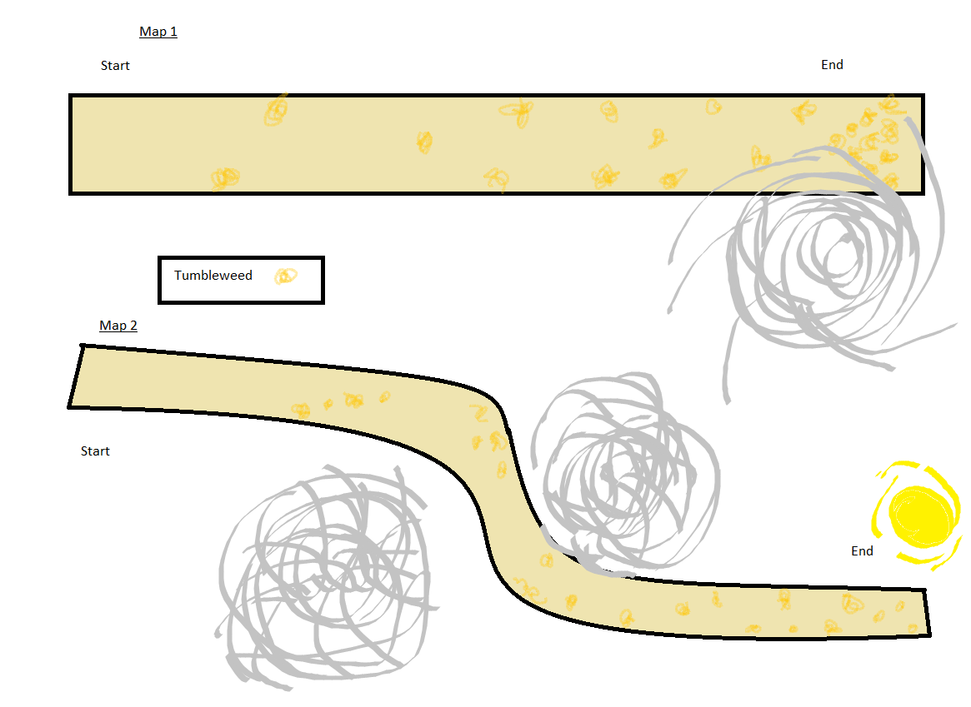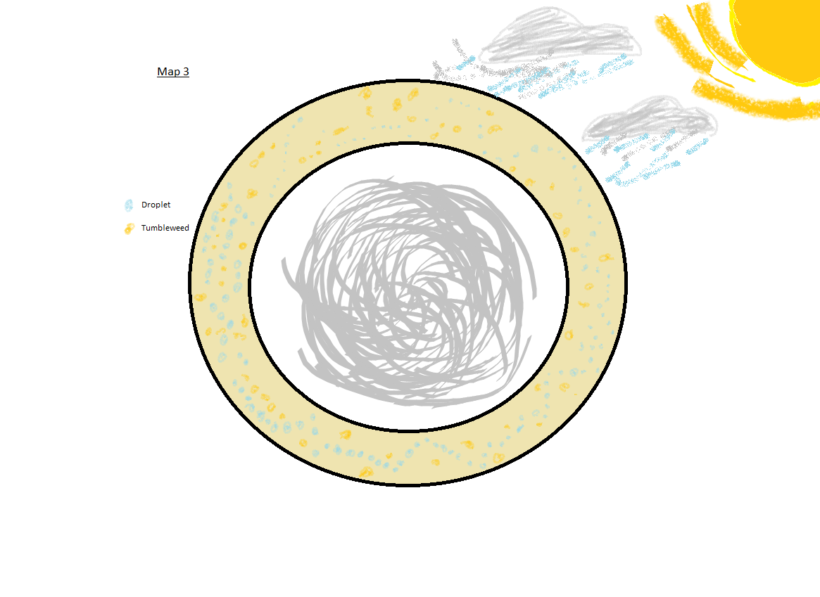

## Mission DESIGN List

|  |  |
| --- | --- |
| Name of Mission | Name of Mission Design Document |
| Road | Level Design Diagram 1 and 2 |
| The Storm | Level Design Diagram 3 |

# ACCESSIBILITY & Use

*From the Game Design Document.*

*According to these guidelines:* [*http://gameaccessibilityguidelines.com*](http://gameaccessibilityguidelines.com) *how will your game be made accessible to the greatest number of abilities? Write the goals for accessibility the general inclusion strategies here.*

## INCLUSION

|  |  |  |
| --- | --- | --- |
| Ability | Level (Basic, Intermediate, Advanced) | Strategy for inclusion |
| *Fine Motor* | *Basic* | *We will ensure controls are as simple as possible.* |
| *Large Motor* | *Basic* | *We will ensure controls are as simple as possible.* |
| *Cognitive* | *Basic* | *We will ensure the use of an easily readable default font size. We will use clear language.* |
| *Vision* | *Basic* | *We will ensure the use of an easily readable default font size.* |
| *Hearing* | *Basic* |  |
| *Speech* | *Basic* | *We will ensure that speech input is not required.* |
| *General* | *Basic* | *Given the limited development time, additional difficulty levels will not be considered. The game will not be made to be difficult to complete. Further general accessibility will be dependent on the abilities given to us by Coregames.* |

## GAME REQUIREMENTS

*These are the requirements for the game that will become the traceability matrix and will help the team communicate who are working on the game, there is a scoping meeting with the team to determine which requirements will be built and which will be in the next release or iteration of the project. Add a row for each requirement to this table.*

|  |  |  |  |  |
| --- | --- | --- | --- | --- |
| Done  (Y/N) | # | Requirement Description | Originator of Req. | Scope (In/Out) |
| N | 1 | The player shall be able to interact with the raindrops, thunder, and other collidable objects. | Ray | Out |
| N | 2 | The painting will be able to change color based on the player’s progress. | Ray | Out |

## USER CHARACTERISTICS

*Users are anyone who interacts with the game in some way. Some examples have been filled in to guide you. Delete or add as needed.*

|  |  |  |
| --- | --- | --- |
| How many? | Title | Description of Characteristics |
| 1-16 | Casual players | Some of them are part time (easily distracted by shiny things). These players are able to complete the task given without too much unnecessary difficulty |
| 0-16 | Experienced players | They are further along in their understanding of the game. These users are able to try to beat their best time by improving time management and reflexes when avoiding obstacles |

## 

## USER OBJECTIVES

|  |  |  |
| --- | --- | --- |
| Title | Description of Objectives | Workflow |
| Collect raindrops | Players will run into raindrops to increase score | Ian makes assets, Alvin/Maddy implements in engine |
| Avoid thunder | Players avoid thunder to preserve score. | Ian makes assets, Alvin/Maddy implements in engine |

## USE CASE DIAGRAM

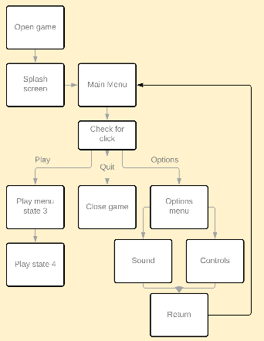

## USE CASE NARRATIVE (Game Start)

*Copy and paste this section for each of the use cases.*

|  |  |
| --- | --- |
| ***Details of the use case actors*** | |
| *Use Case Name:* | Game Start |
| *Primary Actors:* | Player |
| *Secondary Actors:* | Watchers |

*Purpose:*

This use case occurs when a player initiates the game

*Trigger:*

The player or system requires opening the software.

*Pre-conditions:*

Using PC or Mac platform

*Basic Course:*

The splash screen appears and the player chooses to play, quit, or look at options

*Post-Conditions*:

Player enters the state of the game.

*Possible Alternate Flows:*

*Exit out*

## USE CASE NARRATIVE (Main Menu)

*Copy and paste this section for each of the use cases.*

|  |  |
| --- | --- |
| ***Details of the use case actors*** | |
| *Use Case Name:* | Main Menu |
| *Primary Actors:* | Player |
| *Secondary Actors:* | Watchers |

*Purpose:*

Main way for players to interact with the game states.

*Trigger:*

The player finishing the game start condition

*Pre-conditions:*

The player finishing the game start condition

*Basic Course:*

The splash screen appears and the player chooses to play, quit, or look at options

*Post-Conditions*:

Player enters the state of the game.

*Possible Alternate Flows:*

*Exit out*

## USE CASE NARRATIVE (Games State 3)

*Copy and paste this section for each of the use cases.*

|  |  |
| --- | --- |
| ***Details of the use case actors*** | |
| *Use Case Name:* | Games State 3 |
| *Primary Actors:* | Player |
| *Secondary Actors:* | Watchers |

*Purpose:*

The main game is contained in this case.

*Trigger:*

The player entering through the main menu.

*Pre-conditions:*

Requires the player be at the main menu.

*Basic Course:*

The player can play the game.

*Post-Conditions*:

Player goes to the main menu, the player quits, or the player fails the game.

.*Possible Alternate Flows:*

*None*

## USE CASE NARRATIVE (Games State 4)

*Copy and paste this section for each of the use cases.*

|  |  |
| --- | --- |
| ***Details of the use case actors*** | |
| *Use Case Name:* | Games State 4 |
| *Primary Actors:* | Player |
| *Secondary Actors:* | Watchers |

*Purpose:*

This is the game’s failure state.

*Trigger:*

The player failed the game.

*Pre-conditions:*

Requires the player to fail.

*Basic Course:*

The player can exit the game, go to the main menu, or restart the game.

*Post-Conditions*:

Player goes to the main menu, the player quits, or the player starts a new game.

.*Possible Alternate Flows:*

*None*

## USE CASE NARRATIVE (Options)

*Copy and paste this section for each of the use cases.*

|  |  |
| --- | --- |
| ***Details of the use case actors*** | |
| *Use Case Name:* | Options |
| *Primary Actors:* | Player |
| *Secondary Actors:* | Watchers |

*Purpose:*

Main way for players to interact with the game settings.

*Trigger:*

The player entering through the main menu.

*Pre-conditions:*

Requires the player be at the main menu.

*Basic Course:*

The player can alter various provided settings.

*Post-Conditions*:

Player goes to the main menu.

.*Possible Alternate Flows:*

*None*

# VISUAL ARCHITECTURE

## AESTHETICS

*The game is set in McElwain’s painting, so we will be making use of her depth and composition. The foreground is an excellent stage for the player character to move around from side to side and up and down because of the actual subject of the painting. For visual indicators, because the moving elements are designed to match as closely to the painting as possible, there will be a slight glow to indicate to the player what can be interacted with, so as to make it easier to distinguish without losing the impact of the color. For color blind accessibility, The glow indicating objects that can be interacted with will be different in value and texture from the background to prevent any reliance on the color.*

## COLOR THEORY

*In an effort to maintain the vision of McElwain, her palette will be honored in the design of elements the game team adds. Each color is selected to match those present in Desert Rain God so as to match the feeling of majesty with cool deep blues and purples set against the soft warm oranges, yellows, and tans of the desert background. These colors will also serve to make the player character stand out against the background more, as the backdrop will begin as a desaturated brown and beige colors that the little Rain God’s blue and purple tones will stand out against. As the contrast is lessened and the painting becomes more vibrant, it will serve to immerse the player more wholly in the world of the painting.*

**TYPOGRAPHY**

*The font used for the option, raindrop meter, and instructions will be from the Perpetua family of fonts, or a comparable serif font of equal weight that is available for licensing and within the Coregames engine. Perpetua is usable on Microsoft products for personal computer use. This choice was made because this family of fonts is easily readable, particularly as a serifed font, and it isn’t intense enough to distract from the primary focus of the game- the color progression. The backsplash for the raindrops is included to allow for the player to easily locate and then read the raindrop meter, and menus will also be on a backsplash, as the colors of the entire game will shift so much that a simple color difference will not be reliable enough for contrasting text from background. As there are no large blocks of text, rag, widows, and orphans will not be an issue. Additionally, standard kerning will be effective.*

*.*

## BUTTON MAP

**

*Left- move left*

*Right- move right*

*Space- Jump*

## USER INTERFACE

*Simple, Passive interface that is meant more as indicators for the player of how much time, lives, and raindrops they have at any given point during gameplay. Elements that can be interacted with will retain their color and shape throughout the game to keep the player aware of what items they should be looking for.*

## NAVIGATION HIERARCHY*.*

### Screen [x.1]

Options menu allows for the player to control various aspects of the game, from Sound, including music, ambient audio, and button sound adjustment, to Controls which can map controls to different keys, Help, which has instructions, and Return that will bring the player back to the game.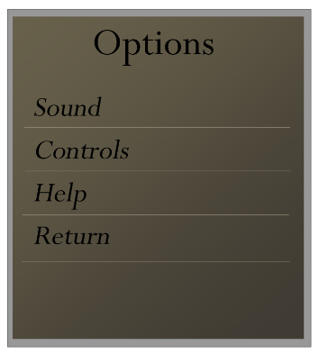

## ENVIRONMENT DESIGN

*We have provided a rough draft below.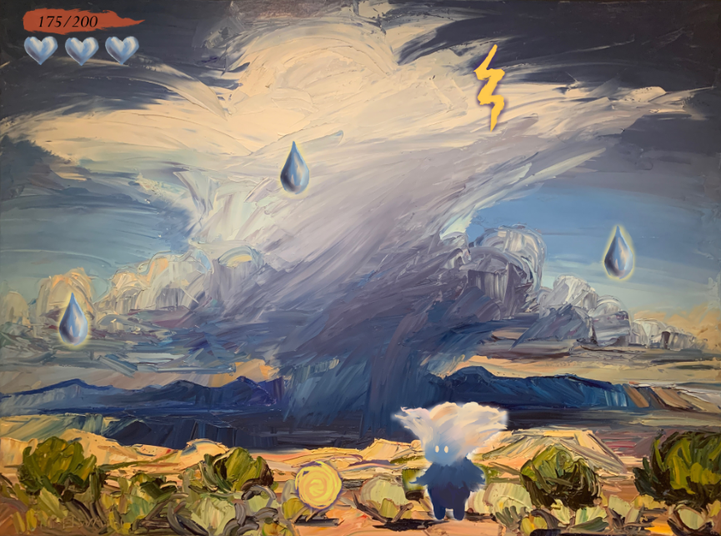*

## VISUAL CHARACTER DESIGN (Little Rain God)

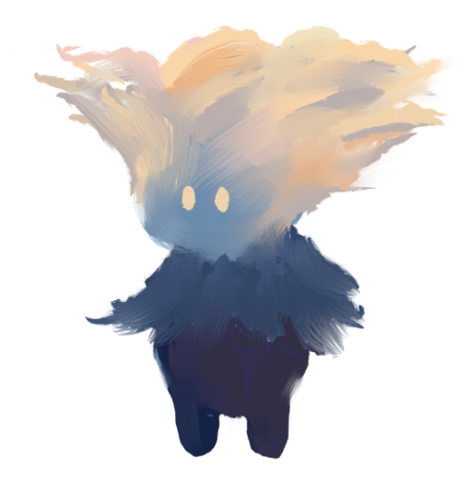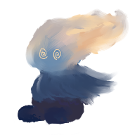

*The Little Rain God will need a walking, jumping, falling, getting up, stun, and hurt animation, with sounds to go with each.*

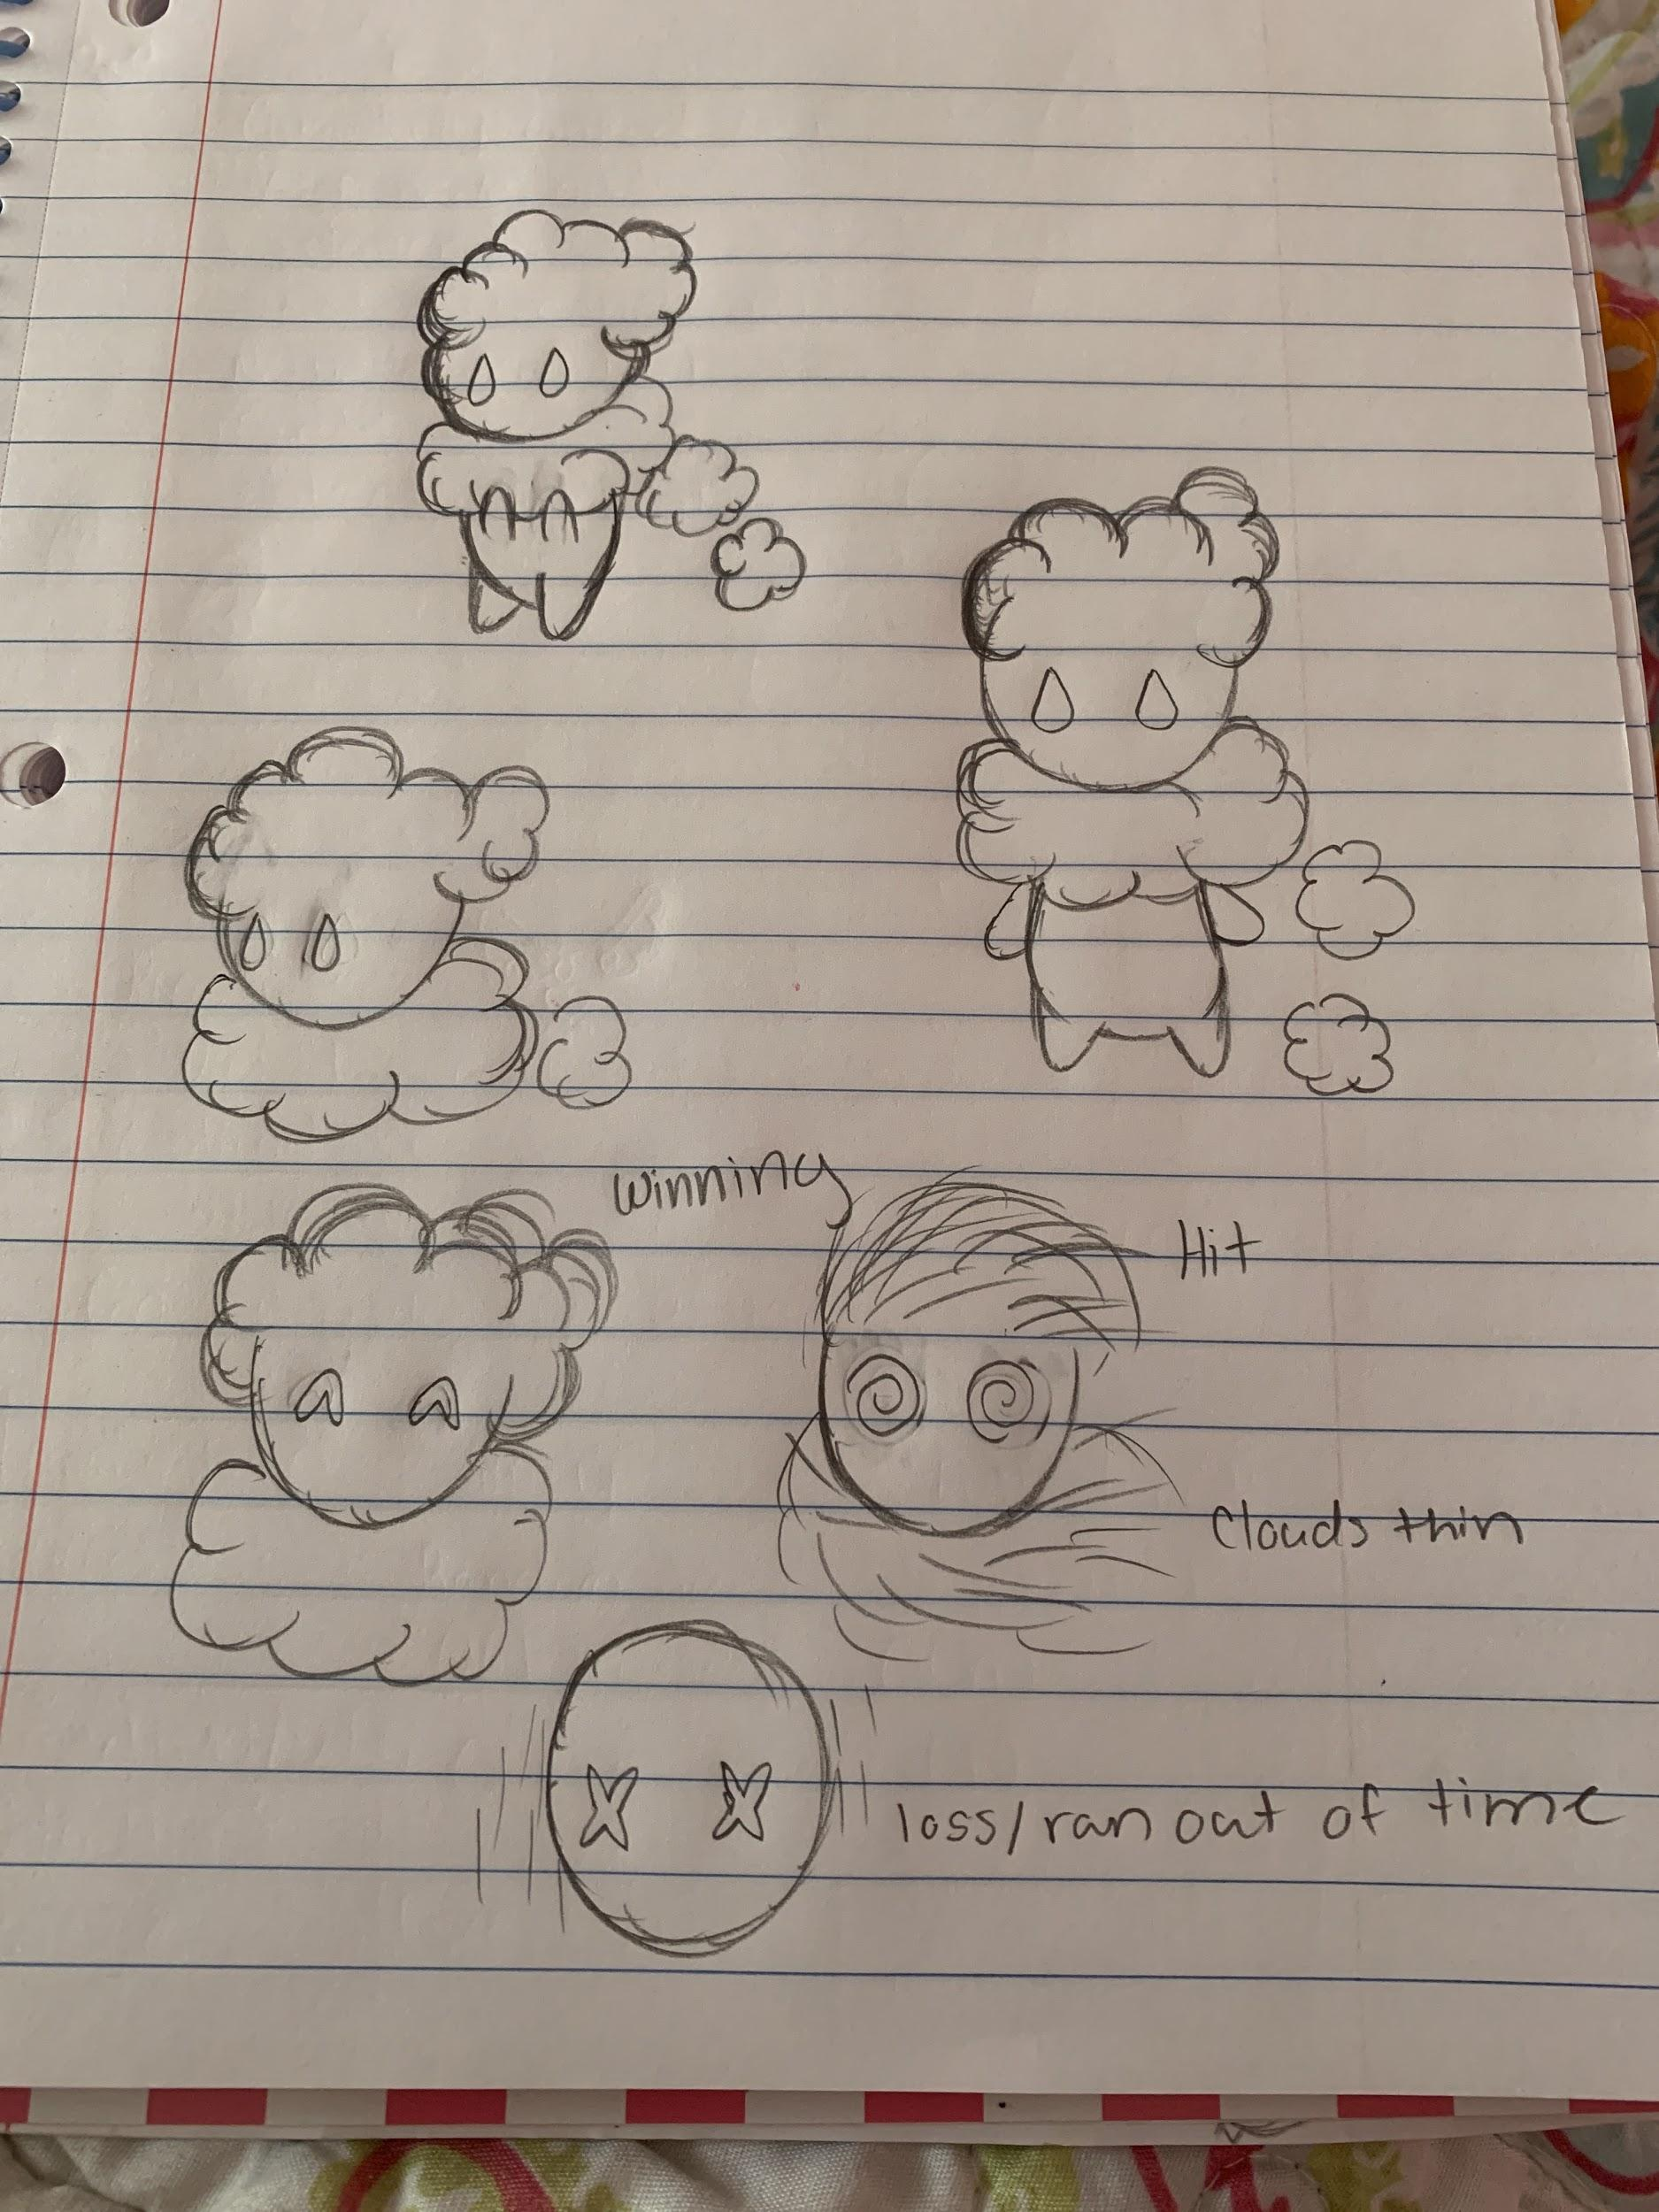

*Concept Art*

# sonic ARCHITECTURE

*Noise from freesound.com can accompany the actions of the avatar when it interacts with its environment. Windows voice recorder are available to capture foley sounds and soundtracks that match the events of game mechanics. Recordings and beats can be organized with Adobe Premiere. When players sit idle too long, a peaceful alternative soundtrack will play.*

## SOUND EFFECTS: STINGERS

*Windy sounds, Thunderclap, Tumbleweed Impact, Collecting Raindrops in a Bucket sound*

## SOUND EFFECTS: TAGS

*Rain on plastic container, Bigger Windy Noises, Shiny sounds for sunshine*

## MUSIC: INTRO

*The Caissons Go Rolling, She’ll be Comin’ Round the Mountain*

## MUSIC: LOOP

*Soundtrack of De Colores, Camptown Races, Tox, Oh Susanna!, and Riding on the Range*

*Peaceful alternate of The Merry Widow Waltz, Fascination*

## MUSIC: TRANSITION

*After a certain number of drops, the first soundtrack plays. After some time of collecting no drops, the peaceful soundtrack comes in.*

# SOFTWARE gameplay ARCHITECTURE

*The game will be made using CORE launcher, an OOAD that drags and drops objects with attributes. 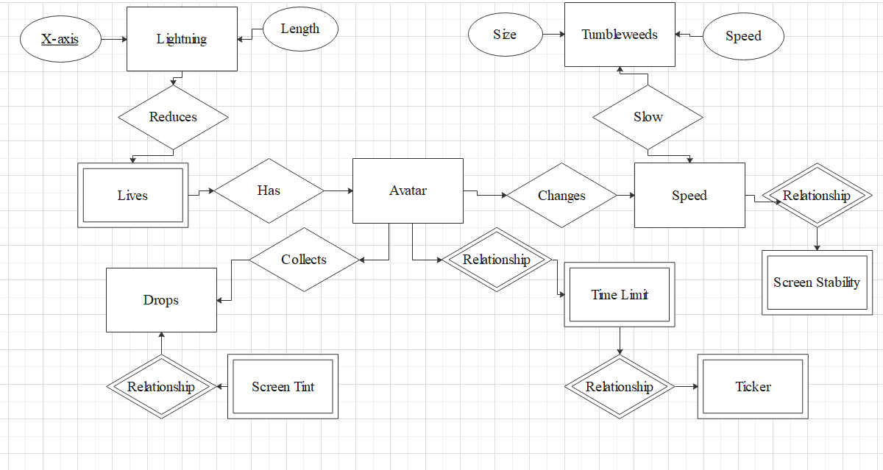*

## LOGICAL VIEW

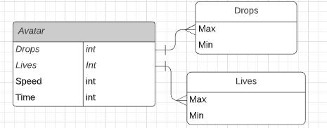

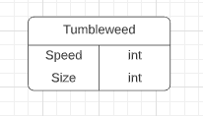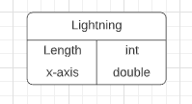

## DATA VIEW

*A relational database that is built in the CORE launcher will be used. This will keep track of numeric values each class uses. The avatar’s speed and health is affected by tumbleweeds and lightning that come into contact with its capsule collider. The number of tumbleweeds and lightning strikes is proportional to drops collected as a storm forms. When the game starts, the avatar has a time limit it can collect raindrops.*

## LOCALIZATION

*The game is available to anyone with virtual museum access worldwide. Adaptations with major languages will be included using translation dictionaries. When publishing the game, it will be usable on Mac, PC, and platform renderings available on CORE.*

## INSTRUMENTATION VIEW

*When creating the project, it will run at intervals to make sure it is working as intended with an IDE. Visual Studio can debug automatically and trace sections of code. Asserts, if-statements, and try-catch statements are usable for exception handling. Profiling can be done with trial and error of different input values. When adjusting colors, hybrid and visual lead can be consulted for desired output. Computer logging should reflect when game objects interact with another by experimenting the game and stimulating for the desired response.*

## SECURITY VIEW

*The game does not require security or memory. Each experience is randomized and the game is short enough that save files are not needed. Hexadecimal mac id filtering can limit the use of this software to museum visitors only.*