# 

***Twenty Objects: The Phoenix Art Museum***

***North Wing Collection Augmented Reality***

***: Desert Rain God***

**Level Design Document**

Written by: Melissa Bridges

Version: 01.00

Date: 09-27-18

|  |  |
| --- | --- |
| phxart.org |  |

Copyright 2018 *Phoenix Art Museum.* All Rights Reserved.

Do not Duplicate or Distribute without the express permission of the copyright holder.

This document is considered to be CONFIDENTIAL and PRIVATE.

# TABLE OF CONTENTS

TABLE OF CONTENTS 2

VERSION HISTORY 3

01.00.00 3

Introduction 4

WORLD DIAGRAM 4

OVERVIEW OF LEVEL DESIGN (Desert Rain God) 4

LEVEL DESIGN DIAGRAM 5

ACCESSIBLITY & Use 5

INCLUSION 5

GAME REQUIREMENTS 5

USER CHARACTERISTICS 6

USER OBJECTIVES 6

DRG USE CASE 7

USE CASE NARRATIVE (Desert Rain God USE CASE) 7

STORY ARCHITECTURE 8

STORY STRUCTURE 8

VISUAL ARCHITECTURE 8

AESTHETICS 8

COLOR THEORY 8

Typography 9

Button Map 9

USER INTERFACE 9

Navigation Hierarchy 9

Screen [x.1] – Aim at picture, wind turns on 9

Screen [x.2] as wind rolls in, button appears 9

Screen [x.3] tap button lightning starts, Thunder sounds 9

Screen [x.4] New button appears after a 3 second delay on lightning. 9

Screen [x.5] Name of Piece Pops in. 9

sonic ARCHITECTURE 9

SOUND effects: STINGERS 10

Sound effects: Tags 10

MUSIC: INTRO 10

MUSIC: LOOP 10

MUSIC: Transition 10

SOFTWARE gameplay ARCHITECTURE 10

LOGICAL VIEW 10

dATA VIEW 11

LOCALIZATION 11

iNSTRUMENTATION VIEW 11

SECURITY VIEW 12

# VERSION HISTORY

*This section contains a listing of each version of your design document. Every time you open your document save it off as a different file and record what you worked on or changed here.*

*About version numbers:*

*XX.YY.ZZ format*

*XX – major revisions, new sections, complete section revisions*

*YY – revisions to existing sections, major and minor*

*ZZ – small corrections, typos, grammar, formatting, etc.*

## 01.00.00

*Added*:

*Put the sections added to here.*

# Introduction

*The level design documents ensure the communication of the design leads so that the overall integrity of the game is preserved. There is a separate document for every level. The lead level designer is the owner of the document. The lead visual designer is the owner of the visual architecture section. The lead sound composer is the owner of the sonic architecture section. The level tech lead is the owner of the software architecture section of this document. Generally, this and other documentation will be in a source control database to keep the integrity of the document intact. If a source control is not available for the team, then make a note here as to how the document will be shared and managed by the level lead.*

## WORLD DIAGRAM

The world diagram will go here with the level that you are working on highlighted on some way. We may not get this information but just know it will be somewhere in this gallery in the museum.

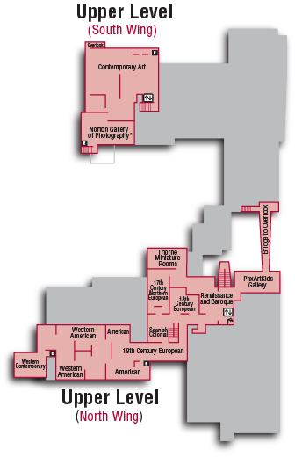

## OVERVIEW OF LEVEL DESIGN (Desert Rain God)

*This is from the Game Design Document. Copy and paste the level you have been assigned on the next page.*

Note on HP Reveal: There is a limit of 50 Overlays that can be attached to a single Trigger Image / Aura in the Aurasma Studio. This number allows for a considerable degree of complexity and interactive potential in an Aura, but when building more complex Aurasma content and planning the creation process it is worth keeping this limit in mind.

Here is more advice on designing for AR: <https://developers.hp.com/epic-stories/blog/augmented-reality-advice-ar-creative-director>

|  |  |  |
| --- | --- | --- |
| Level 1:  Plot Point: | **Goal: Get information on art piece.**  Rules: None  Mechanic: Point and Tap | **Challenge: None**  Strategy:  Tactics: |

*.*

## LEVEL DESIGN DIAGRAM

*The level design document will have a top down view of the level with the location of the challenges, resources, obstacles, etc. all indicated with icons that are identified by a legend.*

[*https://critpoints.net/2018/02/18/good-fps-map-design/*](https://critpoints.net/2018/02/18/good-fps-map-design/)

The level design diagram for this project will be the image with your hotspots (this is almost the same as the button map in this project).

# ACCESSIBLITY & Use

*From the Game Design Document.*

According to these guidelines: <http://gameaccessibilityguidelines.com> this game will be built to the BASIC level of inclusion.

## INCLUSION

|  |  |  |
| --- | --- | --- |
| Ability | Level (Basic, Intermediate, Advanced) | Strategy for inclusion |
| *Fine Motor* | *Basic* | *Unimplemented strategy would be an automatic start after a delay.* |
| *Large Motor* | *Basic* | *No Change* |
| *Cognitive* | *Basic* | *No Change* |
| *Vision* | *Basic* | *Implemented sound* |
| *Hearing* | *Basic* | *Implemented Visuals* |
| *Speech* | *Basic* | *No Change* |
| *General* | *Basic* |  |

## GAME REQUIREMENTS

*These are the requirements for the game that will become the traceability matrix and will help the team communicate who are working on the game, there is a scoping meeting with the team to determine which requirements will be built and which will be in the next release or iteration of the project. Add a row for each requirement to this table.*

|  |  |  |  |  |
| --- | --- | --- | --- | --- |
| Done  (Y/N) | # | Requirement Description | Originator of Req. | Scope (In/Out) |
|  | 1 | The player shall be able to play the piece on both iPhone and Android devices | PAM | In |
|  | 2 | The player shall be able to discover hidden history or experience something new about the artwork through the AR experience. | PAM | In |
|  | 3 | The AR experience will give the player one of these features: 1) a reason to stay, 2) a reason to share, 3) a reason to rescan | Theresa | In |
|  | 4 | The piece will include the hashtag #PhxArtAR | Theresa | In |

## USER CHARACTERISTICS

|  |  |  |
| --- | --- | --- |
| How many? | Title | Description of Characteristics |
| ?? | Casual Museum Attendees  (Adults, Parents, Kids) | All of these players will need no learning curve. These players are able to download and install the game on their phone (either Android or iPhone) and follow instructions to play the game. |
| 20 | Museum Docents | Are trained in educating the public about the collection. They will need further training in using the game. It should be simple for them as well. |
| 3 | Museum Educators | They manage the docents and the educational materials. They train and guide the Docents and the School Art Educators. |
| ?? | School Art Educators | Similar to the Docents, they are trained in the collection and will need training in using the game. |
| 5 | Museum Administrators | They oversee the entire initiative. They will play the game in order to review and approve it. |
| 10 | ASU student developers | Level Design and development of their assigned level. Will be new to game development in general. This will be a quickstart approach for them. |
| 1 | ASU Professor | Overall game design, liaison between ASU student developers and the Phoenix Art Museum educators, guide the students to create a usable experience. |

## 

## USER OBJECTIVES

|  |  |  |
| --- | --- | --- |
| Title | Description of Objectives | Workflow |
| Museum Educators | Initiate project, review requirements and approve, test the game for final approval, train docents, art educators. Liason between ASU Professor and the PAM Administration. | First, intermediary reviews, final approval. |
| ASU Professor | Write GDD and project template for Level Design Documents, guide ASU student developers. | Second, intermediary reviews and guidance. Final approval before PAM Educators approve. |
| ASU student developers | Write Level Design document for their assigned level. Use template provided by ASU Professor Devine, build an AR experience that will be a level in the game produced. | Third. Use GDD requirements to write Level Design Documents and develop a level for the game. Each student will have a credit line. They will be primarily concerned with the player use cases. |
| Museum Administrators | Will approve the game for release in the PAM. | Fourth |
| Museum Docents | Will use the game in their tours after release. | Fifth |
| School Art Educators | Will use the game in their lessons after release. | Sixth |
| Casual Museum Attendees (players) | Play the game for fun, discovery of hidden knowledge | Last |

## DRG USE CASE

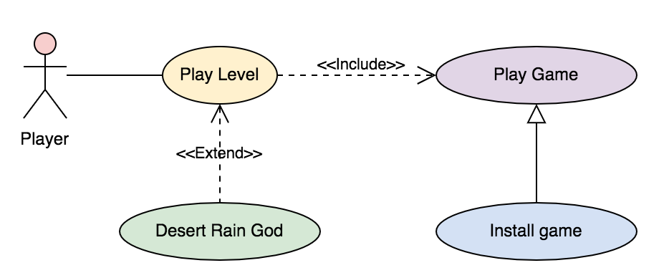

## USE CASE NARRATIVE (Desert Rain God USE CASE)

*Copy and paste this section for each of the use cases.*

|  |  |
| --- | --- |
| *Use Case Name:* | Desert Rain God |
| *Primary Actors:* | Player |
| *Secondary Actors:* | Museum and Art Educators |

*Purpose:*

This use case occurs when ….The player Focuses their phone on Desert Rain god image.

*Trigger:*

A Phone

HP Reveal

Desert rain god image

*Pre-conditions:* Install Game

*Basic Course:*

1. Player goes to museum,
2. player downloads HP reveal,
3. Player finds desert rain god,
4. player looks at desert rain god through phone,
5. sound starts,
6. button pops up,
7. player clicks button that pops,
8. lightning

*Post-Conditions*: What happens when they walk away

Hopefully they are happy or at least interested in learning more about the piece.

*Possible Alternate Flows:* Things that go wrong

* Phone dies
* Buttons don’t pop up
* Weird delay
* Sounds clip
* Phone crashes
* Image doesn’t register
* Player gets frustrated because tapping wont work
* Player gets bored
* Overlays out of order
* Wifi Issues

# STORY ARCHITECTURE

## STORY STRUCTURE

We will be using a “book in the box” structure.

# VISUAL ARCHITECTURE

*The general direction was set in the Game Design Document. In this document concept drawings are developed, assets are created, and storyboards for gameplay are created.*

## AESTHETICS

*What visual strategies will be used?*

* ***Lightning Visuals,***
* ***Fade ins,***
* ***Button pictures.***

## COLOR THEORY

*What possible color strategies can be used in the game?*

* ***Made colors contrast.***
* ***Bold black letters appear in white clouds,***

***vivid red buttons appear at bottom of screen.***

***Lighting seems to strike out of clouds.***

## Typography

***Domine- Bold***

## Button Map

* ***Images,***
* ***Button that appear on the screen***
* ***(Vision ques),***
* ***tapping from left to right on phone screen.***

## USER INTERFACE

*How will people be able to play the game?* ***Downloading The HP reveal app and interacting with the level image.***

## Navigation Hierarchy

*Provide a diagram of the navigation hierarchy that shows how a user moves through the user interface.* This will be particularly important for this project.

### Screen [x.1] – Aim at picture, wind turns on

### Screen [x.2] as wind rolls in, button appears

### Screen [x.3] tap button lightning starts, Thunder sounds

### Screen [x.4] New button appears after a 3 second delay on lightning.

### Screen [x.5] Name of Piece Pops in.

**Screen [x.6] After a Delay, Name of artist rolls in, Thunder sounds again**

# sonic ARCHITECTURE

*The general direction was set in the Game Design Document. What software will you use to compose and record the sound and music? In this document the composition of the sonic environment and music for the game is addressed.* *Also – how will the game be accessible to the blind?*

*Watch this first:*

<https://youtu.be/q4CYUfgRdos> (Video Game Scoring Online Masterclass with [Chance Thomas](http://chancethomas.com/))

*If you are headed to be a composer for games – this book is a must:*

<https://www.amazon.com/Composing-Music-Games-Technology-Business/dp/1138021415>

*This is good information as well:*

<https://www.npr.org/templates/story/story.php?storyId=89565567>

<https://kotaku.com/the-best-video-game-music-of-2017-1821534087>

<https://midnightmusic.com.au/2016/06/the-guide-to-composing-music-for-video-games/>

## SOUND effects: STINGERS

***Thunder when Lightning Appears***

## Sound effects: Tags

*These happen at the end of a level or a game.*

[*http://creativeskillset.org/job_roles/3844_foley_editor*](http://creativeskillset.org/job_roles/3844_foley_editor)

We will not have the opportunity to develop tags for this phase of the project.

## MUSIC: INTRO

*Sets the mood for the gameplay that’s about to occur. Also sets the musical palette for the game soundtrack.*

We will not have the opportunity to develop intro music for this phase of the project.

## MUSIC: LOOP

*“The workhorse of the gaming industry”. A short, repeatable section of music which can be played over and over until the gameplay changes or the character dies (!)*

We will not have the opportunity to develop loop sound for this phase of the project.

## MUSIC: Transition

*Connecting music (i.e. music that accompanies a cut scene that aims to maintain the player’s interest)*

We will not have the opportunity to develop transition music for this phase of the project.

# SOFTWARE gameplay ARCHITECTURE

*Will the game be software (video game)? If so then what type of software architecture will prevail? OOAD? What Design Patterns used? A high level diagram of the architecture can go here. If you arge making a table-top game, then you can delete the logical view, and instrumentation subsections and the word “software” in the title of this section.*

The architecture for this project is predetermined by HP Reveal. The design patterns that coincide with what they have built are: Prototype and State. Prototype for the building of “levels” and State for the image trigger and “auras.”

## LOGICAL VIEW

<https://en.wikipedia.org/wiki/Prototype_pattern>

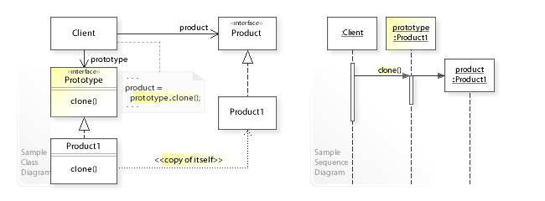

<https://en.wikipedia.org/wiki/State_pattern>

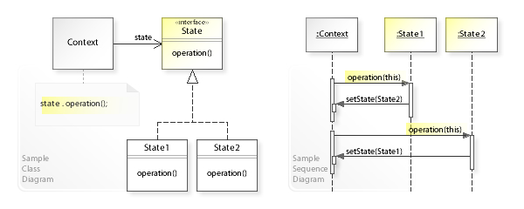

## dATA VIEW

We will be using the database available on HP Reveal. Details are in the instructions for the assignment.

## LOCALIZATION

*Will your game be available globally? What means will you use to adapt to different languages, regional differences and technical requirements of a certain place? Will you need to translate it to braille? If so how will you do it?* [*https://lib.asu.edu/disability*](https://lib.asu.edu/disability)

[*https://lib.asu.edu/disability/hayden*](https://lib.asu.edu/disability/hayden) *(an embosser is here)*

The HP Reveal app speaks different languages! You will have chosen your language setting on your mobile device, and HP Reveal will recognize this setting. HP Reveal will therefore display all app text and messages in your preferred language. Languages supported: English (United Kingdom), English (United States), French, Spanish (Spain), Spanish (Latin America), Portuguese, Japanese, Chinese.

## iNSTRUMENTATION VIEW

*Instrumentation is the ability to monitor or measure the level of a product's performance, to diagnose errors and to write trace information. How will you use the game engine or software to create your plan to address the following:*

* *Code tracing - receiving informative messages about the execution of an application at run time.*
* *Debugging and (structured) exception handling - tracking down and fixing programming errors in an application under development.*
* *Profiling - a means by which dynamic program behaviors can be measured during a training run with a representative input. This is useful for properties of a program which cannot be analyzed statically with sufficient precision, such as alias analysis.*
* *Performance counters - components that allow the tracking of the performance of the application.*
* *Computer data logging - components that allow the logging and tracking of major events in the execution of the application.*

This is all provided by HP Reveal. We have been asked to implement some type of metrics by the museum. We care about generating social media shares and buzz and will want to measure the number of photos and videos shared to social media. We will include a hashtag to easily search from the other end. The hashtag is: **#PhxArtAR**

## SECURITY VIEW

*Does your game need security? Will there be a login for the player? Are you using flat files to store character information on the client computer or on the server? How will you protect that data? Will you encrypt? Will you use hexadecimal or binary data to control the security of the data? Remember that hackers know all the standard encryptions and conversions and be creative with your security solution.*

*If you are building a table top game – are you using imperfect knowledge in your design? If so then how are your players or your game master going to protect the data? Is your game going to take several days to complete? Again – how is the game data stored so that the integrity of the game is not compromised?*

This is all provided by HP Reveal.