Questions/Requirements: Option 1
- Home Network Map: Use Packet Tracer.
- Accurately show Modem or Router provided by Internet provider.
- For all devices Provide: Made by ?, Model, and device type. (switch, PC, phone, ect.)
- If Internet provider only uses Modem, then you will have a separate Router to show as well.
- Note the Internet provider IP address, your Router IP address. Subnet mask. And Default Gateway.
- Show other connected devices, MAC address, and IP address. (i.e Desktop PC, laptop, IoT devices, TVs, ect.)
- Using Packet Tracer, you should end up with a “Home Network Map”. Example below. (you should be able to add any information available)
- According to the Internet Provider, what Upload Bandwidth and Download Bandwidth should you experience? Run a few online speed tests and see what you actually obtain. Note what you experience for each. Average.
- Login to your Modem, Router, or both and note Firewall usage. On? or Off?
- Are there any open ports? Closed/blocked ports?
- Check/test if you can setup an online server. i.e. Web server, FTP server, or Storage server. If running Windows you should have ability to setup a web or ftp server. Or create a Windows VM to run on a Mac platform.
- Setup and configure modem or router to all through the required port or ports.
- You may have to do a little research to complete the setup/configuration.
- Document your success or other experience in a short paragraph or two.
Packet Tracer Network Map: Example
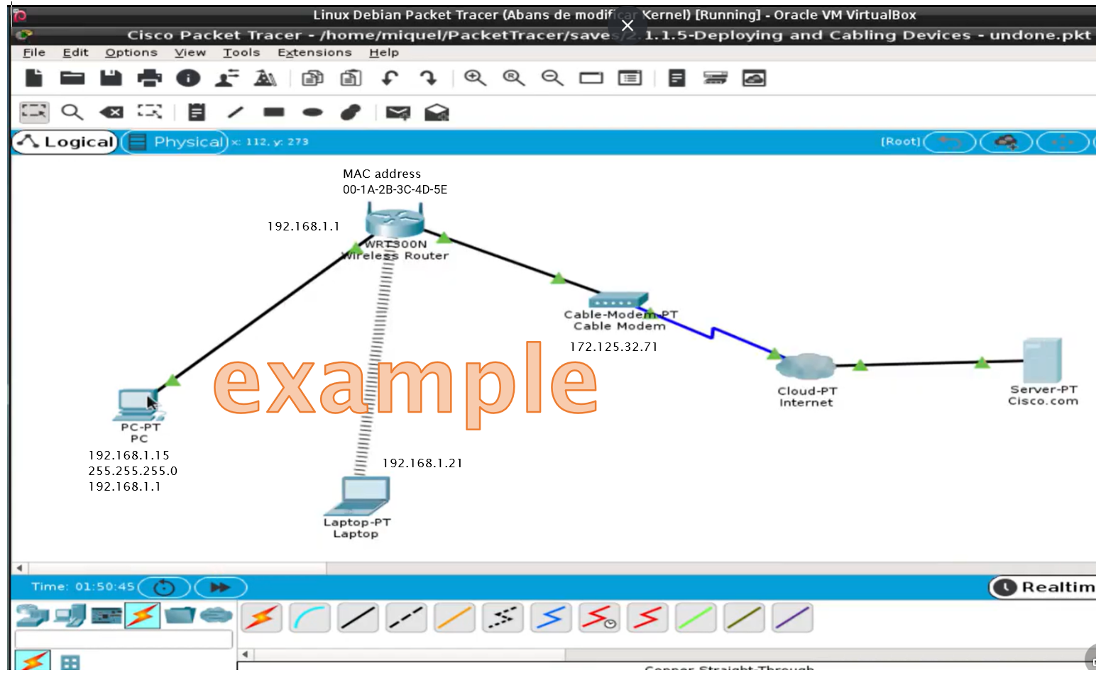
Any Questions be sure to message me via Canvas.

