Prediction methodology and results:
First the fuel consumption formulas used in this paper are describe as follows:
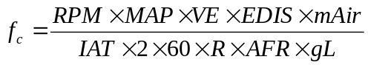(1)
Where 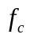 is fuel consumption rate in unit of liter/second, RPM is RPM of the vehicle, MAP is the manifold absolute pressure (kPa), VE is volumetric efficiency which is 0.85 in this study, EDIS is engine displacement (L), mAir is the average molecular mass of air (28.97g/mole), IAT is intake air temperature (Kelvin), R is 8.314 J/°K/mole, AFR is air/fuel mixing ratio (14.7) and gL is gasoline gram per liter (728.3068 gram/liter)
Once the fuel consumption rate is obtained, the total fuel consumption of the trip can be calculated by Eq. 2.
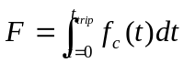 (2)
Where 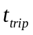 is the total time of the trip. The real historical data of the car recorded by the OBD is discrete, therefore, the Trapezoidal rule is utilized, and the Eq. 2 becomes Eq.3.
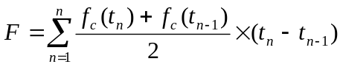 (3)
Where stands for the time of sampling and 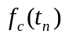 denotes the fuel consumption rate at time . According to Eq. 3, the total fuel consumption for a particular driver in a particular route can be obtained.
The fuel consumption is affected by different variables, ex: changing in car types, average speed or traffic condition, in order to estimate the fuel consumption in different situations, the multivariate regression model is used. The regression model for route is as following.
(4)
Where 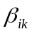 is a set of unknown coefficients that are determined from the historical data (training set). The variable 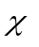 is the measureable data from the OBD installed in the car, and the response variable, 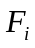, is the fuel consumption in a particular route given the driving data 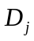.
Solving for 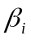 in Eq. 4:
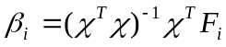(5)
The value 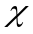 in this study is as follows:
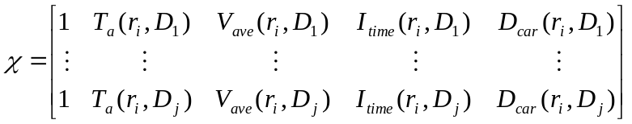(6)
Where 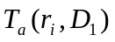 denotes the ambient temperature of route for the first historical data, we assume that the ambient temperature will cause different loading of auxiliary machine, ex: the heater or the air conditioner. 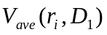 denotes the average speed of car driving in route , since different speed will cause different fuel consumption in the route. 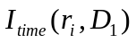 denotes the total idle time of route , we assume that different traffic condition results in different idle time in the route. 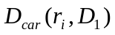 denotes the driver and the displacement of the car he drove, since the fuel consumption rate is different for different car types. Where is the total number of the historical data (training set).
Our objective is to estimate the fuel consumption of a drivers who never driver in a particular road. Based on the regression model of the fuel consumption in a particular route, we can find the relations between different routes and then estimate the fuel consumption of a driver in a particular route in which have not been drove by that driver.
That say driver never drive in route before, and we want to estimate the fuel consumption 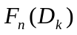 of driver in route given the ambient temperature, the average speed and the idle time. We can establish the relationship between the route and route 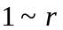by using the multivariate regression model shown in Eq. 7. The regression models, 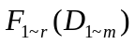 is the training data set. Since we want to use existence data of driver in different route to determine the fuel consumption in the route he never visit, the training data set should be 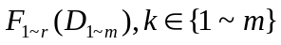. However, since 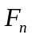 does not include the date of driver , the regression model has to be trained without the data of driver which shown in Eq.7. Also note that the number of driver should be greater than the number of route in order to avoid ill condition of regression model.
, 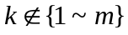 (7)
Where 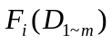 denotes the fuel consumption of drivers (car types) 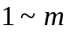in route given ambient temperature, average speed and idle time.
Solving for 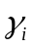 in Eq. 4:
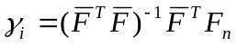 (8)
Where 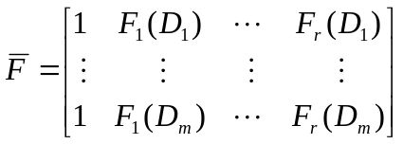,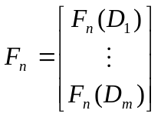.
Since , the 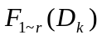 can be determined and substituted into Eq.7. The can be found.
[1]Lennon Rodgers, Erik Wilhelm and Daniel Frey "CONVENTIONAL AND NOVEL METHODS FOR ESTIMATING AN ELECTRIC VEHICLE’S “DISTANCE TO EMPTY”" Proceedings of the ASME 2013 International Design Engineering Technical Conferences & International Conference on Advanced Vehicle Technologies .

[2]Freund, R., 2006, Regression Analysis, Elsevier Inc.

