TryHackMe Advent of Cyber 2025 – Day 2 Walkthrough

Phishing

🎄 Scenario Overview
The Best Festival Company (TBFC) has recently faced multiple security threats. To strengthen defenses, the local red team—Recon McRed, Exploit McRed, and Pivot McRed—has begun a new series of penetration tests.
Today, you join the red team to test employee awareness against phishing attacks, one of the most common and successful forms of social engineering. Your goal is to build a trap, deploy it, and observe whether TBFC staff fall for it.

🎯 Learning Objectives
By completing this challenge, you will:
- Understand the fundamentals of social engineering
- Learn different types of phishing attacks (email, SMS, voice, QR, etc.)
- Explore how red teams create fake login pages for credential harvesting
- Use the Social-Engineer Toolkit (SET) to craft and send a phishing email

🖥️ Machine Setup
Before beginning:
- Start the VM (target machine) – wait ~2 minutes for it to boot.
- Start the AttackBox – this opens in split view.
- If it doesn’t appear, click Show Split View at the top of the page.
You will perform all offensive actions from the AttackBox.

🧠 Understanding the Concepts

Social Engineering
Social engineering manipulates humans into making harmful mistakes—sharing passwords, clicking malicious links, opening attachments, or approving fraudulent actions. Attackers commonly use:
- Urgency (“your account will close immediately!”)
- Authority (“this is your manager”)
- Curiosity (“you won a prize!”)
Because humans—not computers—are the target, social engineering is often called human hacking.

Phishing
Phishing uses messages—email, SMS, voice calls, QR codes, and DMs—to trick users into clicking something or revealing sensitive information.
TBFC trains employees using two S.T.O.P. mnemonics:

S.T.O.P. (All Things Secured)
- Suspicious?
- Telling me to click something?
- Offering me something amazing?
- Pushing me to act now?

S.T.O.P. (TBFC Internal Training)
- Slow down
- Type the address yourself
- Open nothing unexpected
- Prove the sender
Today you test whether TBFC employees actually follow that training.

🎣 Building the Phishing Trap
Your goal: capture the target user’s login credentials.
To do this, TBFC provides a prebuilt fake portal hosted by a simple Python script.

Step 1: Run the Phishing Server
cd ~/Rooms/AoC2025/Day02
./server.py

This starts a credential-harvesting webserver:
Starting server on http://0.0.0.0:8000

- 0.0.0.0 → the server listens on all network interfaces
- Victim-accessible URL (example):
  - http://10.65.66.227:8000
  - or http://127.0.0.1:8000 (local test)

Screenshot Placeholder
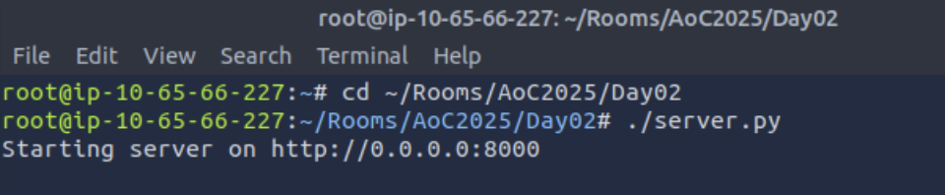
Open Firefox on the AttackBox to preview the fake login page. Note that your IP address will be different given your attackbox:
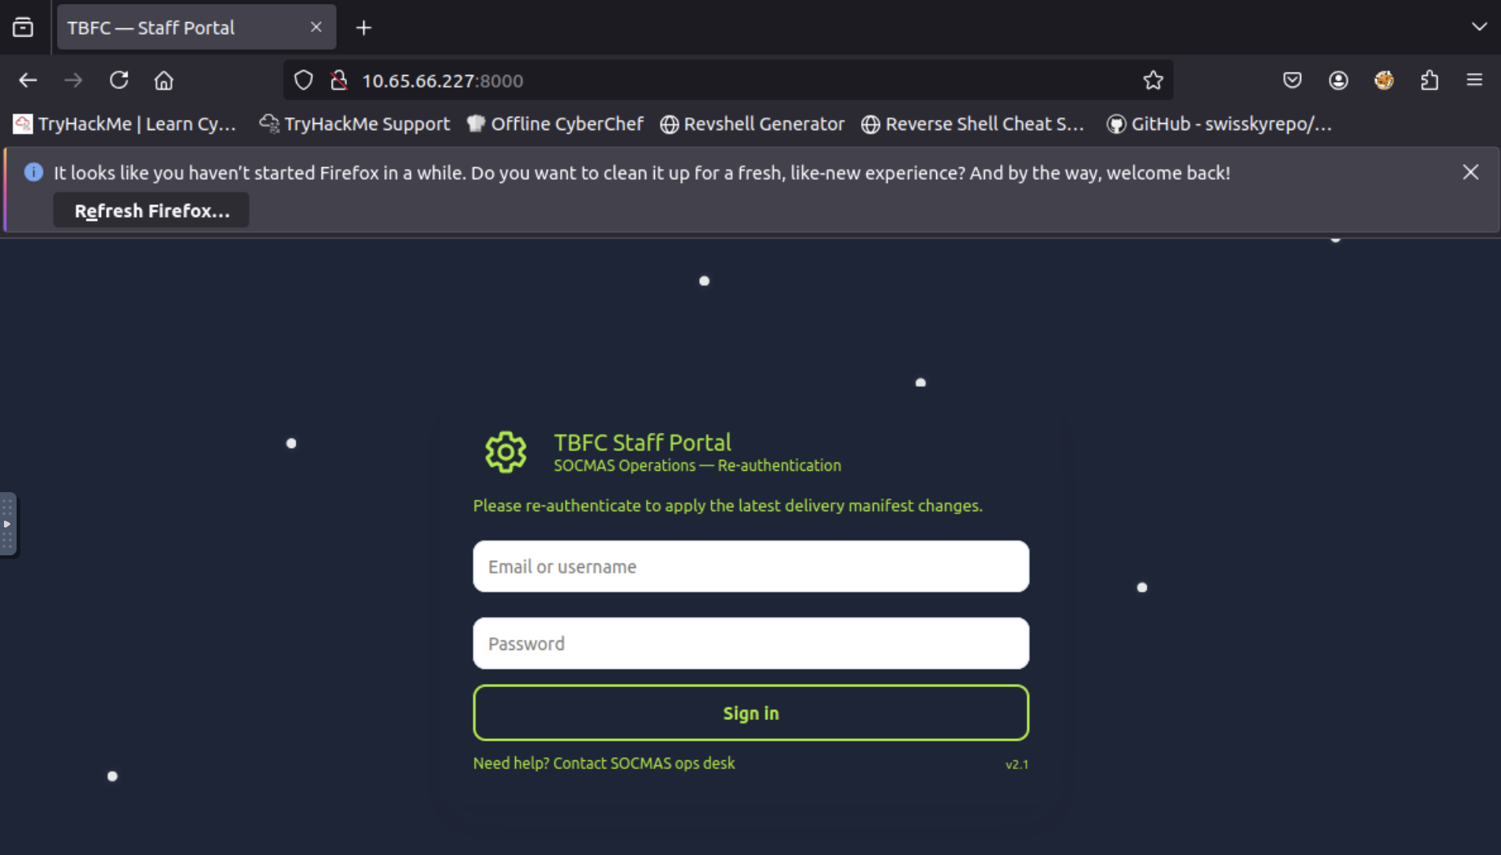

✉️ Sending the Phishing Email with SET
Now you must deliver the trap to a TBFC employee.

Step 2: Launch SET
Open a new terminal window and type setoolkit.
Select:
- Social-Engineering Attacks
- Mass Mailer Attack
- E-Mail Attack Single Email Address

Email configuration used in this challenge
Field | Value
Recipient | factory@wareville.thm
Delivery method | Use your own server / open relay
From address | updates@flyingdeer.thm
Display name | Flying Deer
SMTP server | 10.65.149.246 (example)
Port | 25
High priority? | No
Attach file? | No
Message format | Plaintext
Body includes | URL to fake login page

Screenshot Placeholder
Your options should look like this when following the instruction:
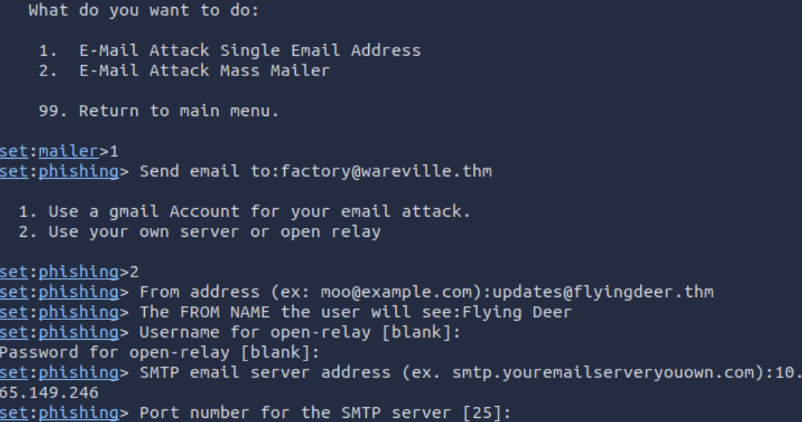
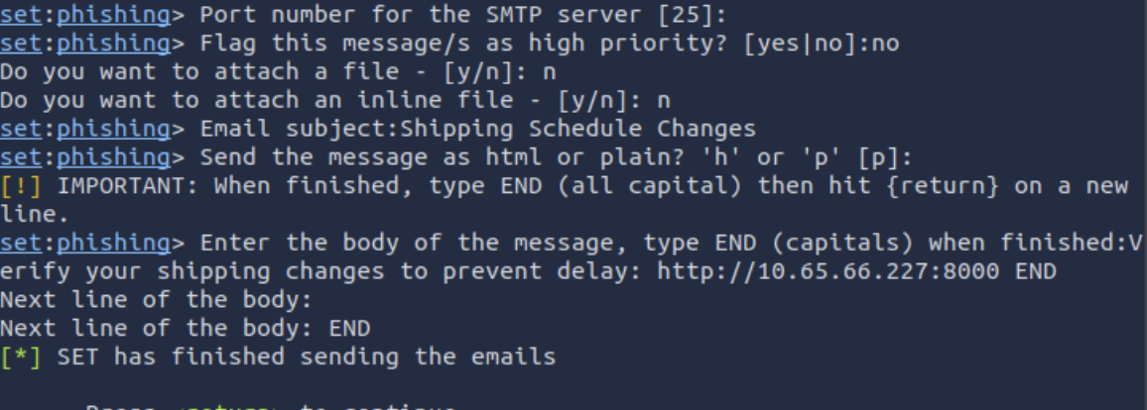

Example Email Body
Dear elves,
Kindly note that there have been significant changes to the shipping schedules due to increased shipping orders.
Please confirm the new schedule by visiting http://10.65.66.227:8000
Best regards,
Flying Deer
END

Once sent, return to the terminal running server.py and wait 1–2 minutes for credentials to appear.

Screenshot Placeholder
If credentials appear, congratulations: someone took the bait.
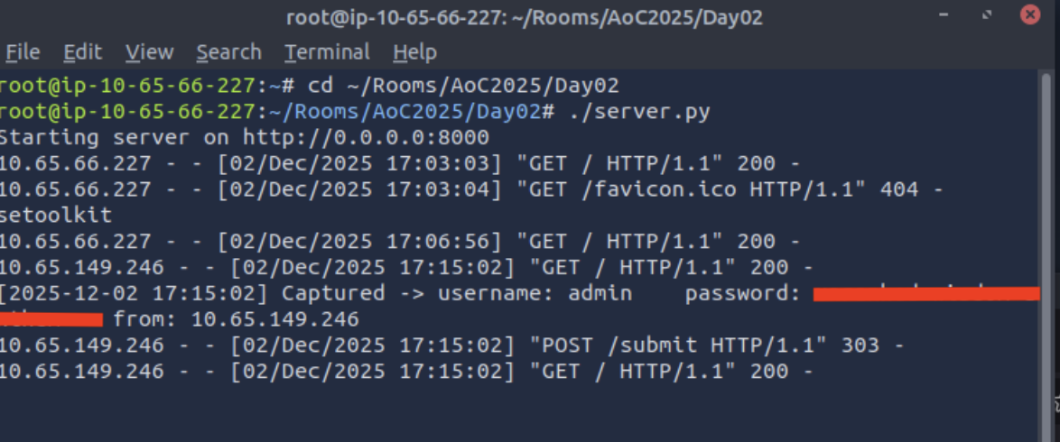

🔍 Post-Phish Investigation
The red team receives at least one valid credential set, which is alarming—this means a real attacker might already have access.
To assess potential damage, you must test the stolen password on the TBFC mail portal.

📝 Challenge Questions

1. What is the password used to access the TBFC portal?
This comes from the credentials harvested by server.py.
Answer:
_________________________

Screenshot Placeholder

2. Browse to your IP address of the using the AttackBox. Log in as factory using the stolen password. What is the total number of toys expected for delivery?
Once inside the mailbox, locate the delivery report and find the number.
Answer:
_______

Screenshot Placeholder
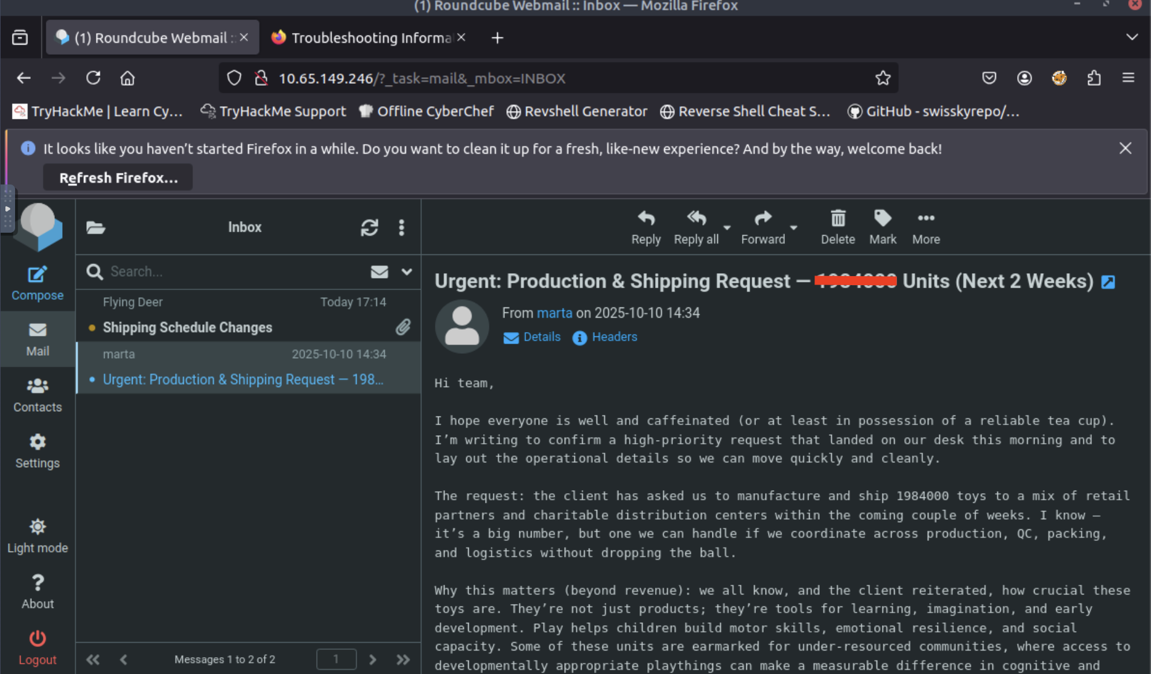

3. Optional: Explore Further
Try the Phishing Prevention room for defensive techniques.
No answer required.

🧩 Key Takeaways
- Social engineering targets people, not technology.
- Phishing attacks are increasingly sophisticated and require employee vigilance.
- Fake login pages + credential harvesting = common real-world attack chain.
- SET is a powerful red-team tool for testing awareness.
- Reused passwords significantly increase organizational risk.

🎁 Wrap-Up
Day 2 teaches one of the most important principles in cyber security:
Even the strongest systems fail if the humans operating them are not vigilant.
You’ve now built a phishing page, delivered it with SET, harvested credentials, and validated their impact—great work!

