🏗️ 1 SYSTEM REQUIREMENTS
🔹 Functional Requirements
- Add product
- Update product
- Delete product
- View products
- Search products
- Track stock levels
- Show dashboard analytics
- Alert low stock
- Process sales (POS – upcoming)

🔹 Non-Functional Requirements
- Fast response time (<2 seconds)
- Secure API endpoints
- Scalable architecture
- User-friendly UI
- Data consistency

👥 2 ACTORS
- Admin
  - Manages products
  - Views reports
  - Controls system
- Cashier (Future POS)
  - Processes sales
  - Views products

🎯 3 USE CASES
Core Use Cases:
Actor | Use Case
Admin | Add Product
Admin | Update Product
Admin | Delete Product
Admin | View Dashboard
Admin | View Alerts
Cashier | Process Sale (future)

5.4 CLASS DESIGN
Main Classes:
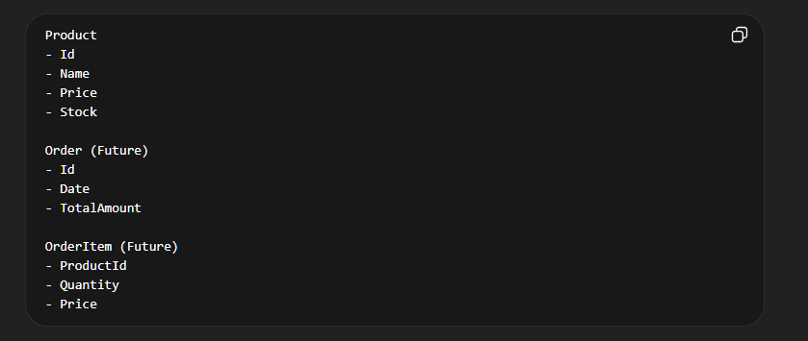
📊 CLASS DIAGRAM (TEXT FORM)
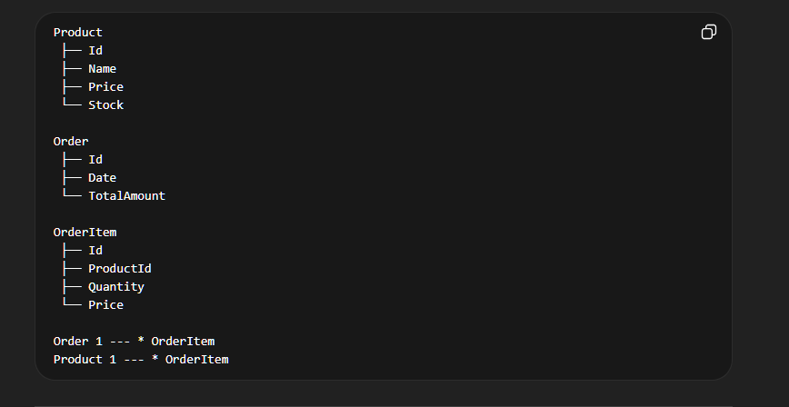
🔄 5.5 ACTIVITY DIAGRAM (ADD PRODUCT)
User → Enter Product Details
→ Click Add
→ Frontend sends POST request
→ Backend validates data
→ Save to DB
→ Return response
→ UI updates list

🔄 5.6 ACTIVITY DIAGRAM (SALE - FUTURE)
Cashier → Select Products
→ Add to Cart
→ Calculate Total
→ Confirm Payment
→ Save Order
→ Reduce Stock
→ Print Receipt
🧠 5.7 SYSTEM ARCHITECTURE
[ React Frontend ]
↓
[ ASP.NET Core API ]
↓
[ Database ]

🔌 API ENDPOINTS
GET /products
POST /products
PUT /products/{id}
DELETE /products/{id}

This is React Frontend code
/*import './App.css';
import { useState, useEffect } from "react";
import { ToastContainer, toast } from "react-toastify";
import "react-toastify/dist/ReactToastify.css";
import { BarChart, Bar, XAxis, YAxis, Tooltip, ResponsiveContainer } from "recharts";
import POS from "./components/POS";

function App() {
const [name, setName] = useState("");
const [price, setPrice] = useState("");
const [stock, setStock] = useState("");
const [products, setProducts] = useState([]);
const [editingId, setEditingId] = useState(null);
const [search, setSearch] = useState("");

// DASHBOARD CALCULATIONS
const totalProducts = products.length;

const lowStock = products.filter(p => p.stock < 5).length;

const totalValue = products.reduce(
(sum, p) => sum + (p.price * p.stock),
0
);

const totalStock = products.reduce(
(sum, p) => sum + p.stock,
0
);
const lowStockItems = products.filter(p => p.stock < 5);

const deleteProduct = async (id) => {
try {
await fetch(`http://localhost:5216/products/${id}`, {
method: "DELETE"
});

toast.success("Product deleted!");
// Refresh list
fetchProducts();
} catch (err) {
toast.error("Failed to delete product");
}
};

const updateProduct = async () => {
const updated = {
name: name,
price: parseFloat(price),
stock: parseInt(stock)
};

try {
await fetch(`http://localhost:5216/products/${editingId}`, {
method: "PUT",
headers: {
"Content-Type": "application/json"
},
body: JSON.stringify(updated)
});

toast.success("Product updated!");
fetchProducts();

setEditingId(null);
setName("");
setPrice("");
setStock("");
} catch (err) {
toast.error("Failed to update product");
}
};

// GET products
const fetchProducts = async () => {
try {
const res = await fetch("http://localhost:5216/products");
const data = await res.json();
setProducts(data);
} catch (err) {
console.error(err);
}
};

useEffect(() => {
fetchProducts();
}, []);

useEffect(() => {
if (lowStockItems.length > 0) {
toast.warn("Some items are low in stock!");
}
}, [products]);

// POST product
const addProduct = async () => {
const product = {
name,
price: parseFloat(price),
stock: parseInt(stock)
};

try {
await fetch("http://localhost:5216/products", {
method: "POST",
headers: {
"Content-Type": "application/json"
},
body: JSON.stringify(product)
});

toast.success("Product added successfully!");

setName("");
setPrice("");
setStock("");

fetchProducts(); // refresh list
} catch (err) {
toast.error("Failed to add product");
}
};

return (
<div style={styles.container}>
<h1 style={styles.title}>Smart Inventory POS</h1>

<div style={styles.dashboard}>
{lowStockItems.length > 0 && (
<div style={styles.alertBox}>
⚠ Warning: {lowStockItems.length} item(s) are low in stock!
</div>
)}
<div style={styles.cardBox}>
<h3>Total Products</h3>
<p>{totalProducts}</p>
</div>

<div style={styles.cardBox}>
<h3>Low Stock</h3>
<p style={{ color: "red" }}>{lowStock}</p>
</div>

<div style={styles.cardBox}>
<h3>Total Value</h3>
<p>${totalValue.toFixed(2)}</p>
</div>

<div style={styles.cardBox}>
<h3>Total Stock</h3>
<p>{totalStock}</p>
</div>
</div>

<div style={styles.chartBox}>
<h3>Stock Levels</h3>

<ResponsiveContainer width="100%" height={300}>
<BarChart data={products}>
<XAxis dataKey="name" />
<YAxis />
<Tooltip />
<Bar dataKey="stock" />
</BarChart>
</ResponsiveContainer>
</div>
<div style={styles.card}>
{/* SEARCH */}
<input
type="text"
placeholder="Search item..."
value={search}
onChange={(e) => setSearch(e.target.value)}
style={styles.input}
/>

{/* FORM */}
<div style={styles.form}>
<input
type="text"
placeholder="Product name"
value={name}
onChange={(e) => setName(e.target.value)}
style={styles.input}
/>

<input
type="number"
placeholder="Price"
value={price}
onChange={(e) => setPrice(e.target.value)}
style={styles.input}
/>

<input
type="number"
placeholder="Stock"
value={stock}
onChange={(e) => setStock(e.target.value)}
style={styles.input}
/>

<button
onClick={editingId ? updateProduct : addProduct}
style={styles.button}
>
{editingId ? "Update Product" : "Add Product"}
</button>
</div>

{/* ITEM LIST */}
<ul style={{ listStyle: "none", padding: 0 }}>
{products
.filter((p) =>
p.name.toLowerCase().includes(search.toLowerCase())
)
.map((product) => (
<li key={product.id} style={styles.product}>
<span>
{product.name} | ${product.price} | Stock: {product.stock}
</span>

<div>
<button
onClick={() => {
setEditingId(product.id);
setName(product.name);
setPrice(product.price);
setStock(product.stock);
}}
>
Edit
</button>

<button
onClick={() => deleteProduct(product.id)}
style={styles.deleteBtn}
>
Delete
</button>
</div>
</li>
))}
</ul>
</div>

{/* TOAST CONTAINER */}
<ToastContainer position="top-right" autoClose={2000} />
{/* POS COMPONENT */}
<POS />
</div>
);
}
const styles = {
dashboard: {
display: "grid",
gridTemplateColumns: "repeat(auto-fit, minmax(150px, 1fr))",
gap: "15px",
maxWidth: "800px",
margin: "20px auto",
},

alertBox: {
backgroundColor: "#fef3c7",
color: "#92400e",
padding: "10px",
borderRadius: "8px",
maxWidth: "800px",
margin: "10px auto",
textAlign: "center",
fontWeight: "bold"
},

cardBox: {
backgroundColor: "#ffffff",
padding: "15px",
borderRadius: "12px",
textAlign: "center",
boxShadow: "0 4px 10px rgba(0,0,0,0.1)",
},

chartBox: {
backgroundColor: "#fff",
padding: "20px",
borderRadius: "12px",
maxWidth: "800px",
margin: "20px auto",
boxShadow: "0 4px 10px rgba(0,0,0,0.1)"
},

container: {
backgroundColor: "#f8fafc",
minHeight: "100vh",
padding: "30px",
fontFamily: "Arial",
},
title: {
textAlign: "center",
color: "#1e293b",
},
card: {
backgroundColor: "#ffffff",
padding: "20px",
borderRadius: "12px",
maxWidth: "600px",
margin: "20px auto",
boxShadow: "0 4px 10px rgba(0,0,0,0.1)",
},
form: {
display: "flex",
flexDirection: "column",
gap: "10px",
},
input: {
padding: "10px",
borderRadius: "8px",
border: "1px solid #ccc",
},
button: {
backgroundColor: "#2563eb",
color: "white",
padding: "10px",
border: "none",
borderRadius: "8px",
cursor: "pointer",
},
item: {
display: "flex",
justifyContent: "space-between",
padding: "10px",
marginTop: "10px",
backgroundColor: "#f1f5f9",
borderRadius: "8px",
},
editBtn: {
backgroundColor: "#22c55e",
color: "white",
border: "none",
padding: "5px 10px",
marginRight: "5px",
borderRadius: "6px",
},
deleteBtn: {
backgroundColor: "#ef4444",
color: "white",
border: "none",
padding: "5px 10px",
borderRadius: "6px",
},
};
export default App;

