SOLUTION ARCHITECTURE AND DESIGN FOR BENNAVI SOFTSOLUTION PORTFOLIO WEBSITE.

Template Revision History

| Ver. | Date | Author | Comments |
| --- | --- | --- | --- |
| 1.0 | 1-April-2023 | XXXX | XXXX |
|  |  |  |  |
|  |  |  |  |
|  |  |  |  |

***Template begins from here….***

DESIGN AND ARCHITECTURE Document For [insert Project Name here]

|  |  |
| --- | --- |
| Prepared by: |  |
| Prepared for: |  |
| Date submitted: |  |
| Business Sponsor: |  |
| Project Manager: |  |
| Solution Architect: |  |
| Filename: |  |
| Document Number: |  |
|  |  |

Table of Contents

1 APPROVALS & REVISION HISTORY 5

1.1 Document Approval 5

1.2 Revision History 5

2 PURPOSE 6

3 REFERENCED DOCUMENTS 6

4 GLOSSARY 6

5 SOLUTION OVERVIEW 7

5.1 Solution Domain 7

5.2 Architecture Overview 7

5.3 Scope 9

5.3.1 In-Scope 9

5.3.2 Out-Scope 9

5.4 Integration Interfaces 9

5.5 Future Architecture 9

5.6 Transition Planning 9

6 ARCHITECTURE GOALS & CONSTRAINTS 10

6.1 Safaricom Enterprise Architecture 10

6.2 Architectural Assumptions and Decisions 10

6.2.1 Assumptions & Decisions 10

6.2.2 Constraints 10

6.2.3 Open Issues 10

6.3 Solution Architecture Attributes 10

6.3.1 Technology 10

6.3.2 Patterns 11

6.3.3 Common Services 11

6.3.4 Common Components 11

6.3.5 Portability 11

6.3.6 Capacity 11

6.3.7 Performance 11

6.3.8 Availability and Reliability 11

6.3.9 Scalability 11

6.3.10 System Management, Monitoring and Administration 11

6.3.11 BC & DR 11

6.3.12 Other Solution Architecture Issues 12

7 APPLICATION ARCHITECTURE 13

7.1 Application Layers 13

7.2 Logical Architecture Model 13

7.3 Physical Architecture Model 14

7.4 Common Service Specifications (Optional) 14

7.5 Component Models 15

7.5.1 Component Diagrams 15

7.5.2 Sequence Diagrams 15

7.6 Walk-Through Models 15

8 DATA ARCHITECTURE 16

8.1 Data Flow and Context Diagrams (Optional) 16

8.2 Conceptual/Logical Data Model 16

8.3 Authoritative Data Sources 16

8.4 Physical Data Elements 16

8.5 XML Resources Guidance 16

8.6 Data Migration Guidance (Optional) 16

9. SECURITY ARCHITECTURE 17

9.1 Security Solution Overview 17

9.2 Security Architecture Goals and Constraints 17

10. INFRASTRUCTURE 18

10.1 Deployment Models 18

11 APPENDIX 19

11.1 Appendix A: Table Structures and Stored Procedures 19

11.2 Appendix B: Web Services Artifacts 19

11.3 Appendix C: Server Resource Information 19

11.4 Appendix D: Other Required Artifacts 19

# 1 APPROVALS & REVISION HISTORY

This document has been approved as the official solution architecture document for the __________ project, and accurately reflects the current understanding of solution design and architecture.

## 1.1 Document Approval

| Ver. | Name | Role/Department | Signature | Date |
| --- | --- | --- | --- | --- |
|  |  |  |  |  |
|  |  |  |  |  |
|  |  |  |  |  |
|  |  |  |  |  |
|  |  |  |  |  |
|  |  |  |  |  |

## 1.2 Revision History

| Ver. | Date | Author | Comments |
| --- | --- | --- | --- |
|  |  |  |  |
|  |  |  |  |
|  |  |  |  |
|  |  |  |  |
|  |  |  |  |

# 2 PURPOSE

The purpose of this document is to define a high-level solution design and architecture for *<Project Name>.*

# 3 REFERENCED DOCUMENTS

<Insert the name, version number, description, and physical location of any documents referenced in this document. Add rows to the table as necessary.>

|  |  |  |
| --- | --- | --- |
| **Document Name** | **Description** | **Location** |
| *<Name & Version>* | *<Document description>* | *<Document URL>* |
|  |  |  |
|  |  |  |

*Table 1: Referenced Documents*

# 4 GLOSSARY

<Insert the definitions of terms and acronyms used in this document. Add rows to the table as necessary.>

|  |  |
| --- | --- |
| **Term** | **Definition** |
| *<Insert Term>* | *<Provide definition of term/acronyms used in this document.>* |
|  |  |
|  |  |

*Table 2: Glossary/Key Terms*

# 5 SOLUTION OVERVIEW

## 5.1 Solution Domain

*<Mention the domain affected by the solution>*

## 5.2 Architecture Overview

*<Provide one or more diagrams depicting an overview of the solution architecture with the necessary descriptive text. The diagram(s) should depict the major components of the solution and the relationships between the components, input and output data flows, major processes, functions, and system tasks. Identify major Safaricom enterprise systems, infrastructure, and platform technology components.>*



*Figure 1: Architecture Overview Example 1*

## 5.3 Scope

### 5.3.1 In-Scope

*<Indicate what has been agreed to be in scope in the project.>*

### 5.3.2 Out-Scope

*<Indicate what has been agreed not to be in scope in the project.>*

## 5.4 Integration Interfaces

*<Identify all the integration interfaces between the solution and other interacting system & indicate whether an outage of the interface will break the target system.>*

|  |  |  |
| --- | --- | --- |
| ***Target System*** | ***Interface Type*** | ***Break*** |
| *<Name>* | *<Upstream or Downstream>* | *<Yes or No>* |

*Table 3: High Level Interfaces*

## 5.5 Future Architecture

*<Identify and describe the application of potential new/future architecture components, if necessary.>*

## 5.6 Transition Planning

*<If the project involves migrating from current system architecture to the proposed/new architecture provide a description of the high-level transition plans (describe the current system architecture and the current business processes to be migrated)>.*

# 6 ARCHITECTURE GOALS & CONSTRAINTS

Description of the goals and constraints of the Solution Design explained further here below.

## 6.1 Safaricom Enterprise Architecture

*<Provide the enterprise architecture context for the solution architecture in relation to Safaricom’s Enterprise Architecture (EA) and how the solution architecture supports the goals and constraints of the EA. Reference applicable Safaricom/Vodafone EA models, that include As-Is and To-Be architectures.>*

## 6.2 Architectural Assumptions and Decisions

### 6.2.1 Assumptions & Decisions

*<List and describe the impact of any significant and central architectural assumptions and decisions, providing a history and description of decisions in the context of governance.>*

### 6.2.2 Constraints

*<List and describe any significant architectural constraints and their impact.>*

### 6.2.3 Open Issues

*<List and describe any significant open issues in the solution and their impact.>*

## 6.3 Solution Architecture Attributes

*<Identify solution architecture attributes required to meet solution requirements.>*

**Sections that are covered in the BRD as solution or non-functional requirements may be left out.**

### 6.3.1 Technology

*<Identify all software and hardware technologies that are to be used in the solution.>*

|  |  |  |  |
| --- | --- | --- | --- |
| ***Vendor*** | ***Product*** | ***Version*** | ***Status*** |
|  |  |  |  |

*Table 4: Required Technologies*

### 6.3.2 Patterns

*<Describe any architectural patterns that apply to the solution architecture (e.g. MVC pattern.>*

### 6.3.3 Common Services

*<Specify any existing common services to be used by the solution architecture and any new common services that will be developed for the solution.>*

### 6.3.4 Common Components

<Specify any reusable common components to be reused as part of the solution.>

### 6.3.5 Portability

*<Describe components that can be easily ported to other host hardware, operating systems, and software tools.>*

### 6.3.6 Capacity

*<Describe how the design satisfies the solution’s capacity requirements, including storage, network capacity, database and data storage requirements.>*

### 6.3.7 Performance

*<Describe how the design satisfies the solution’s performance requirements>*

### 6.3.8 Availability and Reliability

*<Specify how the design satisfies the solution’s requirements for system availability, reliability, redundancy and recovery from failure.>*

### 6.3.9 Scalability

*<Describe how the design accommodates forecasted growth in terms of system function transactions and volume indicated by the solution requirements.>*

### 6.3.10 System Management, Monitoring and Administration

*<Describe how the design satisfies operational and administration requirements as indicated by the solution requirements, e.g. reporting and logging.>*

### 6.3.11 BC & DR

*<Describe how the design satisfies solution requirements for business continuity and disaster recovery (BC/DR).>*

### 6.3.12 Other Solution Architecture Issues

*<Specify other architectural attributes necessary to meet requirements for other miscellaneous solution requirements not captured by the other defined solution architecture attribute sections.>*

# 7 APPLICATION ARCHITECTURE

This is a description of the solution’s application architecture (major solution components and their relationships). Include significant diagrams and specifications.

## 7.1 Application Layers

*<Organize the system components involved according to application layers>*

## 7.2 Logical Architecture Model

*<Create a logical architecture model illustrating data exchange and communication protocols and standards between components and systems in the design>*



*Figure 3: Sample Logical Architecture Model Diagram*

*Figure 3: Sample Logical Architecture Model Diagram 2*

## 7.3 Physical Architecture Model

*<Create a physical architecture model illustrating the physical boxes and components involved in the system including DB servers, application servers, web servers, HA & Load Balancer boxes etc>*



*Figure 4: Sample Physical Architecture Model Diagram*

## 7.4 Common Service Specifications (Optional)

*<If the solution integrates common services, describe how all common services identified by the solution architecture’s common service attributes are integrated into the solution’s application architecture>*

## 7.5 Component Models

### 7.5.1 Component Diagrams

*<Provide component models illustrating static views of component relationships and define all objects and relationships depicted by the models.>*

### 7.5.2 Sequence Diagrams

*<Provide sequence models illustrating dynamic views of component interaction. Include models that illustrate interaction of components across application layers supporting the significant and central use case scenarios.>*

## 7.6 Walk-Through Models

*<Provide walkthrough models to trace system execution and validate the solution’s application architecture and component interaction required to implement significant and central use cases and business processes (illustrated by a numbered sequence of defined events) defined by the solution requirements.*

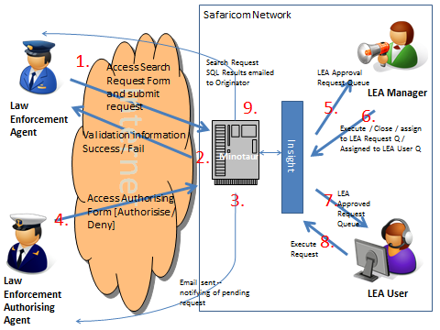

*Figure 5: Sample Workflow Diagram.*

# 8 DATA ARCHITECTURE

## 8.1 Data Flow and Context Diagrams (Optional)

*<Provide context and data flow diagrams showing data flows between a generalized application within the domain and the other entities and abstractions with which it communicates.>*

## 8.2 Conceptual/Logical Data Model

*<Provide conceptual (describing the logical grouping of the basic data building blocks of the solution) and logical (describing the major processes and data requirements of the business) data models.>*

## 8.3 Authoritative Data Sources

*<Identify the authoritative data sources required for access during this project.>*

## 8.4 Physical Data Elements

*<Provide guidelines for extending the logical model with a physical data model to define the physical representation of the data.>*

## 8.5 API Resources Guidance

*<Provide the schemas and guidelines for developers to follow when designing and creating XML/JSON resources – includes web services resources like wsdl, JSON and xsd files>*

## 8.6 Data Migration Guidance (Optional)

*<If the solution involves data migration, define the appropriate transition plan to indicate data migration sequencing requirements in relationship to the solution’s transition from current baseline architecture to the target architecture.>*

# 9. SECURITY ARCHITECTURE

## 9.1 Security Solution Overview

*<Provide a high-level solution overview and description of the security architecture. Identify and describe how the security architecture meets the solution’s security requirements.>*

## 9.2 Security Architecture Goals and Constraints

*<Identify and describe the significant and central security goals and constraints of the solution’s security architecture.>*

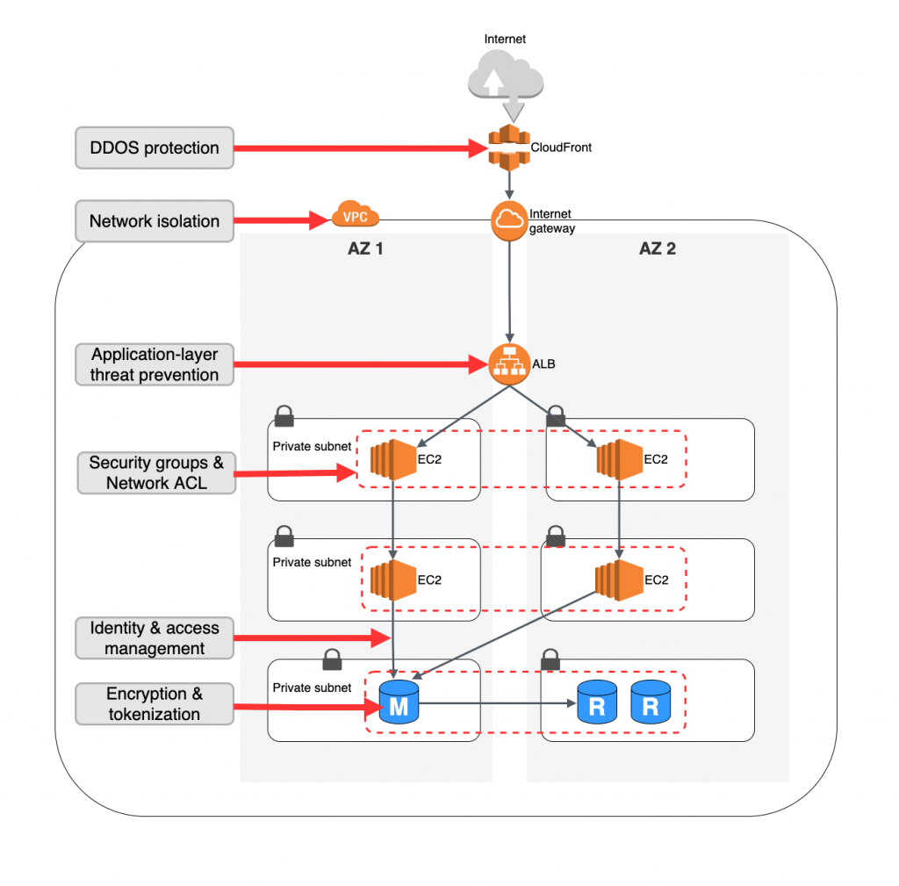

*Figure: Sample Logical Architecture Model Diagram*

# 10. INFRASTRUCTURE

*<Map application architecture deployment models to hardware and software infrastructure specifications including memory and CPU specifications required to meet volume and performance requirements, including architecture guidance and specifications for:*

1. *Software*
2. *Hardware*
3. *Network*
4. *Middleware*

*Provide infrastructure architecture guidance and specifications for all environments required for developing, testing, deploying, and operating the solution.>*

## 10.1 Deployment Models

*<Describe how the application architecture is deployed into one or more physical network (hardware) configurations.*

*Include one or more diagrams to illustrate significant and central components of the infrastructure architecture, these diagrams should be easily cross-referenced with the infrastructure architecture overview diagram.*

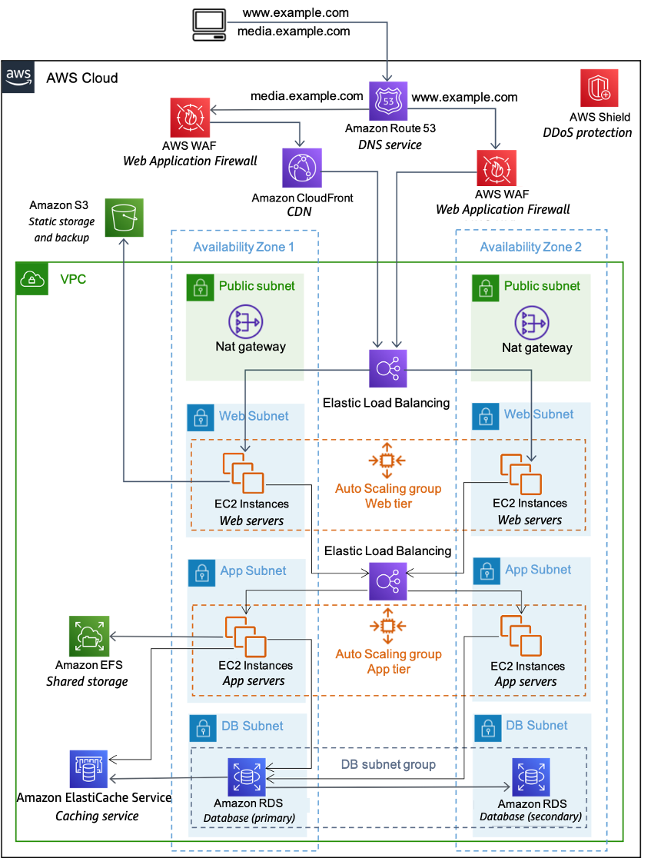

# 11 APPENDICES

## 11.1 Appendix A: Table Structures and Stored Procedures

<Insert structures of the key database tables, views and queries used in the solution. Insert stored procedures and triggers, if they are to be used.>

## 11.2 Appendix B: Web Services Artifacts

<Insert key web services artifacts used in the solution, for example wsdl and xsd interfaces>

## 11.3 Appendix C: Server Resource Information

<Include detailed technical information about the specific server boxes to be used.>

## 11.4 Appendix D: Other Required Artifacts

<Insert any other required solution artifacts.>