

实验报告R 实践报告□

课程名称： Web系统和技术

实验、实践名称： Web系统和技术

实验、实践地点： 腾讯会议

专业班级： 计科Z200X 学号： 202000xxxx

学生姓名： 胡xx

指导教师：

2022年 12 月 24 日

- 项目介绍（包括选题思路、开发环境、技术方案等）
1.选题思路
（1）选择留言板作为本次实验的项目，以github留言板为实例，其中包括用户的登录注册；查看主页留言列表；在留言版上发布留言；查看留言详情；对留言进行评论；搜索留言。
（2）实现后台管理功能，其中包括删除留言；删除评论；将用户添加为管理员；移除现有管理员。
2、 开发环境（Windows 10）
Eclipse、JDK17、tomcat 9.0、mysql 8.0.28
- 技术方案
（1）HTML+CSS实现留言板界面设计。其中包含登录界面，注册界面，留言主界面，发布留言页面，留言详情页面，后台管理界面的设计。
（2）Jsp+Servlet+mysql对用户操作进行处理，登录，注册，查询留言，查看留言详情，发布留言，发布评论，管理留言等操作。
（3）使用mysql关系型数据库对用户信息，留言信息，评论信息进行存储。

二、功能设计（包括项目包含主要模块及其功能介绍等）
（1）登录模块
1.当用户已经注册时，直接进行登录，若用户名或者密码错误则提示“用户名或密码错误”，重新进行登陆；
2.当用户没有注册时，可以直接点击注册链接进入注册界面，当注册成功之后，返回到登录页面。
（2）注册模块
将输入的信息与mysql数据库中存储的用户信息进行比较，若用户名已被注册，则提示该用户名已被注册；若用户名未被注册，则将该用户信息插入mysql数据库中，自动返回到登录页面。
- 主页留言列表模块
查看已经发表的所有的留言。包括留言标题，留言作者，留言发布时间，点击read超链接可以进入留言详情页面。
- 发布留言模块
在主页留言列表点击write message按钮可以进入发布留言页面，写入留言标题、留言内容点击submit按钮完成留言发布，也可点击return链接返回留言列表
- 留言详情模块
点击read超链接可以进入留言详情页面，可以查看留言的具体内容以及相应的评论。
（6）发表评论模块
在留言详情页面可以发布评论，点击Comment按钮后即可发布自己的评论。
（7）搜索留言模块
在主页面query框中输入用户名，即可在留言列表页面中显示出该用户发布的所有留言。
- 后台管理模块
登录管理员账号，进入管理员页面。
- 删除留言
在留言列表页面点击delete即可删除该留言以及其对应的所有评论。
- 用户管理
在留言列表页面点击manage即可查看所有用户和管理员的信息。对于用户，点击grade链接即可将该用户升级为管理员;对于管理员，点击degrade链接即可将该管理员降级为普通用户。
三、数据库设计（包括所有表的表结构及ER图等）
1.用户信息
id | username | password | sex | country | authority
用户id | 用户名 | 密码 | 性别 | 国家 | 权限
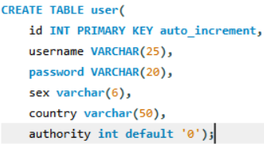
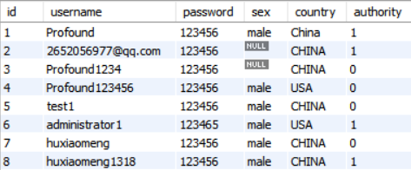
- 留言信息
message_id | user_id | time | title | content
留言id | 用户id | 留言时间 | 标题 | 留言内容
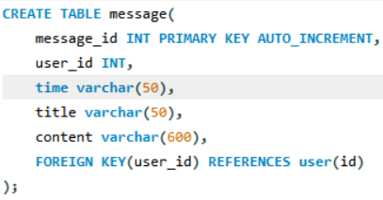
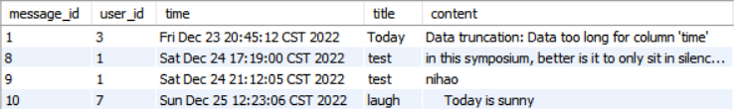
- 评论信息
comment_id | message_id | user_id | comment_content | time
评论id | 留言id | 用户id | 评论内容 | 评论时间
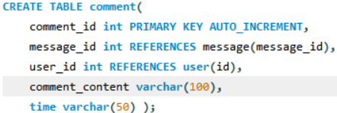
其中user表和message表，message表和comment表，user和comment表均为一对多的关系。
四、详细设计（包括主要界面截图和业务逻辑实现代码等）
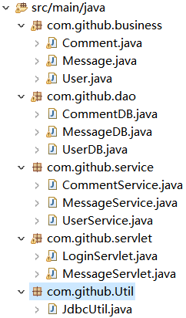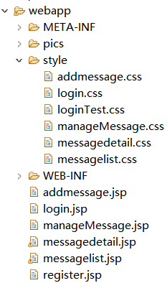
- 登录页面
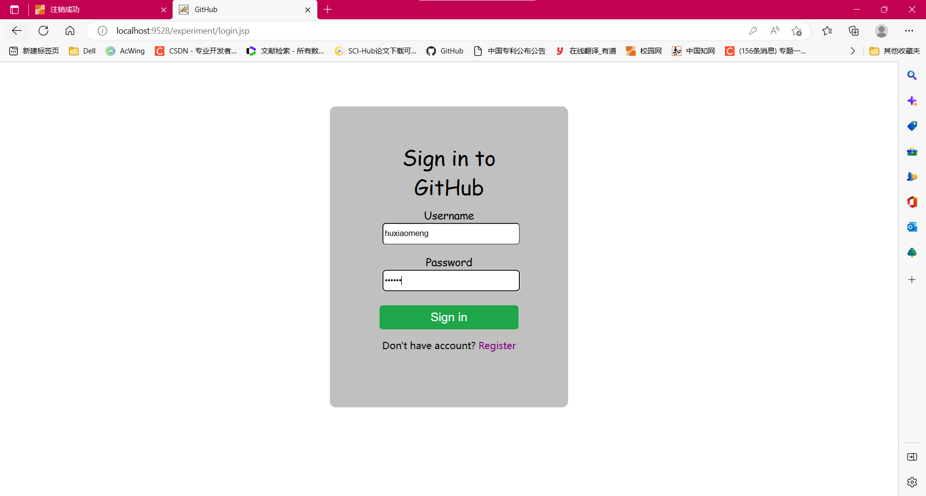
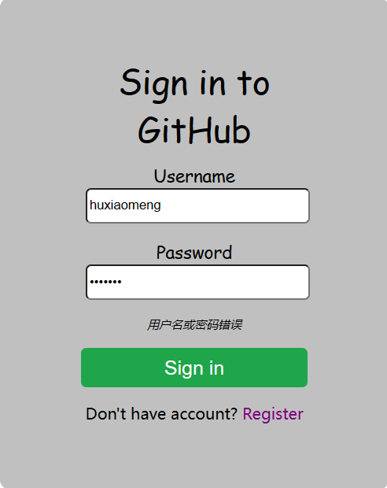
------------------------login.jsp代码----------------------------
<body>
<div class = "box">
<div class = "head">Sign in to GitHub</div>
<form action = "login" method = "post">
<div>
<input type = "hidden" name = "action" value = "login">
</div>
<div>
<label>Username</label><br>
<input type = "text" name = "username" value = "${username}" placeholder="username" maxlength = "20" required>
</div>
<div>
<label>Password</label><br>
<input type = "password" name = "password" value = "${password}" placeholder="password" maxlength = "20" required>
</div>
<div>
<p><i>${message}</i></p>
</div>
<div>
<input type = "submit" name = "login" value = "Sign in" id = "submit">
</div>
<div>
Don't have account? <a href = "register.jsp">Register</a>
</div>
</form>
</div>
</body>
------------------------login.css代码----------------------------
body{
background-color: scrollbar;
}

p{
font-size: 8px;
}

.box{
width: 20%;
height: 400px;
background-color: silver;
margin: auto;
margin-top: 5%;
text-align: center;
border-radius: 10px;
padding: 50px 50px;
}

div{
margin: 10px;
border: 0;
padding: 0;
}

label {
font-size: 18px;
font-family: Comic Sans MS;
width: 6em;
}

input[type = "text"], input[type = "password"]{
width:220px;
height: 30px;
border-radius: 5.5px;
margin-left: 0.5em;
margin-bottom: 0.5em;
}

.radio, .country{
font-size: 16px;
font-family: Comic Sans MS;
}

#submit{
width: 230px;
height: 40px;
background: #1fa54a;
font-size: 20px;
color: white;
border-radius: 5.5px;
margin: 6px;
border: 0;
padding: 0;
}

.head {
font-size: 35px;
font-family: Comic Sans MS;
}

a {
text-decoration-line: none;
color: purple;
}
- 注册页面
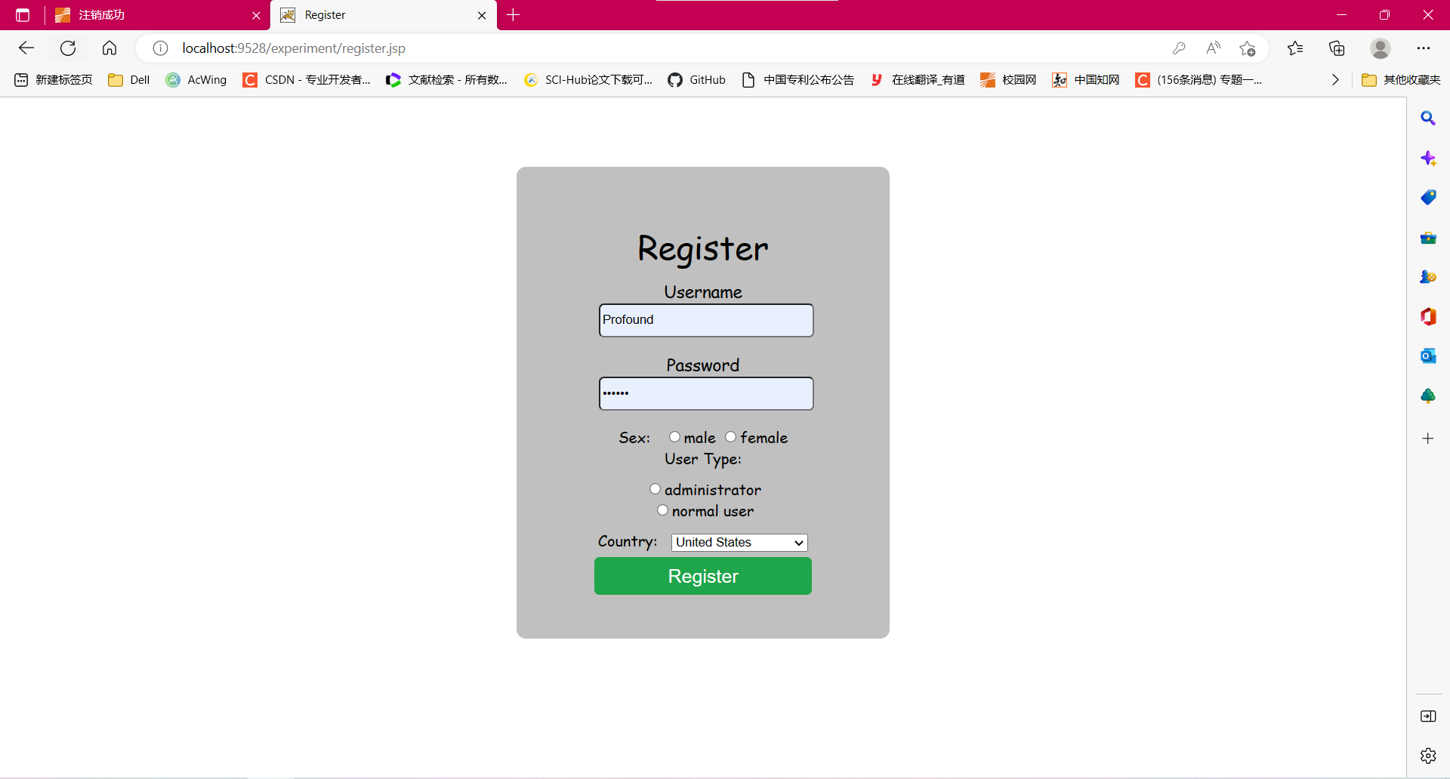
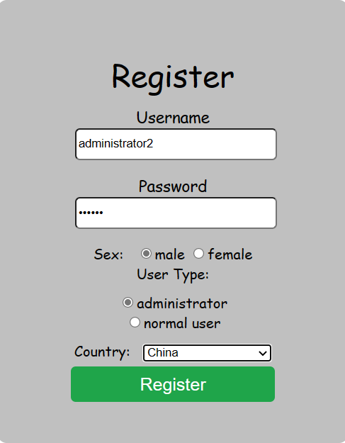
-----------------------register.jsp代码----------------------------

<body>
<div class = "box">
<div class = "head">Register</div>
<form action = "login" method = "post">
<div>
<input type = "hidden" name = "action" value = "register">
</div>
<div>
<label>Username</label><br>
<input type = "text" name = "username" placeholder="username" maxlength = "20" value = "${username}" required>
</div>

<div>
<label>Password</label><br>
<input type = "password" name = "password" placeholder="password" maxlength = "20" value = "${password}" required>
</div>

<div class = "radio">
Sex: &nbsp;
<input type = "radio" name = "radio1" value = "male">male
<input type = "radio" name = "radio1" value = "female">female <br>
User Type:
<div class = "authority">
<input type = "radio" name = "radio2" value = "1">administrator <br>
<input type = "radio" name = "radio2" value = "0">normal user
</div>

<div class = "country">
Country: &nbsp;
<select name = "country">
<option value = "USA">United States</option>
<option value = "CHINA">China</option>
<option value = "UK"> The United Kingdom</option>
<option value = "JAPAN">Japan</option>
</div>

<div>
<p><i>${message}</i></p>
</div>

<div>
<input type = "submit" name = "register" value = "Register" id = "submit">
</div>
</form>
</div>
</body>
-------------------注册登陆servlet端代码----------------------
protected void doPost(HttpServletRequest request, HttpServletResponse response) throws ServletException, IOException {
UserService userService = new UserService();
MessageService messageService = new MessageService();
String action = request.getParameter("action");
HttpSession session = request.getSession();
String url = "";
if(action.equals("login")) {
String username = request.getParameter("username");
String password = request.getParameter("password");
User user = userService.checkLogin(username, password);
if (user.getUsername().equals("")) {
//登录失败
String message = "用户名或密码错误";
request.setAttribute("message", message);
request.setAttribute("username", username);
request.setAttribute("password", password);
url = "/login.jsp";
}
else { //登录成功
session.setAttribute("user", user);
ArrayList<Message> msglist = messageService.getMessage(); //留言板信息
session.setAttribute("msglist", msglist);
url = "/messagelist.jsp";
}
}
else if(action.equals("register")) {
String username = request.getParameter("username");
Boolean flag = userService.checkUser(username);
if(flag) {
String message = "当前用户名已被注册！";
request.setAttribute("message", message);
url = "/register.jsp";
}
else { //当前用户未被注册
User user = new User();
user.setUsername(request.getParameter("username"));
user.setPassword(request.getParameter("password"));
user.setSex(request.getParameter("radio1"));
user.setCountry(request.getParameter("country"));
user.setAuthority(Integer.parseInt(request.getParameter("radio2")));
flag = userService.register(user);
if(flag) { //注册成功
url = "/login.jsp"; //转向登录页面
}
else { //注册失败
String message = "注册失败！";
request.setAttribute("message", message);
url = "/register.jsp";
}
}
}
getServletContext().getRequestDispatcher(url).forward(request, response);
}

protected void doGet(HttpServletRequest request, HttpServletResponse response) throws ServletException, IOException {
doPost(request, response);
}
-------------------注册登陆DAO层代码----------------------
//用户登录验证
public static User checkLogin(String username, String password) {
User user = new User();
ResultSet rs = null;
PreparedStatement ps = null;
Connection con = null;
try {
con = JdbcUtil.getConnection();
String PreparedSQL = "select * from user where username = ? and password = ?";
ps = con.prepareStatement(PreparedSQL);
ps.setString(1, username);
ps.setString(2, password);
rs = ps.executeQuery();
if (rs.next()) {
//登录成功
user.setId(rs.getInt("id"));
user.setUsername(rs.getString("username"));
user.setUsername(rs.getString("password"));
user.setSex(rs.getString("sex"));
user.setCountry(rs.getString("country"));
user.setAuthority(rs.getInt("authority"));
}
} catch(Exception e) {
e.printStackTrace();
} finally { //释放资源
JdbcUtil.release(rs, ps, con);
}
return user;
}

//检查用户名是否已被注册
public static Boolean checkUser(String username) {
//检查用户名是否已被注册
Connection con = JdbcUtil.getConnection();
PreparedStatement ps = null;
ResultSet rs = null;
Boolean flag = false;
String prepareSQL = "select * from user where username = ?";
try {
ps = con.prepareStatement(prepareSQL);
ps.setString(1, username);
rs = ps.executeQuery();
if(rs.next()) {
//该用户名已被注册
flag = true;
}
} catch(Exception e) {
e.printStackTrace();
flag = false;
} finally { //释放资源
JdbcUtil.release(rs, ps, con);
}
return flag;
}

//用户注册
public static Boolean register(User user) {
//检测用户能否注册成功
Connection con = JdbcUtil.getConnection();
String prepareSQL = "insert into user(username, password, sex, country, authority)"
+ "values(?, ?, ?, ?, ?)";
PreparedStatement ps = null;
ResultSet rs = null;
int i = 0;
try {
ps = con.prepareStatement(prepareSQL);
ps.setString(1, user.getUsername());
ps.setString(2, user.getPassword());
ps.setString(3, user.getSex());
ps.setString(4, user.getCountry());
ps.setInt(5, user.getAuthority());
i = ps.executeUpdate();
} catch(Exception e) {
e.printStackTrace();
} finally { //释放资源
JdbcUtil.release(rs, ps, con);
}
return i == 1 ? true : false;
}
- 主页留言列表模块
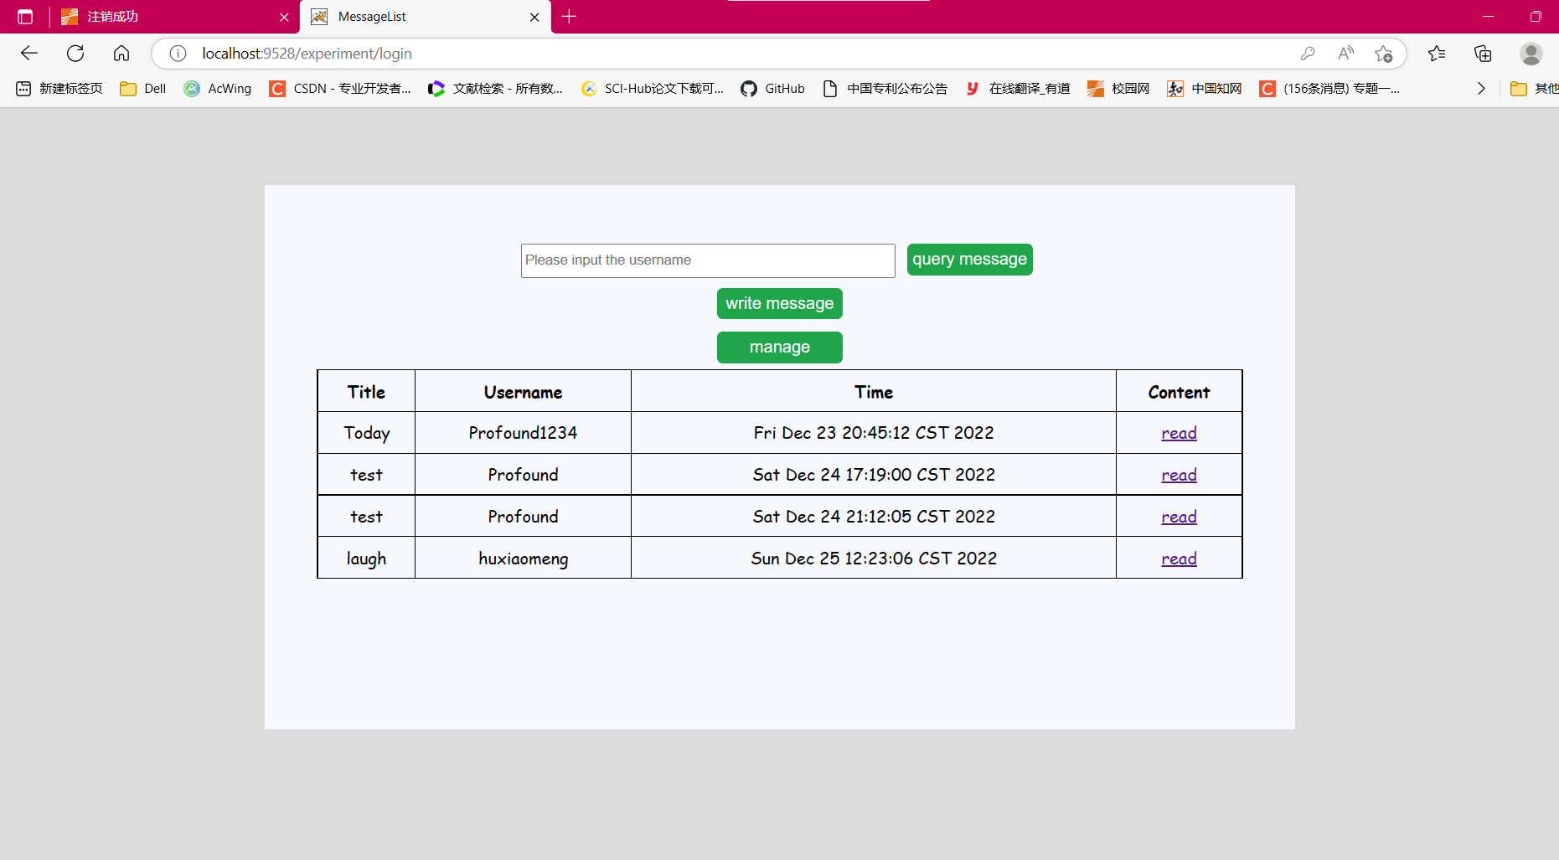
--------------主页留言列表模块messagelist.jsp代码---------------
<body>
<%@ taglib prefix = "c" uri = "http://java.sun.com/jsp/jstl/core" %>
<%@ page import = "java.util.*, com.github.business.*, com.github.dao.*, com.github.service.*" %>
<div class = "box">
<div>
<form action = "Message?action=queryMessage" method = "post">
<input type = "text" name = "username" placeholder = "Please input the username">
<input type = "submit" value = "query message" id = "submit">
</form>
</div>
<div>
<form action = "Message?action=writeMessage" method = "post">
<input type = "submit" value = "write message" id = "submit">
</form>
<form action = "Message?action=manageMessage" method = "post">
<input type = "submit" value = "manage" id = "submit">
</form>
</div>
<div>
<table>
<tr>
<th>Title</th>
<th>Username</th>
<th>Time</th>
<th>Content</th>
</tr>
<%
MessageService messageService = new MessageService();
ArrayList<Message> msglist = (ArrayList<Message>)session.getAttribute("msglist");
if (msglist != null){
Iterator iter = msglist.iterator();
while(iter.hasNext()){
Message msg = (Message)iter.next();
%>
<tr>
<td><%=msg.getTitle() %></td>
<td><%=messageService.getUsername(msg.getUser_id()) %></td>
<td><%=msg.getTime() %></td>
<td><a href = "Message?action=readMessage&message_id=<%=msg.getMessage_id() %>">read</a>
<c:if test = "${user.authority == 1}">
<td><a href = "Message?action=deleteMessage&message_id=<%=msg.getMessage_id() %>">delete</a>
</td>
</c:if>
</tr>
<%
}
}
%>
</table>
</div>
</div>
</body>

- 发布留言模块
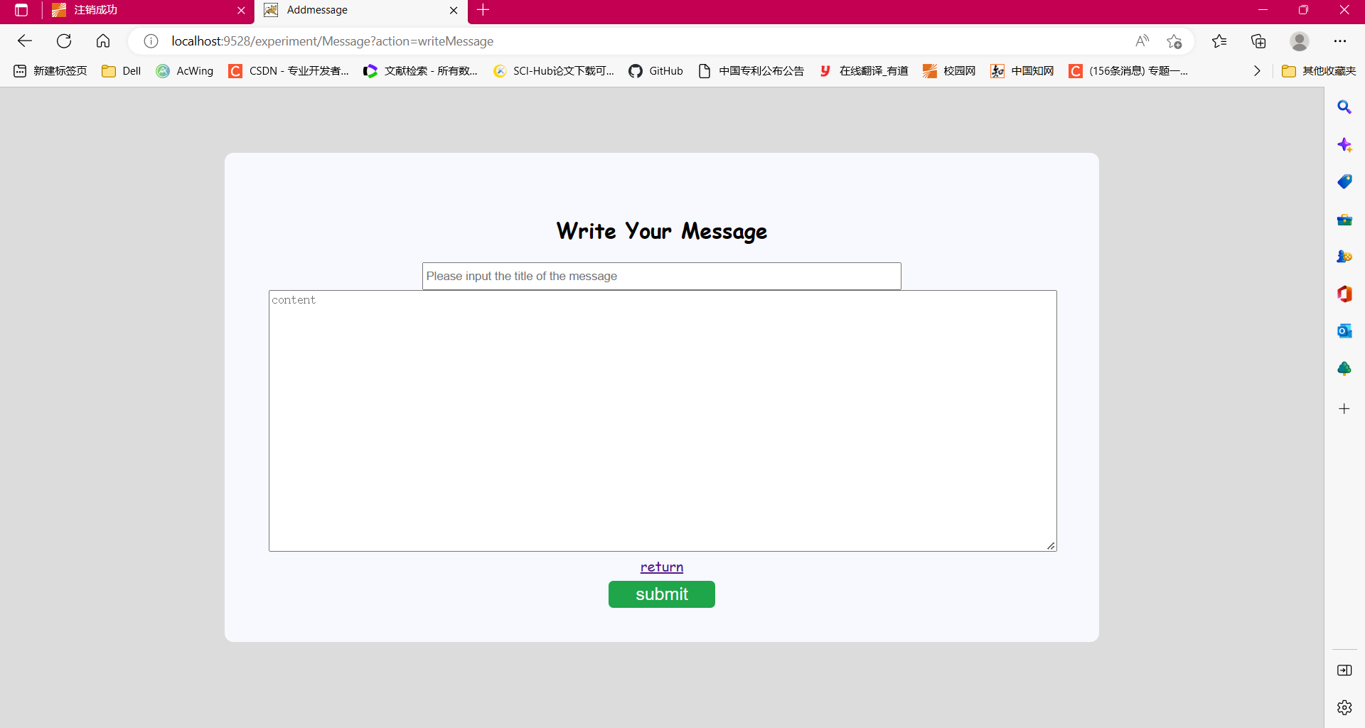
--------------主页留言列表模块addmessage.jsp代码---------------
<body>
<div class = "box">
<h2>Write Your Message</h2>
<form action="Message?action=submitMessage" method="post">
<div>
<input type="text" name="title" placeholder="Please input the title of the message" required>
</div>
<div>
<textarea rows="20" cols="120" name="content" placeholder="content" required></textarea>
</div>
<a href = "Message?action=returnMessage">return</a>
<div>
<input type="submit" value ="submit" id = "submit">
</div>
</form>
</div>
</body>
-------------------发布留言servlet端代码----------------------
UserService userService = new UserService();
MessageService messageService = new MessageService();
CommentService commentService = new CommentService();
String action = request.getParameter("action");
String url = "/messagelist.jsp";
if (action.equals("submitMessage")) {
HttpSession session = request.getSession();
User user = (User)session.getAttribute("user");
Message message = new Message();
message.setUser_id(user.getId());
message.setTime(new Date(System.currentTimeMillis()).toString());
message.setTitle(request.getParameter("title"));
message.setContent(request.getParameter("content"));
int i = messageService.insert_message(message);
System.out.println(i);
if(i == 1) {
url = "/messagelist.jsp";
ArrayList<Message> msglist = messageService.getMessage();
session.setAttribute("msglist", msglist);
}
else {
url = "/addmessage.jsp";
}
}
-------------------发布留言DAO层代码----------------------
//插入留言信息
public static int insert_message(Message message) {
Connection con = JdbcUtil.getConnection();
String prepareSQL = "insert into message values(?,?,?,?,?)";
PreparedStatement ps = null;
int i = 0;
try {
ps = con.prepareStatement(prepareSQL);
ps.setInt(1, message.getMessage_id());
ps.setInt(2, message.getUser_id());
ps.setString(3, message.getTime());
ps.setString(4, message.getTitle());
ps.setString(5, message.getContent());
i = ps.executeUpdate();
} catch(SQLException e) {
e.printStackTrace(); //插入记录失败
i = 0;
} finally {
JdbcUtil.release(null, ps, con);
}
return i;
} public static int insert_message(Message message) {
Connection con = JdbcUtil.getConnection();
String prepareSQL = "insert into message values(?,?,?,?,?)";
PreparedStatement ps = null;
int i = 0;
try {
ps = con.prepareStatement(prepareSQL);
ps.setInt(1, message.getMessage_id());
ps.setInt(2, message.getUser_id());
ps.setString(3, message.getTime());
ps.setString(4, message.getTitle());
ps.setString(5, message.getContent());
i = ps.executeUpdate();
} catch(SQLException e) {
e.printStackTrace(); //插入记录失败
i = 0;
} finally {
JdbcUtil.release(null, ps, con);
}
return i;
}
//得到所有留言信息
public static ArrayList<Message> getMessage(){
ArrayList msglist = new ArrayList();
Connection con = null;
Statement stat = null;
ResultSet rs = null;
try {
con = JdbcUtil.getConnection();
String SQL = "select * from message";
stat = con.createStatement();
rs = stat.executeQuery(SQL);
while(rs.next()){
Message msg = new Message();
msg.setMessage_id(rs.getInt(1));
msg.setUser_id(rs.getInt(2));
msg.setTime(rs.getString(3));
msg.setTitle(rs.getString(4));
msg.setContent(rs.getString(5));
msglist.add(msg);
}
}catch(SQLException e) {
e.printStackTrace(); //查询失败
msglist = null;
} finally {
JdbcUtil.release(rs, stat, con);
}
return msglist;
}
- 留言详情模块
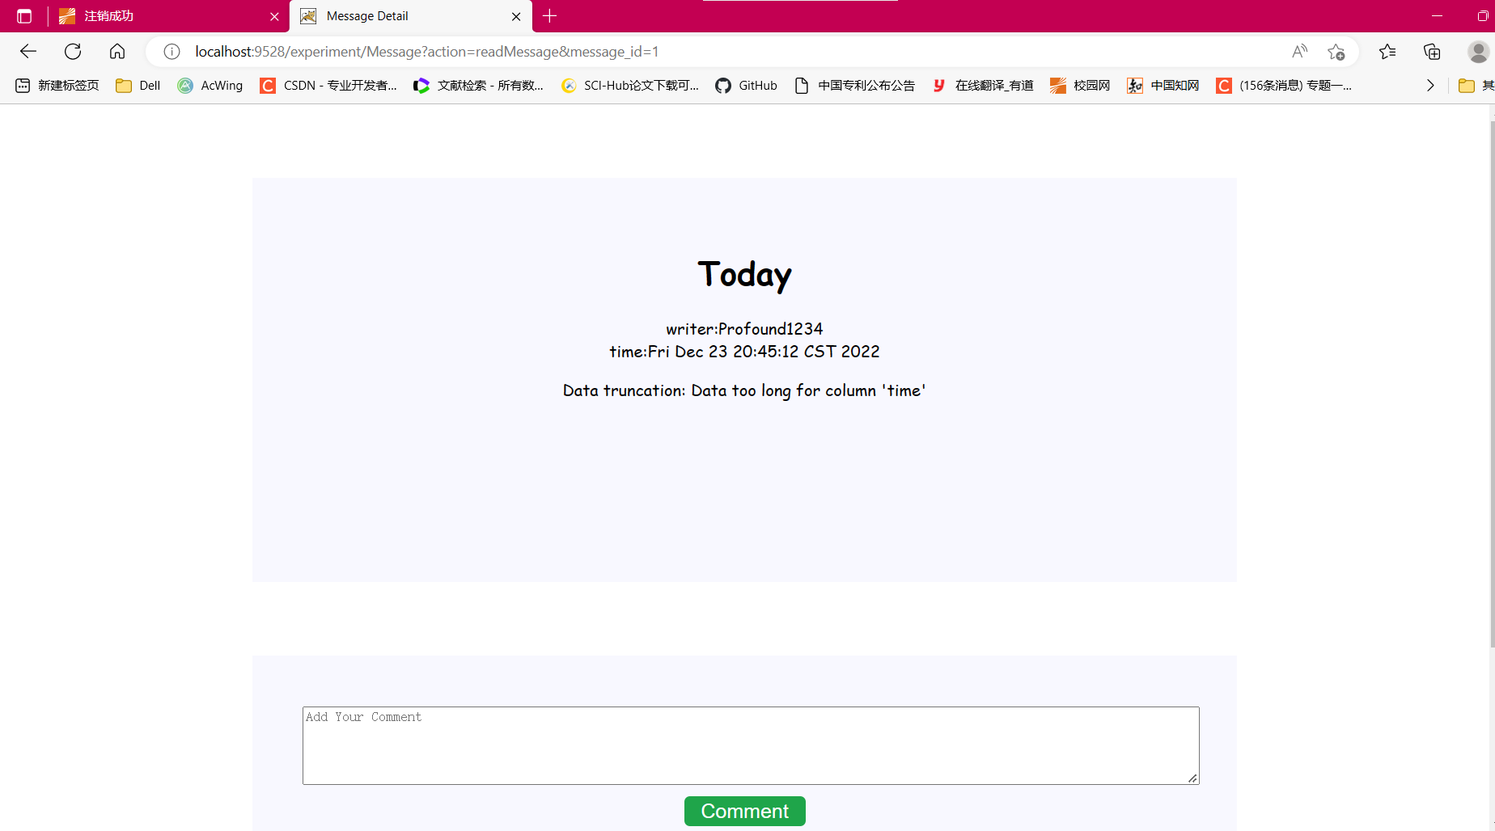
-------主页留言列表和发表评论模块messagedetail.jsp代码----------
<body>
<%@ page import = "com.github.business.*, com.github.dao.*, java.util.*, com.github.service.*" %>
<%
MessageService messageService = new MessageService();
CommentService commentService = new CommentService();
Message msg_detail = (Message)session.getAttribute("msg_detail");
%>
<div class = "box">
<h1><%=msg_detail.getTitle() %></h1>
<div>
writer:<%=messageService.getUsername(msg_detail.getUser_id()) %><br>
time:<%=msg_detail.getTime() %>
</div>
<p><%=msg_detail.getContent() %></p>
</div>
<div class = "box">
<form action = "Message?action=addComment" method = "post">
<textarea rows="5" cols="120" name="content" placeholder="Add Your Comment" required></textarea>
<input type = "submit" value = "Comment" id ="submit">
</form>
<table>
<%
System.out.println(msg_detail.getMessage_id());
ArrayList<Comment> c = commentService.queryComment(msg_detail.getMessage_id());
if (c != null){
Iterator iter = c.iterator();
while(iter.hasNext()){
Comment comment = (Comment)iter.next();
%>
<tr>
<td>
<%=messageService.getUsername(comment.getUser_id()) %> &nbsp;&nbsp;
<%=comment.getTime() %> <br>
<%=comment.getComment_content() %>
</td>
</tr>
<%
}
}
%>
</table>
</div>
</body>
-------------------查看留言详情servlet端代码------------------
else if(action.equals("readMessage")) {
//得到要阅读的留言信息
String messageId = request.getParameter("message_id");
HttpSession session = request.getSession();
ArrayList<Message> msglist = (ArrayList<Message>)session.getAttribute("msglist");
Iterator iter = msglist.iterator();
Message msg_detail = null;
while(iter.hasNext()){
Message msg = (Message)iter.next();
if(msg.getMessage_id() == Integer.parseInt(messageId)){
//找到对应留言信息
msg_detail = msg;
break;
}
}
session.setAttribute("msg_detail", msg_detail);
url = "/messagedetail.jsp";
}
-------------------查看留言详情dao端代码------------------
public static String getUsername(int id) {
//由用户id获取其用户名
String username = "";
Connection con = null;
PreparedStatement ps = null;
ResultSet rs = null;
String prepareSQL = "select username from user where id = ?";
try {
con = JdbcUtil.getConnection();
ps = con.prepareStatement(prepareSQL);
ps.setInt(1, id);
rs = ps.executeQuery();
if(rs.next()) {
username = rs.getString(1);
}
}catch(Exception e) {
e.printStackTrace();
} finally {
JdbcUtil.release(rs, ps, con);
}
return username;
}
6.发表评论模块
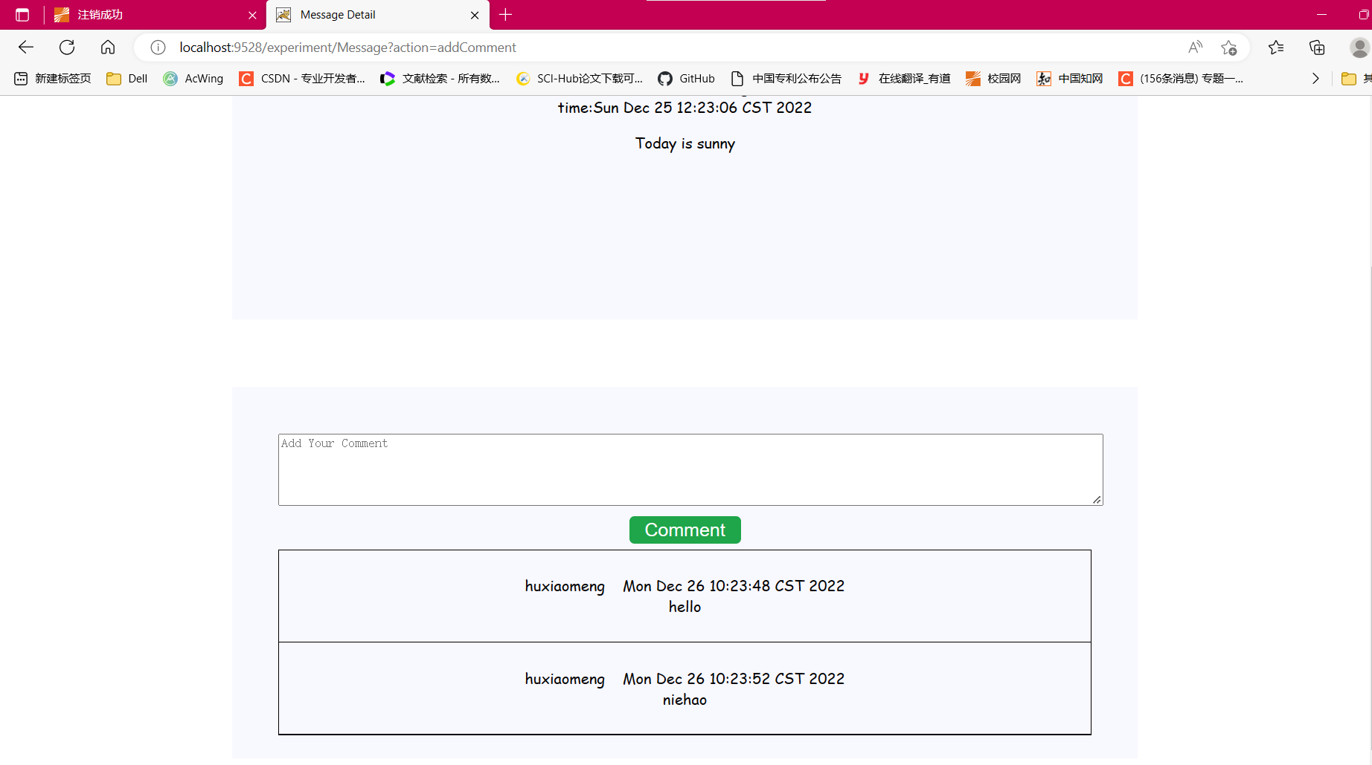
----------------发表评论模块servlet代码-----------------------
else if(action.equals("addComment")) {
url = "/messagedetail.jsp";
String Comment = request.getParameter("content");
Comment comment = new Comment();
HttpSession session = request.getSession();
int message_id = ((Message)session.getAttribute("msg_detail")).getMessage_id();
User user = (User)session.getAttribute("user");
comment.setMessage_id(message_id);
comment.setUser_id(user.getId());
comment.setComment_content(Comment);
comment.setTime(new Date(System.currentTimeMillis()).toString());
int i = commentService.insert_comment(comment);
}
----------------发表评论模块DAO层代码-----------------------
public static int insert_comment(Comment comment) {
Connection con = JdbcUtil.getConnection();
String prepareSQL = "insert into comment values(?,?,?,?,?)";
PreparedStatement ps = null;
int i = 0;
try {
ps = con.prepareStatement(prepareSQL);
ps.setInt(1, comment.getComment_id());
ps.setInt(2, comment.getMessage_id());
ps.setInt(3, comment.getUser_id());
ps.setString(4, comment.getComment_content());
ps.setString(5, comment.getTime());
i = ps.executeUpdate();
} catch(SQLException e) {
e.printStackTrace(); //插入记录失败
i = 0;
} finally {
JdbcUtil.release(null, ps, con);
}
return i;
}
//显示出该留言所有评论
public static ArrayList<Comment> queryComment(int message_id){
//根据留言名查找所有评论
Connection con = JdbcUtil.getConnection();
String prepareSQL = "select * from comment where message_id = ?";
PreparedStatement ps = null;
ResultSet rs = null;
ArrayList<Comment> c = new ArrayList<Comment>();
try {
ps = con.prepareStatement(prepareSQL);
ps.setInt(1, message_id);
rs = ps.executeQuery();
while(rs.next()) {
Comment comment = new Comment();
comment.setComment_id(rs.getInt(1));
comment.setMessage_id(rs.getInt(2));
comment.setUser_id(rs.getInt(3));
comment.setComment_content(rs.getString(4));
comment.setTime(rs.getString(5));
c.add(comment);
}
} catch(Exception e) {
e.printStackTrace();
} finally {
JdbcUtil.release(rs, ps, con);
}
return c;
}
7.搜索留言
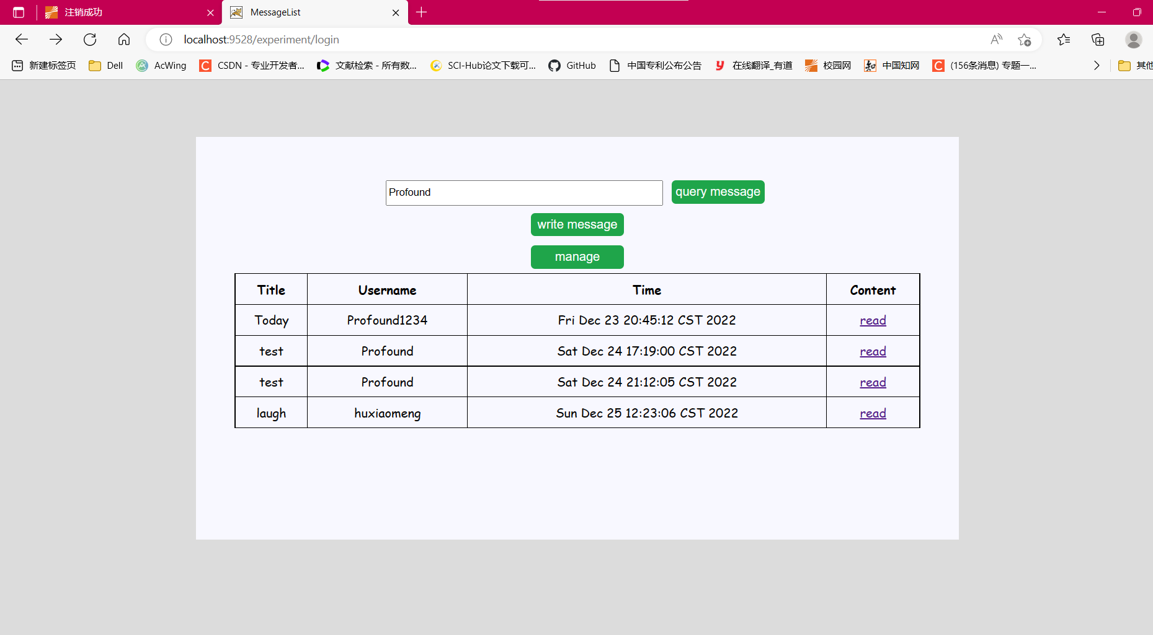
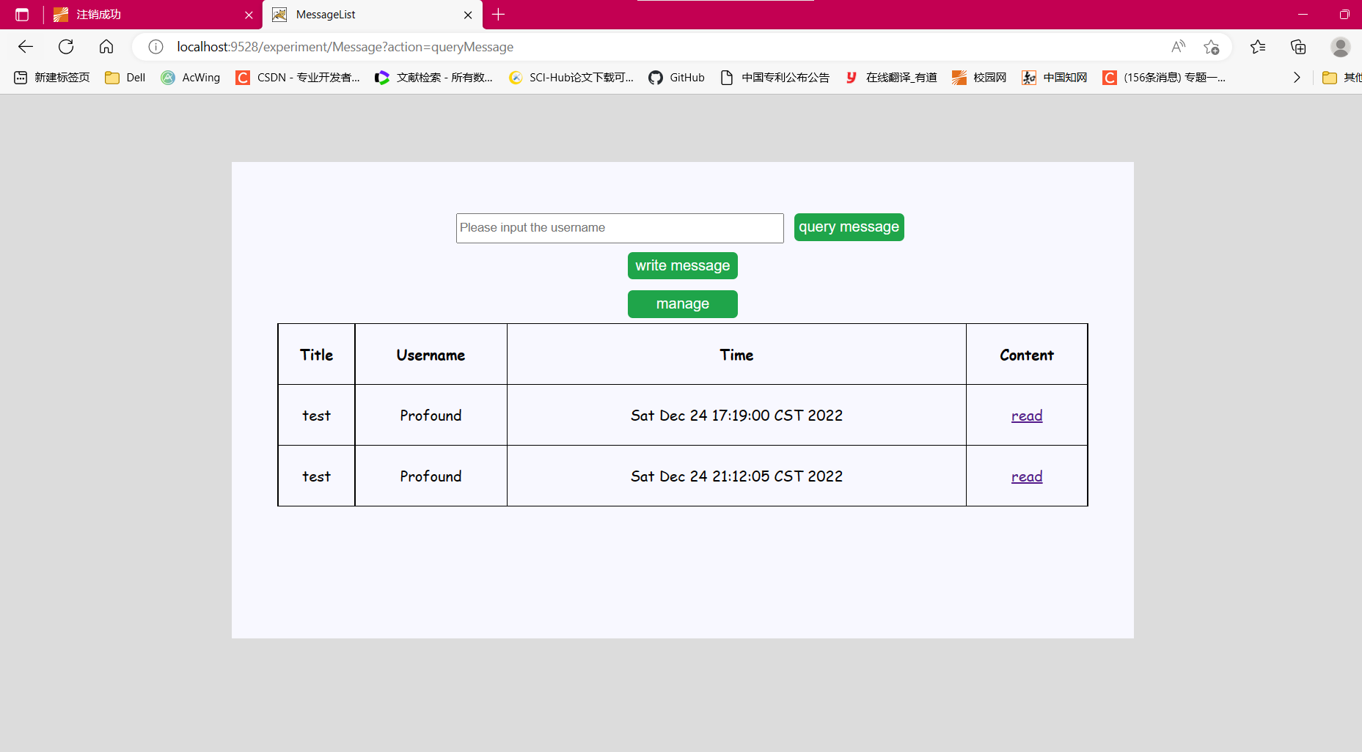
----------------搜索模块servlet代码-----------------------
else if(action.equals("queryMessage")) {
url = "/messagelist.jsp";
String username = request.getParameter("username");
HttpSession session = request.getSession();
ArrayList<Message> msglist = (ArrayList<Message>)session.getAttribute("msglist");
ArrayList<Message> t = new ArrayList<Message>();
Iterator iter = msglist.iterator();
while(iter.hasNext()){
Message msg = (Message)iter.next();
if(messageService.getUsername(msg.getUser_id()).equals(username)){
t.add(msg);
}
}
session.setAttribute("msglist", t);
}
- 后台管理页面
1.对留言删除
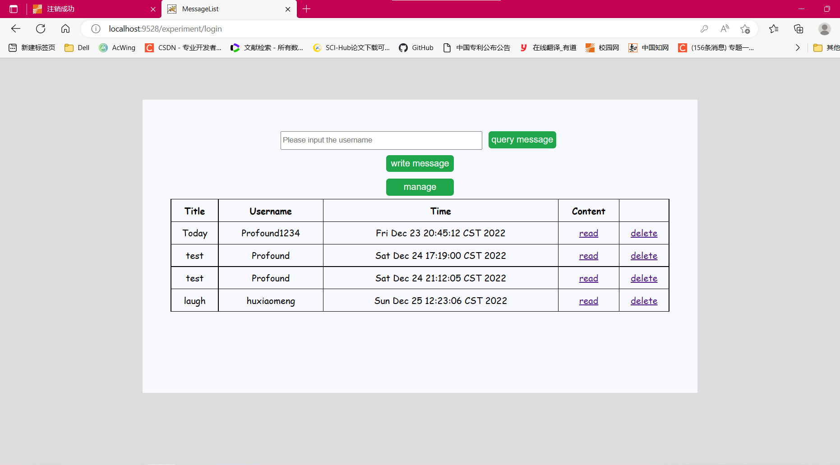
----------------留言删除模块servlet代码-----------------------
else if(action.equals("deleteMessage")) {
//得到要删除的留言信息
HttpSession session = request.getSession();
url = "/messagelist.jsp";
String messageId = request.getParameter("message_id");
if(messageService.delete_message(Integer.parseInt(messageId))) {
//删除成功
System.out.println("删除成功！");
ArrayList<Message> msglist = messageService.getMessage();
session.setAttribute("msglist", msglist);
}
}
----------------删除留言模块DAO层代码-----------------------
public static Boolean delete_message(int message_id) {
//获取数据库连接
Connection con = JdbcUtil.getConnection();
//先删除该留言对应的所有评论
String sql1 = "delete from comment where message_id = ?";
//删除该留言
String sql2 = "delete from message where message_id = ?";
PreparedStatement ps1 = null;
PreparedStatement ps2 = null;
Boolean flag = true;
try {
ps1 = con.prepareStatement(sql1);
ps1.setInt(1, message_id);
ps1.executeUpdate();
} catch(Exception e) {
e.printStackTrace();
flag = false;
}
try {
ps2 = con.prepareStatement(sql2);
ps2.setInt(1, message_id);
ps2.executeUpdate();
} catch(Exception e) {
e.printStackTrace();
flag = false;
}
JdbcUtil.release(null, ps1, null);
JdbcUtil.release(null, ps2, con);
return flag;
}
- 对用户管理

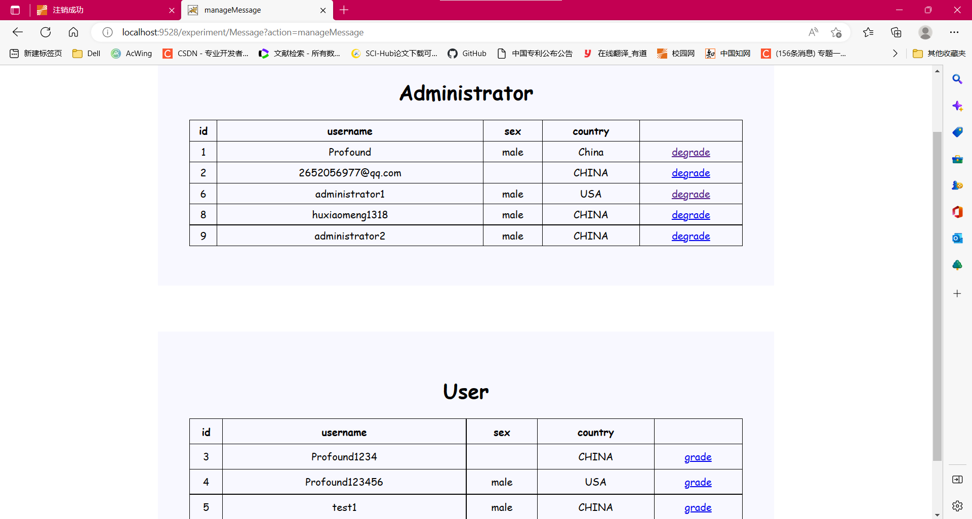
--------------用户管理模块manageMessage.jsp代码----------------
<body>
<div class = "box">
<h1>Administrator</h1>
<table>
<tr>
<th>id</th>
<th>username</th>
<th>sex</th>
<th>country</th>
</tr>
<c:forEach var = "c" items = "${adminlist}">
<tr>
<td>${c.id}</td>
<td>${c.username}</td>
<td>${c.sex}</td>
<td>${c.country}</td>
<td><a href = "Message?action=degrade&id=${c.id}">degrade</a></td>
</tr>
</c:forEach>
</table>
</div>
<div class = "box">
<h1>User</h1>
<table>
<tr>
<th>id</th>
<th>username</th>
<th>sex</th>
<th>country</th>
</tr>
<c:forEach var = "c" items = "${userlist}">
<tr>
<td>${c.id}</td>
<td>${c.username}</td>
<td>${c.sex}</td>
<td>${c.country}</td>
<td><a href = "Message?action=grade&id=${c.id}">grade</a></td>
</tr>
</c:forEach>
</table>
</div>
</body>
----------------用户管理模块servlet代码-----------------------
else if(action.equals("manageMessage")) {
url = "/manageMessage.jsp";
ArrayList<User> userlist = messageService.getUser();
ArrayList<User> adminlist = messageService.getAdministrator();
HttpSession session = request.getSession();
session.setAttribute("userlist", userlist);
session.setAttribute("adminlist", adminlist);
}
else if(action.equals("grade")) {
//将用户升级管理员
String id = request.getParameter("id");
userService.grade(Integer.parseInt(id));
}
else if(action.equals("degrade")){
//将管理员降级为普通用户
String id = request.getParameter("id");
userService.degrade(Integer.parseInt(id));
}
----------------用户管理模块DAO层代码-----------------------
//得到所有的普通用户
public static ArrayList<User> getUser(){
ArrayList userlist = new ArrayList();
Connection con = null;
Statement stat = null;
ResultSet rs = null;
String SQL = "select * from user where authority = 0"; //查找普通用户
try {
con = JdbcUtil.getConnection();
stat = con.createStatement();
rs = stat.executeQuery(SQL);
while(rs.next()) {
User user = new User();
user.setId(rs.getInt(1));
user.setUsername(rs.getString(2));
user.setPassword(rs.getString(3));
user.setSex(rs.getString(4));
user.setCountry(rs.getString(5));
user.setAuthority(rs.getInt(6));
userlist.add(user);
}
}catch(Exception e) {
e.printStackTrace();
userlist = null;
} finally {
JdbcUtil.release(rs, stat, con);
}
return userlist;
}
//得到所有的管理员
public static ArrayList<User> getAdministrator(){
ArrayList adminlist = new ArrayList();
Connection con = null;
Statement stat = null;
ResultSet rs = null;
String SQL = "select * from user where authority = 1"; //查找普通用户
try {
con = JdbcUtil.getConnection();
stat = con.createStatement();
rs = stat.executeQuery(SQL);
while(rs.next()) {
User user = new User();
user.setId(rs.getInt(1));
user.setUsername(rs.getString(2));
user.setPassword(rs.getString(3));
user.setSex(rs.getString(4));
user.setCountry(rs.getString(5));
user.setAuthority(rs.getInt(6));
adminlist.add(user);
}
}catch(Exception e) {
e.printStackTrace();
adminlist = null;
} finally {
JdbcUtil.release(rs, stat, con);
}
return adminlist;
}
--------------------------------------------------------------
连接数据库Util类：
//获取连接
public static Connection getConnection() {
Connection con = null;
try {
Class.forName("com.mysql.cj.jdbc.Driver");
String dbURL = "jdbc:mysql://localhost:3306/web";
String username = "root";
String password = "123456";
con = DriverManager.getConnection(dbURL, username, password);
return con;
} catch(Exception e) {
e.printStackTrace();
return null;
}
}
//释放资源
public static void release(ResultSet rs, Statement stat, Connection con) {
//释放资源
if (rs != null) {
try {
rs.close();
} catch (SQLException e) {
e.printStackTrace();
}
}
if (stat != null) {
try {
stat.close();
} catch (SQLException e) {
e.printStackTrace();
}
}
if (con != null) {
try {
con.close();
} catch (SQLException e) {
e.printStackTrace();
}
}
}

五、心得总结（包括项目缺点、改进方案、遇到的困难及解决途径等）
1.通过本次实验，我对web技术分层开发有了更深的认识，深入感受了MVC模式开发各个模块的作用，学会了如何使用前端技术和后端技术以及他们之间的联系。
2.在该项目中，我觉的自己的最大缺点是JSP页面写的不好。为了实现一些功能，我使用了大量的嵌套java语句。这是由于我对EL和JSTL的掌握很少，导致在写JSP页面时遇到了很大的困难，在写JSP页面时不得不使用一些嵌套java代码来实现具体的功能。在以后的改进中，可以尝试用EL或JSTL来替代java代码。
3.做项目中我遇到的另一大困难是自己css代码写的不好。
自己不知道怎么将一个元素放到自己想要的位置，不清楚怎么调样式，导致自己的页面做出来使用性很差。
4.一开始时写项目时思路不清楚，总是写完了又改，对MVC模式的了解不够，导致在写代码过程中不能够正确划分各个模块。在不断的调试中掌握了MVC各个模块应该承担的任务，之后通过划分各个模块到各自包中使得项目架构更加清晰，代码易于理解和调试。
5.一开始对数据库的连接操作不是很熟练，经过反复练习，熟悉了连接数据库的一般步骤，问题得到解决。

参考文献
[1]梁胜彬、乔保军：《Java Web 应用开发与实践》，清华大学出版社，2012

