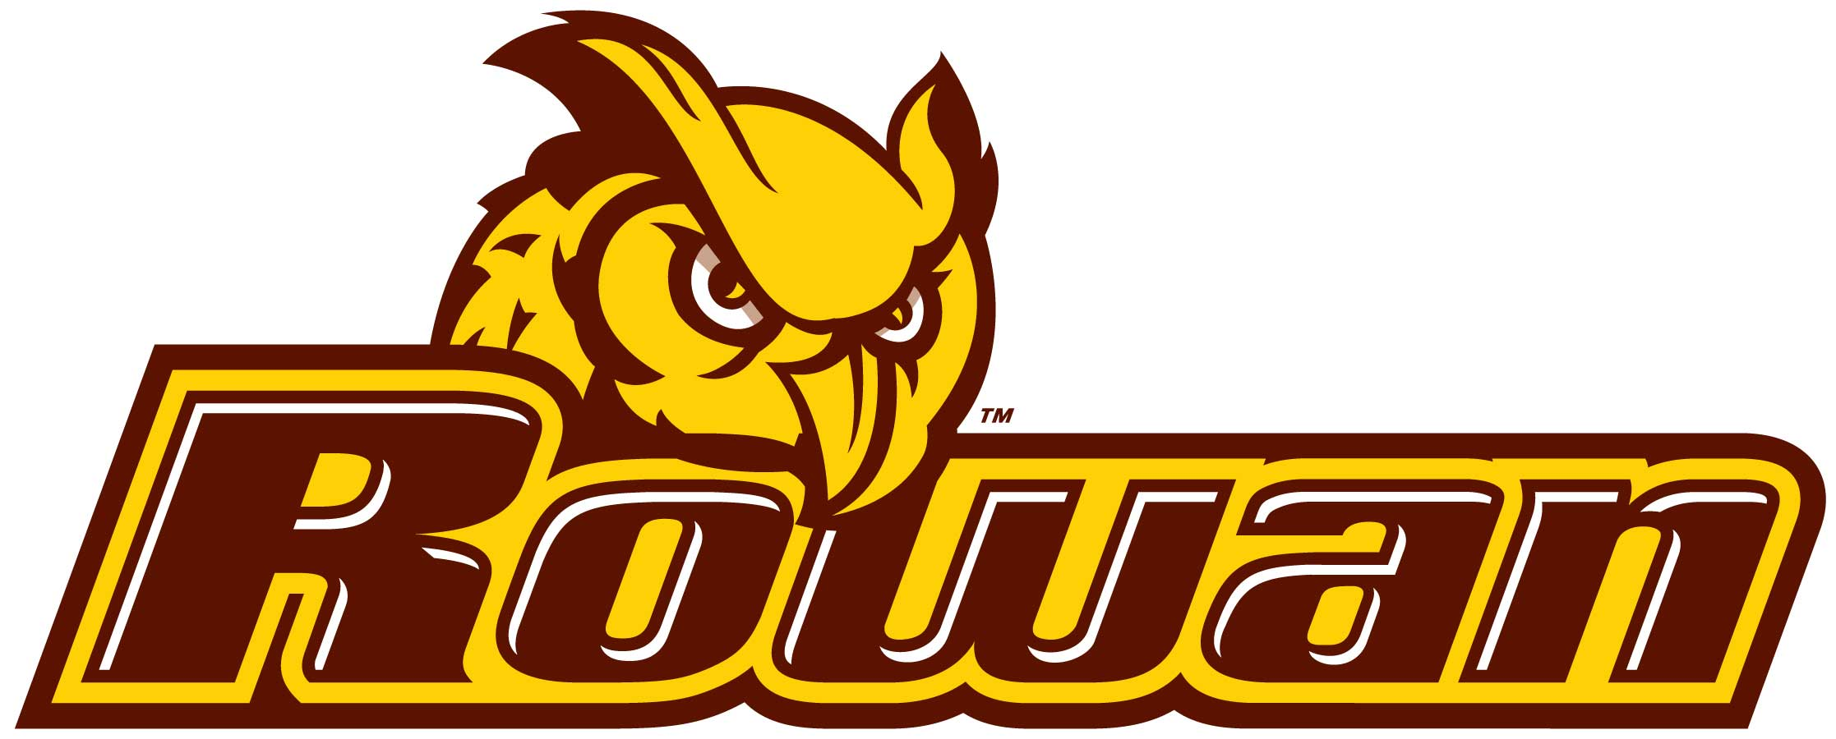

**SW Engineering Tool Suite**

***Rowan University Senior Project Dr. Baliga***

Principle Innovators:

**Dharmik Pandya Yousuf Ahmed Roger Miller Cole Christensen Tim McClintock Krunal Patel**

***https://github.com/computer-science-team/seniorproject101***

Project Title***: “Software Engineering Tool Suite”***

Project Summary:

Rowan University - Software Engineering Tool Suite (RU-SWETS) is a web based social toolkit framework that organizes software engineering resources into Student *Artifacts* stored within a *Toolkit*, which is based upon available resources to Students in Engineering majors at Rowan University. This app will help Rowan University make available a universal set of resources Students in Engineering majors will need throughout their respective College experiences. One example of a Student *Artifact* available within the *Toolkit* framework is “The Wallet”. “The Wallet” maintains "Cards" that are stored categorically. When an Engineer requires a specific “Card” from “The Wallet”, they may choose the “Card” based on the need for their project and what is available at their University. Another artifact is “The Keyring”. “The Keyring” stores basic information the user needs to maintain multiple social accounts for their courses. This tool will enable Universities to eliminate the downtime needed for Students to learn tools that may be recurring throughout their Student careers. This framework will also optimize available resources that exist for Students which might initially be unknown to them such as Microsoft student tools, Hackathons and contests, and Subscriptions to tutorial sites, discount sites, and magazines. The tools will be ranked by Popularity (Trends), Frequency of Use (How many times it is used), and Relevancy (What capabilities it is best known for).

Project Goals:

The initial goals that are fundamental to the overall success of this project include:

1. A Working website that is available and error free (respectively.)
2. A Database with the ability to store information appropriately.
3. User friendly web interface that includes sign on (Login) and sign up (Register)
4. API Framework that is scalable.

Product Features:

The product features will include:

* A University Specific Toolkit
  + The Wallet
    - Cards
  + Keyring
    - Accounts
* Front End User Interface
* Back End Server
  + Database Services
  + Web Hosted
  + API Accessibility
  + Required encryption for stored credentials.
* API Definitions

Project Limitations:

Threats that have been analyzed and anticipated include a lack of time and material resources. This project is being architected to embrace engineering concepts and programming concepts that have been learned throughout our collective experiences as Students at Rowan University. Outside of this scope we face challenges in knowledge gathering. It is imperative that we quickly learn how to better ascertain the tools that other Universities are using, and from an Administrative standpoint, which frameworks Universities are already using for the deployment of ‘like’ resources that benefit their Students and that may compete with our Tool/Web Service.

Project Stretch Goals:

The vision of this group is that we may develop this web app into a mobile app available on Android and Mac OS platforms. We desire scalability and reusability so cloud services are the most optimal end game to support our application. Once scalability and mobility are achieved we wish to extend this App from a Rowan University App to a multi-University adjustable framework that features advanced security through complex algorithmic encryption methods. This is designed to eventually become a social media tool which many Universities can create adaptations from. At this stage, our project will develop a self-formed community of networked professionals who can share tools and create fast forming teams based upon the latest available tools. In turn, it is our hope that our tool may effectively accelerate learning, especially in the field of Computer Science.