

**COMSATS University Islamabad,**



**COMSATS Road, off GT Road, Sahiwal, Pakistan**

**SOFTWARE DESIGN**

**DESCRIPTION**

**(SDD DOCUMENT)**

**for**

**<** Photography Market Place **>**

Version 1.0

***By***

**M. Azeem Anjum** **CIIT/SP16-BCS-033/SWL**

**M. Zain Haider** **CIIT/SP16-BCS-046/SWL**

***Supervisor***

***Muhammad Usman Nasir***

***Bachelor of Science in Computer Science (2016-2020)***

Contents

Table of Figures: 3

Revision History 4

Application Evaluation History 5

1. Introduction 6

2. Scope 6

3. Design methodology and software process model 6

**3.1 Incremental Model** 6

**3.2 Agile Model** 7

4. System overview 7

5. Architectural design 7

**5.1 Process flow/Representation** 9

6. Design models 10

7. Data design 12

8. Data dictionary 12

9. Algorithm & Implementation 13

10. Human interface design 13

**10.1 Screen images** 14

**10.2 Screen objects and actions** 15

# Table of Figures:

Figure 1: Architecture design using Model View Controller 8

Figure 2: Architecture design System 8

Figure 3: Flow Chart 9

Figure 4: Sequence Diagram 10

Figure 5 : Class Diagram 11

Figure 5 : DFD Level 0 11

Figure 6: DFD Level 1 12

Figure 8: Screen image 1 14

Figure 9: Screen image 2 14

# Revision History

|  |  |  |  |
| --- | --- | --- | --- |
| **Name** | **Date** | **Reason for changes** | **Version** |
|  |  |  |  |
|  |  |  |  |
|  |  |  |  |

# Application Evaluation History

|  |  |
| --- | --- |
| **Comments (by committee)**  *include the ones given at scope time both in doc and presentation | **Action taken** |
|  |  |
|  |  |

**Supervised by**

**<Muhammad Usman Nasir>**

Signature______________

**Co-Supervised by**

**<Muhammad Amir >**

Signature______________

# 1. Introduction

Photography websites are spread over the whole country. They provide the basic facilities and functionalities to photographers which include their portfolio galleries and their e-stores to sell their products like photographs, Photoshop actions, presets and plug-in. Freelancer websites are also providing a lot of freelance work for photographers and clients in foreign countries but are not doing well in our country. Similarly, online photography competitions are also a main trend nowadays. These systems lack multiple facilities for their users and are a waste of time and money for those who need all these facilities like, the photographers who need to build their own portfolio website have to build a new system from scratch on which they can display their portfolio gallery and sell their products. This process is very time consuming and waste of money for buying domains, hosting and paying to the developers. That’s the point where it is needed to build a website which include all these features and merging them into a single website so users do not have to waste their time by going onto different websites to perform their tasks or pay heavily for building their profiles. We are providing a single platform which performs almost every basic task related to photography which all the photographers and people interested in this field are looking for, so they can get all that facilities which they need under a single platform.

# 2. Scope

The system aims to develop a batch advisory system related to the needs of academic institutions. This primarily targets academic advisors (admins) and students, facilitating the efficient allocation of courses and the streamlined submission of online applications by the students.

# 3. Design methodology and software process model

## **3.1 Incremental Model**

Waterfall model has many drawbacks in the development of any product, to overcome these drawbacks incremental model is used in the development phase of our project. In this model the product is developed in increments and in module wise one after one, each modules contains more functionalities than before. These smaller pieces then built and delivered to client in increments. Quick response from clients. Each module is smaller than compare to whole module. This model is used in our project.

## **3.2 Agile Model**

When client don’t want changes in their product then Agile model is useful. This method assists teams in responding to the unpredictability of constructing software. It uses incremental, iterative work sequences that are commonly known as sprints. The ability to create and respond to change to succeed in an uncertain and turbulent environment.

# 4. System overview

This system will be used by clients and the buyers including the photographers. The scope of this system is restricted and it can be used with in our country only, starting from best photos to purchase and it also includes filters for the photographers to purchase to improve the quality of their photos within whole country. This will be a complete end to end system that will be designed in a very easy to use interface that can be used by everyone easily. After completion this will be uploaded to the host with a unique domain name in order to facilitate our local freelancers and photographers to earn within country with easy money transaction procedure. This system provides the best facilities and services to every photographer and freelancer in a certain environment which includes filter and photos purchasing. Basic e-commerce services, Maintenance of user’s accounts and data to be sell, Money transaction procedures are the services of the product. There should be a check and balance for the common facilities as well as it is also their responsibility to keep their earning environment clean to be facilitated. So that's why we thought of making a system that could help a lot than local dealers and sellers in performing their tasks way better than before. This system will have following module: User module, Admin module, Client Side. All modules will be responsive so that can easily be accessed by mobiles too.

# 5. Architectural design

The structure of the system explains its core components, their relationships, and how they deal with each other. Software architecture and design includes several factors such as business strategy, quality attributes, human dynamics, design and IT environment. In Architecture, nonfunctional decisions are cast and separated by the functional requirements. In Design, functional requirements are accomplished. Admin module is very important. It is a major module in this admin have all rights to manage system, sales, client members, message, feedback. Anyone can visit, anyone can visit the main page related to system and can get information and know about our system that how to use to system and how anyone can get their self-registered. A combination of the modules makes up the system. We can use flowcharts to represent and illustrate the architecture.

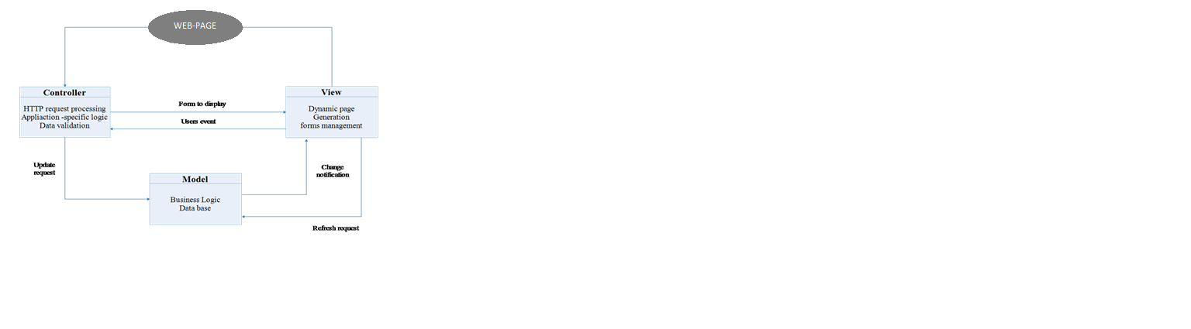

Figure 1: Architecture design using Model View Controller

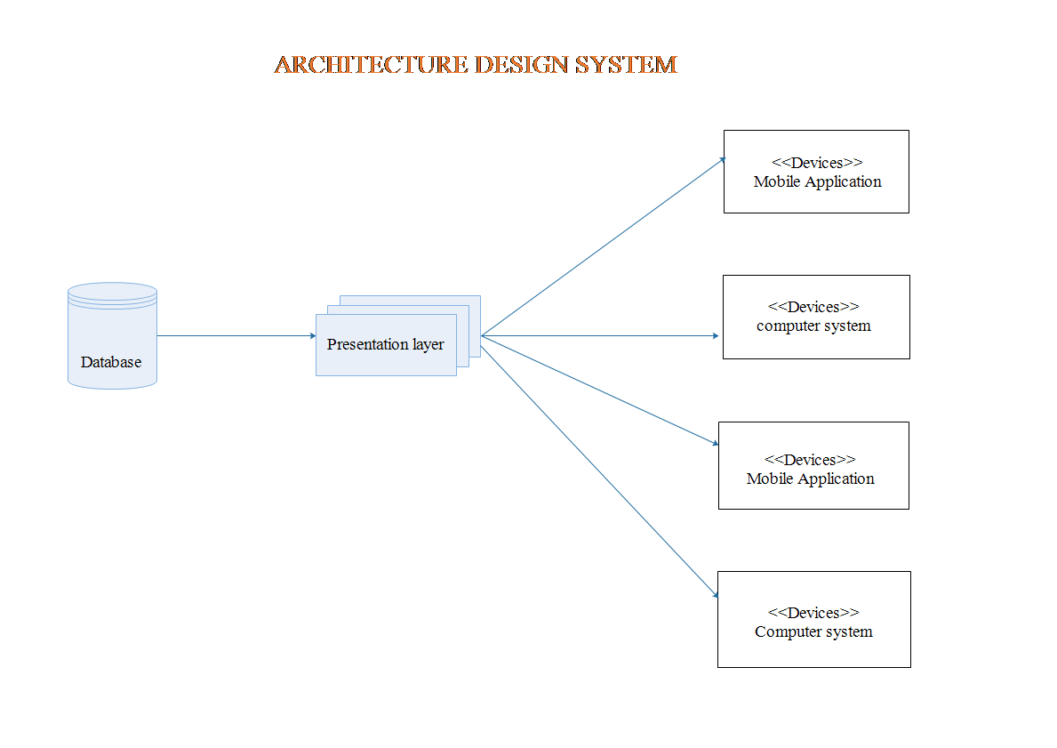

Figure 2: Architecture design System

## **5.1 Process flow/Representation**

**Flow Chart**

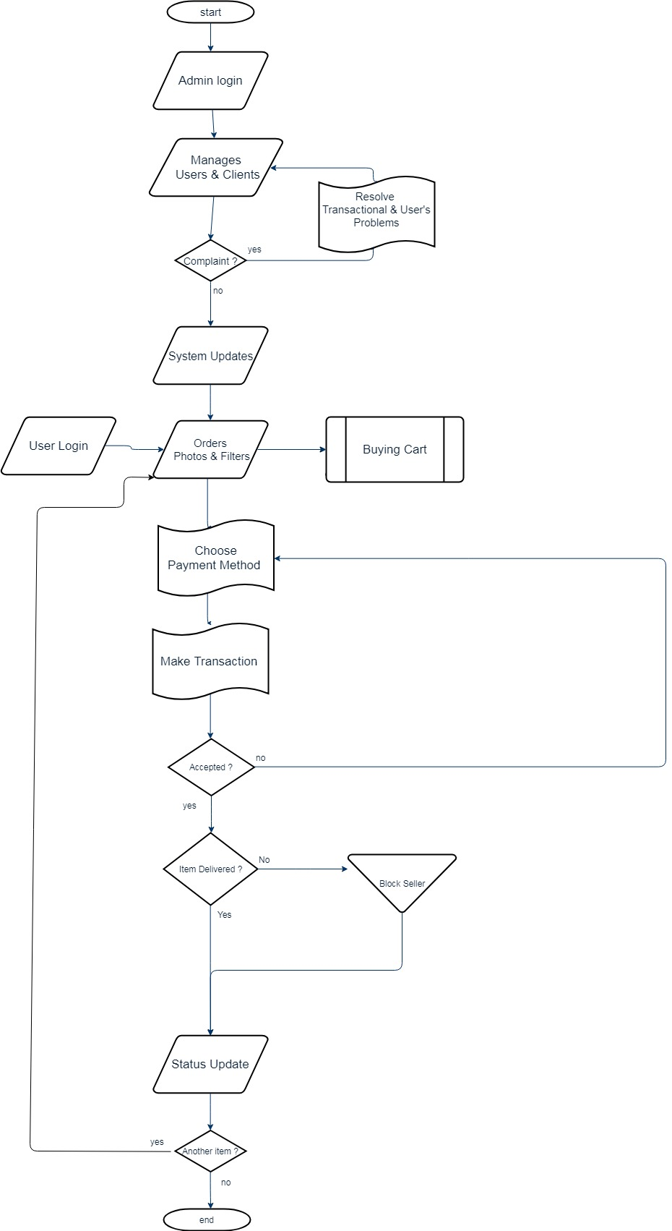

Figure 3: Flow Chart

# 6. Design models

**Sequence Diagram**

This image shows that how system will work, tasks after task with sequence wise. It gives the complete description the working of our system.

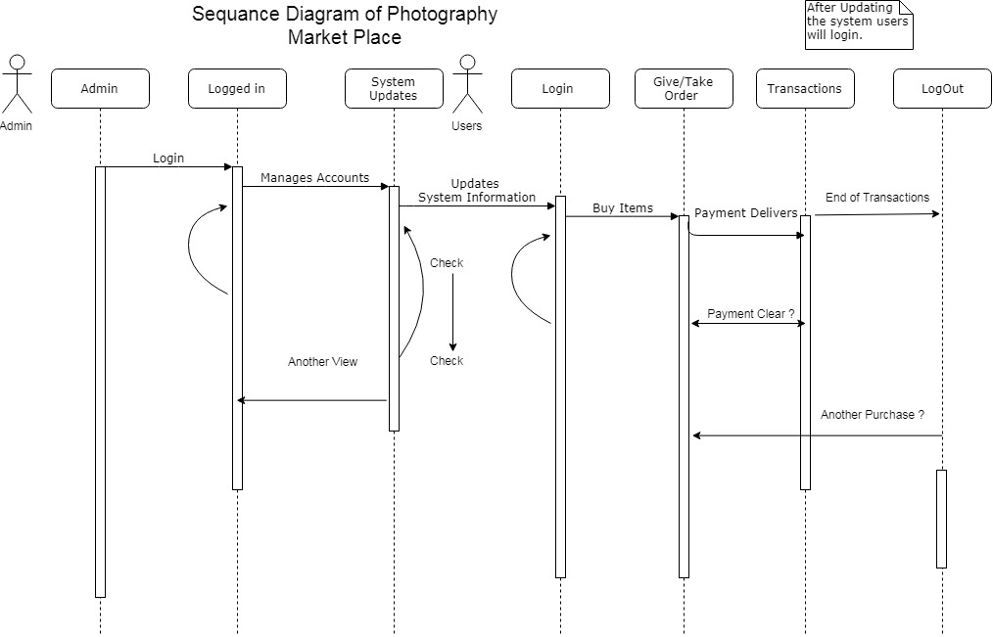

Figure 4: Sequence Diagram

**Class Diagram**

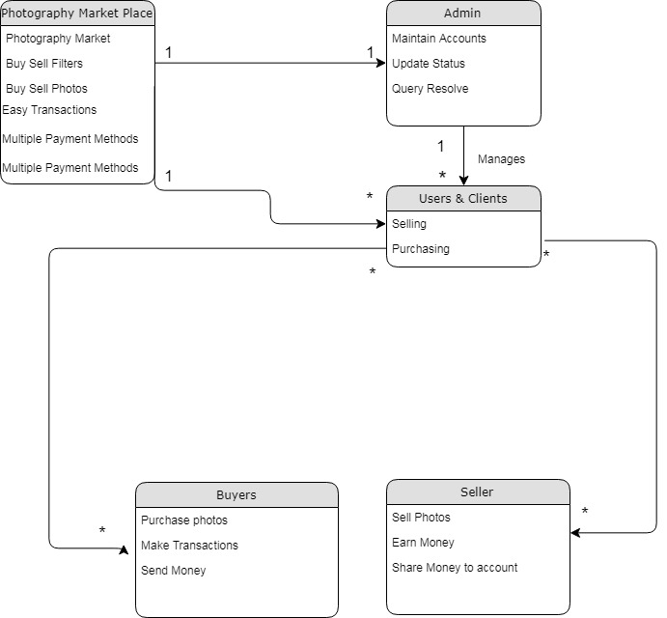

Figure 5 : Class Diagram

**Data Flow Diagram**

This diagram represents the flow of data or process of the system. It gives complete information about the outputs and generated after providing user’s inputs of each module and process itself**.**

**LEVEL 0:**

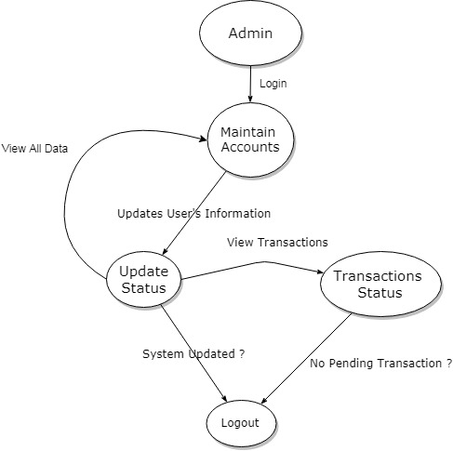

Figure 5 : DFD Level 0

**LEVEL 1:**

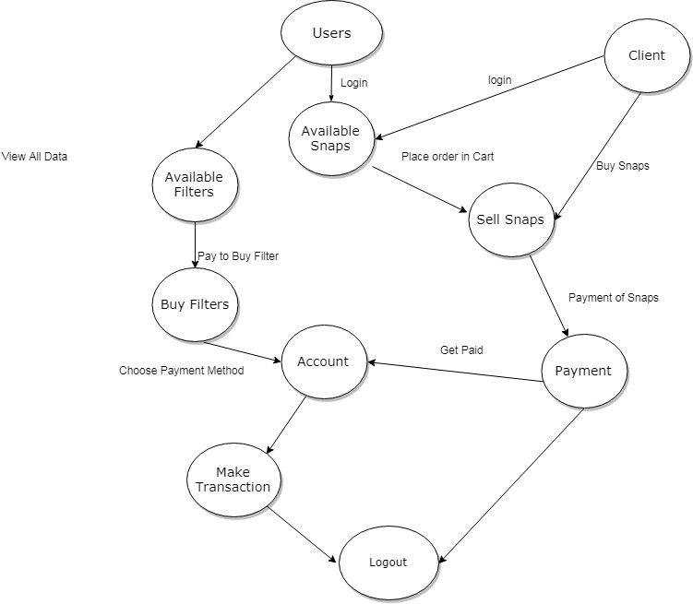

Figure 6: DFD Level 1

# 7. Data design

During the data design process, [data type](http://ecomputernotes.com/java/data-type-variable-and-array/explain-data-types-in-java)s is specified along with the required and provided rules for the data. Databases have made related to the three modules of this photography market place system featuring user, client and admin. Data design is basically made to explain the relationship between user and client to share their data and get paid for example in our community the visitor goes through the website, gain his information through about us and get the best photos at their place without visiting any market. Register himself for account of this system and once become the member can buy or sell his photos and can also discuss it with other members in the comment section. In this way multiple databases are made using Xampp server.

# 8. Data dictionary

* E-Commerce System for Photographers –PMP
* Multiple Transaction system – MTS
* Data Flow Diagram – DFD
* Vice President – VP
* Entity Relationship Diagram – ERD
* Graphic User Interface -GUI
* Procedural description language – PDL
* State Transition Diagram – STD
* Unified Modeling Language -UML

# 9. Algorithm & Implementation

* We don’t have to implement this application within any organization, educational institutes, or within corporation, you just need to host it to give facilitates the photographers so they can easily earn within their local places.
* User must login to get facilitate.
* Select the photos well likely to get paid.
* Write down the details of photos.
* Submit the item to Cart.
* Upon transaction of any photo or preset, he will be given the transaction number from the server.
* Firstly, we must give an access to any administrator for administrator’s role.
* He can register all the users or client of this system.
* Any member can access this application with high speed internet connection and with his/her email address and password.
* Members can buy, check status of transaction, give feedback and modify his profile.
* Admin can update user’s status whenever someone gave a complaint against them.
* Administrator can update add and delete.

# 10. Human interface design

There will be a user-friendly and responsive GUI. A user maybe a member or admin of the system. Member have separate panel that is member panel. A member can get access after login. Then he/she can buy or sell items from the page of item’s page. A member also can manage profile and send feedback after completion process of money transactions.

## **10.1 Screen images**

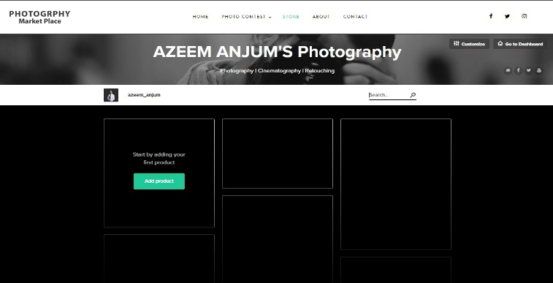

Figure 8: Screen image 1

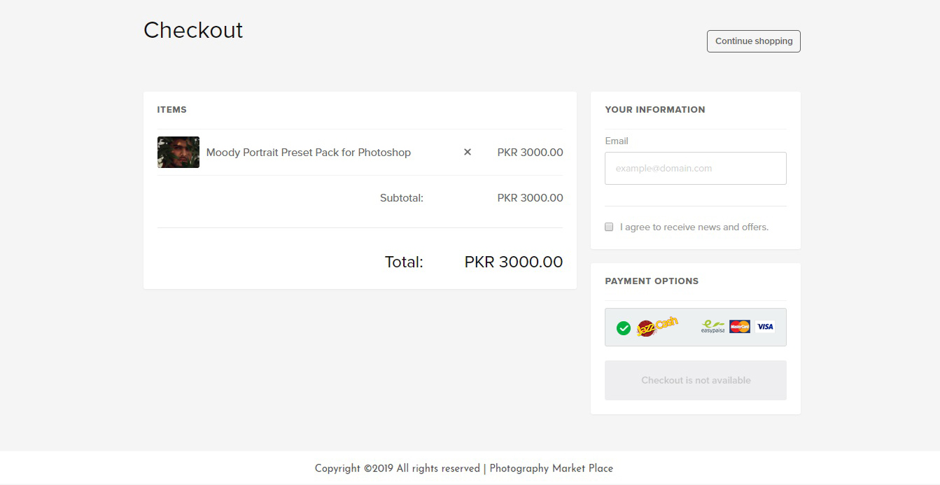

Figure 9: Screen image 2

## **10.2 Screen objects and actions**

Screen objects contain the user panel and transaction page. So that the Person can register himself through the user panel by putting his information and getting himself registered to be member. In admin panel, there is login page for the registered admin who will handle all the transactions, manage users, manage comments, manage all the complaints given by the users.

**Appendix I**

* Epstein, N. (2018). *Susan Sontag's On Photography*: Macat Library.
* Freelancer. (2019). Freelancer Retrieved from https://www.freelancer.com
* Lee, C.-k. (2018). Time-lapse photography system and method: US Patent App. 15/622,975.
* symufa. (2019, 03 26). *sellfy*. Retrieved from <https://sellfy.com>
* Upwork. (2019). Upwork. Retrieved from https://www.upwork.com
* ViewBug. (2019). Retrieved from https://www.viewbug.com