Final Project – Movie Database: Movie Review App

Submitted by: Rawa Jalal & Steven Ye

PROG3180 Section 4 – Programming Mobile Applications

Submitted to: Sabbir Ahmed

Submission Due Date: April 23, 2018

**Table of Contents**

**Project Charter** 3

**Project Name** 3

**Business Purpose** 3

**Project Roles/Responsibilities** 3

Rawa Jalal 3

Steven Ye 3

**Technical Architecture** 3

**Events Table** 4

**Use Case Diagram** 5

**Use Case Descriptions** 6

**User Interface Prototype** 7

**Entity Relationship Diagram (ERD)** 8

**User Documentation – Help System** 9

**Description** 9

**How To Use** 9

**About The Programmers** 9

**References** 10

# **Project Charter**

## **Project Name**

Movie Database

## **Business Purpose**

Our objective is to create a Cordova/PhoneGap app that allows multiple users to look up information about movies and read/write reviews for them. The user will be able enter data not only for multiple reviewers, but for multiple reviews as well. By keeping track of various reviews, the user can give themselves a frame of reference for what movies are well-received.

## **Project Roles/Responsibilities**

### Rawa Jalal

* Main programmer

### Steven Ye

* Documentation, Planning, Testing

## **Technical Architecture**

The technologies under consideration for this project include HTML5, CSS3, JavaScript (and the JavaScript libraries jQuery and jQuery Mobile), and WebSQL, as well as PhoneGap/Cordova for packaging the app as a standalone Android APK.

# **Events Table**

|  |  |  |  |  |
| --- | --- | --- | --- | --- |
| **Event** | **Source** | **Use Case #** | **Response** | **Destination** |
| User wants to look up a movie | User | UC01 | Movie details are displayed | User |
| User wants to see reviews of a movie | User | UC02 | Movie reviews are displayed | User |
| User wants to add a review for a movie | User | UC03 | Movie review added to database | System |
| User wants to edit a review for a movie | User | UC04 | Movie review in database modified | System |
| User wants to add a user to the app | User | UC05 | User added to database | System |
| User wants to reset the app to default | User | UC06 | Database cleared | System |

# **Use Case Diagram**

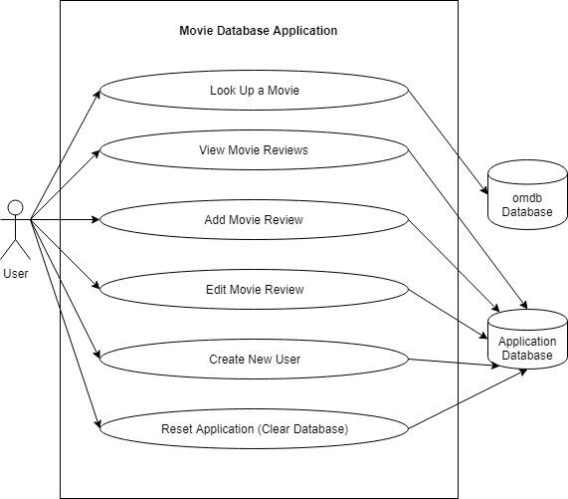

# **Use Case Descriptions**

|  |  |  |  |  |
| --- | --- | --- | --- | --- |
| **Use Case #** |  | | | |
| **Use Case Name** |  | | | |
| **Scenario** |  | | | |
| **Triggering Event** |  | | | |
| **Brief Description** |  | | | |
| **Actors** |  | | | |
| **Related Use Cases** |  | | | |
| **Pre-conditions** |  | | | |
| **Post-conditions** |  | | | |
| **Flow of Events** |  | |  | |
|  | 1. |  | 2. |  |
|  | 3. |  | 4. |  |
|  | 5. |  | 6. |  |
| **Exceptions** |  | | | |

Table 1: UC01-Create something

# **User Interface Prototype**

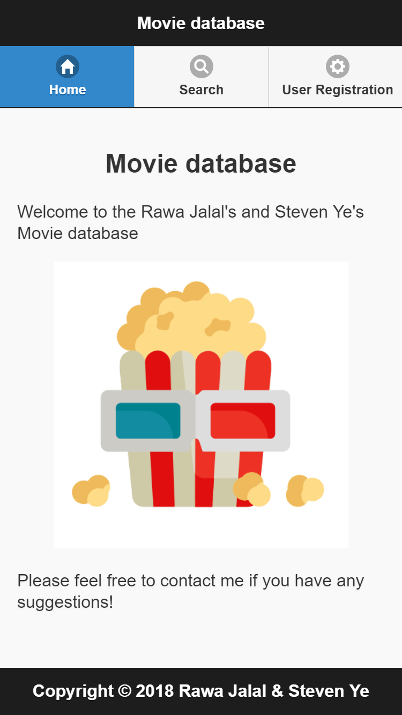

Figure 1: Screen 1 - Home

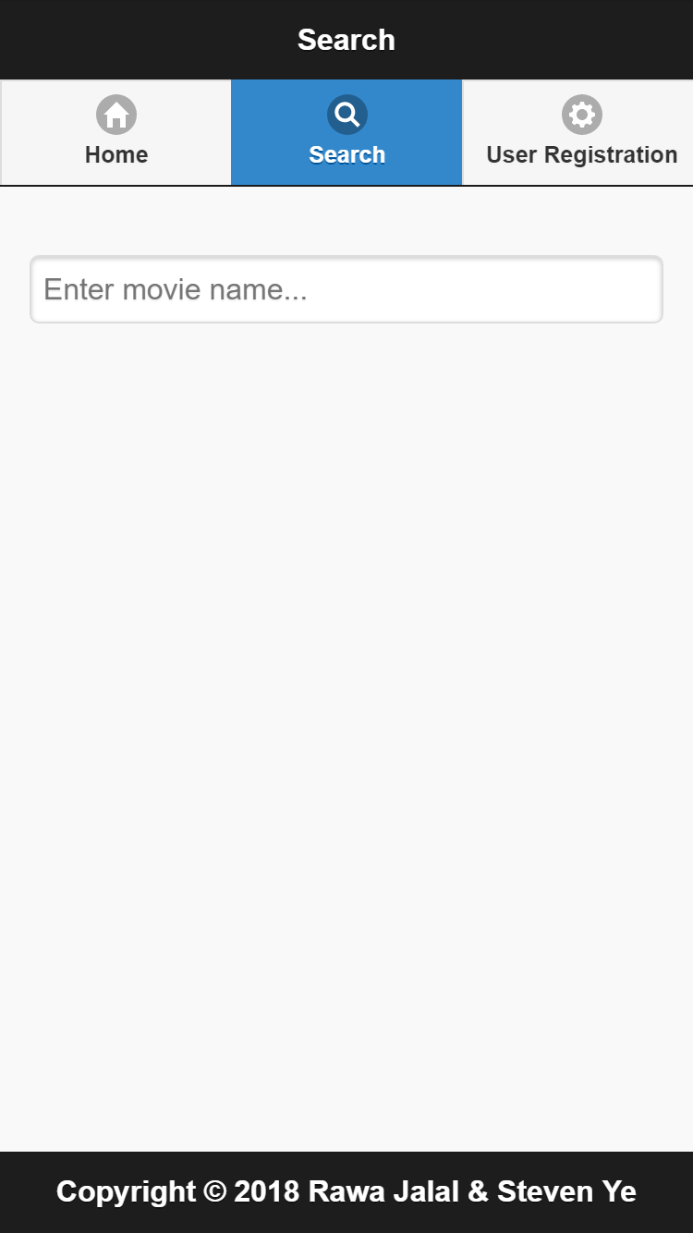

Figure 2: Screen 2 - Search

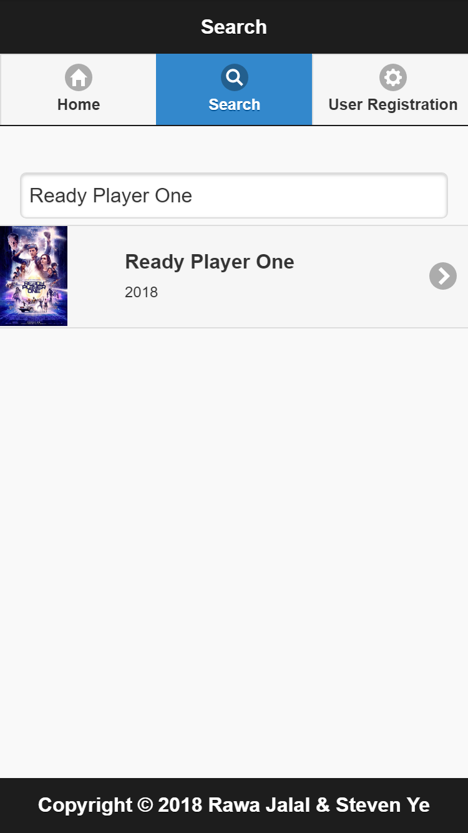

Figure 3: Screen 2 – Search Results

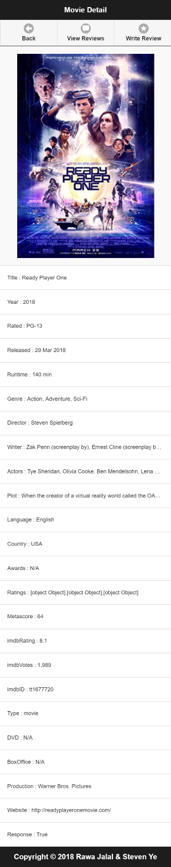  
Figure 4: Screen 3 – Movie Details

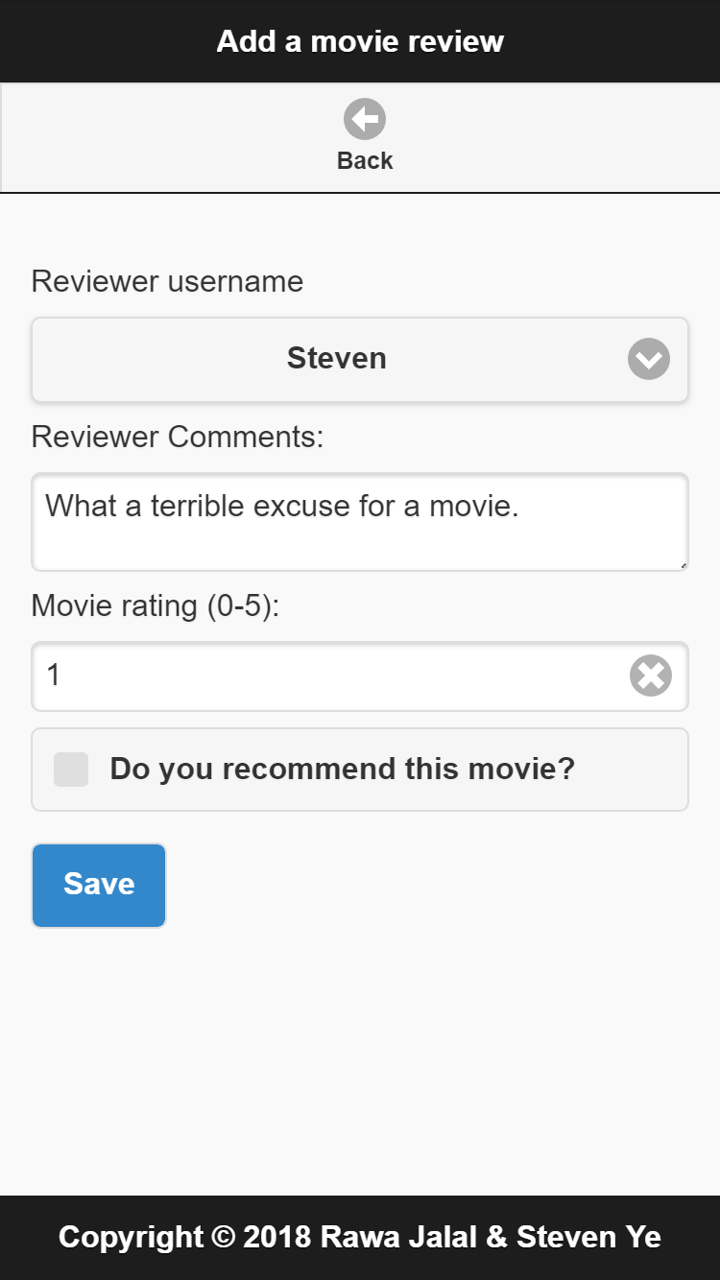

Figure 5: Screen 4 – Add Review

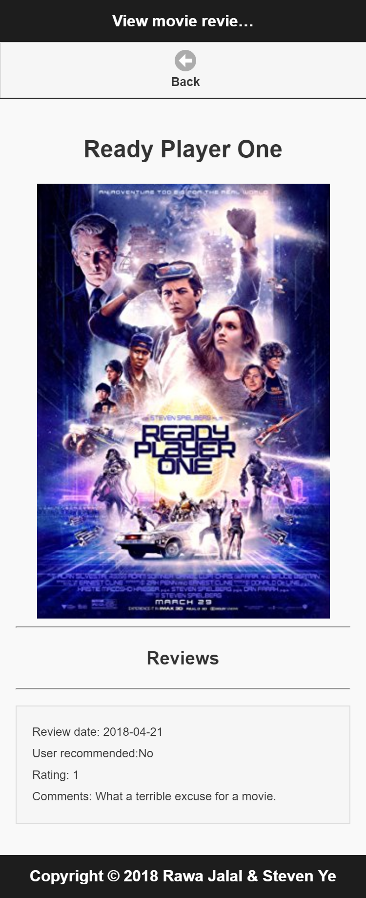

Figure 6: Screen 5 – View Reviews

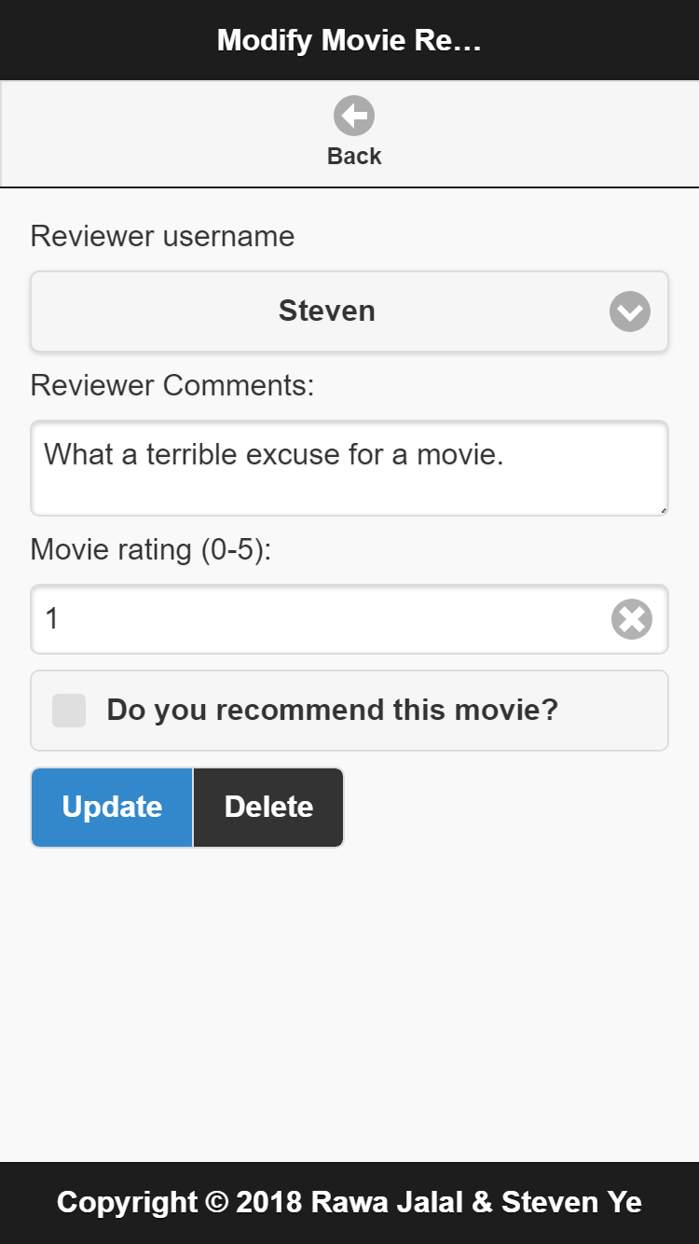

Figure 7: Screen 6 – Edit or Delete Review

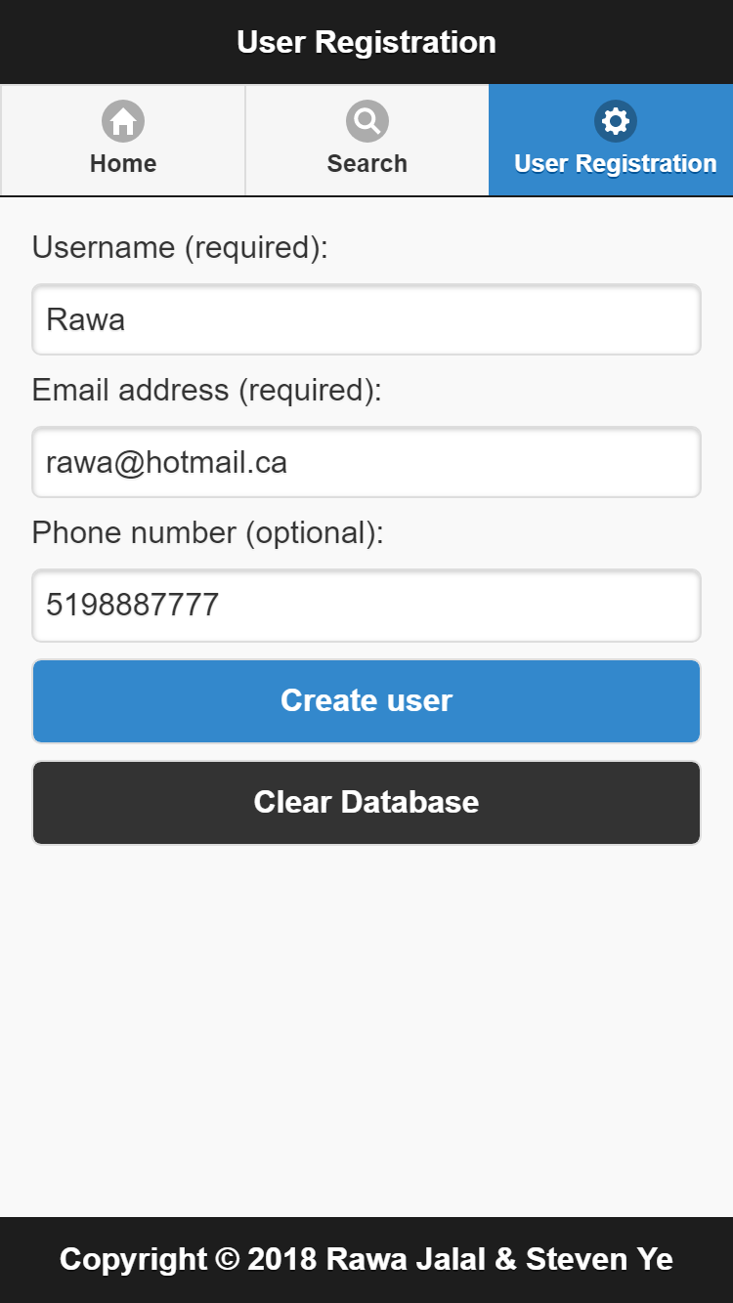

Figure 8: Screen 7 – User Registration & Settings

# **Entity Relationship Diagram (ERD)**

Gotta drop that diagram with relationships, primary keys, foreign keys, firled names, data types, and table names

# **User Documentation – Help System**

## **Description**

Here’s a brief description.

## **How To Use**

Screenshots for how to use

## **About The Programmers**

Rawa Jalal and Steven Ye are classmates in Conestoga College’s Computer Programmer/Analyst program. Their collective interest in computer science and film led them to create this app.

# **References**

1. jQuery Mobile: <https://jquerymobile.com/>
2. PhoneGap API: <http://docs.phonegap.com/plugin-apis/>
3. omdb API: <http://www.omdbapi.com/>