CarMind Sprint 2 Progress and Test Report
CCSW 431 Mobile Programming
20 October 2026
Version 0.2 release candidate
Sprint 2 adds a Bluetooth OBD workflow and a vehicle dashboard to the existing Android application. The software implementation builds successfully and passes 28 unit tests and 6 Android emulator tests. Verification with the team’s physical reader and a vehicle remains pending.
Project members: __________________________________________________
Actual two week sprint dates: _________________________________________

Develop

Story 003 Bluetooth OBD reader connection
A signed-in user can choose a reader already paired with the Android phone, grant the required Bluetooth permission and request a reading. The app reports failures, supports cancellation and closes the connection after each request. A request has a 40 second overall timeout.

Story 004 Vehicle readings and local history
The app requests supported engine RPM, vehicle speed and coolant temperature. It displays the available values with units, recording time and reader name, then keeps the latest 20 snapshots on the phone for that account. Missing values remain unavailable instead of becoming zero.

Test and release
Debug and release builds passed. Android lint has no errors and only two dependency update notices. The class presentation and source package accompany this report. The release APK is unsigned. The debug APK is for development, and needs the team Firebase configuration and a rebuild for sign-in.
The existing Firebase login flow remains in place. Registration is still absent from this checkout and needs the teammate’s implementation before presenting the combined Sprint 1 and 2 increment as complete.

Application screens
These are screenshots of the implemented dashboard rendered on an Android emulator. The fixed banner identifies simulated test data. They verify interface rendering and are not evidence of a connection to a vehicle.
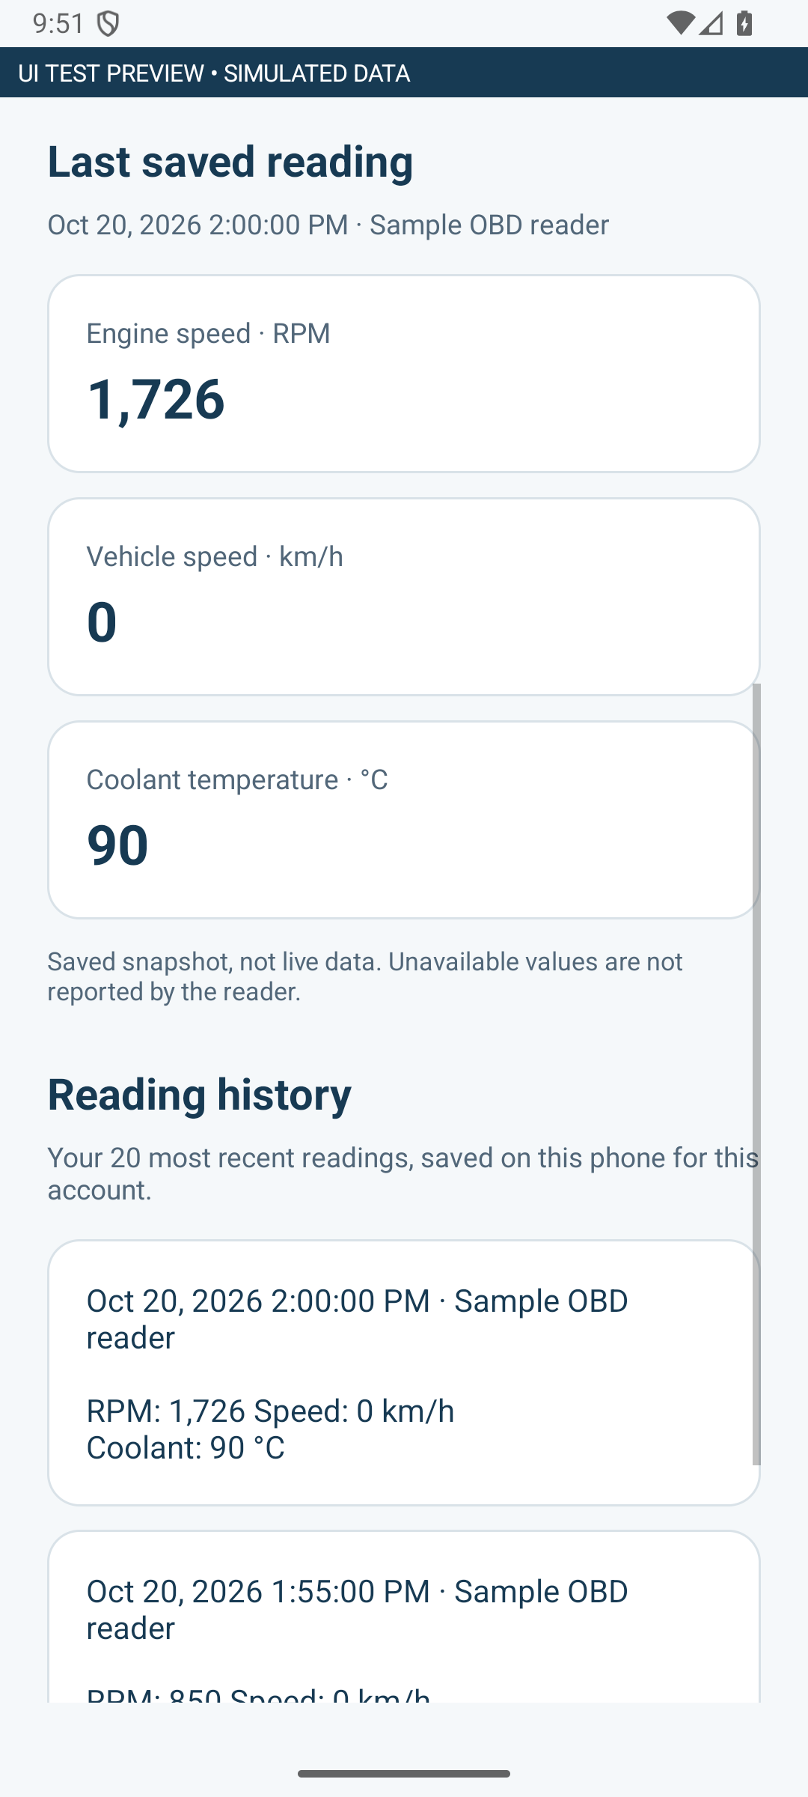  Dashboard with units and recording time | 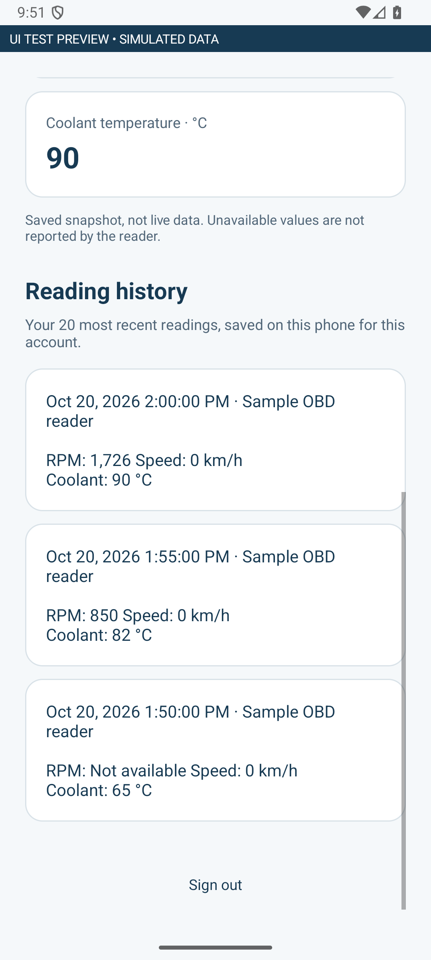  Local history with reader and timestamps
The reader selection screen and empty state are included as separate PNG files in the images package.

Hardware and software roles
The team has a ready-made reader that plugs into the vehicle OBD port and communicates with the phone using Bluetooth. The photographs show the actual reader with its casing opened. They do not establish its exact model or supported protocol.
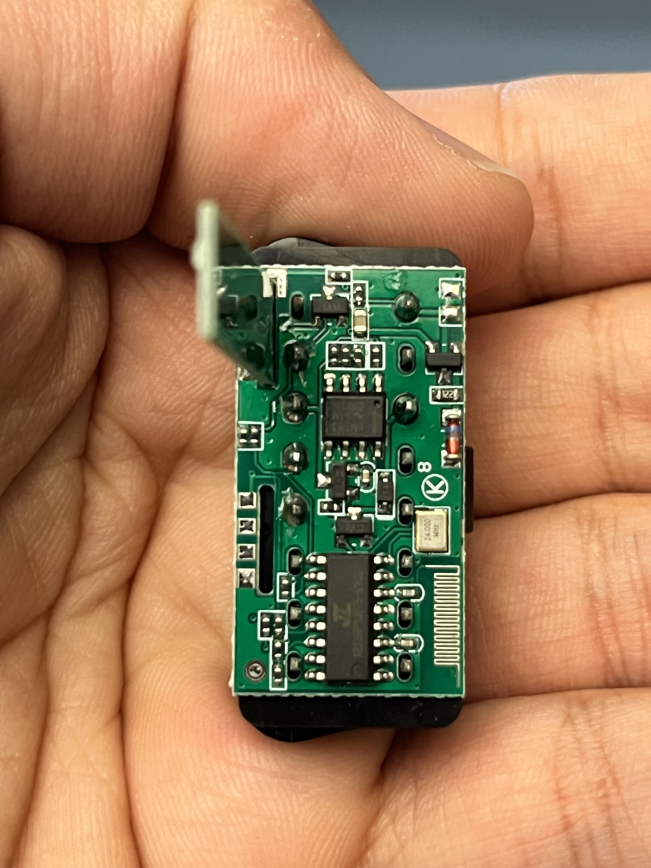
Team photograph of the actual OBD reader

Simple explanation for the presentation
We use an existing OBD reader to obtain the data supported by the vehicle. Our software requests readings, converts the response into understandable numbers and displays them in the mobile app. The app also keeps a dated history so the user can review previous readings.

What the reader and app each do
The reader handles communication with the vehicle. The Android app handles the user interface, Bluetooth connection, interpretation of responses and local storage. The sprint does not require the team to design electronic circuits.

Compatibility boundary
This implementation supports Bluetooth Classic serial readers that accept ELM-compatible commands. Bluetooth Low Energy and Wi-Fi readers are not implemented. The actual reader must be checked with the selected vehicle. The app requests readings only and does not clear fault codes or control the vehicle.

Automated test cases
Executed on 20 October 2026. The unit suite contains 28 tests, including 6 existing login validation tests. The Android suite contains 6 tests on an API 36 emulator. The cases below summarize the executed checks.
ID | Action | Expected result | Outcome
A01 | Decode RPM, speed and coolant replies. | Correct formulas and units; zero remains a real value. | Pass
A02 | Supply echoes, spaces, lowercase and multiple responses. | Use the first valid response without combining ECUs. | Pass
A03 | Supply malformed, truncated or unrelated responses. | Do not invent a value or substitute zero. | Pass
A04 | Run a request using a speed-only support mask. | Send only setup, support query and speed request. | Pass
A05 | Return partial data, no data or setup failure. | Keep valid values; fail clearly if no reading is available. | Pass
A06 | End the stream before the prompt or exceed the limit. | Fail with a bounded read error. | Pass
A07 | Create invalid or incomplete reading records. | Reject empty snapshots, invalid time, non-finite values and invalid ranges. | Pass
A08 | Save and reload under different account identifiers. | Restore the original record only for its owner. | Pass
A09 | Save 25 records; separately load corrupted history. | Retain the newest 20; safely ignore damaged data. | Pass
A10 | Render data and empty states, recreate the screen and open signed-out Home. | Show correct labels and values; restore preview; redirect signed-out users to Login. | Pass
A11 | Run existing login validation tests. | Keep required-field and email validation behavior. | Pass
Evidence: ObdProtocolTest, VehicleReadingTest, LoginValidationTest and Sprint2DeviceTest in the source package. Test summaries and reproduction commands are in docs/SPRINT2_TEST_RESULTS.txt.

Physical device acceptance cases
These cases require the team’s reader, a physical Android phone and a compatible stationary vehicle. They have not been run here. Fill the outcome after performing each test.
ID | Action | Expected result | Outcome
P01 | Deny Nearby devices permission, then grant it. | Show a permission message; allow choosing a reader after grant. | Pending
P02 | Turn Bluetooth off or leave the reader unpaired. | Explain the required setup without starting a read. | Pending
P03 | Pair the actual reader and select it in the app. | Show its name and enable the reading action. | Pending
P04 | Request supported values from the stationary vehicle. | Show real values and timestamp; save one snapshot. | Pending
P05 | Use a vehicle that does not return one target value. | Show unavailable for that value; retain other valid values. | Pending
P06 | Interrupt power or move out of range during a read. | Recover with an error within the timeout and permit retry. | Pending
P07 | Cancel, background or rotate during a request. | Close the connection and avoid stale updates or a stuck form. | Pending
P08 | Sign out, sign in as another user, then return. | Separate histories and block unauthenticated Home access. | Pending
Field record: phone and Android version _________________________________
Reader model and advertised Bluetooth name _____________________________
Vehicle make model and year __________________________________________
Supported values observed ____________________________________________
Test date and tester _________________________________________________

Release and class demo

Setup before the live demo
- Add the team configuration at app/google-services.json for package com.carmind.app. Enable Firebase Email/Password authentication and use an authorized existing account.
- Rebuild the app after adding the configuration. The supplied APK was built without private Firebase configuration, so its normal login is unavailable until configuration and rebuild.
- Pair the OBD reader in Android settings. Grant Nearby devices permission when requested, then choose the reader in CarMind.
- Verify the real reader and vehicle using the acceptance cases. Integrate the teammate’s registration screen for the combined Sprint 1 and 2 presentation.

Demo sequence
Sign in, show the physical reader, select it, request one reading with the vehicle stationary, explain the displayed units and timestamp, open the history and sign out. If the vehicle check has not happened, use the marked interface previews and describe field validation as pending.

Submission contents
The package includes the presentation with Arabic speaker notes, this editable report, photos and screenshots, source ZIP, debug APK, unsigned release APK and test results. Complete the real meeting records and team names before uploading to Blackboard.

References
CCSW 431 Final Project brief, pages 2–4 and 7. The user supplied the PDF.
Android Developers, Bluetooth permissions: https://developer.android.com/develop/connectivity/bluetooth/bt-permissions
Android Developers, Connect Bluetooth devices: https://developer.android.com/develop/connectivity/bluetooth/connect-bluetooth-devices
Elm Electronics, ELM327 data sheet: https://www.elmelectronics.com/wp-content/uploads/2016/07/ELM327DS.pdf
Hardware photos: IMG_5459.HEIC, IMG_5458.HEIC and IMG_5454.heic supplied by the team.

Sprint 2 meeting 1 record
Complete this form using an actual team meeting. The course requires at least two meetings per sprint.
Project members: ____________________________________________________
Meeting date and time: ____________________________________________________
Sprint start and end dates: ____________________________________________________
Scrum master: ____________________________________________________
Client: ____________________________________________________
Pair programmers: ____________________________________________________
Stories: 003 Bluetooth OBD reader connection; 004 Vehicle readings and local history.

What has been completed since the last meeting
________________________________________________________________
________________________________________________________________

What will the team work on next
________________________________________________________________
________________________________________________________________

What issues or impediments need help
________________________________________________________________
________________________________________________________________

New findings to share
________________________________________________________________
________________________________________________________________

Scrum master comments
________________________________________________________________
________________________________________________________________
Next action and owner: ______________________________________________

Sprint 2 meeting 2 record
Complete this form using an actual team meeting. The course requires at least two meetings per sprint.
Project members: ____________________________________________________
Meeting date and time: ____________________________________________________
Sprint start and end dates: ____________________________________________________
Scrum master: ____________________________________________________
Client: ____________________________________________________
Pair programmers: ____________________________________________________
Stories: 003 Bluetooth OBD reader connection; 004 Vehicle readings and local history.

What has been completed since the last meeting
________________________________________________________________
________________________________________________________________

What will the team work on next
________________________________________________________________
________________________________________________________________

What issues or impediments need help
________________________________________________________________
________________________________________________________________

New findings to share
________________________________________________________________
________________________________________________________________

Scrum master comments
________________________________________________________________
________________________________________________________________
Next action and owner: ______________________________________________

