LAB 1 - Django Backend

Passo 0

Acesse: https://replit.com/@replit/django?v=1

1. Criar o App tasks
No Console do Replit:
python manage.py startapp tasks

Isso cria a pasta task

2. Em Django project, settings.py, adicione 'tasks' ao INSTALLED_APPS.

Antes

INSTALLED_APPS = [
'django.contrib.admin',
'django.contrib.auth',
'django.contrib.contenttypes',
'django.contrib.sessions',
'django.contrib.messages',
'django.contrib.staticfiles',
]

Depois (não se esqueça da vírgula!)
INSTALLED_APPS = [
'django.contrib.admin',
'django.contrib.auth',
'django.contrib.contenttypes',
'django.contrib.sessions',
'django.contrib.messages',
'django.contrib.staticfiles',
'tasks',
]
3. Criar o Modelo Em tasks/models.py:

from django.db import models

class Task(models.Model):
STATUS_CHOICES = [
('P', 'Pendente'),
('C', 'Concluída'),
]
title = models.CharField(max_length=255)
description = models.TextField(blank=True)
status = models.CharField(max_length=1, choices=STATUS_CHOICES, default='P')

def __str__(self):
return self.title

4. Migrar o Banco
No terminal digite

python manage.py makemigrations
python manage.py migrate

5. Criar Superusuário para Admin
No terminal digite:
python manage.py createsuperuser

-Insira uma senha que você lembre! Como
unama123456.

6. Registrar no Admin
Em tasks/admin.py

from django.contrib import admin
from .models import Task

admin.site.register(Task)

7. Criar Formulário

Crie o arquivo forms.py dentro de tasks (tasks/forms.py)

from django import forms
from .models import Task

class TaskForm(forms.ModelForm):
class Meta:
model = Task
fields = ['title', 'description', 'status']

8. Cole em tasks/views.py:

from django.shortcuts import render, redirect
from .models import Task
from .forms import TaskForm

def task_list(request):
tasks = Task.objects.all()
return render(request, 'tasks/task_list.html', {'tasks': tasks})

def task_create(request):
form = TaskForm(request.POST or None)
if form.is_valid():
form.save()
return redirect('task_list')
return render(request, 'tasks/task_form.html', {'form': form})

def task_update(request, pk):
task = Task.objects.get(id=pk)
form = TaskForm(request.POST or None, instance=task)
if form.is_valid():
form.save()
return redirect('task_list')
return render(request, 'tasks/task_form.html', {'form': form})

def task_delete(request, pk):
task = Task.objects.get(id=pk)
if request.method == "POST":
task.delete()
return redirect('task_list')
return render(request, 'tasks/task_confirm_delete.html', {'task': task})

9. Crie o urls.py dentro de tasks

from django.urls import path
from . import views

urlpatterns = [
path('', views.task_list, name='task_list'),
path('create/', views.task_create, name='task_create'),
path('update/<int:pk>/', views.task_update, name='task_update'),
path('delete/<int:pk>/', views.task_delete, name='task_delete'),
]

10. Agora,NA PASTA django project, acesse e altere o arquivo urls.py

from django.contrib import admin
from django.urls import path, include

urlpatterns = [
path('admin/', admin.site.urls),
path('', include('tasks.urls')),
]

11. Dentro da pasta tasks, Crie a pasta templates e a subpasta tasks
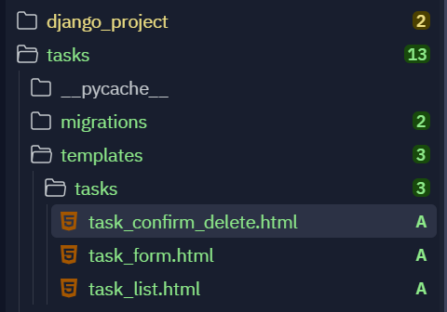
12. Dentro de tasks/templates/tasks, crie as seguintes tasks.
- task_list.html

<h1>Lista de Tarefas</h1>
<a href="/create/">Nova Tarefa</a>
<ul>
{% for task in tasks %}
<li>
{{ task.title }} - {{ task.get_status_display }}
[<a href="/update/{{ task.id }}/">Editar</a>]
[<a href="/delete/{{ task.id }}/">Excluir</a>]
</li>
{% endfor %}
</ul>

- task_form.html

<h2>Formulário de Tarefa</h2>
<form method="post">
{% csrf_token %}
{{ form.as_p }}
<button type="submit">Salvar</button>
</form>

- task_confirm_delete.html

<h2>Confirmar Exclusão</h2>
<p>Tem certeza que deseja excluir "{{ task.title }}"?</p>
<form method="post">
{% csrf_token %}
<button type="submit">Sim</button>
<a href="/">Cancelar</a>
</form>

13. Verifique o arquivo .replit
Observe que existe a linha

run = "python manage.py runserver 0.0.0.0:3000" ou 8000

Exercício
- Teste as Funcionalidades: Criar, editar e excluir tarefa
- Acesse o painel de administrador, em /admin.
  - Crie e edite grupos
  - Crie e edite tarefas
  - Crie e edite usuários
Envie um documento com os prints comprovando a execução de cada exercício

