**PROGRAMMING PATTERNS**

420-301-VA

#### **ASSIGNMENT-2-**

### Implement a Custom Data Structure: Doubly Linked List

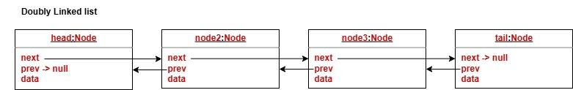

1. Implement a custom Generic Doubly Linked list. A Doubly Linked list is similar to a single linked list but, in addition to the next reference, each node maintains a reference to the previous node. You may start with the single linked list that you already implemented as a basis and modify it.
   1. Implement the class as DoublyLinkedList.
   2. A node in a doubly linked list maintains a **Prev** reference, referencing the previous element.
   3. A doubly linked list also maintains a **tail** and a **head**.
   4. Implement the **void add(E e)** method that adds an element to the beginning of the list.
   5. Implement the **void addLast(E e)** method that adds an element to the end of the list.
   6. Implement the boolean **contains(E e)** method that verifies whether an element is in the list or not.
   7. Implement the **E remove(int index)** method that deletes an element from the list.
   8. Write the client code to test your implementation.