**ERROR #1**

Al configurar : <a [routerLink]="['/post' , post.id]">

En el archivo : [home.component.html](http://home.component.html)

Minuto del video : Instalación Angular Material con schematics - Angular 8 - #3 : [17:57](https://www.youtube.com/watch?v=w6ET2uOhyhg&t=1077s)

<https://www.youtube.com/watch?v=w6ET2uOhyhg&lc=UgxscJ64ORvrSMQ8zj14AaABAg>

Me sale este error :

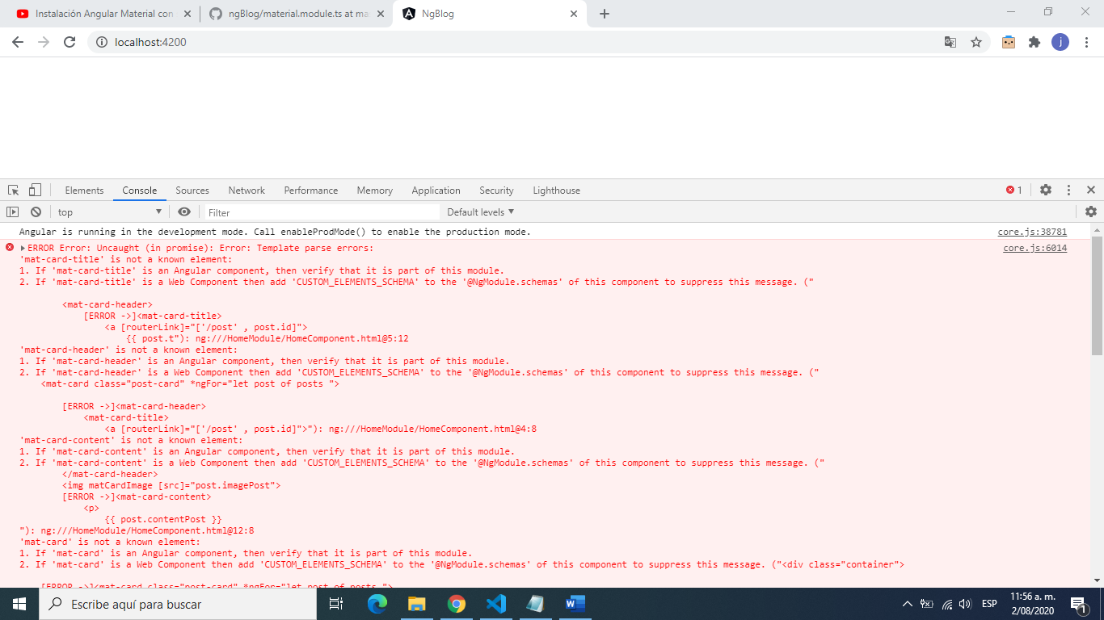

-----------------------------------

core.js:6014 ERROR Error: Uncaught (in promise): Error: Template parse errors:

'mat-card-title' is not a known element:

1. If 'mat-card-title' is an Angular component, then verify that it is part of this module.

2. If 'mat-card-title' is a Web Component then add 'CUSTOM_ELEMENTS_SCHEMA' to the '@NgModule.schemas' of this component to suppress this message. ("

<mat-card-header>

[ERROR ->]<mat-card-title>

<a [routerLink]="['/post' , post.id]">

{{ post.t"): ng:///HomeModule/HomeComponent.html@5:12

'mat-card-header' is not a known element:

1. If 'mat-card-header' is an Angular component, then verify that it is part of this module.

2. If 'mat-card-header' is a Web Component then add 'CUSTOM_ELEMENTS_SCHEMA' to the '@NgModule.schemas' of this component to suppress this message. ("

<mat-card class="post-card" *ngFor="let post of posts ">

[ERROR ->]<mat-card-header>

<mat-card-title>

<a [routerLink]="['/post' , post.id]">"): ng:///HomeModule/HomeComponent.html@4:8

'mat-card-content' is not a known element:

1. If 'mat-card-content' is an Angular component, then verify that it is part of this module.

2. If 'mat-card-content' is a Web Component then add 'CUSTOM_ELEMENTS_SCHEMA' to the '@NgModule.schemas' of this component to suppress this message. ("

</mat-card-header>

<img matCardImage [src]="post.imagePost">

[ERROR ->]<mat-card-content>

<p>

{{ post.contentPost }}

"): ng:///HomeModule/HomeComponent.html@12:8

'mat-card' is not a known element:

1. If 'mat-card' is an Angular component, then verify that it is part of this module.

2. If 'mat-card' is a Web Component then add 'CUSTOM_ELEMENTS_SCHEMA' to the '@NgModule.schemas' of this component to suppress this message. ("<div class="container">

[ERROR ->]<mat-card class="post-card" *ngFor="let post of posts ">

<mat-card-header>

"): ng:///HomeModule/HomeComponent.html@2:4

Error: Template parse errors:

'mat-card-title' is not a known element:

1. If 'mat-card-title' is an Angular component, then verify that it is part of this module.

2. If 'mat-card-title' is a Web Component then add 'CUSTOM_ELEMENTS_SCHEMA' to the '@NgModule.schemas' of this component to suppress this message. ("

<mat-card-header>

[ERROR ->]<mat-card-title>

<a [routerLink]="['/post' , post.id]">

{{ post.t"): ng:///HomeModule/HomeComponent.html@5:12

'mat-card-header' is not a known element:

1. If 'mat-card-header' is an Angular component, then verify that it is part of this module.

2. If 'mat-card-header' is a Web Component then add 'CUSTOM_ELEMENTS_SCHEMA' to the '@NgModule.schemas' of this component to suppress this message. ("

<mat-card class="post-card" *ngFor="let post of posts ">

[ERROR ->]<mat-card-header>

<mat-card-title>

<a [routerLink]="['/post' , post.id]">"): ng:///HomeModule/HomeComponent.html@4:8

'mat-card-content' is not a known element:

1. If 'mat-card-content' is an Angular component, then verify that it is part of this module.

2. If 'mat-card-content' is a Web Component then add 'CUSTOM_ELEMENTS_SCHEMA' to the '@NgModule.schemas' of this component to suppress this message. ("

</mat-card-header>

<img matCardImage [src]="post.imagePost">

[ERROR ->]<mat-card-content>

<p>

{{ post.contentPost }}

"): ng:///HomeModule/HomeComponent.html@12:8

'mat-card' is not a known element:

1. If 'mat-card' is an Angular component, then verify that it is part of this module.

2. If 'mat-card' is a Web Component then add 'CUSTOM_ELEMENTS_SCHEMA' to the '@NgModule.schemas' of this component to suppress this message. ("<div class="container">

[ERROR ->]<mat-card class="post-card" *ngFor="let post of posts ">

<mat-card-header>

"): ng:///HomeModule/HomeComponent.html@2:4

-----------------------------------

**SOLUCION:**

Archivo: material.module.ts

Descripción:

En vez de importar en una solo import todos los módulos de Material:

/*

//Importar Libreria Angular Material

import {

  MatButtonModule,

  MatMenuModule,

  MatToolbarModule,

  MatIconModule,

  MatSidenavModule,

  MatListModule

} from '@angular/material';

*/

Se debe importar uno por uno asi:

import { MatButtonModule } from '@angular/material/button';

import { MatMenuModule } from '@angular/material/menu';

import { MatToolbarModule } from '@angular/material/toolbar';

import { MatIconModule } from '@angular/material/icon';

import { MatSidenavModule } from '@angular/material/sidenav';

import { MatListModule } from '@angular/material/list';

import { MatCardModule } from '@angular/material/card';