**COMPUTER NETWORKS LAB**

**Week 05**

**Basic Network Configuration using switch and router.**

**Topology Diagram**

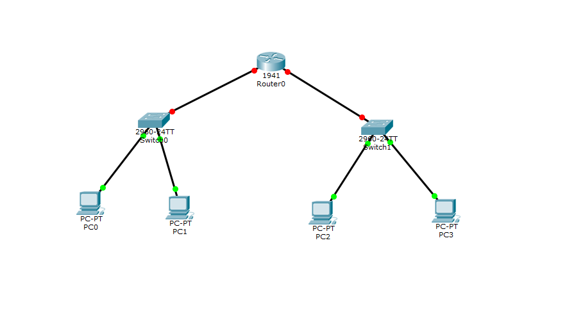At this moment the connection between **switches** and **router** is NOT Established because we are not configure the router yet. So, we need to configure the router first.

**Router Configuration**

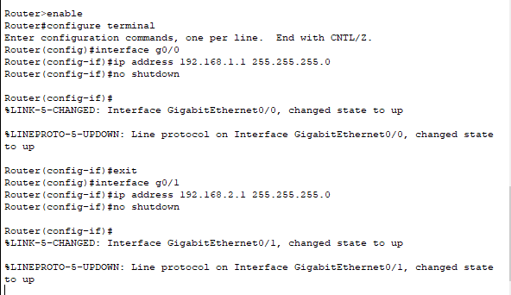

So, after the configuration of router we see the connection between switches and router become established successfully ( lights become green)

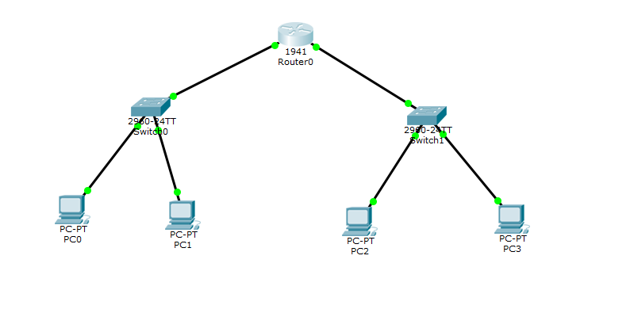

**IP CONFIGURATION For:**

**PC0:**

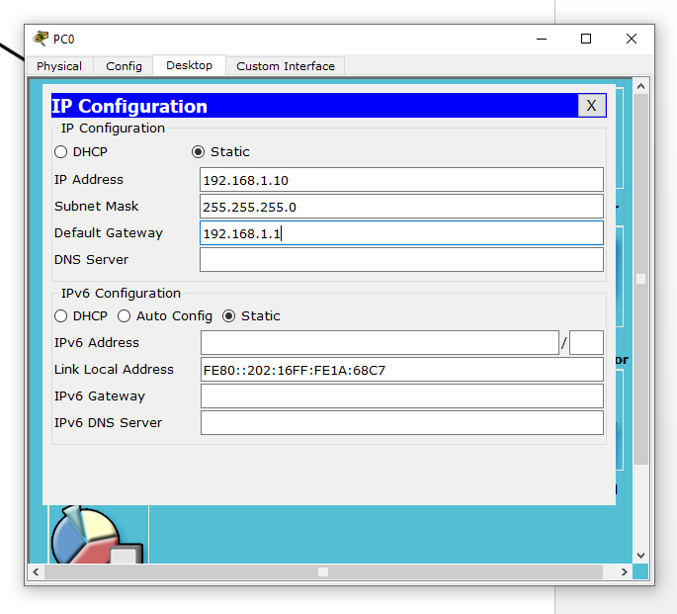

**PC1:**

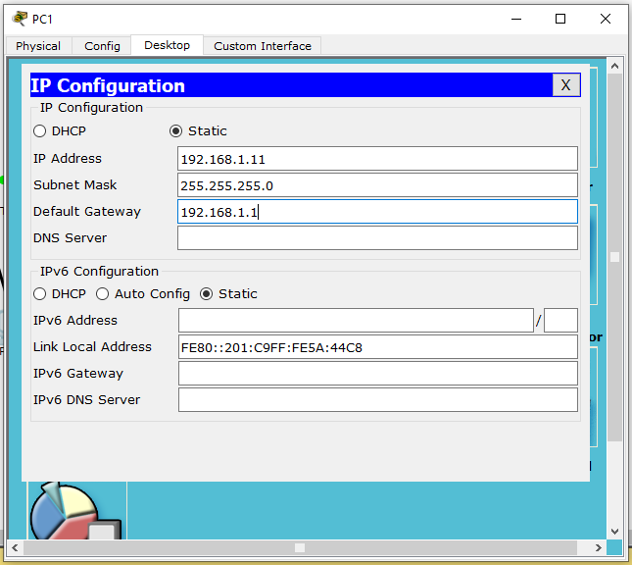

**PC 2:**

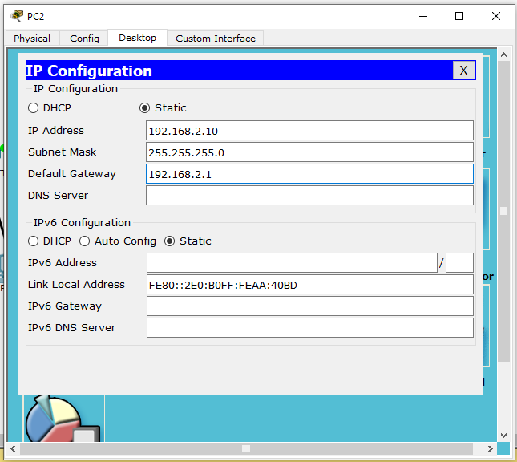

**PC 3:**

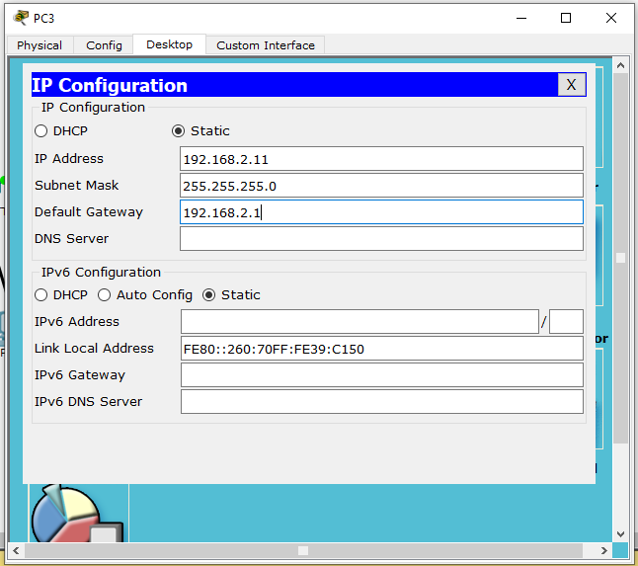

Now , we can successfully communicate in this network