Heap:

Heap is a complete binary tree where parent is greater than or equal to its childs or either parent is minimum.

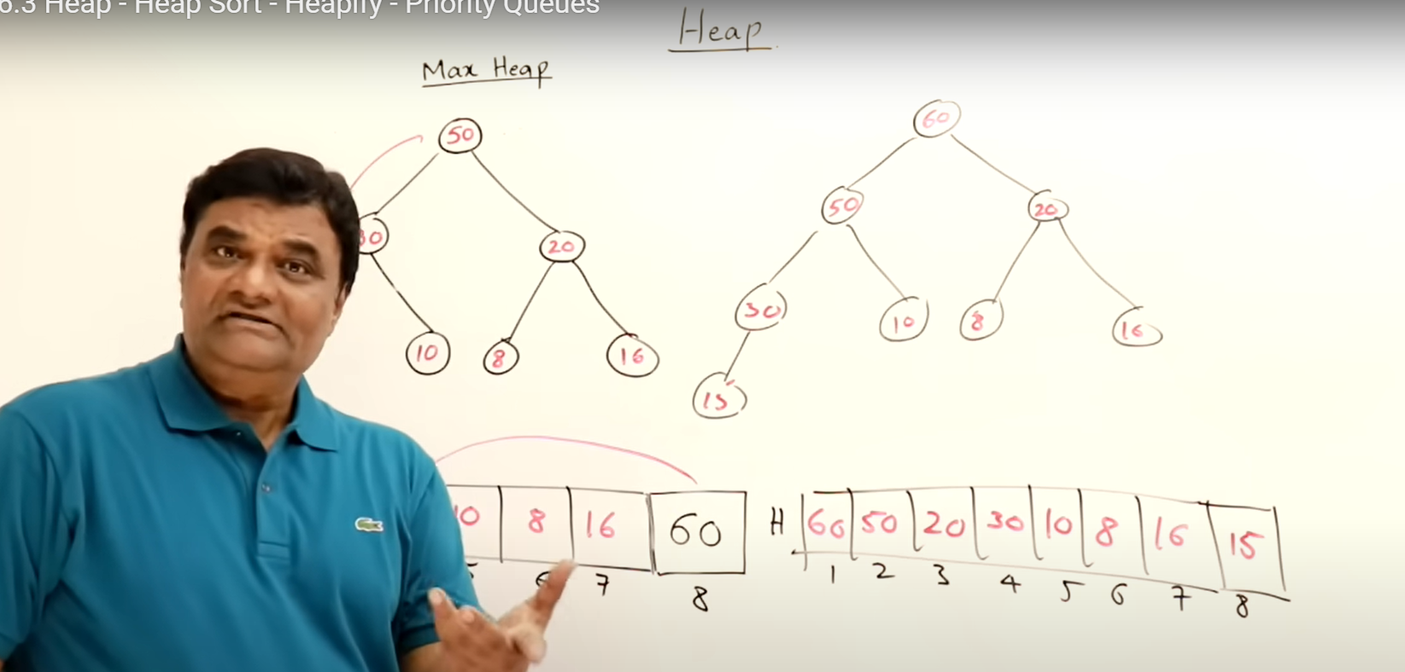

For insertion in max heap, it depends on height. Height is complete binary tree is O(log n )

Height -> 2^h+1 - 1

If we add at root, then tree will not be complete binary tree so heap not maintained

Like apples are maintained tree like at shops, best one at top

Deletion , we delete from right side at last level, last element will go to root

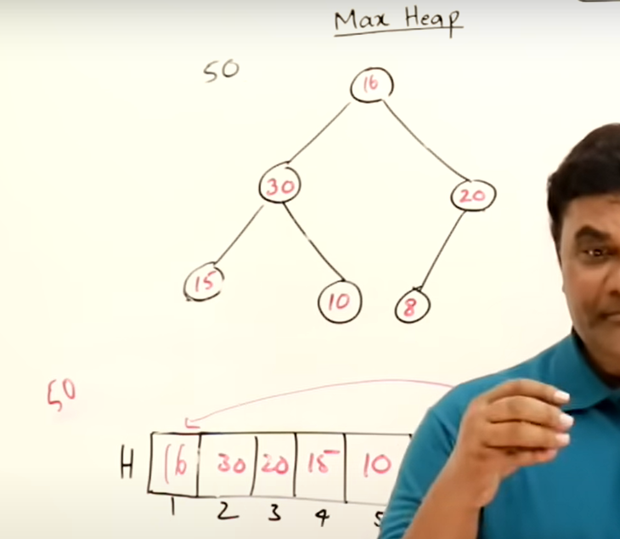

Insertion takes O(n log n ) log n is height

Delettion takes O(n log n)

So two times of O( n log n ) is also O( n log n)

Heapify is O (n) that is faster than insertion and deletion

# Priority Que:

