If our application not behaving well on production level then we can use loggers.

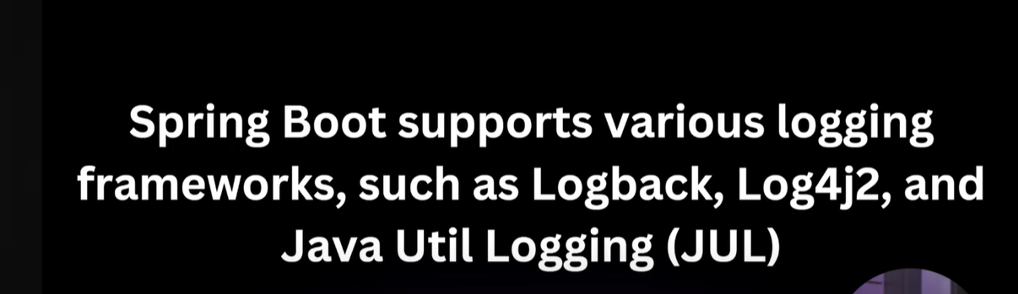

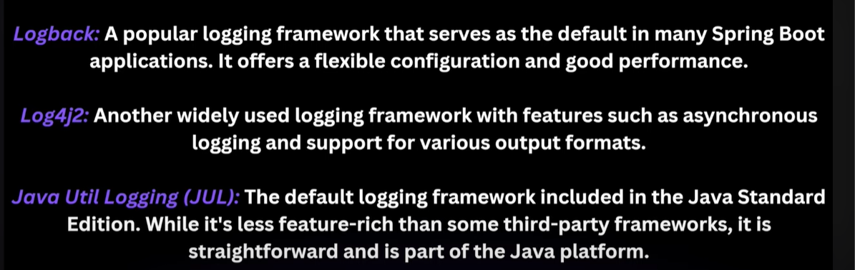

Most of the companies use LOGBACK logging framework.



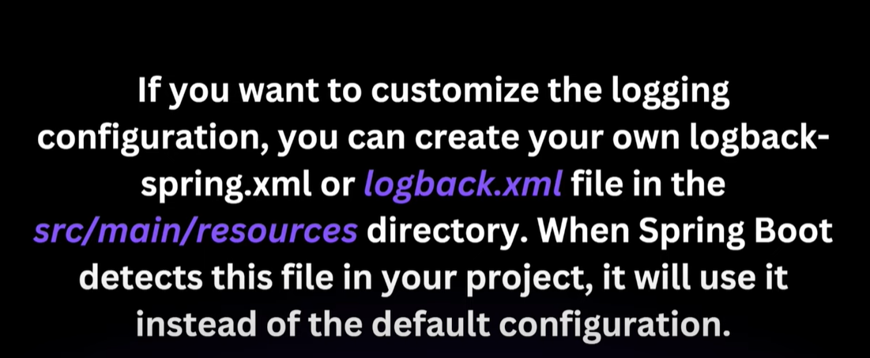

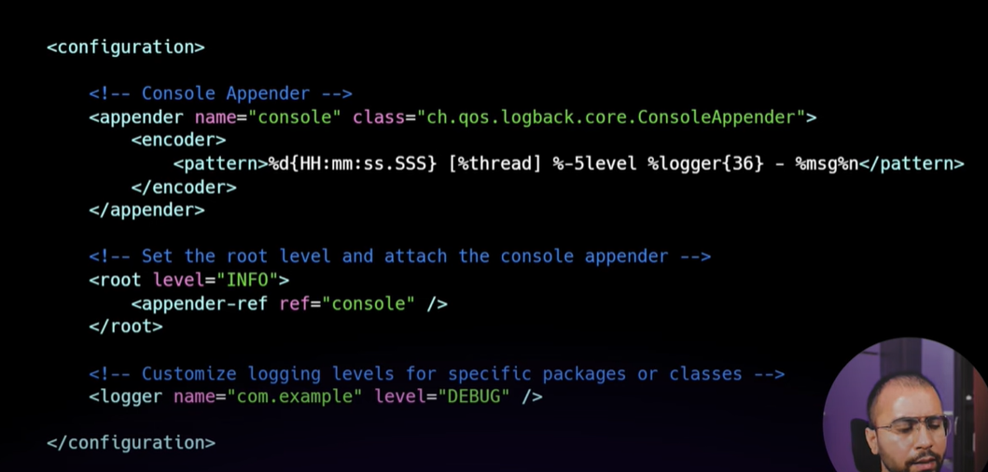

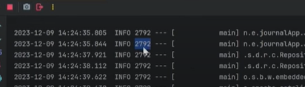

2792 is process id

**Logging Levels**

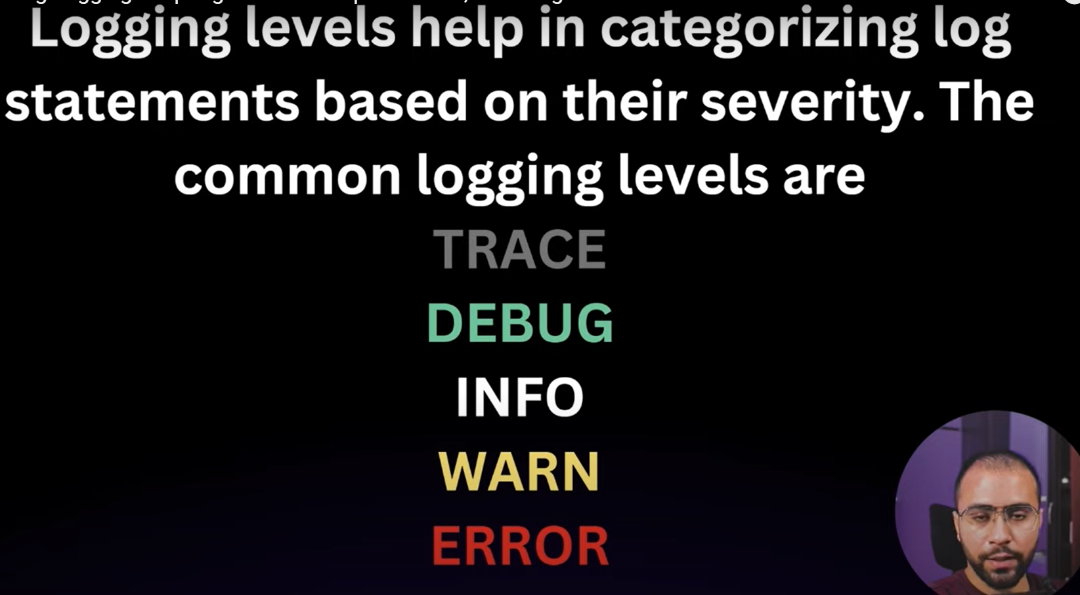

**Trace** -> Details

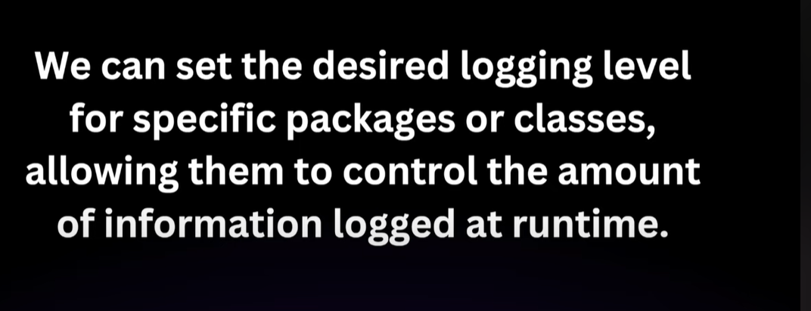

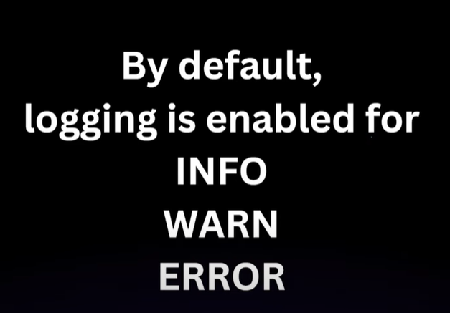





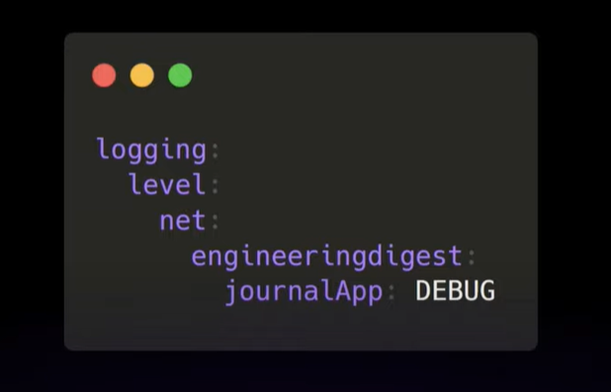

Here, after level there is package name

Here debug is written so only those errors will come that have severity greater than debug including debug as well

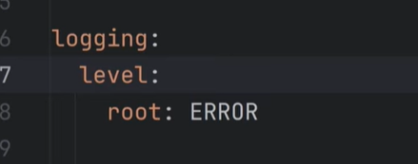

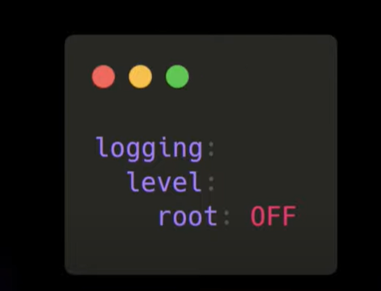

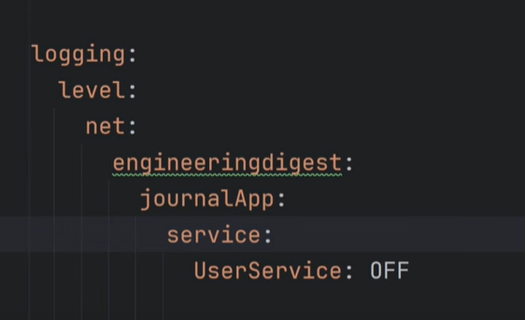

We use xml file for logs

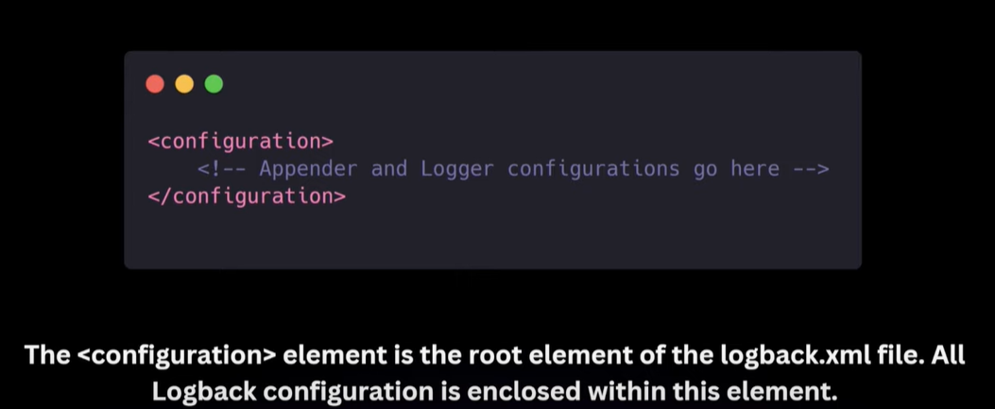

Console for printing on console and File-APPENDER for printing in File.

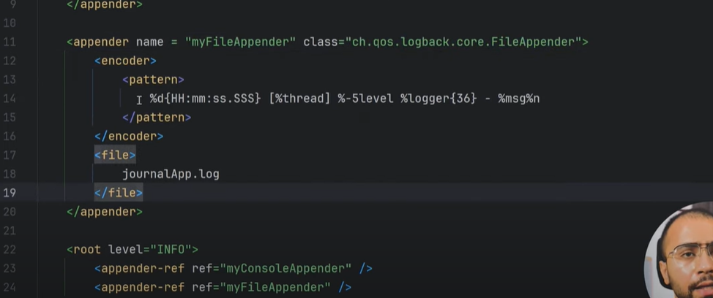

Format specifier for printing the log

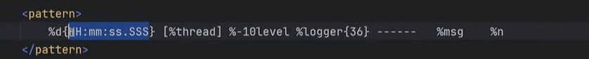

10 space right of log name

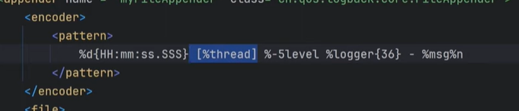

If we want logs for specific days, every day different then 🡪

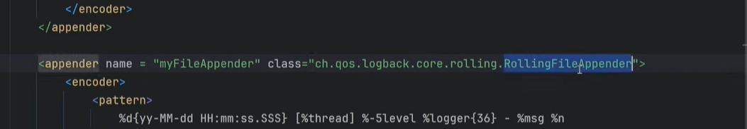

If size becomes 10 mb, create new file

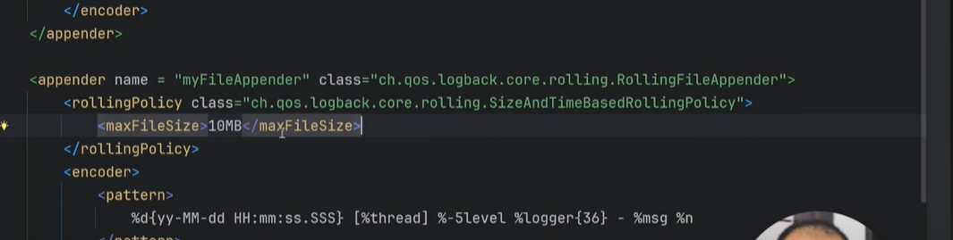

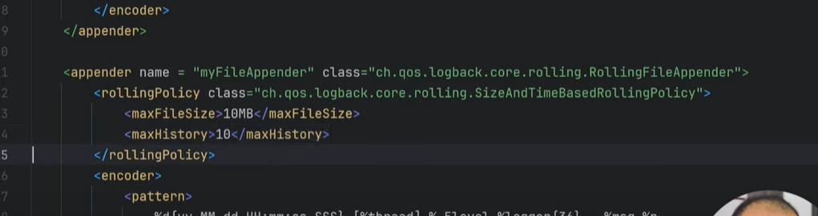

It will delete log file after 10 exceeds

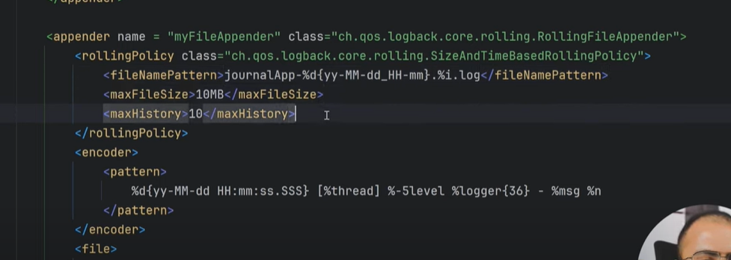

Write file name before

