**Project Name**

***Adjustable, Regulated and Protected DC Power Supply***

Summary

In this project, we have designed a D.C. voltage source which is short circuit protected, over voltage and under voltage protected and fine- tunned. For designing this voltage source we have considered cost and simplicity to use.

Objectives

The objectives of this project are –

➢ To make a regulated dc power supply.

➢ To provide over voltage Protection.

➢ To provide under voltage protection.

➢ To provide short circuit protection.

➢ To provide uninterrupted supply.

➢ To protect transformer.

Introduction

DC voltage supply is the most essential part of any electronic circuit .Sometimes this component faces many issues like short circuit ,over-voltage and under voltage damage. This can cause a problem or damage our main circuit or component. Sometimes the supply voltage may change.For this we need a constant voltage,To solve these problems, adjustable ,regulated ,over voltage protected, under voltage protected and short circuit protected power supply is needed.In this project,we are trying to make such a DC power supply that would follow these conditions.

Background

The operation of power supply circuit refers rectifiers, filters, regulators, adjustable part, protec-tions etc. starting with an ac voltage, we obtain a steady dc voltage by rectifying the voltage. Then filtering to a desired dc level and finally regulating to obtain a desired fixed dc voltage. Generally our power supply in main line is 220V r.m.s which is very high in amplitude for electronics devices and circuits. For electronics >30 is better suited. So we can remove this problem by using step down transformer. In this power supply we have used a step down transformer of rating 24V ( r.m.s ),1000mA.

Apparatus required

* Transformer- 1 piece (220V to 24V,1A)
* Diode-6 pieces(1N4007)
* Capacitor-3 pieces(2200uF,0.1uF,1 uF)
* Resistor-15pieces
* Adjustable regulator IC-1 piece(LM317T)
* Regulator IC-2piece(LM7806,LM7824)
* Variable resistor-3 pieces(10KOhm)
* Transistor-4 pieces(2222A,2905A)
* Relay-2 pieces(6V)
* LED-4pieces(Red, Green,Yellow)
* Fuse-1piece(300V,1A)
* Backup battery-3piece(9V)

Circuit diagram

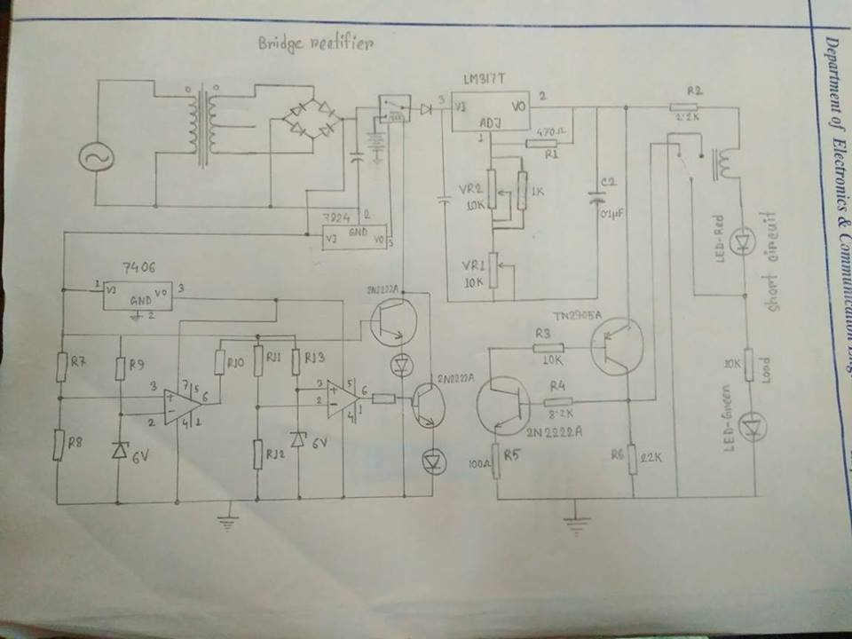

Figure: Circuit Diagram of DC Power Supply

Circuit description

* RECTIFIER

The main objective is to make DC power supply for that reason we have used bridge rectifier circuit.It contains four diodes connected to form bridge. The 1N4007 series diodes were used.For the positive half cycle of AC signal diode D1 & D2 were forward biased and D3 & D4 were reverse biased.On the other hand during negative half cycle,D1 & D2 were reverse biased and D3 & D4 were forward biased.In this way we always get the DC voltage which is needed for our desired output.

* FILTER CIRCUIT

The DC output we got from the bridge rectification is not pure DC voltage ,it has got ripple,So for removing ripple a filter circuit was used. For this a capacitor was connected to the output of bridge. this capacitor blocks AC and passes DC. So when capacitor passes the DC signal and opposes the AC then a perfect DC was obtained.Here we found the output voltage across the capacitor was

* REGULATED DC SUPPLY

We used a regulator and adjustable IC (LM317). We gaveinput to the IC. A variable resistor (10 kilo-ohm)was used for varying the output. Capacitors were used for making the input and output a perfect DC. When the variable resistor was varied then the output also varied.We got the output voltage across the capacitor was .We found the lower voltage and the upper voltage .The output of the circuit depended on the ratio of VR1 & r1 as follows,𝑣=1.25(1+𝑉𝑅1/𝑅1).

By varying the resistance of the variable resistor regulated output was found.

* SHORT CIRCUIT PROTECTION

The circuit gave us a short circuit protected output. Transistor Q1 was initially off. Depending on the value of load resistor Q2 transistor’s got biased, hence started conducting. As Q2 was con-ducting aQ1 transistor also started conducting. & the load R2 was isolated. Actually R2 & Red LED acted as a trigger. If the load was shorted the transistor Q2 goes off hence Q2 goes off state. So the current flew through R2 & Red LED indicating short circuit. As the output current was limited by the resistor R2 the circuit was protected when it was short.

* OVER VILTAGE PROTECTION

A portion of the circuit acted as over voltage protection. For over voltage protection we used relay (6 V). Rectified output was given to the relay’s input. We used IC LM7824 which gives constant voltage 24V to operate the relay. Here we used a transistor to sense relay that it got ground.The zener diode was applied to the inverting input.When the value of voltage of non-inverting input was above zener voltage, the comparator gave the output which turned on the transistor and the relay was turned on and isolated the load from being affected by over voltage which was indicated by LED.So, when output voltage across the limit then the over voltage and current went to ground through transistor. Thus all the circuit was isolated from the rectified over voltage. The condition for LM741s to gave positive output was defined as follows

6.6=(R8/(R7+R8))*V

* UNDER VILTAGE PROTECTION

Another portion of the circuit acted as under voltage protection.In this portion the zener diode was applied as reference voltage to the non-inverting input. The operation was same as over voltage protection .We used a transistor to sense relay that it got ground. When the value of voltage of non-inverting input was below zener voltage, the comparator gave the output which turned on the transistor and the relay is turned on and isolated the load from being affected by under voltage which was indicated by LED.So when the output voltage across the limit then the under voltage and current went to ground through transistor. Thus all the circuit was isolated from the rectified under voltage. The condition for LM741s to gave positive output was defined as follows

6.6=(R12/(R11+R12))*V

* RELAY OPERATION

A relay is an electrically operated switch. Relays are used where it is necessary to control a circuit by a low-power signal (with complete electrical isolation between control and controlled circuits) or to protect electrical circuits from overload or faults. When an electric current is passed through the coil, it generates a magnetic field that attracts the armature and the consequent movement of the movable contacts either makes or breaks (depending upon construction) a connection with a fixed contact. If the set of contacts was closed when the relay was de-energized, then the movement opens the contacts and breaks the connection, and vice versa if the contacts were open. When the current to the coil is switched off, the armature is returned by a force, approximately half as strong as the magnetic force, to its relaxed position. In a low-voltage application this reduces noise; in a high voltage or current application it reduces arcing. When the coil is energized with direct current, a diode is often placed across the coil to dissipate the energy from the collapsing magnetic field at deactivation, which would otherwise generate a voltage spike dangerous to semiconductor circuit components.

Result analysis:

* Transformer input=220 V ac.
* Input supply voltage range for operation =200~260 V ac.
* Transformer output= V(p-p) ac,
* Output voltage after filtering= VDC.
* Output voltage across Load= vdc
* Regulated output= v
* Maximum output current= mA
* Short Circuit Current= mA

Cost analysis:

|  |  |  |  |  |  |  |  |  |  |  |  |  |  |  |  |  |  |  |  |  |  |  |  |  |  |  |  |  |  |  |  |  |  |  |  |  |  |  |  |  |  |  |  |  |  |  |  |  |  |  |  |  |  |  |  |  |
| --- | --- | --- | --- | --- | --- | --- | --- | --- | --- | --- | --- | --- | --- | --- | --- | --- | --- | --- | --- | --- | --- | --- | --- | --- | --- | --- | --- | --- | --- | --- | --- | --- | --- | --- | --- | --- | --- | --- | --- | --- | --- | --- | --- | --- | --- | --- | --- | --- | --- | --- | --- | --- | --- | --- | --- | --- |
| |  |  |  |  | | --- | --- | --- | --- | | Name | Price /Unit  (Taka) | Quantity | Total price  (Taka) | |  |  |  |  | | Transformer (2x12V,1A) | 105 | 1 | 105 | | Fuse (1A) | 5 | 1 | 5 | | Capacitor  (2200uF,1uF,.1uF) | 5 | 1+1+1 | 15 | | Diode | 1 | 6 | 6 | | ZENER Diode | 2 | 2 | 4 | | Resistor | 0.5 | 15 | 7.5 | | IC | 15 | 3 | 45 | | Variable Resistor 10kΩ  Op-amp | 25  15 | 3  2 | 75  30 | | Transistor 2N2222A,2N2905 | 4,65 | 3+1 | 77 | | Relay 6V | 25 | 2 | 50 | | LED  Others | 2 | 4 | 8  50 | |  | | Total= 477.5 | | |

Applications:

This DC supply can be used as-

* Constant dc source.
* Contionous dc voltage source
* Labaratory power supply or various household work

Advantages:

* The circuit operation is quite simple and can be easily used for various purposes.
* The price of the components & manufacturing cost is very low.

Limitations:

* It can be used only as a step down regulator. In case of AC-DC power supplies, a transformer with rectification and filtering must be placed before the linear power supply. This pre-power conditioning increases the cost.
* It has only one output voltage. To get additional output voltage, an entire separate linear regulator must be added. It increases system cost.

Discussion:

In this project we made a DC power supply. The DC power supply was short circuit protected.When the circuit would be short the red led would glow and the relay would protect the circuit and would make the current flow less then the normal stage.We used 2.2k resistance in the short circuit protection which droped the current and made the circuit short circuit protected.When the circuit would not short then the green led would glow.We made the circuit under and lower voltage protected.For instrumental problem we faced many problems.Sometimes the resistor was burnt for connection problem.We could make the circuit short circuit protected,over and under voltage protected,fine tuned and got the wanted output through the load.When we used below 100ohm the resistor burnt.So to get perfect output we used 10k resistor.Thus we completed the project.We successfully made a DC power supply which was protected,adjustable and regulated.

Conclusion:

From this project we learnt about the basic of a DC power supply.We made a DC power supply which was short circuit protected.We faced many instrumentation problem.This project enriched our knowledge and developed our practical skills on electronics.

References:

* Principles of Electronics-

-by V.K Mehta, RohitMehta,S. Chand

& Company

* <https://www.wikipedia.org/wiki/>
* http://en.wikipedia.org/wiki/Power_supply