**CONTENTS:**

1. OBJECTIVES.

2. INTRODUCTION.

3. THEORY.

4. APPARATUS.

5. CIRCUIT DIAGRAM.

6. OPERATION.

7. RESULT ANALYSIS.

8. COST ANALYSIS.

9. PROBLEMS FACED.

10. SOLUTION.

11. APPLICATION.

12. DISCUSSION.

13. CONCLUSION.

**OBJECTIVES:**

The objectives of this project is given below:

1. To familiar with an uninterruptible power supply (UPS).
2. To construct an UPS.
3. To get a 50 Hz, 220 Volt (AC) output.

**INTRODUCTION:**

While the electricity utilities try to supply uninterrupted, clean, stable electrical power to their customers, there are times when the network may be overloaded or subject to accidents to accidents which could give rise to some problems such as black-out, voltage transient (spike), overvoltage, brown out(drop in voltage level), frequency drift etc. These are harmful for electrical devices. For protecting the devices from any harm, UPS is used. The purpose of this experiment is to build an uninterruptible power supply that provides a 50 Hz, 220 Volt AC output. It will provide emergency power without delay or transients when the main is interrupted or for other unacceptable conditions.

**THEORY:**

UPS stands for uninterruptible power supply. It is a device that supplies power to devices for a fixed amount of time without stopping even when there are problems occurring with utility power and other power sources. It is used to protect hardware such as computers, data centers, telecommunication equipments or other electrical for protecting these devices from any harm. It provides short-time power when the main fails. It can also correct common utility power problems such as voltage spike, noise, instability of main’s frequency, momentarily reduction in voltage, harmonic distortion. It is used to supply sensitive applications with secure power. It is positioned between the utility and sensitive loads. An UPS has the following components-

1. Rectifier Circuit: It converts AC into DC. It also charges the battery and provides supply to the inverter.
2. Inverter circuit: It generates an ac output signal with fixed amplitude and frequency.
3. Rechargeable battery: It makes the UPS autonomous with respect to the utility in the

event of utility outage.

1. Transformers: To transform voltage from one level to another.

**APPARATUS:**

|  |  |  |  |
| --- | --- | --- | --- |
| SL No. | Apparatus Name | Rating | Quantity |
| 1 | Transformer | 24 V | 2 |
| 2 | Resistors | 100Ω,220Ω, 15KΩ,18kΩ | 6 |
| 3 | Capacitor | 0.1µF,0.33µF,2200µF | 3 |
| 4 | Diode | 1N4007 | 7 |
| 5 | LED | - | 1 |
| 6 | MOSFET | IRFZ44 | 2 |
| 7 | Oscillating IC | CD-4047 | 1 |
| 8 | Battery | 12 V | 1 |

**CIRCUIT DIAGRAM:**

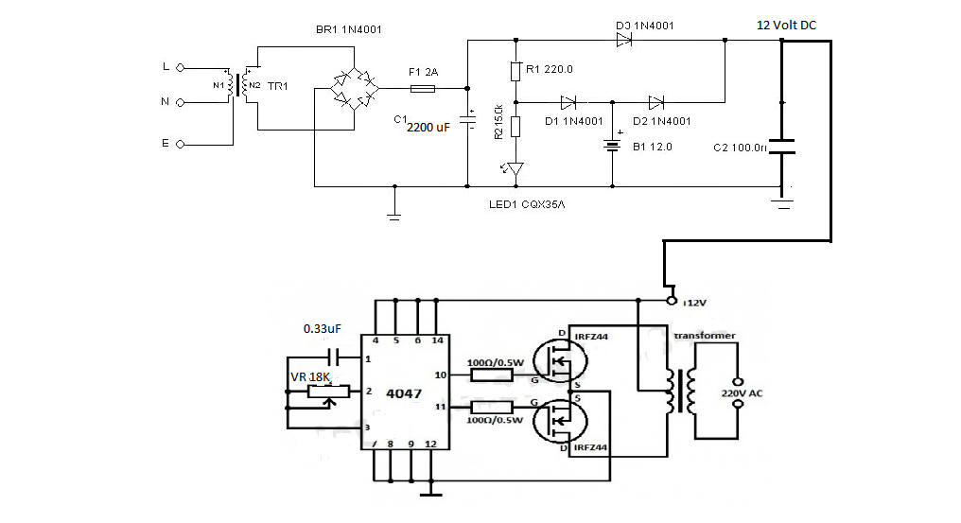

Fig-3.1: Circuit diagram of UPS.

**OPERATION:**

An UPS is an electrical apparatus that provides emergency power to a load when the input power source fails. The figure-3.1 shows an UPS circuit. It consists of a rectifier circuit, a battery and an inverter circuit. The transformer T1 is a step down transformer. The input of the primary winding of T1 is 220 Volt. It steps down the main voltage to 12 V AC. The Bridge converts the AC into DC. The fuse acts as a mini circuit breaker for short circuit protection. The rectified signal is applied to the capacitor for to remove repeal. The LED will be turned on when there will be presence of electricity. The light of LED will set off upon power outage and then the battery will take over. When there will be presence of main, battery will be charged through a diode. When main is not available, the battery supplies 12 Volt voltage to the terminal. The diode D3 blocks reverse flow of current when the battery is providing supply. The capacitor C2 does the work of filtering.

Then, the inverter circuit comes. IC-CD4047 is an important part of this circuit. Here, it works as an astable multivibrator. Here, a capacitor and a resistor is connected to the tank circuit of this IC. By changing the values of capacitor and resistor, we can control the value of frequency. In this circuit, we needed 50 Hz frequency. The IC provides clock pulses of 50 Hz frequency. The output of the IC is taken from pin number 10 and 11.This pulses are applied to the n-MOSFET to drive the transformer. Transformer steps up the voltage to 220 Volt. By turning on and off the MOSFETs at 50 Hz frequency, we will get 50 Hz, 220 V full cycle output at the transformer.

**RESULT ANALYSIS:**

1. Input signal(main) = 220 Vac
2. The rectified output = 12.22 Vdc
3. The output of IC -4047 = 6.4 Vac
4. Frequency = 49 Hz
5. MOSFET output each = 12 Vac
6. The main output(at transformer) = 195 Vac

**COST ANALYSIS:**

|  |  |  |  |  |
| --- | --- | --- | --- | --- |
| SL NO. | Apparatus | Price (Tk) | Quantity | Total Price (Tk) |
| 1 | Transformer | 150 | 2 | 300 |
| 2 | Resistors | 0.50 | 6 | 3 |
| 3 | Capacitor | 25,1.5,1.5 | 3 | 28 |
| 4 | Diode | 1.43 | 7 | 10 |
| 5 | LED | 2 | 1 | 2 |
| 6 | MOSFET | 10 | 2 | 20 |
| 7 | IC-4047 | 26 | 1 | 26 |
| 8 | Battery | 950 | 1 | 950 |
| 9 | Others | 100 | - | 100 |
|  |  |  |  | TOTAL-1440 Tk |

**PROBLEMS FACED:**

We faced some problems during this project. In order to get a 12 V dc, we used IC-7812. But because of this IC, the original current generated by the transformer was very much reduced. What happened here is the input to IC-7812 was nearly 12 Volt dc and it gave 11.9 V dc as output. It grounded much current for this action. As a result the input to the neutral wire of the transformer carried insufficient current which might be a cause for 12 V to 220 V inverter action failure. Except this we faced no problem that forced us to bring any change in our circuit diagram.

**SOLUTION:**

To solve the problem we removed the IC-7812 and we received 12V output at each of the MOSFET and we received the expected output at the transformer. Instead of step-up transformer, we used a step down transformer where we applied the drain voltages and 12 V dc to the primary windings of the transformer and received output from the secondary winding.

**APPLICATION:**

Because of power failures such as power outages, computer devices such as servers and workstations may break down, leading to various problems such as the loss of important data. Even a momentary voltage drop on factory production lines, can result in system stoppages, defective products and damage of equipments. These problems can be solves by simply installing UPS in computers, network systems, production lines. By using various function of UPS, it is possible to operate systems with stability and efficiency.

**DISCUSSION:**

By doing this project we have learnt about the basic concept of uninterruptible power supply (UPS) circuit. We built an ups with 50 Hz ,220 V ac output to get continuous ,undisturbed and conditioned power supply. The first component of the ups is step down transformer which converts 220 v ac into 12 v ac . The second is rectifier circuit which converts ac into 12 v dc and provides supply to the inverter. Then the inverter circuit converts this dc into ac with fixed amplitude and frequency. Then we use rechargeable battery. When the main or supply power is turned off, the ups circuit gets power from this battery. Our output value from the inverter circuit was not same at the given supply. For the instrumental error, we faced this problem. Having this components problem the output was closed to the actual supply. We fulfilled our all objectives. So, we successfully completed this project.

**CONCLUSION:**

After completing this project lab , we have familiar with a new electronic device and their components. By doing this experiment we capable of building an ups circuit which gives a continuous 195 v ac output supply. This project enhanced our knowledge on electronic components and increased our practical skill.