# Deployment Document

## Step File Issue

## Problem Statement: Step file is not creating after baseline creation.

**Proposed Solution:** BMIDE Configuration.

1. Open BMIDE
2. Open Item Revision business object.
3. Copy as object action is added for saveAs and Revise operations on Iman Rendering relation into BMIDE.
4. Save data model and Reload and deploy it.
5. Attach release status flag for step file, Workflow handler is updated while creating baseline.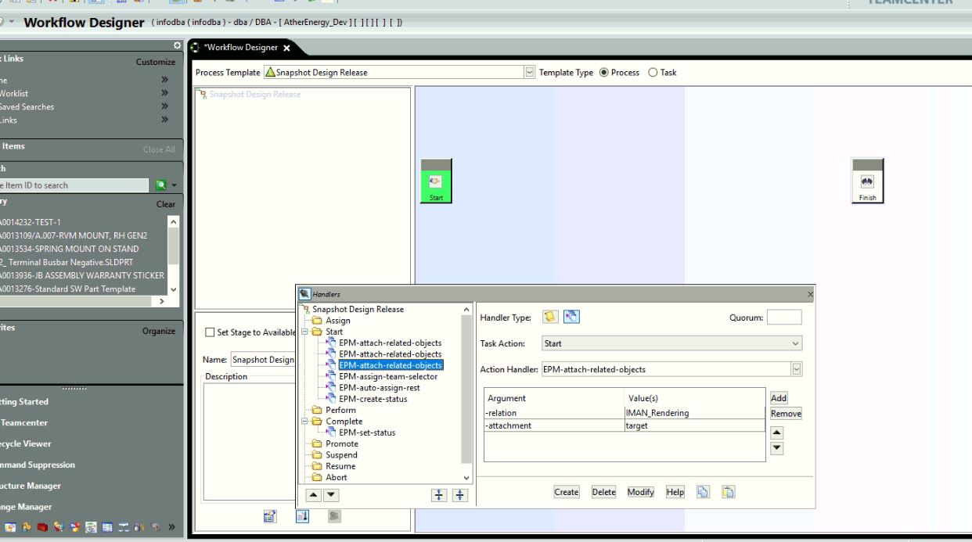

**Steps** :

1. Login to Teamcenter and create custom type of item

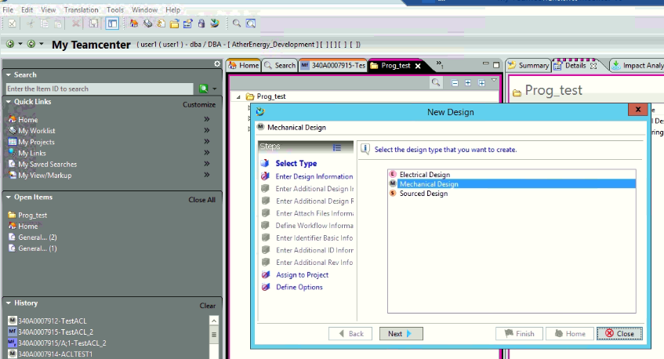

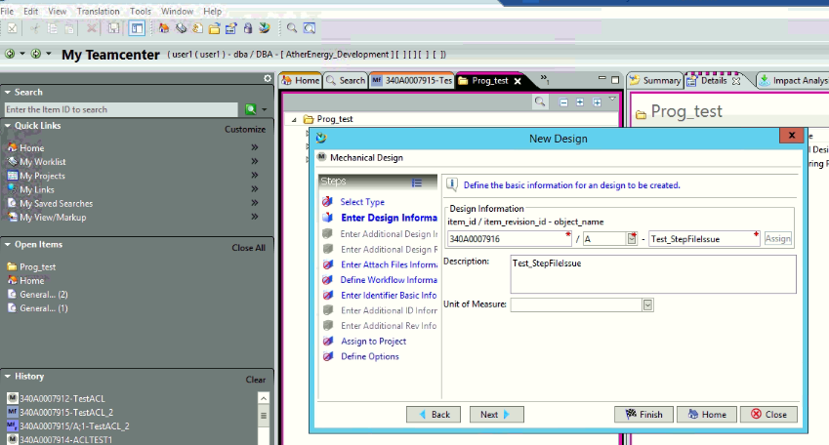

1. Create item and attach dataset

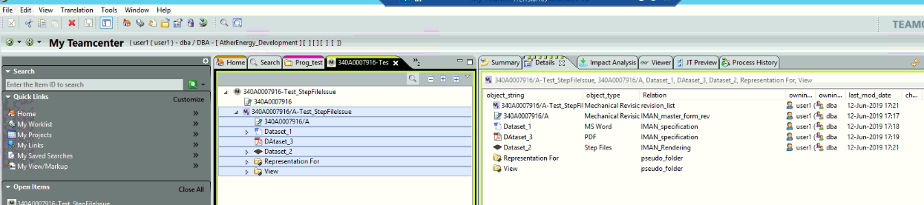

1. Send to structure manager for baseline creation

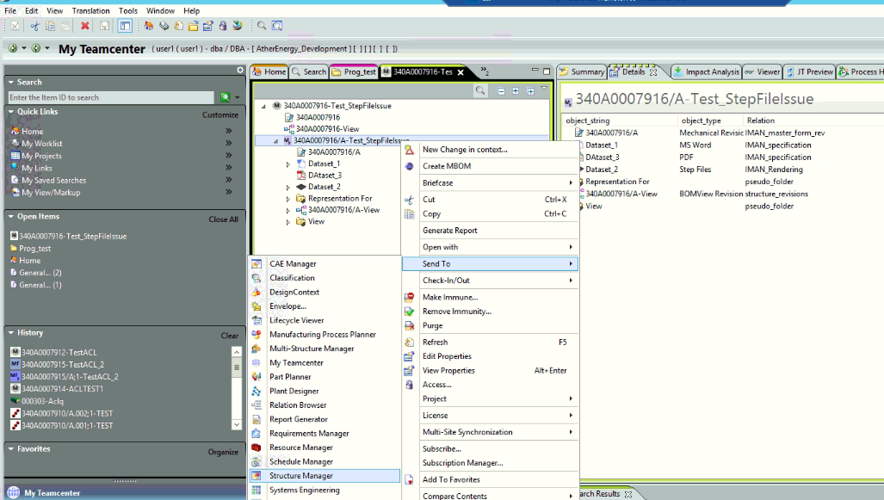

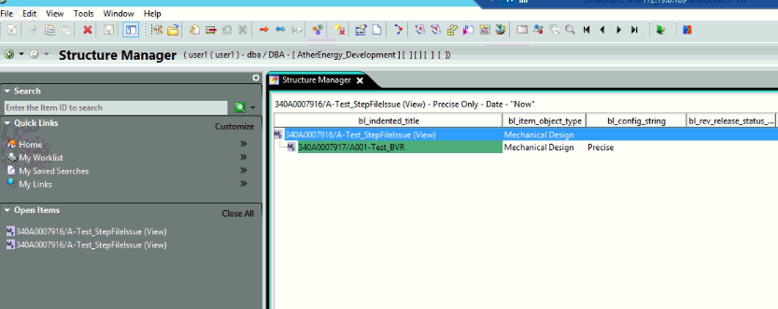

1. Create baseline

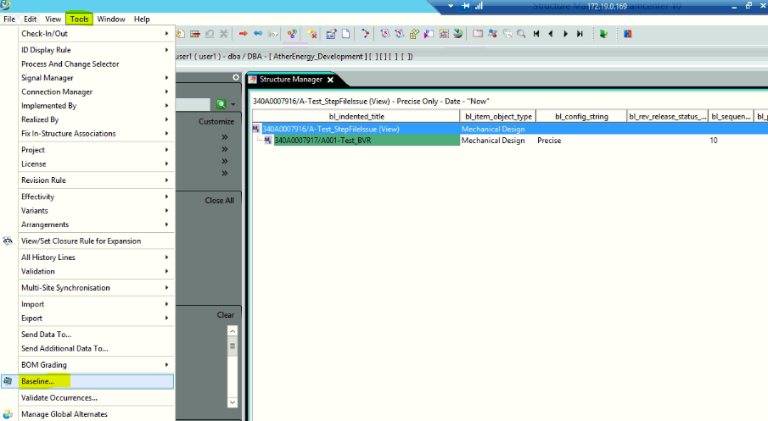

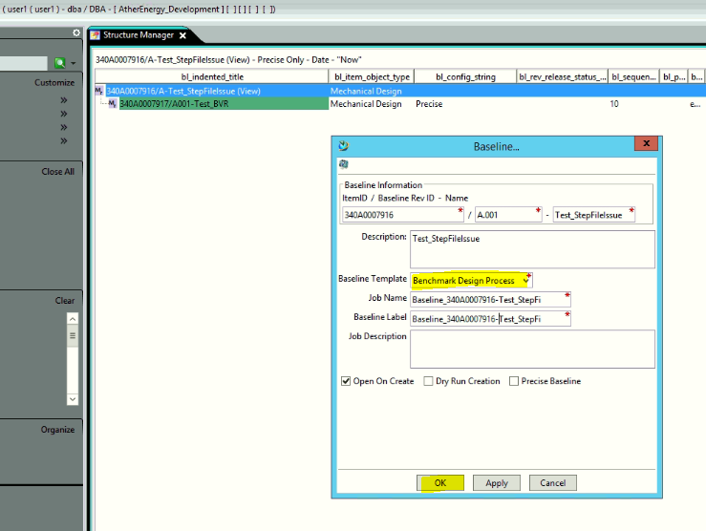

1. Go to my Teamcenter

Result : Step file is created after baseline creation.

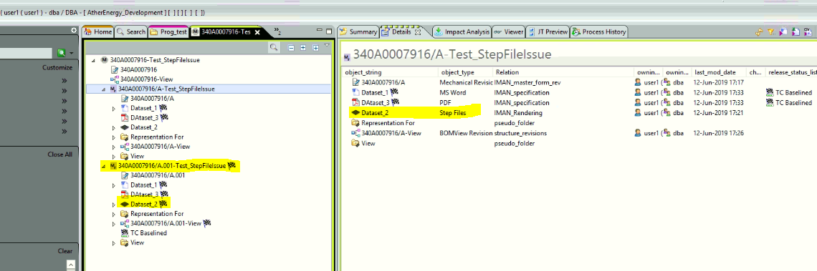

1. Test Result for Revise operation

