# Test Cases For Step File Issue

## Problem Statement: Step file is not creating after baseline creation.

**Proposed Solution:** BMIDE Configuration

**Steps** :

1. Login to Teamcenter and create custom type of item

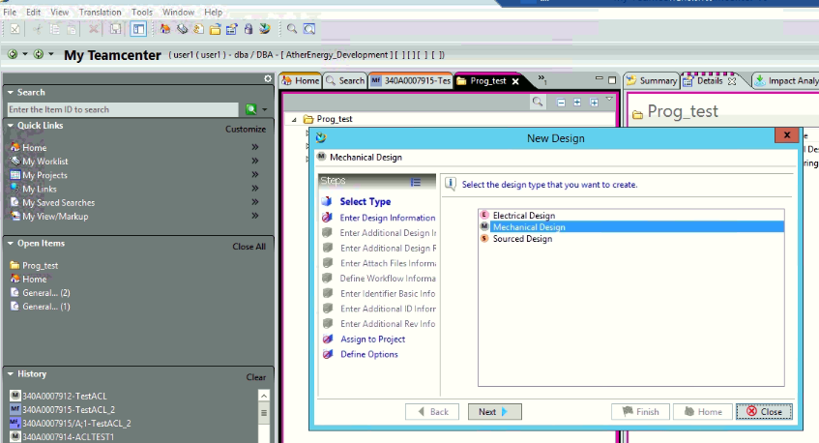

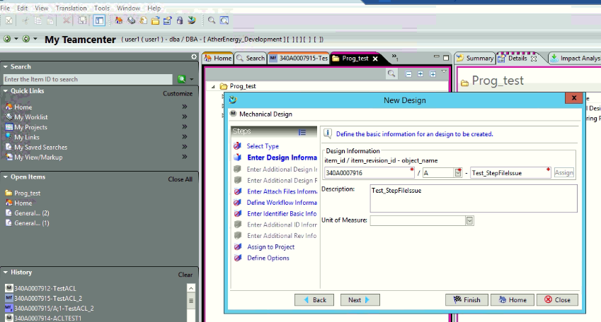

1. Create item and attach dataset

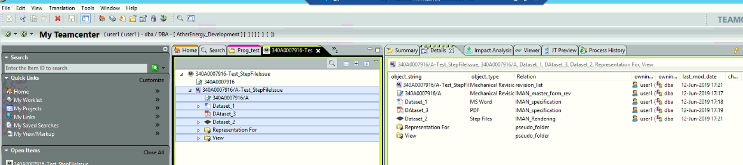

1. Send to structure manager for baseline creation

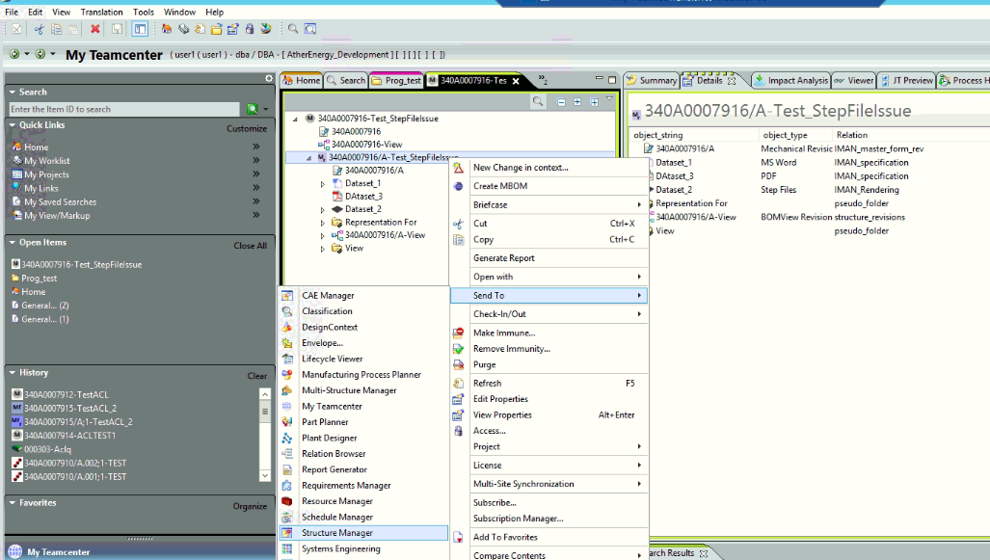

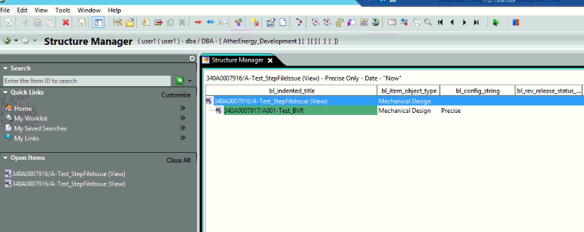

1. Create baseline

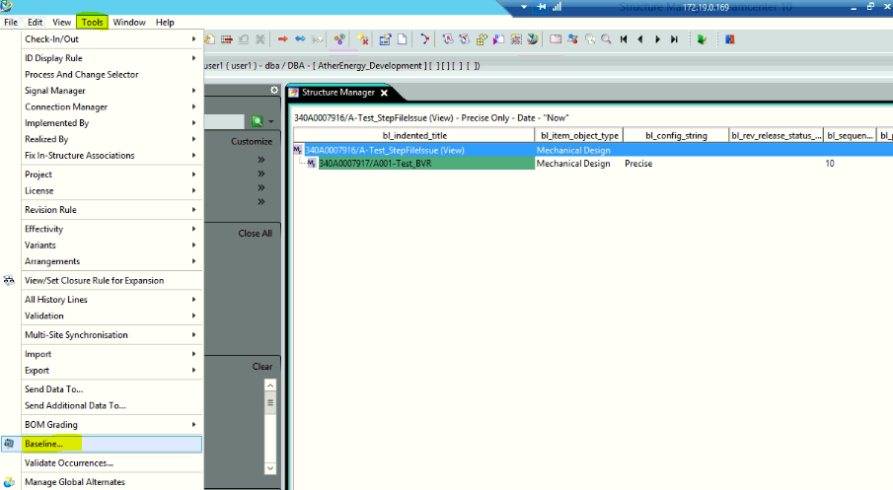

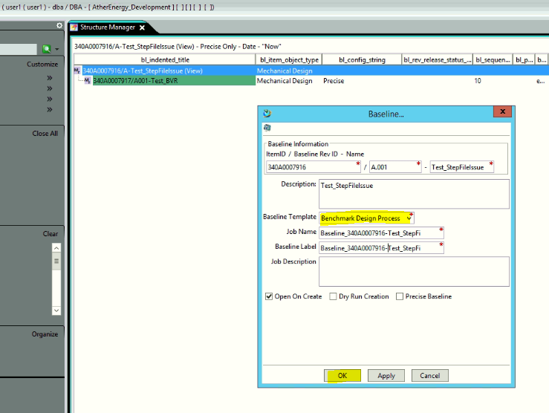

1. Go to my Teamcenter

Result : Step file is created after baseline creation.

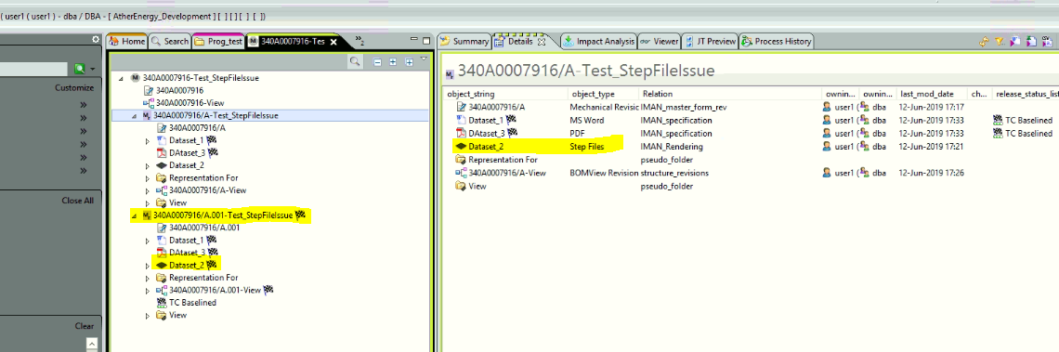

1. Test Result for Revise operation

