Schedule Management Reports :

1. Project Level UI :

For project level UI : Schedule should be like below. First milestone and the it’s tasks

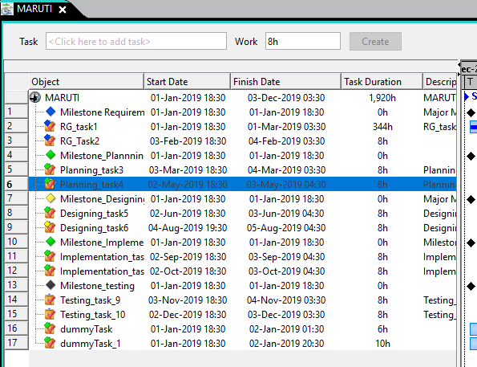

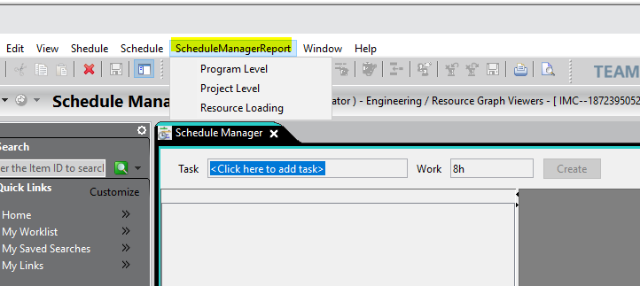

1. Project Level UI : UI is completed as POC demo
   1. UI is created with SWT grid and fields
   2. Live data is fetched from teamcenter
   3. All active schedules are displayed into list
   4. Progress bar with milestones are displayed on swt grid.
   5. Milestone related all tasks are displayed under milestone in Tree Grid

All active project list

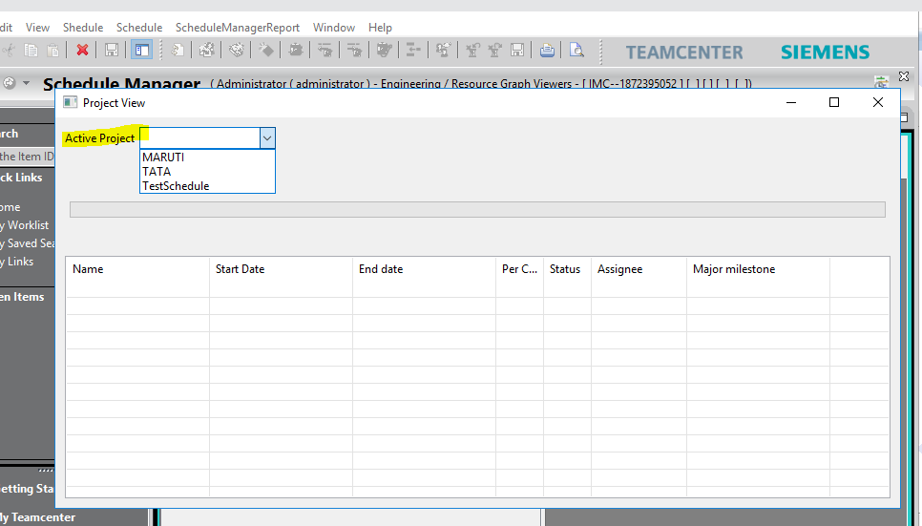

After Project selection

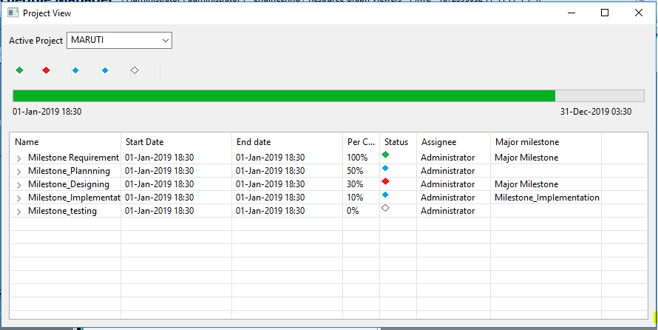

Bar shows : Selected project progress

Diamonds shows : Milestones

Green – Completed

Red – Delay

Blue – In progress

White – Others

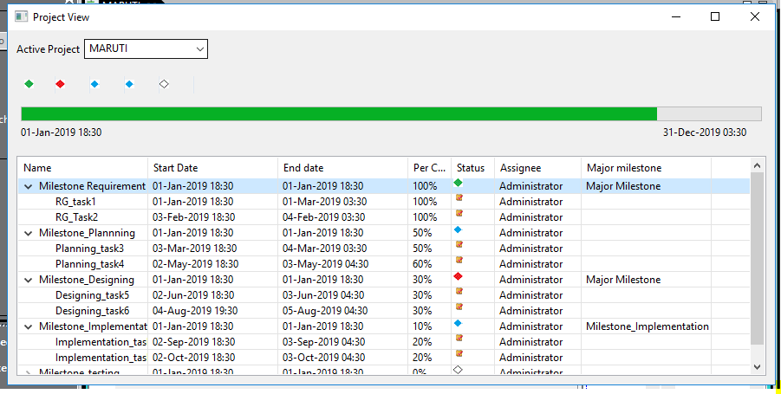

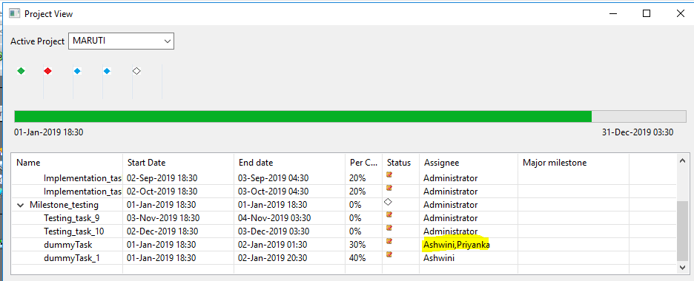

2. Resource Loading graph : UI is created for POC display View only with hard coded values

a. UI is created in SWT nebula grid and fields

b. Hard coded data list is retrieved through list and displayed on grid

c. Data reading logic is generic for hard coded data list

d. All users unique list is fetched from teamcenter schedules

e. All users task data fetching work is in progress

f. Live data loading on grid with user time duration utilization calculations work is not yet started

