## Important Preferences

|  |  |
| --- | --- |
| **Preference Name** | **Value** |
| **Mail_OSMail_activated** | **true** |
| **Mail_server_charset** | **Default value** |
| **Mail_server_name** | **Mail server IP address or name** |
| **Mail_server_port** | **25 (default)** |

**Note: Port 25 must be opened on all client machines where mails are going to be triggered.**

## Sample Configuration

**Preferences**

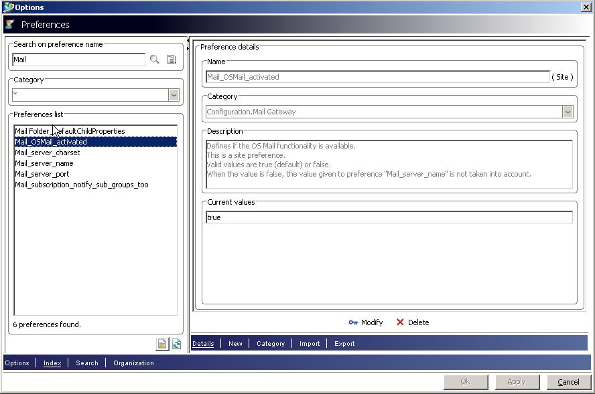

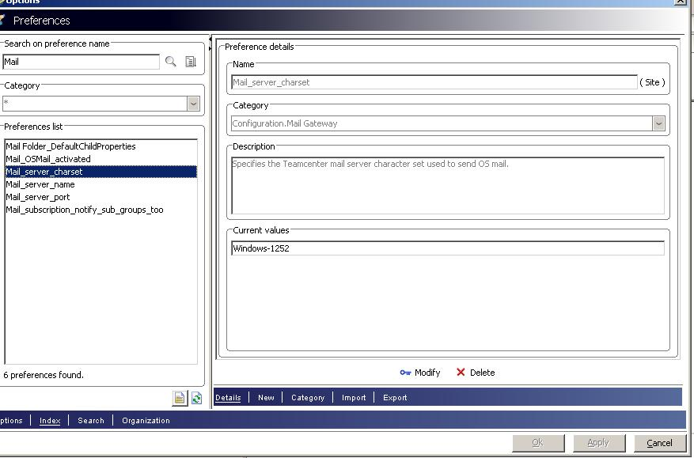

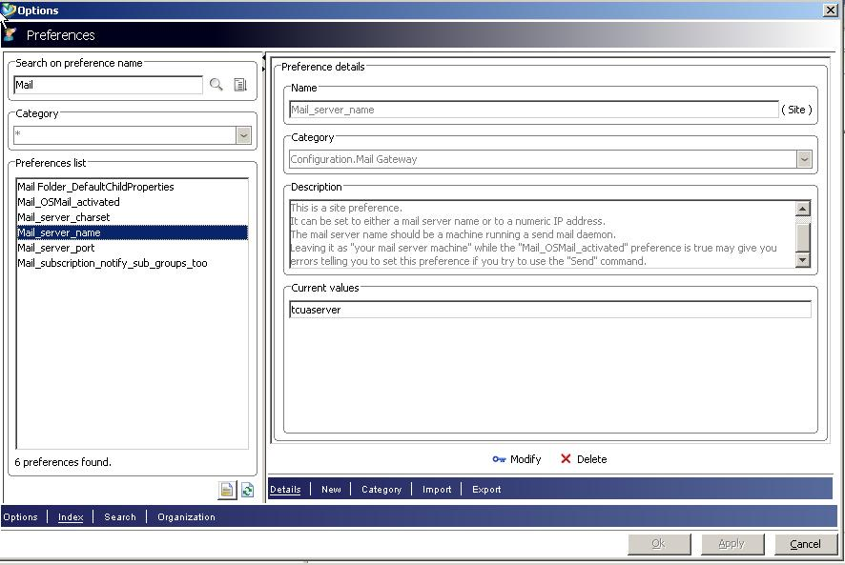

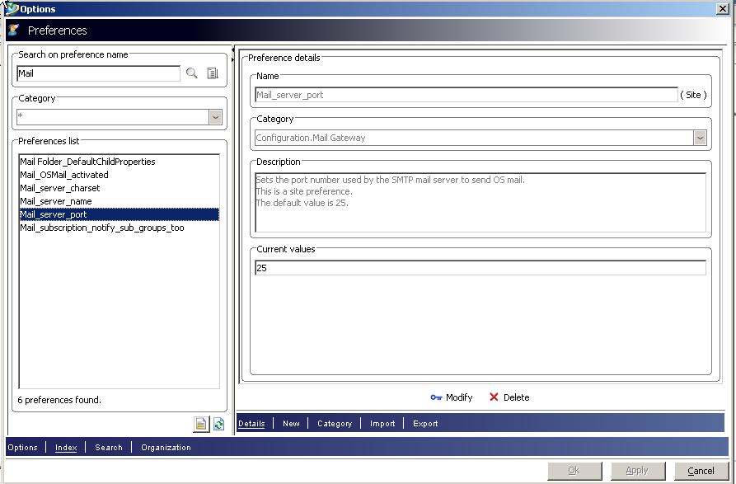

**Person Creation**

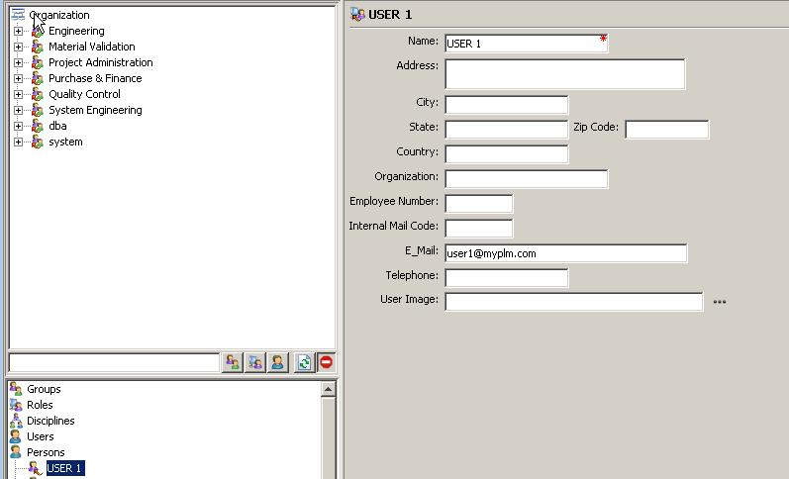

**Sample Workflow**

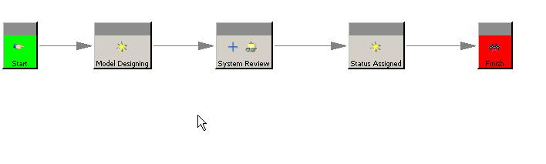

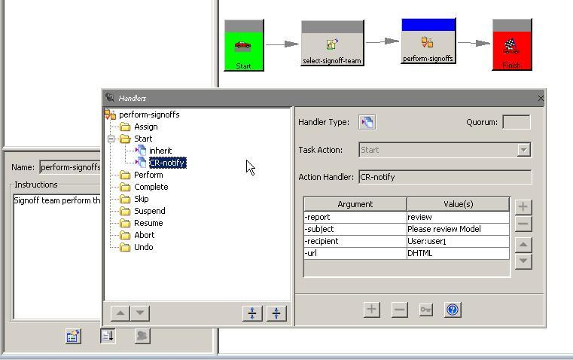

**Mail server Configuration (To be done by IT Administrator)**

**Note:** Below configuration is for POP3 service only (For Demo only). Actual mail server need to be configured by concerned IT admin only.

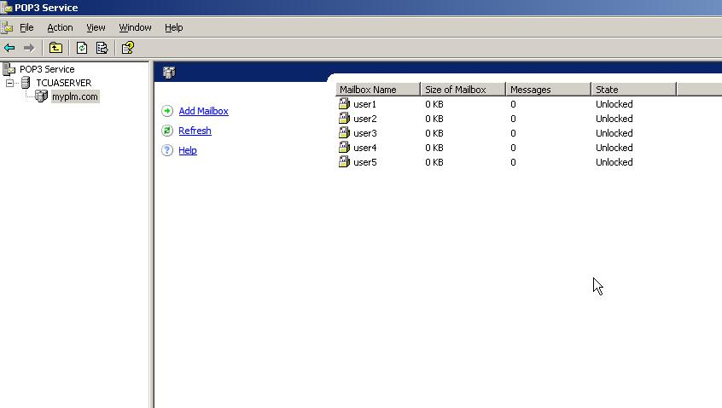

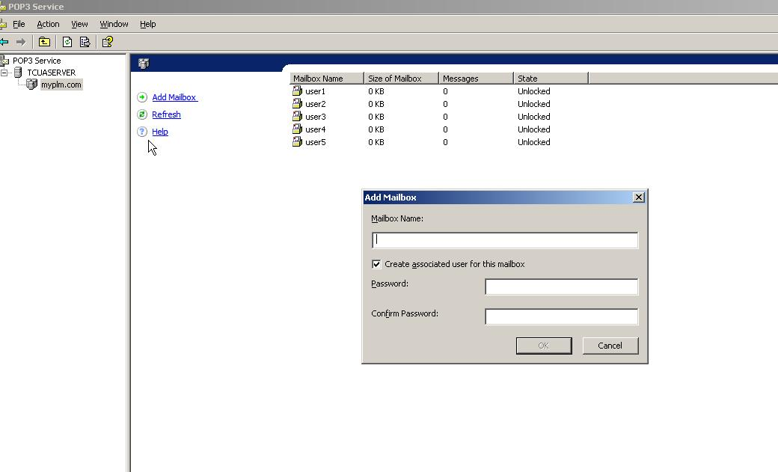

**Note:** POP3 service is an add-on component of Windows server 2003. You need to install it separately.