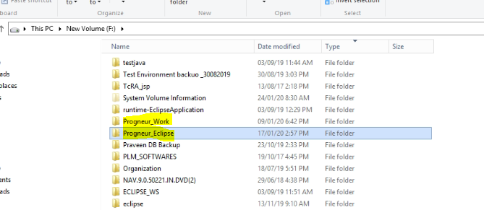

Start eclipse with RAC.bat

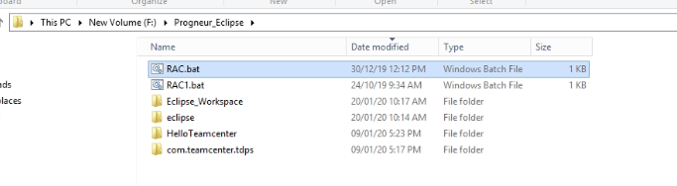

Project workspace location

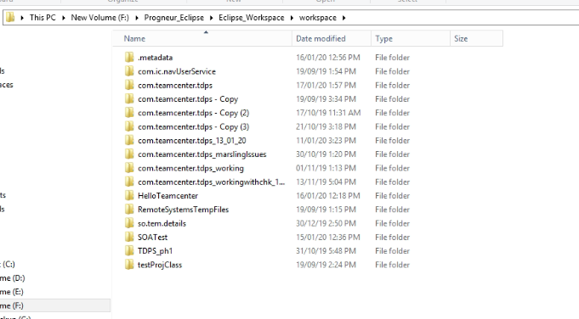

Com.teamcenter.tdps :- TDPS reporting tool plugin project

HelloTeamcenter : - For Quick data fetching

1. Call SOA fetch data from teamcenter
2. Segregate data and store into Teamcenter

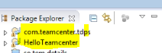

Main highlighted classes

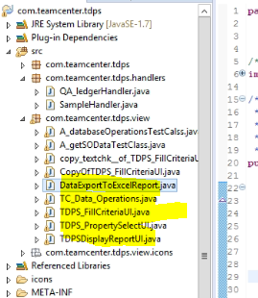

Input filter

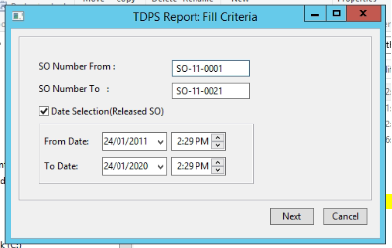

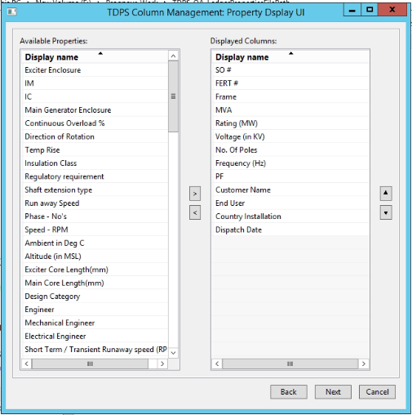

Right table properties are hardcoded into code : Due to sequence alignment

Left table properties are coming from below image path

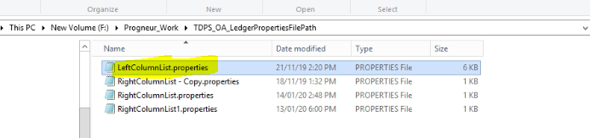

Output Column list saves on below location

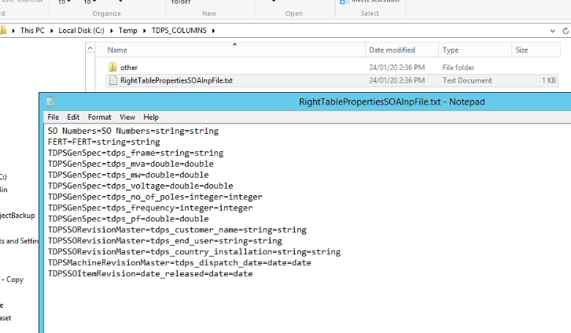

Report UI

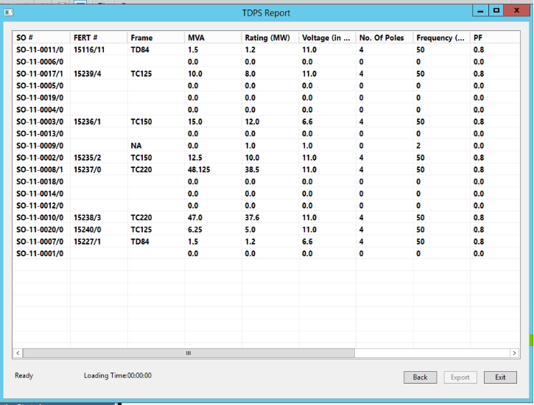

SOA code location in BMIDE

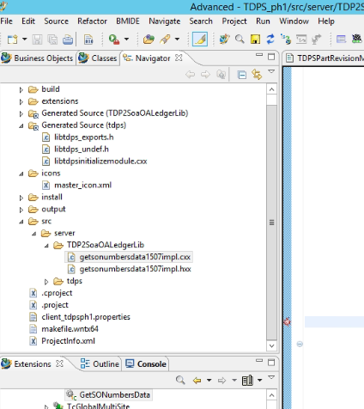

Code Backups

